STEMVAULT
A STEM CELL BANK MANAGEMENT SYSTEM
A project report submitted in partial fulfilment of the requirements for the course
DATABASE MANAGEMENT SYSTEMS
(Course code: ____________)
Submitted by
MANISH VASAM SAMBASIVARAO
Register Number: 25BCE2961
Under the guidance of
Prof. ____________________
SCHOOL OF COMPUTER SCIENCE AND ENGINEERING
VELLORE INSTITUTE OF TECHNOLOGY
VELLORE – 632 014, TAMIL NADU, INDIA
OCTOBER 2026

ABSTRACT
A haematopoietic stem-cell transplant requires a donor whose tissue type matches the patient at the HLA loci, so a stem-cell bank is a search problem over a shared national inventory rather than an inventory problem within one hospital. At the same time a cryopreserved unit must travel in vapour-phase nitrogen under a documented chain of custody, which makes distance a real operational constraint. StemVault resolves these competing pressures through a defined policy and records the resulting decision permanently.
The system models the complete workflow — donor consent, collection, laboratory testing, cryogenic storage, request, matching, allocation, transplant and outcome — in thirteen normalized relations. All thirteen satisfy the third normal form and most satisfy Boyce-Codd normal form; four denormalizations are deliberate and justified. The clinical rules live in the database: thirty-six triggers implement status machines, consent validation and an append-only audit trail, and eighteen stored procedures carry the multi-statement operations with row-level locking so that a unit cannot be allocated twice.
The matching module scores compatibility over six HLA alleles at the A, B and DRB1 loci and then searches in widening rings — same district, same state, anywhere in India — returning only the nearest ring that holds a compatible unit, with the tier stored alongside the shortlist. Authorization is expressed through six database roles, a column-level privilege and row-level views, mirrored in the application.
The system was populated with a registry-scale data set of 2,550 people — 1,600 donors and 950 patients — across 24 hospitals in 13 states, holding 1,413 cryopreserved units and 420 transplant requests. Verification against MySQL 8.0.46 confirmed that every object was created, that the seeded scenarios exercised every status path and every search tier, that twelve deliberate violations were rejected as designed, and that the full workflow ran end to end through the REST interface.
Keywords: relational design, normalization, stored procedures, triggers, transaction management, database security, HLA matching.

1. INTRODUCTION

1.1 Background and problem
Haematopoietic stem-cell transplantation replaces diseased marrow with healthy stem cells drawn from umbilical cord blood, bone marrow or peripheral blood. Compatibility is decided mainly by the human leukocyte antigen (HLA) system rather than by ABO group, and HLA types are highly polymorphic, so a patient may have no suitable unit among thousands and an exact match among the next thousand.
Two requirements therefore pull against each other. Match quality is a clinical constraint: below a defined HLA threshold a unit must not be considered at all. Distance is an operational constraint: a cryopreserved unit travels in vapour-phase nitrogen under a chain of custody, and for an urgent case delay itself is harmful. Without a defined policy the choice between a nearby good match and a distant better one is made informally and is never recorded.

1.2 Objectives
- Model the stem-cell banking workflow as a normalized schema of thirteen relations, with no entity added merely to increase complexity.
- Enforce every clinical rule inside the database, using constraints where SQL can express them and triggers or procedures where it cannot.
- Implement tiered geographic matching — district, state, country — combined with HLA scoring, in one stored procedure.
- Maintain an append-only audit trail attributable to a named user.
- Express authorization through database roles, column-level privileges and row-level views, mirrored in the application.
- Populate the system at registry scale, so that the design is exercised by realistic data volumes rather than by a handful of demonstration rows.

1.3 Scope
The work covers donor and patient registration, consent, collection and testing, storage with capacity control, request review, shortlisting, allocation, transplant and outcome, expiry maintenance and auditing. Conventional blood-bank inventory, billing, courier tracking and notifications are excluded; each would add entities without deepening the database concepts demonstrated.

2. REQUIREMENTS ANALYSIS
Institutional banks commonly keep inventory in spreadsheets or a single-hospital application. Three deficiencies follow: a unit stored at one hospital is invisible to a doctor at another; rules such as consent withdrawal and double allocation are enforced only in the user interface, so any other client can violate them; and the shortlist that led to a choice is never retained, which makes clinical audit impossible. The requirements below answer these directly.
Module | Functional requirement
Donor and consent | Register HLA-typed donors; record and revoke collection, storage and clinical-use consent
Sample and testing | Register collected units; record five laboratory tests; release a tested unit into a storage slot; discard rejected or expired units
Storage | Maintain cryogenic tanks with capacity; refuse storage beyond capacity or into a non-operational tank; report occupancy
Request and matching | Submit a request with unit type, minimum HLA match and urgency; approve or reject it; search by district, state and country; shortlist candidates
Allocation and transplant | Allocate one unit to one approved request under concurrency control; schedule the transplant; record completion and outcome
Audit and security | Record every critical change with its author; restrict each role to the data it needs
Table 2.1 Functional requirements by module
Non-functional requirements. Integrity: no clinical rule may be violated by any client, including direct SQL. Traceability: every change must be recoverable with its author and time. Concurrency: two coordinators must not be able to allocate the same unit. Privacy: a doctor must search the inventory without learning donor identity. Scale: the design must remain usable with thousands of donors and hundreds of open requests. Portability: vendor-specific constructs are avoided where a standard equivalent exists.
Platform. MySQL 8.0.16 or later with InnoDB (CHECK constraints are enforced only from this version); Node.js 18 with Express and the mysql2 driver; React with Vite for the interface; any modern browser as client.

3. CONCEPTUAL DATABASE DESIGN
Entity | Purpose
User | Login identity and role; the only entity holding a password hash
Donor / Patient | Persons with HLA typing; the patient additionally carries a diagnosis
Hospital | Registered institution; holds the address and so anchors the geography
Doctor | Clinician employed at exactly one hospital, who raises requests
StorageLocation | One cryogenic tank at a hospital, with a capacity
StemCellSample | One collected unit, its processing stage and its availability
SampleTest | One laboratory test performed on one unit
Consent | A donor’s permission for collection, storage or clinical use
TransplantRequest | A doctor’s request for a unit on behalf of one patient
RequestSample | The candidacy of one unit for one request, with score and tier
Transplant | The transplant performed with one allocated unit
AuditLog | Append-only history of changes to critical entities
Table 3.1 Entities and their purpose (Donor and Patient are separate relations)

3.1 Attributes requiring comment
HLA typing. Each person carries two alleles at each of three loci, so typing is six attributes with fixed positions. The cardinality is fixed by biology and each position has its own meaning, so this is not a repeating group and does not violate the first normal form.
Two status attributes on a unit. Processing status records the laboratory lifecycle and availability status the registry lifecycle. A unit can be released by the laboratory and still unavailable because its donor withdrew consent, so one combined attribute would have to enumerate the cross-product.
Derived attributes. Age, storage occupancy and a unit’s blood group are derived and never stored; the match score and search tier of a candidate are stored despite being computable, for the reason in Section 5.5.

3.2 Relationships and cardinalities
Relationship | Cardinality | Participation
User – Donor / Patient / Doctor | 1:1 | Optional for donor and patient; mandatory for doctor
Hospital – Doctor, Hospital – StorageLocation | 1:M | Each belongs to exactly one hospital
Donor – Consent, Donor – StemCellSample | 1:M | Each belongs to exactly one donor
StorageLocation – StemCellSample | 1:M | Optional: a unit may be unstored
StemCellSample – SampleTest | 1:M | A test belongs to exactly one unit
Patient – Request, Doctor – Request | 1:M | One open request per patient at a time
TransplantRequest – StemCellSample | M:N | Resolved by RequestSample
RequestSample – Transplant | 1:1 | A transplant uses one shortlisted candidate
Table 3.2 Relationships and cardinalities

3.3 Entity–relationship diagram
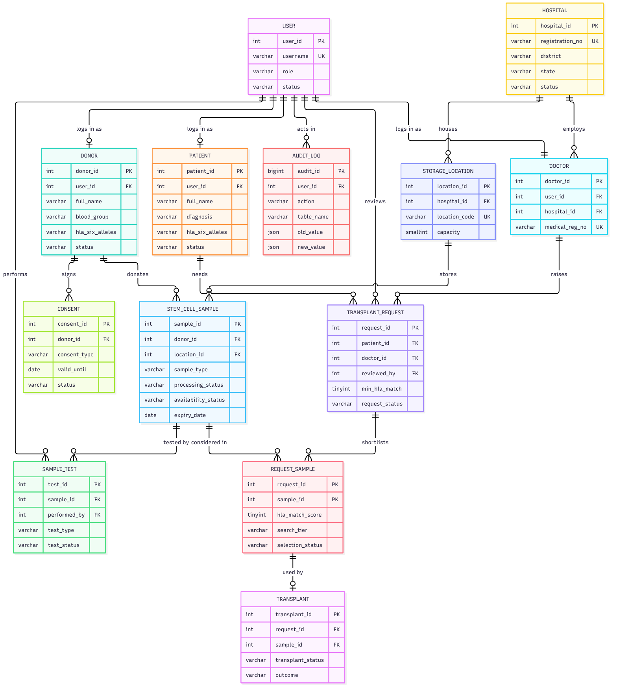
Figure 3.1 ER diagram of the StemVault database. In REQUEST_SAMPLE both key attributes are foreign keys forming the composite primary key.

3.4 Special modelling constructs
Weak entities. SampleTest and Consent cannot exist without their sample and donor; in Chen notation they are weak entities with partial keys (test type, test date) and (consent type, consent date), preserved as UNIQUE constraints after mapping.
Associative entity. RequestSample resolves the M:N relationship and carries its own attributes — score, tier, selection status, allocation date — so it is an entity rather than a link table.
Aggregation. A transplant relates not to a request and a unit separately but to the candidacy between them. This is implemented as a composite foreign key from Transplant to RequestSample, which makes it impossible to record a transplant of a unit that was never shortlisted for that request.

4. LOGICAL DESIGN AND RELATIONAL SCHEMA
Each strong entity became a relation with a surrogate key. Every 1:1 relationship became a nullable foreign key with a UNIQUE constraint, every 1:M relationship a foreign key on the many side, and the single M:N relationship its own relation with a composite key.
user(PK user_id, username UQ, password_hash, role, status, created_at)
donor(PK donor_id, FK user_id UQ, full_name, date_of_birth, gender, blood_group,
hla_a_1, hla_a_2, hla_b_1, hla_b_2, hla_drb1_1, hla_drb1_2, phone, email,
address, registration_date, status)
patient(PK patient_id, FK user_id UQ, full_name, date_of_birth, gender, blood_group,
hla_a_1 … hla_drb1_2, diagnosis, phone, email, address,
registration_date, status)
hospital(PK hospital_id, hospital_name, registration_no UQ, address_line, city,
district, state, pincode, phone, email UQ, registered_on, status)
doctor(PK doctor_id, FK user_id UQ, FK hospital_id, full_name, specialization,
medical_reg_no UQ, phone, email, status)
storage_location(PK location_id, FK hospital_id, location_code UQ, storage_area,
storage_type, capacity, current_status)
stem_cell_sample(PK sample_id, FK donor_id, FK location_id, storage_position,
sample_type, collection_date, volume_ml, cd34_count,
processing_status, availability_status, expiry_date, created_at)
sample_test(PK test_id, FK sample_id, test_type, test_date, result, test_status,
remarks, FK performed_by)
consent(PK consent_id, FK donor_id, consent_type, consent_date, valid_until,
revoked_on, revocation_reason, status)
transplant_request(PK request_id, FK patient_id, FK doctor_id, request_date,
required_sample_type, min_hla_match, urgency, request_status,
FK reviewed_by, reviewed_at, review_remarks)
request_sample(PK (FK request_id, FK sample_id), hla_match_score, search_tier,
selection_status, allocation_date)
transplant(PK transplant_id, FK (request_id, sample_id), transplant_date,
transplant_status, outcome, remarks)
audit_log(PK audit_id, FK user_id, action, table_name, record_id, action_time,
old_value, new_value)

4.1 Keys
Surrogate keys were preferred because every natural identifier in this domain can change or be entered wrongly; natural keys are retained as UNIQUE constraints. The one exception is request_sample, whose primary key is the composite (request_id, sample_id): the pair is the candidacy, it prevents a unit being shortlisted twice for one request, and it gives transplant a precise target.
Relation | Candidate / unique keys besides the primary key
user | username
donor, patient | (full_name, date_of_birth, phone); user_id; email (nullable)
hospital | registration_no; email
doctor | user_id; medical_reg_no
storage_location | location_code
stem_cell_sample | (location_id, storage_position) — one unit per slot
sample_test | (sample_id, test_type, test_date)
consent | (donor_id, consent_type, consent_date)
transplant | request_id; sample_id (each alone)
Table 4.1 Candidate and unique keys. A nullable unique attribute such as email is not strictly a candidate key.

4.2 Referential actions
The policy is asymmetric by design. Clinical links use RESTRICT so traceability from a transplanted unit back to its donor can never be severed; only the candidate rows of a request cascade, because they have no meaning without it. Deleting a login must not delete a clinical record, so those links use SET NULL.
Foreign key | On delete | On update
donor.user_id, patient.user_id → user | SET NULL | CASCADE
doctor.user_id → user; doctor.hospital_id, storage_location.hospital_id → hospital | RESTRICT | CASCADE
stem_cell_sample.donor_id → donor; sample_test.sample_id → sample; consent.donor_id → donor | RESTRICT | CASCADE
stem_cell_sample.location_id → storage_location; transplant_request.reviewed_by → user | RESTRICT | RESTRICT
request_sample.request_id → transplant_request | CASCADE | CASCADE
transplant.(request_id, sample_id) → request_sample | RESTRICT | CASCADE
Table 4.2 Foreign keys and referential actions
The two RESTRICT-on-update entries are not a preference but a MySQL rule: an attribute used inside a CHECK constraint may not carry a cascading referential action. In practice clinical rows are retired through their status attribute and never deleted.

4.3 Domain and integrity constraints
Status attributes are VARCHAR with a CHECK listing permitted values rather than ENUM, which keeps them portable, visible in the schema and alterable without a table rebuild. Representative constraints: blood group restricted to the eight ABO-Rh values; pincode matching ^[1-9][0-9]{5}$; all six HLA attributes null or all six non-null; expiry later than collection; (location_id IS NULL) = (storage_position IS NULL); a unit AVAILABLE only when RELEASED and located; (reviewed_by IS NULL) = (reviewed_at IS NULL); an outcome other than PENDING only on a completed transplant.
A CHECK constraint may not call CURDATE() or NOW(), because a non-deterministic predicate would make the same row valid today and invalid tomorrow. Every rule depending on the current date — expiry, consent validity, donor age — is therefore enforced in a trigger or procedure.

4.4 Indexes
Index | Attributes | Query served
idx_sample_avail | availability_status, sample_type, expiry_date | Availability view and the first filter of every search
idx_hospital_geo | state, district | Tier classification in the matching procedure
idx_request_queue | request_status, urgency, request_date | Review queue ordered by urgency
idx_consent_active | donor_id, consent_type, status | Consent validation inside triggers
idx_audit_entity | table_name, record_id, action_time | History of one record
Name indexes on donor, patient, hospital | full_name / hospital_name | Prefix searches of the form LIKE ‘Pri%’
Table 4.3 Indexes created beyond the automatic key indexes
Attribute order follows the leftmost-prefix rule: (state, district) serves a query on both attributes and one on state alone, but not one on district alone — acceptable because every tier query filters on state and district names repeat across states. Low-cardinality attributes such as gender are left unindexed, as the optimizer prefers a scan; the HLA attributes are unindexed because scoring is a computed comparison over an already-filtered set.

5. NORMALIZATION

5.1 First normal form
Every attribute is atomic and every relation has a primary key. The only construct needing justification is HLA typing: the two alleles per locus are fixed by biology and each position has a distinct meaning, so six attributes are six facts, not a repeating group. A child relation would add a join to every comparison in the scoring function without removing any anomaly.

5.2 Second normal form
Twelve relations have single-attribute keys and are in 2NF trivially. In request_sample(request_id, sample_id) every non-key attribute depends on the whole key: the score compares this patient with this donor, the tier measures this unit’s distance from this request’s hospital, and the selection status records this unit’s fate in this request. Placing sample_type here, convenient for display, would create a partial dependency on sample_id alone.

5.3 Third normal form
Transitive dependency avoided | Resolution
sample_id → donor_id → blood_group | Blood group stored only on donor; views join for it
doctor_id → hospital_id → hospital_name | doctor stores only hospital_id
request_id → doctor_id → hospital_id | The request stores no hospital attribute
location_id → hospital_id → district, state | The tank stores no address
location_id → count of stored units | Occupancy derived in a view, never stored
Table 5.1 Transitive dependencies identified and removed

5.4 Boyce-Codd normal form
A relation is in BCNF when every determinant is a candidate key. The additional determinants here are hospital.registration_no, doctor.medical_reg_no, and in transplant both request_id and sample_id, each unique. All are candidate keys, so these relations satisfy BCNF and the rest do so trivially.

5.5 Intentional denormalization
Item | Justification and cost accepted
request_sample.hla_match_score, search_tier | A snapshot of a clinical decision: re-typing a donor must not silently rewrite a past shortlist. The stored values may diverge from a recomputation, which is the intent
consent.status | Derivable from revoked_on and valid_until but filtered on constantly, including in triggers. A CHECK ties REVOKED to revoked_on; an event sets EXPIRED
audit_log JSON images | History is never queried relationally; the images cannot be joined, which is acceptable for an append-only log
hospital address attributes | In India pincode → district is not strict: some codes span districts and district names repeat across states. A location relation would be more correct but was omitted to keep the schema focused
Table 5.2 Intentional denormalizations
A fifth case is reported as a weakness rather than a decision: a request’s hospital is reached through doctor.hospital_id, so a doctor transferring hospitals would make past requests appear to originate from the new one. Storing hospital_id on the request would correct this.

6. DATABASE PROGRAMMING
The guiding principle is to use the weakest mechanism capable of expressing a rule: a CHECK for a single-row rule, a trigger for a rule spanning rows or depending on the current date, and a stored procedure where atomicity or locking is needed. The database contains 11 views, 11 functions, 36 triggers, 18 procedures and 1 scheduled event.

6.1 Views and functions
The eight general views cover available units (excluding donor identity), patient requests, hospital-level request counts, per-unit testing status, storage occupancy, donor consent status, transplant summaries and request candidates; three further views implement row-level access (Section 7.3). The principal functions are fn_hla_match_score and fn_locus_match for compatibility, fn_search_tier and fn_tier_rank for geography, fn_has_active_consent and fn_sample_tests_passed for release validation, and fn_location_free_slots for capacity.

6.2 Triggers and status machines
Entity | Permitted transitions
Sample processing | COLLECTED → PROCESSING → QUARANTINE → RELEASED; any state → REJECTED
Sample availability | NOT_AVAILABLE ↔ AVAILABLE → ALLOCATED → TRANSPLANTED; EXPIRED → DISCARDED
Request | PENDING → APPROVED / REJECTED / CANCELLED; APPROVED → ALLOCATED / CANCELLED; ALLOCATED → COMPLETED, or back to APPROVED on release
Transplant | SCHEDULED → COMPLETED / CANCELLED; CANCELLED → SCHEDULED
Table 6.1 Permitted status transitions, enforced in BEFORE UPDATE triggers
Any other transition raises SQLSTATE ‘45000’ with a readable message. Triggers also cascade state automatically: allocating a candidate sets the unit and the request to ALLOCATED; releasing an allocation returns the unit to the pool, or marks it EXPIRED or NOT_AVAILABLE if its expiry passed or consent lapsed, and the request to APPROVED; completing a transplant sets the unit to TRANSPLANTED, clears its slot and closes the request; revoking storage or clinical-use consent withdraws every available unit of that donor; and a failed mandatory test rejects and discards the unit.

6.3 Transactions and concurrency
Allocation is the operation requiring isolation: two coordinators viewing the same shortlist could otherwise allocate one unit twice, a lost-update anomaly with clinical consequences. sp_allocate_sample opens a transaction, takes SELECT … FOR UPDATE on the request row and then the unit row, re-validates availability, type and score inside the lock, updates the candidate row and commits; an EXIT HANDLER FOR SQLEXCEPTION rolls back and re-signals. Locking in a fixed order — request before unit — prevents deadlock. Three further procedures are transactional for atomicity: donor registration, sample registration with its five tests, and request cancellation.

6.4 Audit trail
Triggers on five relations write every insert, update and delete into audit_log as JSON before and after images. A trigger cannot see the application user, so the API executes SET @app_user_id = ? on its pooled connection before each write and a shared helper reads the session variable. BEFORE UPDATE and BEFORE DELETE triggers on audit_log raise an error unconditionally, so even the root account cannot rewrite history through SQL. Loading the demonstration data alone produced 9,205 audit rows.
Cursor and event. sp_expiring_samples_report declares a cursor over units expiring within a given number of days and classifies each row into an action priority; the event ev_daily_maintenance runs nightly and marks expired units and lapsed consents.

7. MATCHING MODULE AND DATABASE SECURITY

7.1 HLA scoring
Each person carries two alleles at each of three loci. Because allele order within a locus is arbitrary, both pairings are evaluated and the better retained:
locus score = MAX( (p1 = d1) + (p2 = d2), (p1 = d2) + (p2 = d1) )
The three locus scores sum to a match out of six; the function returns NULL when either person is untyped. A request carries its own minimum, four by default.
Locus | Patient alleles | Donor alleles | Score
HLA-A | A26:01, A01:01 | A26:01, A33:03 | 1
HLA-B | B57:01, B07:02 | B57:01, B07:02 | 2
HLA-DRB1 | DRB104:01, DRB111:01 | DRB104:01, DRB111:01 | 2
 |  | Total | 5 / 6
Table 7.1 Worked match calculation: a candidate at a minimum of 4, not at 6

7.2 The tiered search
sp_find_candidates(request_id, save) locates the requesting district and state through request → doctor → hospital; filters to units that are available, of the required type, unexpired, in an operational tank at an active hospital, covered by active clinical-use consent and scoring at or above the request minimum; classifies each by comparing its hospital’s district and state with the request’s; takes the nearest non-empty ring; and, when save = 1, stores those candidates with their score and tier frozen. Equality of district also requires equality of state, because district names repeat across Indian states.
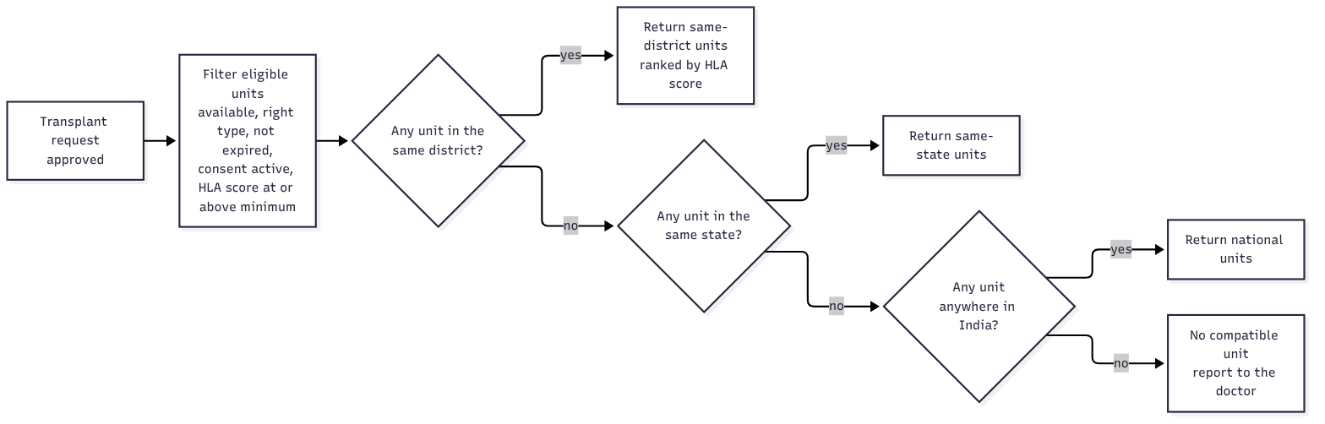
Figure 7.1 Tiered search: district, state, national fallback
The procedure returns two result sets: a summary of all three rings, so a user can see that a national match existed even when it was not offered, and the candidates of the selected ring ordered by score, then ABO identity, then CD34 count, then expiry. Distance thus outranks match quality between rings but never within one — a defensible policy rather than an indisputable one, and one that can be changed by editing a single procedure.
Cost at scale. For n units of the required type, scoring is O(n) with six comparisons each, over a set already reduced by idx_sample_avail. Measured against the populated database — 1,413 units, of which 1,125 are available — a complete tiered search returns in approximately 0.1 s, so the linear scan is not a practical limit at this size.

7.3 Authorization
Six database roles implement least privilege: sv_admin (full access), sv_bank_staff (donors, consents, units, tests and storage, plus EXECUTE on ten workflow procedures), sv_doctor (patients and requests, with no privilege at all on donor or stem_cell_sample), sv_donor and sv_patient (row-level views only), and sv_app, the application account, which holds no DDL and only SELECT and INSERT on audit_log.
Staff may review a request without rewriting its clinical content, enforced at column level:
GRANT SELECT, UPDATE (request_status, reviewed_by, reviewed_at, review_remarks)
ON stemvault.transplant_request TO sv_bank_staff;
MySQL has no row-level security, so donors and patients reach their own records through SQL SECURITY DEFINER views filtered by WHERE u.username = SUBSTRING_INDEX(USER(), '@', 1). USER() returns the session’s client account even inside a definer view, whereas CURRENT_USER() would return the definer. The limitation is that this needs one database account per person; the application enforces the same restriction independently using the identity in its token.

8. IMPLEMENTATION
The application layer is intentionally thin, since the rules reside in the database. Backend: an Express API over seventeen route groups; reads query the views and every state change calls a stored procedure, so no clinical rule is implemented in application code. A helper borrows a pooled connection, sets @app_user_id, performs the work and clears the variable, which is what makes the audit trail attributable. Database errors are translated into HTTP responses: SQLSTATE ‘45000’ becomes 400 carrying the trigger’s message, duplicate keys 409, and privilege errors 403. List endpoints return at most 200 matching rows, which keeps a query over 1,600 donors bounded; narrowing is done with the filters.
Frontend: a React single-page application presenting five role-based views — administrator, bank staff, doctor, donor and patient — determined by the role in the authentication token. Two presentation choices carry information: the HLA score is drawn as six filled or empty marks so that 5/6 and 6/6 are distinguishable at a glance, and a search result is drawn as three rings showing what each tier held and which was used, so a coordinator can see that a better national match existed and was deliberately not offered.
Authentication: passwords are stored as bcrypt hashes with a work factor of ten; a JSON Web Token carries the user identifier, role and linked doctor, donor or patient identifier, and ownership is re-checked per record, so a doctor opening another doctor’s request is refused even though the route admits doctors.

9. TESTING AND RESULTS
Testing was carried out against a live MySQL 8.0.46 instance in four stages: object verification, loading of demonstration data through the real procedures, deliberate violation of each class of rule, and an end-to-end run of the workflow through the REST interface. All scripts executed without error, producing 13 tables, 11 views, 36 triggers, 29 routines, 1 event and 10 additional indexes.

9.1 The demonstration data set
The database was populated at registry scale by a deterministic generator, so that the design is exercised by realistic volumes rather than by a handful of rows. Because the data is inserted through the stored procedures and triggers rather than as raw rows, loading it is itself a test of the database logic; the complete load takes about eight seconds.
Entity | Rows | Composition
Hospitals | 24 | Across 13 states and 23 districts; one suspended, one inactive
Storage tanks | 48 | Two under maintenance, one decommissioned
Donors | 1,600 | 1,512 HLA-typed; the rest awaiting typing, deferred or withdrawn
Patients | 950 | Across fourteen diagnoses; a few inactive or deceased
Stem cell units | 1,413 | 1,125 available, 69 allocated, 47 transplanted, 44 expired, 41 discarded, 87 withheld
Laboratory tests | 7,065 | Five per unit, including pending and failed results
Consents | 4,472 | Collection, storage and clinical use, with revocations
Transplant requests | 420 | 143 pending, 64 approved, 69 allocated, 47 completed, 56 rejected, 41 cancelled
Transplants | 73 | Scheduled and completed, with all four outcome values
User accounts | 87 | 3 administrators, 9 bank staff, 26 doctors, 49 donor and patient logins
Audit rows | 9,205 | Written entirely by triggers during the load
Table 9.1 Volume and composition of the demonstration data
Two defects in the generator were revealed by the triggers during loading. A failed infectious screen discards its unit, so later test rows for that unit were rejected until the generator recorded the failed test last; and a collection date could precede the donor’s consent date, which the collection trigger refuses. Both confirm that the triggers detect inconsistencies a direct insert would have introduced silently.

9.2 Constraint, trigger and authorization tests
Test case | Observed result
Duplicate username | Rejected — 1062, unique key
Blood group “C+” | Rejected — 3819, CHECK
Five-digit pincode | Rejected — 3819, CHECK
Test for a non-existent unit | Rejected — 1452, foreign key
Delete a hospital that has doctors | Rejected — 1451, RESTRICT
Patient with no diagnosis | Rejected — 1364, NOT NULL
Request status COMPLETED → PENDING | Rejected — 45000, invalid transition
Delete a row from audit_log | Rejected — 45000, append-only
Release a unit before its tests pass | Rejected — 45000, mandatory tests
Doctor account: SELECT on donor | Denied — 1142
Donor account: SELECT on own view / on donor | One row returned / denied — 1142
Staff account: UPDATE urgency / UPDATE request_status | Denied — 1143 / permitted
Table 9.2 Constraint, trigger and authorization tests — all twelve behaved as designed

9.3 Matching and workflow results
The eight scenario requests confirm each path through the matching procedure against the full data set. Request 1 is satisfied in its own district in Chennai while the outer rings stay unused; request 2, raised in Madurai, falls back to Tamil Nadu and returns a 5/6 unit while a 6/6 unit in Delhi appears in the summary and is not offered; request 3, raised in Kochi, falls back to the national ring; and request 4 finds no compatible unit anywhere in India. Because the 1,500 background donors are generated from the common allele pools and each scenario patient carries three private alleles, no background donor can satisfy a scenario request by accident, so the demonstration is stable however large the data set grows.
A complete cycle was then executed through the API: approval of a pending request, the tiered search, shortlisting, allocation, scheduling by the treating doctor and completion with an outcome. A second allocation attempt on the same request was refused by the trigger, and a doctor who did not own the request received 403. All twenty-six interface routes rendered across the five roles without errors; the dashboard query returns in under 0.02 s.
Not tested. No load testing was performed, and concurrency was verified by manual locking in two sessions rather than by a concurrent client harness. Index behaviour was confirmed by examining EXPLAIN plans in addition to the measured response times above.

10. CONCLUSION AND FUTURE ENHANCEMENTS
The project demonstrates that a clinical workflow can be governed by its database rather than by the software in front of it. Thirty-six triggers, eighteen procedures and a complete constraint set hold the rules, and twelve deliberate violations were rejected at the database level with no application code involved: a unit cannot be allocated twice, a transplant cannot use a unit that was never shortlisted, withdrawal of consent removes units from matching, and the audit trail cannot be edited by any account. Populating the system with 2,550 people and 1,413 units showed that the design holds at a realistic size: the tiered search still completes in about a tenth of a second, and the 9,205 audit rows were written entirely by triggers.
The tiered matching module is the principal contribution. It is not a complex query but a policy — distance outranks match quality between rings, never within one — expressed in one procedure and recorded permanently in the shortlist, so that a clinical audit years later reflects the decision as it was made.
Limitation | Consequence
A request’s hospital is derived through doctor.hospital_id | A doctor transferring would make past requests appear to come from the new hospital
One open request per patient | A patient needing two unit types at once cannot be modelled
Row-level security needs one account per person | Does not scale beyond a demonstration
The tier policy ignores urgency | A critical case is treated like a routine one when choosing a ring
HLA at three loci, low resolution | Clinical registries match at eight or ten alleles
The scoring function is evaluated per candidate row | Acceptable at 1,413 units; at millions it should be computed once into the temporary relation
No shipment or chain-of-custody tracking | An allocated unit has no transit record
Table 10.1 Known limitations
Future enhancements, in order of value: store hospital_id on the request at submission, correcting the single genuine design flaw; introduce a shipment entity with carrier, dispatch and receipt timestamps and a temperature log; weight the matching policy by urgency, with any override recorded; move HLA typing into a child relation keyed by locus to support eight- and ten-allele matching; partition audit_log by month with a retention policy, since the log already grows faster than any other relation; and replace per-person database accounts with a service account plus application identity.

REFERENCES
- R. Elmasri and S. B. Navathe, Fundamentals of Database Systems, 7th ed. Pearson, 2016.
- A. Silberschatz, H. F. Korth and S. Sudarshan, Database System Concepts, 7th ed. McGraw-Hill, 2019.
- C. J. Date, An Introduction to Database Systems, 8th ed. Addison-Wesley, 2003.
- E. F. Codd, “A relational model of data for large shared data banks”, Communications of the ACM, vol. 13, no. 6, pp. 377–387, 1970.
- Oracle Corporation, MySQL 8.0 Reference Manual — CHECK constraints (13.1.20.6), Roles (6.2.10), Stored Programs (25). Available: dev.mysql.com/doc/refman/8.0/en/
- World Marrow Donor Association, International Standards for Unrelated Haematopoietic Stem Cell Donor Registries, 2023.
- National Marrow Donor Program, HLA Matching Guidelines for Unrelated Donor Transplantation, 2022.
- N. Provos and D. Mazières, “A future-adaptable password scheme”, in Proc. USENIX Annual Technical Conference, 1999.

