PROJECT DESIGN PHASE — II
Data Flow Diagrams & User Stories
WhatNext Vision Motors: Shaping the Future of Mobility with Innovation and Excellence

PROJECT INFORMATION
Date | 06 April 2025
Team ID | WNV-2025-01
Project Name | WhatNext Vision Motors: Shaping the Future of Mobility with Innovation and Excellence
Team Lead | MANISHA
Team Members | MANISHA (TL) | RAJKUMAR | TAMIZHKUMARAN | VINITH
Maximum Marks | 4 Marks

DATA FLOW DIAGRAMS — OVERVIEW
A Data Flow Diagram (DFD) is a traditional visual representation of the information flows within a system. A neat and clear DFD can depict the right amount of system requirement graphically. It shows how data enters and leaves the system, what changes the information, and where data is stored.
WhatNext Vision Motors employs DFDs at two levels. The Level-0 Context DFD represents the complete platform as a single process with all external entities identified. The Level-1 DFDs then decompose each major subsystem — one per team member — into individual processes, data stores, and data flows.

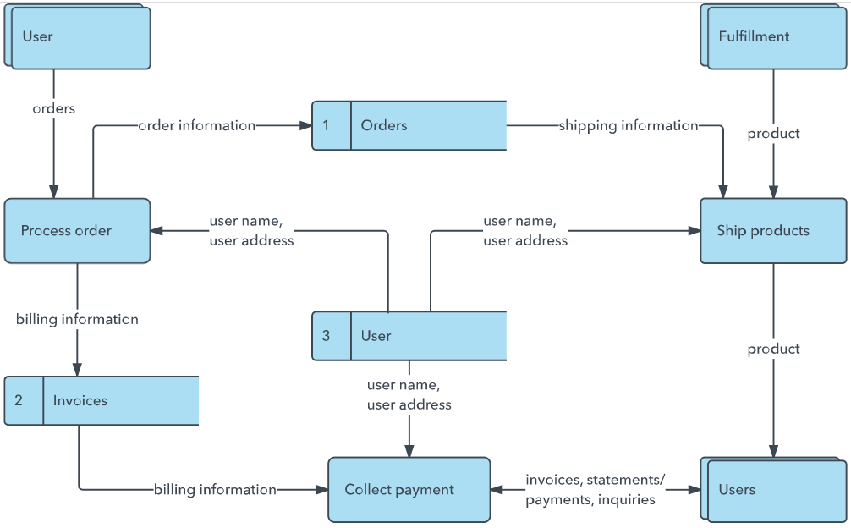


DFD NOTATION LEGEND
The following symbols are used consistently across all WhatNext Vision Motors DFDs in this document:

Symbol | Meaning | Shape | Example
External Entity | Source or destination of data outside the system boundary | Rectangle with double border | Driver, Fleet Manager, Charging Network API
Process | Transformation that converts input data to output data | Circle / rounded shape with reference number | AI Range Optimizer (1.2), Collision Engine (2.2)
Data Store | Persistent repository where data is stored for future use | Open-ended rectangle — two parallel horizontal lines | D1: Driver Profiles DB, D6: Incident Logs DB
Data Flow | Movement of data between entities, processes, and data stores | Directed arrow with descriptive label | Biometric Input, Charge Status, Fleet Config

LEVEL-0 CONTEXT DFD — WhatNext Vision Motors Platform
The Level-0 Context DFD models the entire WhatNext Vision Motors platform as a single high-level process (Process 0). It identifies all six external entities that exchange data with the platform and labels every primary data flow.

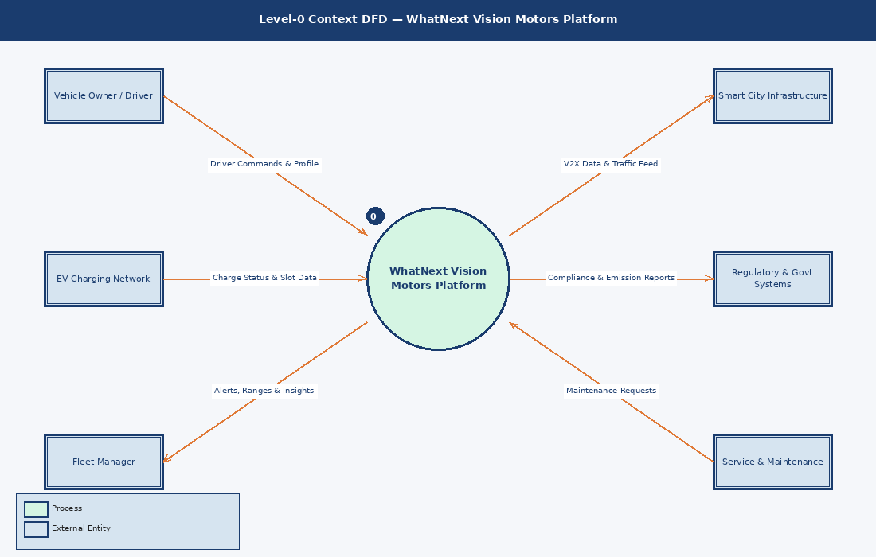

External Entity | Data Flows Description
Vehicle Owner / Driver | Sends driver commands, profile data and driving preferences; receives real-time range estimates, route suggestions and in-car AI personalisation outputs.
Fleet Manager | Provides fleet configuration and management commands; receives live fleet health dashboards, predictive maintenance alerts and ESG compliance reports.
Smart City Infrastructure | Supplies V2X (Vehicle-to-Everything) data, traffic signal states and road condition feeds; receives vehicle telemetry for smart city traffic optimisation.
EV Charging Network | Provides real-time charging station availability and slot booking confirmations; receives advance reservation requests from the platform.
Regulatory & Govt Systems | Receives automated carbon emission data and compliance reports; provides updated policy thresholds and regulatory mandates to the platform.
Service & Maintenance | Receives predictive maintenance alerts and service job tickets; sends repair completion confirmations and parts procurement data back to the platform.

LEVEL-1 DFD — AI Range & EV Management System
Owner: RAJKUMAR | Subsystem: AI-Powered Range Optimisation & Charging Management
This Level-1 DFD decomposes Process 1.0 into five sub-processes covering driver profile management (1.1), AI range optimisation (1.2), charging slot scheduling (1.3), route and alert generation (1.4), and battery health monitoring (1.5). Three data stores — Driver Profiles DB, Charging Slots DB, and Battery Telemetry DB — persist the data required across these processes.

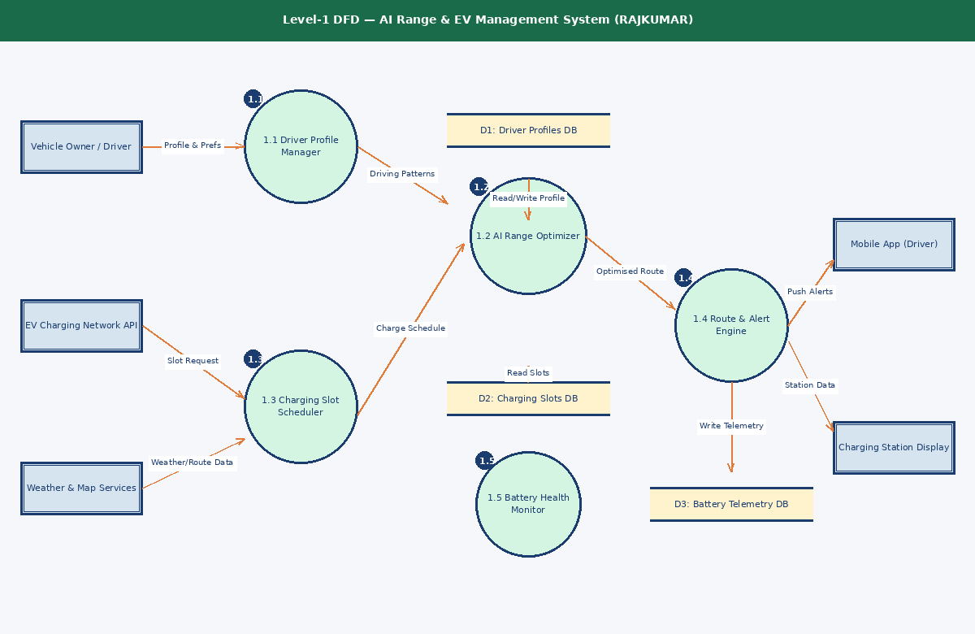

LEVEL-1 DFD — Safety & ADAS System
Owner: MANISHA (TL) | Subsystem: Predictive Collision Avoidance & AI Fatigue Detection
This Level-1 DFD decomposes Process 2.0 into five sub-processes: AI fatigue detection (2.1), collision prediction engine (2.2), sensor data processing (2.3), incident response management (2.4), and safety log recording (2.5). Data stores include Driver Biometrics DB, Sensor Events DB, and Incident Logs DB. This subsystem directly fulfils Problem Statement PS-3 from the Define phase.

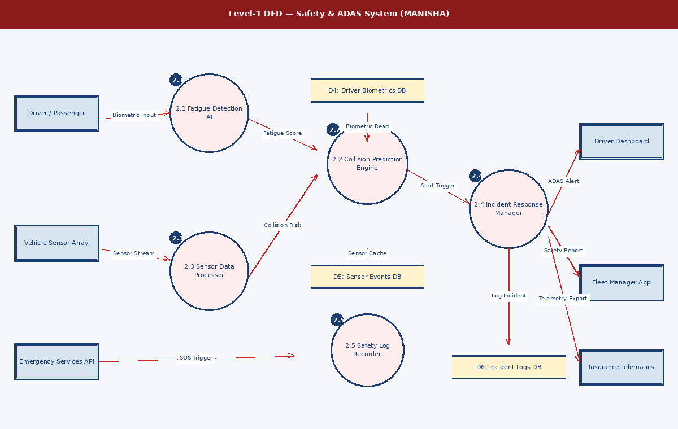

LEVEL-1 DFD — Fleet Intelligence & Sustainability System
Owner: TAMIZHKUMARAN | Subsystem: Real-Time Fleet Monitoring, Predictive Maintenance & ESG Reporting
This Level-1 DFD decomposes Process 3.0 into five sub-processes: fleet onboarding manager (3.1), real-time fleet monitor (3.2), predictive maintenance AI (3.3), report and alert generator (3.4), and carbon footprint tracker (3.5). Data stores cover Fleet Registry DB, Maintenance Logs DB, and Emissions Data DB. This subsystem addresses PS-2 (Fleet Manager) and PS-5 (Eco-Conscious Buyer).

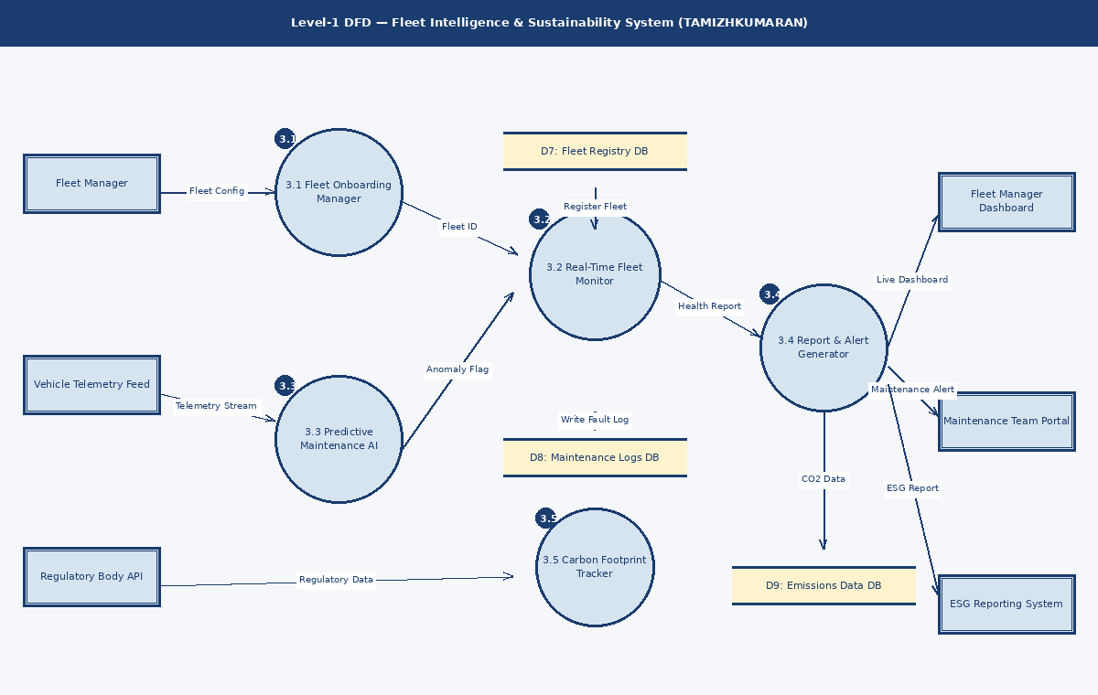

LEVEL-1 DFD — AI Co-Pilot & Connected UX System
Owner: VINITH | Subsystem: Personalised AI Co-Pilot, OTA Feature Marketplace & Smart Home Integration
This Level-1 DFD decomposes Process 4.0 into five sub-processes: user profile and preferences engine (4.1), AI co-pilot personaliser (4.2), IoT integration hub (4.3), contextual UX renderer (4.4), and OTA feature manager (4.5). Data stores cover User Preference DB, IoT Device DB, and Feature Packages DB. This subsystem directly fulfils PS-4 (Tech-Savvy Professional).

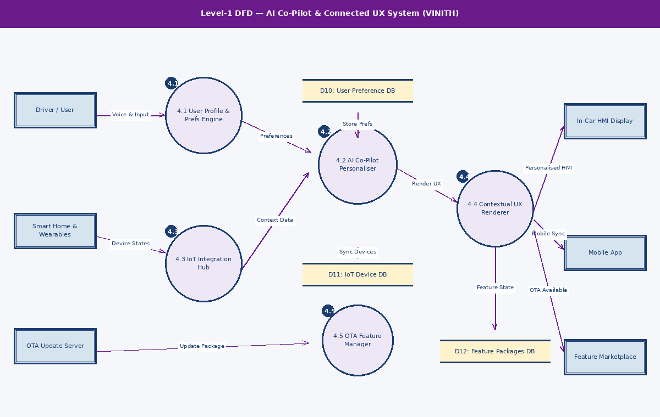

USER STORIES — WhatNext Vision Motors Platform
The following 28 user stories define the functional requirements of the platform across six user types. Each story follows the standard format: As a [user type], I can [action] so that [benefit]. Acceptance criteria define measurable, testable conditions for each story's completion. Stories are prioritised High, Medium, or Low and assigned to a sprint release.

User Type | Epic (Functional Req.) | USN | User Story / Task | Acceptance Criteria | Priority | Release
EV Driver (Mobile App) | Registration & Onboarding | USN-01 | As an EV driver, I can register on the WhatNext app by entering my name, email, vehicle VIN, and password so I can access my personalised dashboard. | Account created; OTP email received; dashboard loads on first login within 3 seconds. | High | Sprint-1
 |  | USN-02 | As an EV driver, I can log in using email/password or Google SSO so I can securely access my vehicle data. | Login succeeds in under 2 seconds; session token issued; invalid credentials show an error message. | High | Sprint-1
 | Range & Charging | USN-03 | As an EV driver, I can view my real-time battery percentage and AI-estimated remaining range on the home screen so I can plan my trip confidently. | Range updates every 30 seconds; AI accuracy within 5% of actual; low-battery warning shown below 20%. | High | Sprint-1
 |  | USN-04 | As an EV driver, I can search for nearby charging stations on a map and reserve a slot in advance so I can avoid charging queues. | Map loads in under 3 seconds; slot reservation confirmed with booking ID and estimated wait time. | High | Sprint-1
 |  | USN-05 | As an EV driver, I receive a push notification when my battery drops below a threshold I configure so I am never caught off-guard during a journey. | Notification fires at exact threshold; configurable from 10% to 40%; works reliably in background mode. | Medium | Sprint-2
 | AI Co-Pilot | USN-06 | As an EV driver, I can interact with the in-car AI co-pilot via voice commands to adjust climate, navigation, and media preferences so my hands remain on the wheel. | Voice commands processed in under 1 second; intent recognition accuracy above 95%. | High | Sprint-2
 |  | USN-07 | As an EV driver, I can download new AI co-pilot feature packs from the OTA marketplace so I can upgrade my vehicle intelligence post-purchase. | Feature pack downloads via OTA; installs without a vehicle restart; previous version rollback available within 24 hours. | Medium | Sprint-3
 | Safety Alerts | USN-08 | As an EV driver, I receive an in-dash fatigue alert with a recommended rest stop suggestion when the AI detects drowsiness patterns so I can drive safely. | Alert fires within 5 seconds of drowsiness detection; nearest rest stop within 10 km is suggested automatically. | High | Sprint-2
 | Carbon Dashboard | USN-09 | As an EV driver, I can view my monthly carbon savings comparing my EV against an equivalent petrol vehicle so I remain motivated to maintain eco-driving habits. | Dashboard shows CO2 saved in kg, cost saved in INR, and a tree-equivalent metric updated monthly. | Low | Sprint-3
Safety-Conscious Parent (Web & App) | ADAS & Safety | USN-10 | As a parent, I can view the vehicle active safety feature status and ADAS operational state so I know my family is protected at all times. | Safety status page loads in under 2 seconds; all ADAS features listed with live on/off status indicators. | High | Sprint-2
 |  | USN-11 | As a parent, I can create a teen driver profile that limits maximum speed and deactivates non-essential in-car features so my teenager drives safely. | Profile activates within one tap; speed cap enforced; parent receives a real-time override notification. | High | Sprint-2
 | Collision Alerts | USN-12 | As a parent, I receive an automatic emergency alert on my phone if the vehicle detects a collision or airbag deployment so I am immediately informed of an incident. | Alert sent within 10 seconds of incident; includes GPS coordinates, severity level, and emergency contact option. | High | Sprint-1
 |  | USN-13 | As a parent, I can view monthly safety scores for each driver in my family account so I can identify and discuss risky driving habits constructively. | Safety score calculated weekly; broken down by speed, harsh braking, and fatigue sub-scores. | Medium | Sprint-3
Fleet Manager (Web Portal) | Fleet Onboarding | USN-14 | As a fleet manager, I can register and manage all fleet vehicles from a single dashboard so I have complete operational visibility across all locations. | Up to 200 vehicles per account; bulk CSV import supported; dashboard loads within 3 seconds. | High | Sprint-1
 |  | USN-15 | As a fleet manager, I can view the real-time GPS location and battery status of every vehicle on a live map so I can optimise dispatch and routing decisions. | Map refreshes every 15 seconds; vehicle markers colour-coded by battery level and operational status. | High | Sprint-1
 | Predictive Maintenance | USN-16 | As a fleet manager, I receive AI-generated maintenance alerts 48 hours before a predicted component fault so I can schedule repairs proactively and avoid unplanned downtime. | Alert includes fault type, confidence score above 80%, predicted failure window, and recommended service action. | High | Sprint-2
 |  | USN-17 | As a fleet manager, I can generate monthly fleet health and cost-per-km reports in PDF so I can present operational performance to senior management. | Report generated in under 30 seconds; includes all active vehicles; exportable as both PDF and CSV formats. | Medium | Sprint-2
 | Sustainability | USN-18 | As a fleet manager, I can view aggregated carbon emission savings across the entire fleet so I can report accurate ESG metrics to regulatory bodies and clients. | CO2 data accurate within 2% of actual; comparison against fossil-fuel baseline included; exportable for ESG reporting. | Medium | Sprint-3
Tech-Savvy Professional (App & In-Car) | Personalisation | USN-19 | As a tech-savvy user, I can configure my AI co-pilot personality, communication style, and driving preferences so the in-car experience feels uniquely tailored to me. | At least 5 personality modes available; voice style and response verbosity customisable; preferences persist across sessions. | Medium | Sprint-2
 | Smart Home | USN-20 | As a tech-savvy user, I can connect my smart home devices — thermostat, lights, and security — to my vehicle so my home environment is ready when I arrive. | At least 3 smart home platforms supported (Google Home, Apple HomeKit, Alexa); device sync completes in under 5 seconds. | Medium | Sprint-3
 | OTA Updates | USN-21 | As a tech-savvy user, I receive OTA update notifications and can schedule installs at my preferred time so software updates never interrupt my daily schedule. | Scheduling available in 30-minute slots; install completes silently; automatic rollback if error rate exceeds threshold. | High | Sprint-2
 |  | USN-22 | As a tech-savvy user, I can browse and purchase feature add-ons from the in-app OTA marketplace so I can continuously expand my vehicle capabilities. | Marketplace loads in under 2 seconds; payment gateway integrated; purchased features activate within 60 seconds of install. | High | Sprint-3
System Administrator (Admin Portal) | User Management | USN-23 | As a system admin, I can create, suspend, and delete user accounts and assign platform roles so I maintain security governance and access control. | Role changes take effect immediately; full audit log records every admin action with timestamp and user ID. | High | Sprint-1
 |  | USN-24 | As a system admin, I can view system-wide usage analytics and real-time error logs so I can proactively monitor platform health and SLA compliance. | Dashboard shows active users, API error rates, system uptime, and latency — all updated every 60 seconds. | High | Sprint-1
 | Data & Compliance | USN-25 | As a system admin, I can configure data retention policies and process GDPR-compliant data deletion requests so the platform meets all regulatory data privacy requirements. | Data deletion confirmed within 24 hours; audit log records request timestamp, admin ID, and affected data scope. | High | Sprint-2
 |  | USN-26 | As a system admin, I can configure OTA update deployment schedules and automatic rollback policies so firmware updates across the fleet are safe and fully controlled. | Deployment schedule enforced accurately; automatic rollback triggers if error rate exceeds 5% within 1 hour of release. | Medium | Sprint-2
Customer Care Executive (CRM Portal) | Support & Tickets | USN-27 | As a customer care executive, I can view a customer complete vehicle history, profile, and ticket log so I can resolve issues without asking the customer to repeat information. | Customer history loads in under 2 seconds; ticket history shows last 12 months with full conversation threads. | High | Sprint-2
 |  | USN-28 | As a customer care executive, I can raise and assign service tickets to the nearest service centre so the customer receives timely, location-appropriate support. | Ticket created within 30 seconds; auto-notification sent to customer and assigned service centre; SLA timer starts immediately. | High | Sprint-2

USER STORY SUMMARY — BY USER TYPE & PRIORITY

User Type | Total Stories | High Priority | Medium Priority | Low Priority
EV Driver (Mobile App) | 9 | 5 | 3 | 1
Safety-Conscious Parent | 4 | 3 | 1 | 0
Fleet Manager (Web Portal) | 5 | 3 | 2 | 0
Tech-Savvy Professional | 4 | 2 | 2 | 0
System Administrator | 4 | 3 | 1 | 0
Customer Care Executive | 2 | 2 | 0 | 0
TOTAL | 28 | 18 | 9 | 1

SPRINT RELEASE PLAN
The 28 user stories are distributed across three sprints. Sprint-1 establishes the core platform foundation. Sprint-2 delivers all safety, AI intelligence, and fleet management capabilities. Sprint-3 completes the OTA ecosystem, smart home integration, and sustainability dashboard features.

Sprint | Focus Area | User Stories Covered | Team Owner
Sprint-1 | Core platform — registration, login, real-time range, fleet onboarding, admin setup, collision alerts | USN-01, USN-02, USN-03, USN-04, USN-12, USN-14, USN-15, USN-23, USN-24 | ALL MEMBERS
Sprint-2 | Safety, ADAS, AI fatigue detection, fleet maintenance AI, OTA core, CRM support portal | USN-05, USN-06, USN-08, USN-10, USN-11, USN-13, USN-16, USN-17, USN-19, USN-21, USN-25, USN-26, USN-27, USN-28 | MANISHA RAJKUMAR TAMIZHKUMARAN
Sprint-3 | OTA marketplace, smart home integration, ESG carbon reporting, teen safety profile, carbon dashboard | USN-07, USN-09, USN-18, USN-20, USN-22 | VINITH TAMIZHKUMARAN

WhatNext Vision Motors
Shaping the Future of Mobility with Innovation and Excellence

