PROJECT DESIGN PHASE — II
Data Flow Diagrams & User Stories
WhatNext Vision Motors: Shaping the Future of Mobility with Innovation and Excellence

PROJECT INFORMATION
Date | 06 April 2025
Team ID | WNV-2025-02
Project Name | WhatNext Vision Motors: Shaping the Future of Mobility with Innovation and Excellence
Team Leader | MANISHA R
Team Members | MANISHA R (TL) | RAJKUMAR L | TAMIZHKUMARAN M | VINITH S | PORSELVAN A
Maximum Marks | 4 Marks

TEMPLATE REFERENCE — Problem-Solution Fit Canvas
This document is produced under the Project Design Phase framework. The Problem-Solution Fit Canvas below (from the uploaded template) illustrates how each DFD subsystem is rooted in a validated customer problem and maps directly to an actionable solution owned by a team member.


References: https://www.ideahackers.network/problem-solution-fit-canvas/ | https://medium.com/@epicantus/problem-solution-fit-canvas-aa3dd59cb4fe

DATA FLOW DIAGRAMS — OVERVIEW
A Data Flow Diagram (DFD) is a traditional visual representation of the information flows within a system. It shows how data enters and leaves the system, what processes transform the information, and where data is stored. WhatNext Vision Motors uses a two-level DFD hierarchy:

- Level-0 Context DFD — represents the entire platform as a single process with all six external entities and primary data flows identified.
- Level-1 DFDs — one per team member, each decomposing their assigned subsystem into five processes, three data stores, and all associated data flows.

DFD NOTATION LEGEND
The following symbols are used consistently across all WhatNext Vision Motors DFDs in this document:

Symbol | Meaning | Shape | Example
External Entity | Data source or destination outside the system boundary | Rectangle with double inner border | Driver, Fleet Manager, Charging Network
Process | Transforms input data to produce output data | Circle with numbered badge (e.g. 1.1) | AI Range Optimizer, Fatigue Detection AI
Data Store | Persistent repository where data is stored | Open-ended rectangle (two parallel lines) | D1: Driver Biometrics DB, D7: Fleet Registry
Data Flow | Movement of data between nodes, labelled with content | Directed arrow with descriptive label | Sensor Stream, Fleet Config, OTA Package

TEAM OWNERSHIP — DFD SUBSYSTEM ASSIGNMENTS
Each of the five team members owns one complete Level-1 DFD subsystem. Every subsystem is traceable to one or more customer problem statements identified in the Define phase.

Member | Role | Subsystem Owned | DFD Scope
MANISHA R | Team Leader | Safety & ADAS System | Fatigue Detection AI, Collision Prediction, Sensor Processing, Incident Response, Safety Logs
RAJKUMAR L | Innovation Analyst | AI Range & EV Mgmt | Driver Profile Manager, AI Range Optimizer, Charging Slot Scheduler, Route & Alert Engine, Battery Health Monitor
TAMIZHKUMARAN M | Product Strategist | Fleet Intelligence & Sustainability | Fleet Onboarding, Real-Time Monitor, Predictive Maintenance AI, Report Generator, Carbon Footprint Tracker
VINITH S | UX & Design Lead | AI Co-Pilot & Connected UX | User Profile Engine, AI Personaliser, IoT Integration Hub, Contextual UX Renderer, OTA Feature Manager
PORSELVAN A | Service Engineer | Customer Portal & After-Sales | Customer Account Manager, Service Booking Engine, Ticket & CRM Processor, Warranty & Claims Handler, Feedback Collector

LEVEL-0 CONTEXT DFD — WhatNext Vision Motors Platform
The Level-0 Context DFD models the entire WhatNext Vision Motors platform as a single process (Process 0). It identifies all six external entities that exchange data with the platform and labels every primary data flow direction.

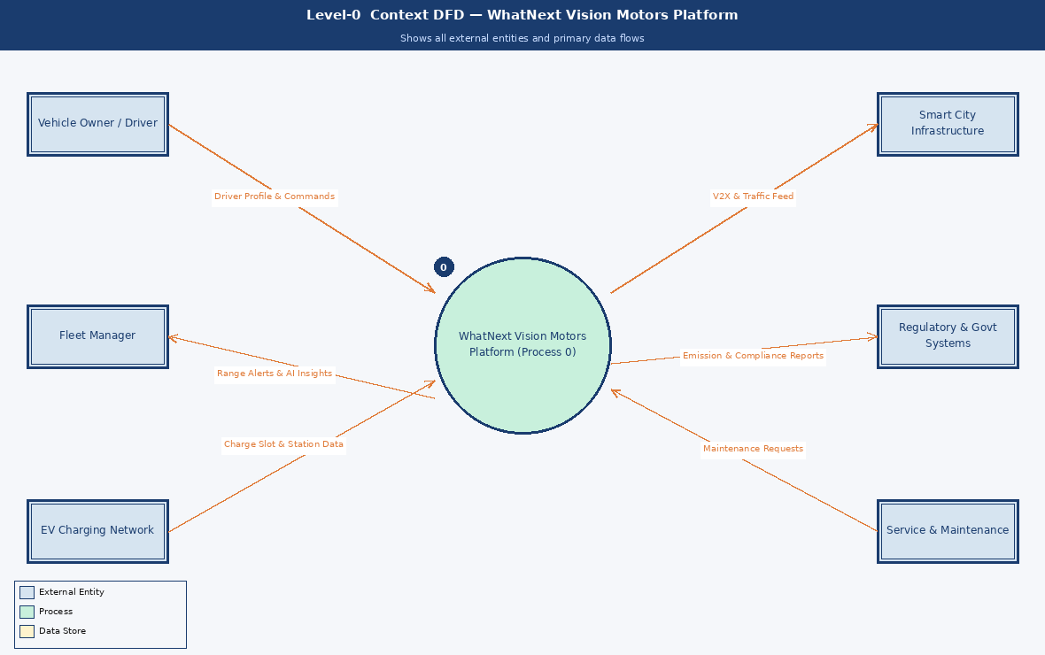

External Entity | Data Flows
Vehicle Owner / Driver | Sends driver profile, voice commands and trip requests; receives AI range estimates, fatigue alerts and personalised co-pilot responses.
Fleet Manager | Provides fleet configuration and management commands; receives live telemetry dashboards, predictive maintenance alerts and ESG compliance reports.
EV Charging Network | Provides real-time station availability and slot booking confirmations; receives advance reservation requests from the platform.
Smart City Infrastructure | Supplies V2X data, traffic signals and road condition feeds; receives vehicle telemetry for smart city optimisation.
Regulatory & Govt Systems | Receives automated carbon emission reports and compliance data; provides updated policy thresholds and regulatory mandates.
Service & Maintenance | Receives predictive maintenance alerts and service tickets; sends repair completions and parts procurement confirmations back to the platform.

LEVEL-1 DFD — Safety & ADAS System
Owner: MANISHA R (Team Leader) | Processes 1.1 – 1.5
This subsystem decomposes into five processes: Fatigue Detection AI (1.1) analyses driver biometrics and eye-tracking data in real time; Collision Prediction Engine (1.2) fuses radar, LiDAR and camera data to compute collision probability; Sensor Data Processor (1.3) normalises the high-frequency sensor stream; Incident Response Manager (1.4) orchestrates emergency alerts to the driver, fleet manager and emergency services; Safety Log Recorder (1.5) maintains an auditable incident history for insurance and compliance. Data stores: D1 Driver Biometrics DB, D2 Sensor Events DB, D3 Incident Logs DB.

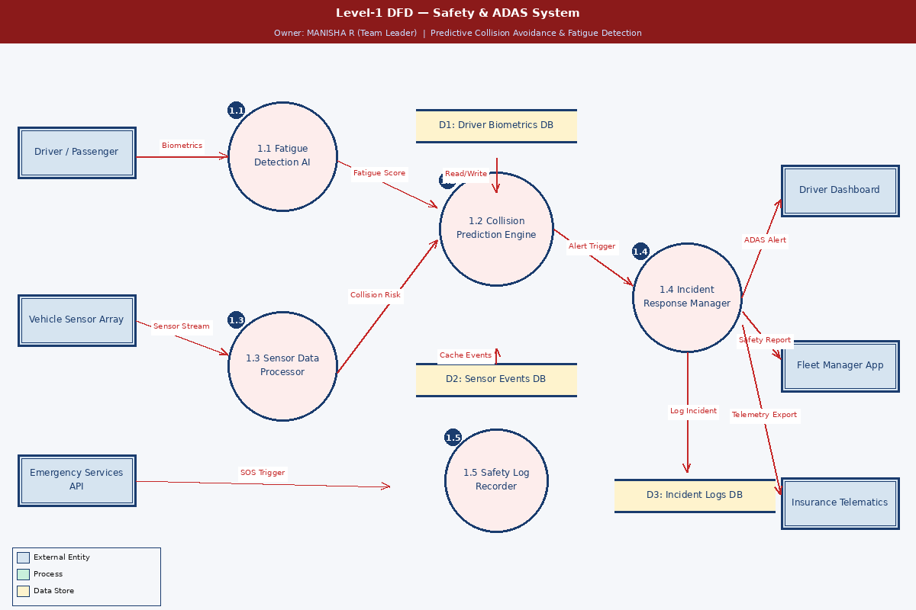

LEVEL-1 DFD — AI Range & EV Management System
Owner: RAJKUMAR L | Processes 2.1 – 2.5
This subsystem decomposes into five processes: Driver Profile Manager (2.1) captures driving patterns and vehicle preferences; AI Range Optimizer (2.2) uses machine learning on weather, route and battery telemetry to produce dynamic range estimates; Charging Slot Scheduler (2.3) integrates with the EV Charging Network API for real-time slot reservations; Route & Alert Engine (2.4) pushes personalised navigation and low-battery alerts to the driver app; Battery Health Monitor (2.5) logs telemetry for predictive degradation analysis. Data stores: D4 Driver Profiles DB, D5 Charging Slots DB, D6 Battery Telemetry DB.

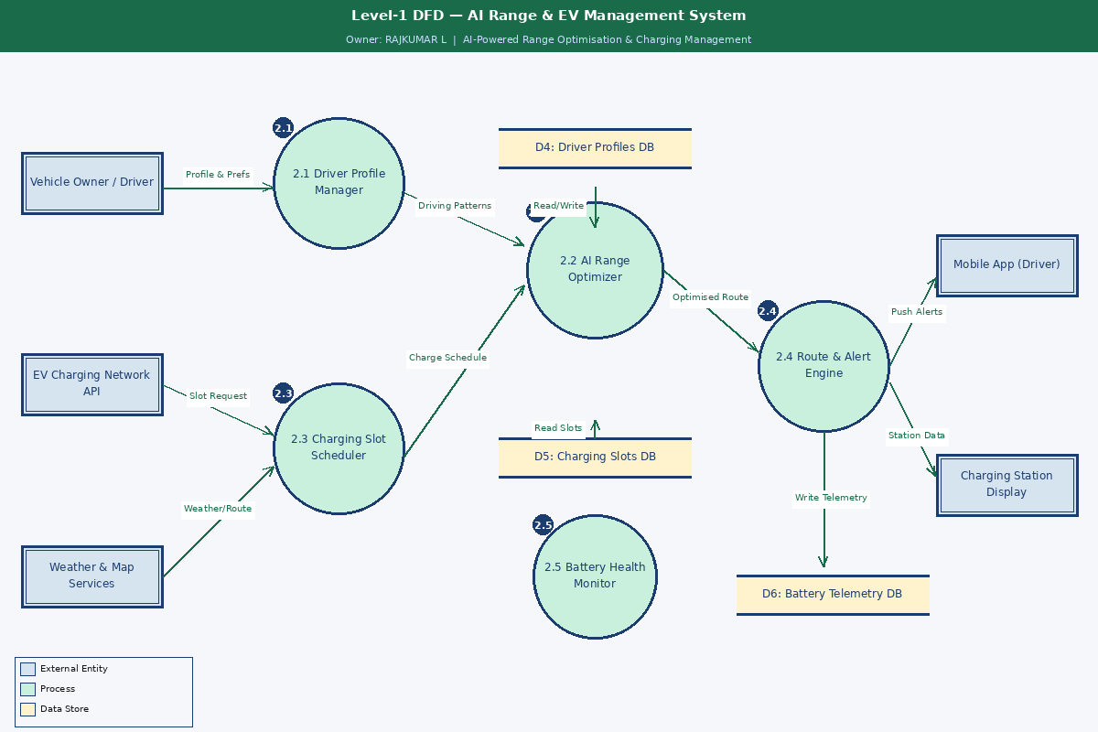

LEVEL-1 DFD — Fleet Intelligence & Sustainability System
Owner: TAMIZHKUMARAN M | Processes 3.1 – 3.5
This subsystem decomposes into five processes: Fleet Onboarding Manager (3.1) registers vehicles and configures fleet policies; Real-Time Fleet Monitor (3.2) aggregates live telemetry from all vehicles onto a unified map dashboard; Predictive Maintenance AI (3.3) analyses historical fault patterns to predict failures 48 hours ahead; Report & Alert Generator (3.4) produces on-demand and scheduled reports for managers and regulators; Carbon Footprint Tracker (3.5) calculates per-vehicle and fleet-level CO2 savings for ESG reporting. Data stores: D7 Fleet Registry DB, D8 Maintenance Logs DB, D9 Emissions Data DB.

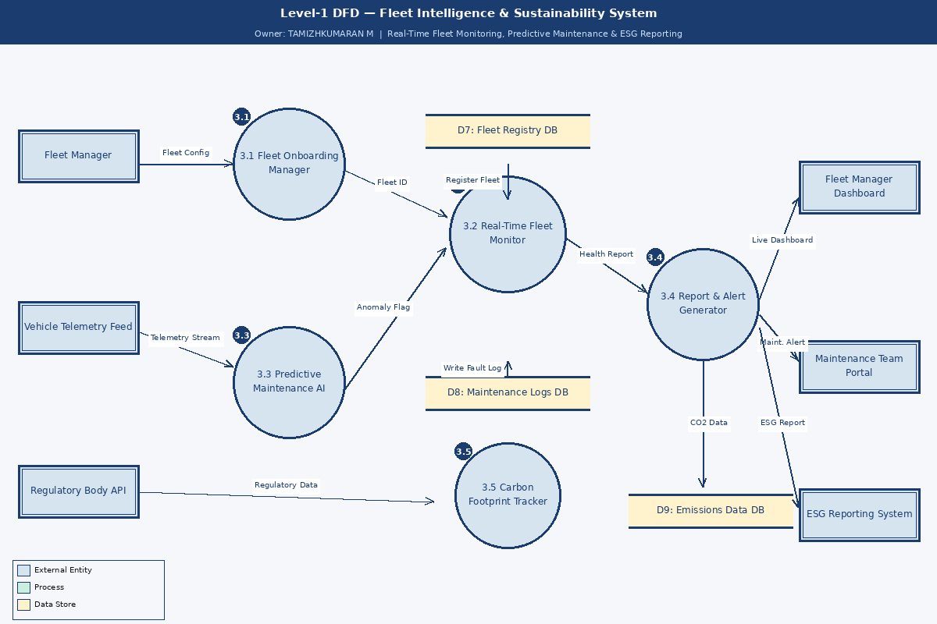

LEVEL-1 DFD — AI Co-Pilot & Connected UX System
Owner: VINITH S | Processes 4.1 – 4.5
This subsystem decomposes into five processes: User Profile & Prefs Engine (4.1) stores driver preferences and AI interaction history; AI Co-Pilot Personaliser (4.2) uses reinforcement learning to adapt responses over time; IoT Integration Hub (4.3) synchronises vehicle state with smart home devices; Contextual UX Renderer (4.4) adapts the HMI layout based on driving context; OTA Feature Manager (4.5) handles secure download, verification, installation and rollback of feature packages. Data stores: D10 User Preference DB, D11 IoT Device DB, D12 Feature Packages DB.

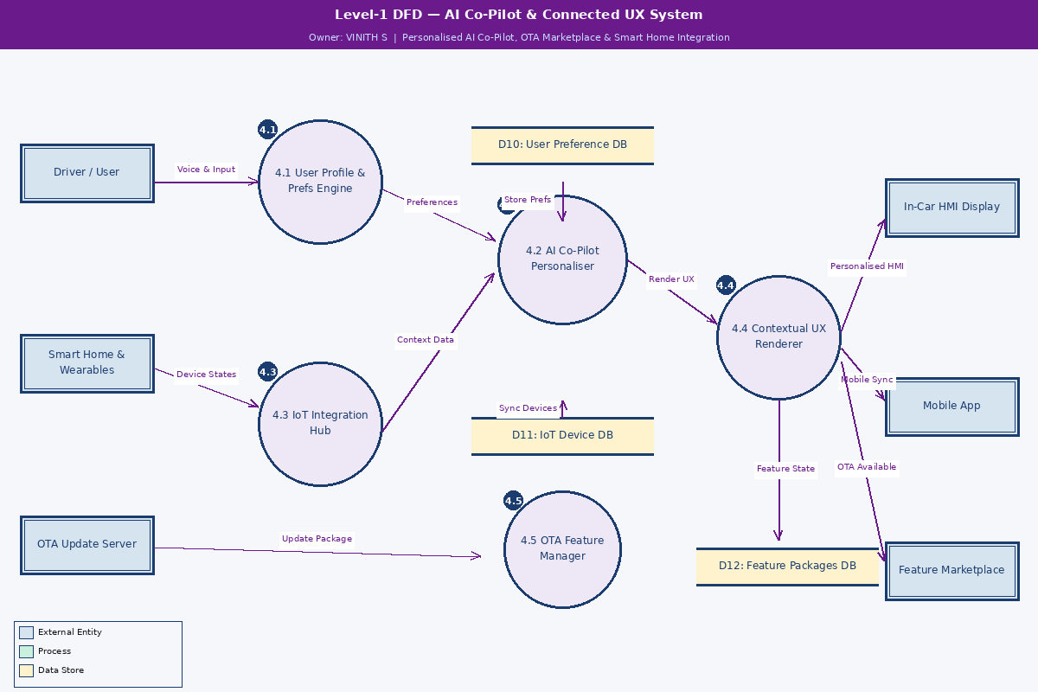

LEVEL-1 DFD — Customer Portal & After-Sales Service System
Owner: PORSELVAN A | Processes 5.1 – 5.5
This subsystem decomposes into five processes: Customer Account Manager (5.1) handles registration, profile management and vehicle association; Service Booking Engine (5.2) allows customers to schedule service appointments at preferred centres; Ticket & CRM Processor (5.3) creates and tracks support tickets through to resolution; Warranty & Claims Handler (5.4) processes warranty claims digitally with real-time status tracking; Feedback & NPS Collector (5.5) gathers post-service ratings to drive continuous quality improvement. Data stores: D13 Customer Profiles DB, D14 Service Tickets DB, D15 Warranty Records DB.

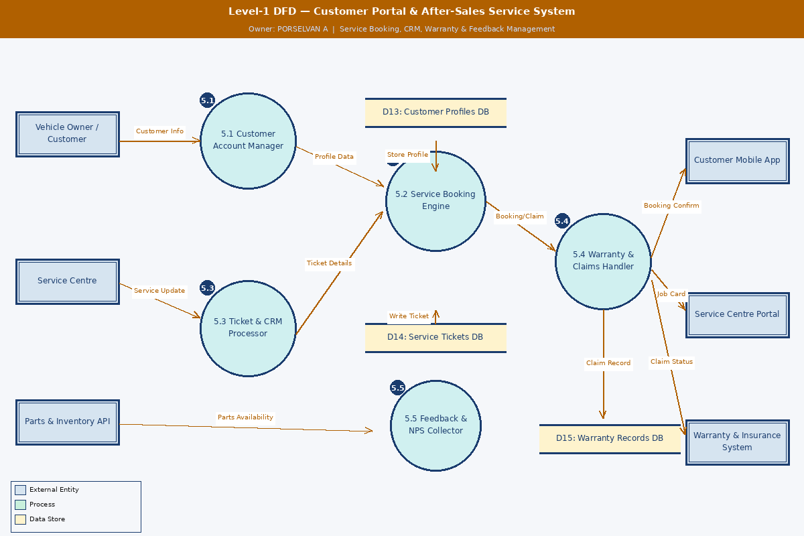

USER STORIES — WhatNext Vision Motors Platform
The following 33 user stories define the functional requirements of the platform across seven user types. Each story follows the standard format: As a [user type], I can [action] so that [benefit]. Acceptance criteria define measurable, testable conditions for each story. Stories are prioritised High, Medium, or Low and assigned to a sprint release.

User Type | Epic (Functional Req.) | USN | User Story / Task | Acceptance Criteria | Priority | Release
EV Driver (Mobile App) | Registration & Onboarding | USN-01 | As an EV driver, I can register on the WhatNext app by entering my name, email, vehicle VIN, and password so I can access my personalised dashboard. | Account created; OTP email received; dashboard loads on first login within 3 seconds. | High | Sprint-1
 |  | USN-02 | As an EV driver, I can log in with email/password or Google SSO so I can securely access my vehicle data. | Login completes in under 2 seconds; session token issued; invalid credentials display a clear error. | High | Sprint-1
 | Range & Charging | USN-03 | As an EV driver, I can view my real-time battery percentage and AI-estimated range on the home screen so I can confidently plan every trip. | Range updates every 30 seconds; AI accuracy within 5% of actual; low-battery warning fires below 20%. | High | Sprint-1
 |  | USN-04 | As an EV driver, I can search for nearby charging stations on a map and reserve a slot in advance so I avoid charging queues. | Map loads under 3 seconds; slot reservation returns a booking ID and estimated queue time. | High | Sprint-1
 |  | USN-05 | As an EV driver, I receive a push notification when battery drops below my configured threshold so I am never caught off-guard mid-journey. | Notification fires at exact threshold; configurable from 10%–40%; works reliably in background. | Medium | Sprint-2
 | AI Co-Pilot | USN-06 | As an EV driver, I can interact with the in-car AI co-pilot by voice to adjust climate, navigation, and media so my hands stay on the wheel. | Commands processed under 1 second; intent recognition accuracy above 95%. | High | Sprint-2
 |  | USN-07 | As an EV driver, I can download new AI co-pilot feature packs from the OTA marketplace so I can enhance my vehicle after purchase. | OTA pack installs without a vehicle restart; rollback to previous version available within 24 hours. | Medium | Sprint-3
 | Safety | USN-08 | As an EV driver, I receive an in-dash fatigue alert with a rest-stop recommendation when AI detects drowsiness so I drive safely. | Alert fires within 5 seconds of detection; nearest rest stop within 10 km suggested automatically. | High | Sprint-2
 | Carbon | USN-09 | As an EV driver, I can view my monthly carbon savings versus an equivalent petrol vehicle so I remain motivated to drive sustainably. | Dashboard shows CO2 saved in kg, INR savings, and tree-equivalent metric; updated monthly. | Low | Sprint-3
Safety-Conscious Parent | ADAS & Safety | USN-10 | As a parent, I can view the live status of all active ADAS safety features so I know my family is protected at all times. | Safety page loads under 2 seconds; all ADAS features listed with live on/off indicators. | High | Sprint-2
 |  | USN-11 | As a parent, I can create a teen driver profile that caps maximum speed and restricts non-essential in-car features so my teenager drives safely. | Speed cap enforced immediately on activation; parent receives a real-time override notification. | High | Sprint-2
 | Collision Alerts | USN-12 | As a parent, I receive an automatic emergency alert on my phone if the vehicle detects a collision so I am immediately informed. | Alert sent within 10 seconds; includes GPS coordinates, severity level, and emergency contact option. | High | Sprint-1
 |  | USN-13 | As a parent, I can view monthly safety scores for every driver in my family account so I can discuss and improve driving habits. | Score calculated weekly; broken down by speed, harsh braking, and fatigue sub-scores. | Medium | Sprint-3
Fleet Manager (Web Portal) | Fleet Onboarding | USN-14 | As a fleet manager, I can register and manage all fleet vehicles from a single dashboard so I have complete operational visibility. | Up to 200 vehicles per account; bulk CSV import available; dashboard loads within 3 seconds. | High | Sprint-1
 |  | USN-15 | As a fleet manager, I can view real-time GPS location and battery status of every vehicle on a live map so I can optimise dispatch. | Map refreshes every 15 seconds; vehicles colour-coded by battery level and operational status. | High | Sprint-1
 | Predictive Maintenance | USN-16 | As a fleet manager, I receive AI maintenance alerts 48 hours before a predicted component fault so I can schedule repairs proactively. | Alert includes fault type, confidence score above 80%, and recommended service action. | High | Sprint-2
 |  | USN-17 | As a fleet manager, I can generate monthly fleet health and cost-per-km reports in PDF so I can present performance to senior management. | Report generated in under 30 seconds; includes all vehicles; exportable as PDF and CSV. | Medium | Sprint-2
 | ESG & Sustainability | USN-18 | As a fleet manager, I can view aggregated carbon emission savings across the entire fleet so I can report against ESG targets accurately. | CO2 data accurate within 2%; comparison against fossil-fuel baseline included; exportable for ESG. | Medium | Sprint-3
Tech-Savvy Professional | Personalisation | USN-19 | As a tech user, I can configure my AI co-pilot personality and communication style so the driving experience feels uniquely mine. | At least 5 personality modes; voice style customisable; preferences persist across sessions. | Medium | Sprint-2
 | Smart Home | USN-20 | As a tech user, I can connect my smart home devices to my vehicle so my home environment is ready when I arrive. | At least 3 smart home platforms supported; device sync completes in under 5 seconds. | Medium | Sprint-3
 | OTA Updates | USN-21 | As a tech user, I receive OTA update notifications and can schedule installs at my preferred time so updates never interrupt my day. | Scheduling available in 30-minute slots; install completes silently; automatic rollback on error. | High | Sprint-2
 |  | USN-22 | As a tech user, I can browse and purchase feature add-ons from the OTA marketplace so I continuously expand my vehicle capabilities. | Marketplace loads under 2 seconds; payment integrated; purchased features activate within 60 seconds. | High | Sprint-3
System Administrator | User Management | USN-23 | As an admin, I can create, suspend, and delete user accounts and assign platform roles so I maintain security governance. | Role changes take effect immediately; full audit log records every admin action with timestamp. | High | Sprint-1
 |  | USN-24 | As an admin, I can view system-wide usage analytics and real-time error logs so I can proactively monitor platform health. | Dashboard shows active users, API error rates, uptime and latency — updated every 60 seconds. | High | Sprint-1
 | Compliance | USN-25 | As an admin, I can configure data retention policies and process GDPR data deletion requests so the platform meets regulatory requirements. | Data deletion confirmed within 24 hours; audit log records scope, admin ID and timestamp. | High | Sprint-2
 |  | USN-26 | As an admin, I can schedule OTA deployment windows and configure automatic rollback policies so firmware updates are safe and controlled. | Deployment schedule enforced accurately; rollback triggers automatically if error rate exceeds 5%. | Medium | Sprint-2
Vehicle Owner (Service Portal) | Service Booking | USN-27 | As a vehicle owner, I can book a service appointment online and choose a preferred service centre so I receive convenient, timely maintenance. | Booking confirmed within 30 seconds; confirmation SMS and email sent; calendar invite generated. | High | Sprint-2
 |  | USN-28 | As a vehicle owner, I can track the real-time status of my vehicle during a service visit so I know exactly when it will be ready. | Status updates every 30 minutes during service; technician notes visible; completion alert sent. | High | Sprint-2
 | Warranty & Claims | USN-29 | As a vehicle owner, I can submit a warranty claim online with photos and a description so I do not need to visit a service centre just to file. | Claim submitted in under 5 minutes; acknowledgement email sent; reference number issued within 1 minute. | High | Sprint-2
 |  | USN-30 | As a vehicle owner, I can view my complete vehicle service history and warranty status in one place so I have full transparency of ownership costs. | History loads in under 2 seconds; shows all visits, parts replaced, costs, and remaining warranty period. | Medium | Sprint-3
 | Feedback | USN-31 | As a vehicle owner, I can rate and review my service experience after each visit so WhatNext can continuously improve service quality. | Rating prompt sent within 1 hour of service completion; feedback stored and visible to service team. | Low | Sprint-3
Customer Care Executive | Support & Tickets | USN-32 | As a customer care executive, I can view a customer complete vehicle, profile, and ticket history so I resolve issues without asking them to repeat information. | Customer history loads under 2 seconds; shows last 12 months with full conversation threads. | High | Sprint-2
 |  | USN-33 | As a customer care executive, I can raise and assign service tickets to the nearest service centre so the customer receives timely and location-appropriate support. | Ticket created within 30 seconds; auto-notification to customer and service centre; SLA timer starts. | High | Sprint-2

USER STORY SUMMARY — BY USER TYPE & PRIORITY

User Type | Total | High | Medium | Low
EV Driver (Mobile App) | 9 | 5 | 3 | 1
Safety-Conscious Parent | 4 | 3 | 1 | 0
Fleet Manager (Web Portal) | 5 | 3 | 2 | 0
Tech-Savvy Professional | 4 | 2 | 2 | 0
System Administrator | 4 | 3 | 1 | 0
Vehicle Owner (Service Portal) | 5 | 3 | 1 | 1
Customer Care Executive | 2 | 2 | 0 | 0
TOTAL | 33 | 21 | 10 | 2

SPRINT RELEASE PLAN
The 33 user stories are distributed across three sprints. Sprint-1 delivers the core platform foundation. Sprint-2 delivers all safety, AI intelligence, fleet management, and after-sales capabilities. Sprint-3 completes the OTA ecosystem, sustainability dashboard, service history, and feedback features.

Sprint | Focus Area | User Stories | Team Owners
Sprint-1 | Core platform — registration, login, real-time range, charging map, fleet onboarding, admin setup, collision alerts | USN-01, USN-02, USN-03, USN-04, USN-12, USN-14, USN-15, USN-23, USN-24 | ALL MEMBERS
Sprint-2 | Safety, ADAS, AI fatigue, fleet maintenance AI, OTA core, service booking, warranty claims, CRM portal | USN-05, USN-06, USN-08, USN-10, USN-11, USN-13, USN-16, USN-17, USN-19, USN-21, USN-25, USN-26, USN-27, USN-28, USN-29, USN-32, USN-33 | MANISHA R, RAJKUMAR L, TAMIZHKUMARAN M, PORSELVAN A
Sprint-3 | OTA marketplace, smart home integration, ESG carbon reporting, service history, teen safety, feedback & NPS | USN-07, USN-09, USN-13, USN-18, USN-20, USN-22, USN-30, USN-31 | VINITH S, TAMIZHKUMARAN M, PORSELVAN A

WhatNext Vision Motors
Shaping the Future of Mobility with Innovation and Excellence

