**Description:** This simple application retrieves the users data from [**http://mocker.egen.io**](http://mocker.egen.io)by using angular **$http service**. The data consists of different users details like id, name, email-address etc.

**Screen shot of data:**

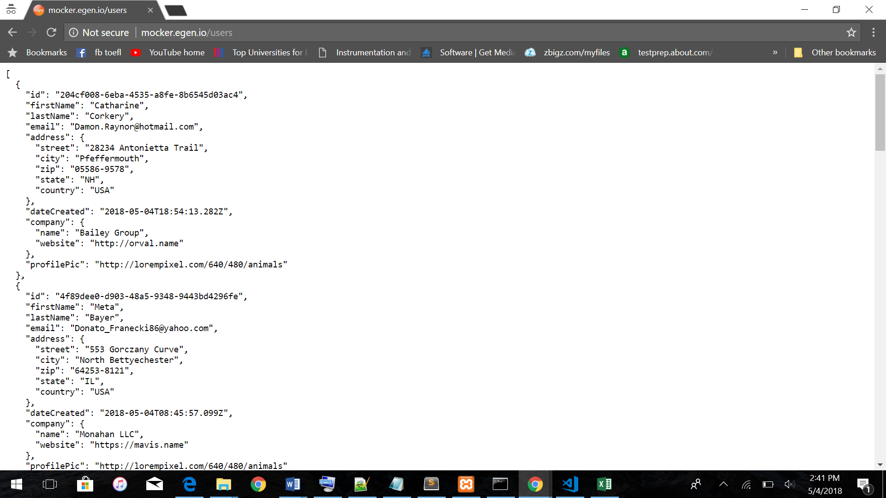

* Retrieved the e-mail address of all the users from the data retrieved.
* Identified various email services that users use (Eg: Gmail, yahoo).
* Categorized all the distinct e-mail services and calculated the number of users using a particular email -service.
* Plotted them on a bar graph. Where each bar represents an email service category.

**Output:**

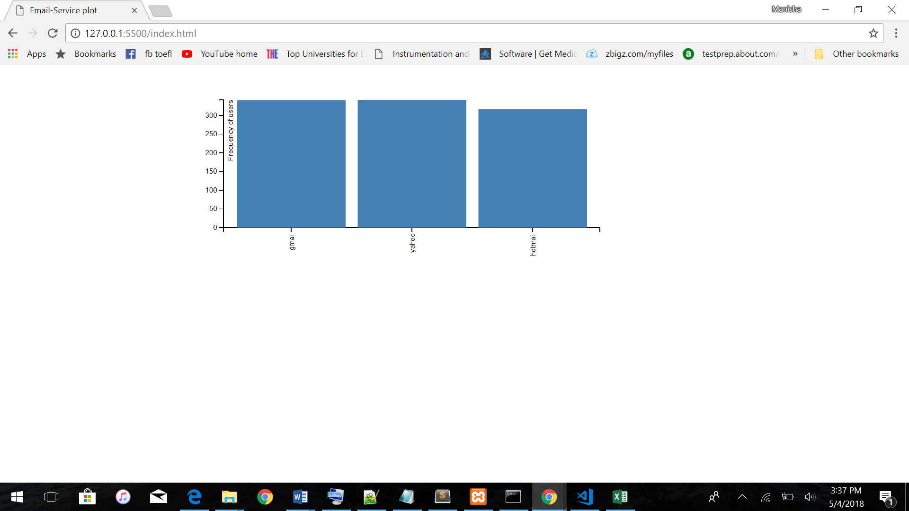  
**socket.io** can be used to make the connection open to the server to have a continuous communication of data from the server and make the visualizations live without refreshing the page. As, the API used has allowance to only limited number of requests, the connection failed when I tried using sockets.