* [**Home**](http://www.exforsys.com)
* **Tutorials**
* **Software Testing**
* **Programing**
* **Data Management**
* **Certification**
* **Career Center**
* [**Skill Test**](http://www.exforsys.com/iq/)
* [**Forums**](http://www.exforsys.com/forum/)
* [**Interview Questions**](http://www.geekinterview.com)

[](http://www.exforsys.com/)

* [Learn Oracle](http://www.exforsys.com/learn-oracle.html)
* [Learn Microsoft](http://www.exforsys.com/learn-microsoft.html)
* [Learn J2EE](http://www.exforsys.com/learn-j2ee.html)
* [Learn Networking](http://www.exforsys.com/learn-networking.html)
* [Learn Concepts](http://www.exforsys.com/learn-concepts.html)
* [Testing Articles](http://www.exforsys.com/tutorials/testing.html)
* [SQA Tutorials](http://www.exforsys.com/tutorials/sqa.html)
* [Swing Testing](http://www.exforsys.com/tutorials/swing-testing.html)
* [Project Risk Management](http://www.exforsys.com/career-center/risk-management.html)
* [C Language](http://www.exforsys.com/tutorials/c-language.html)
* [CSS](http://www.exforsys.com/tutorials/css.html)
* [MainFrame](http://www.exforsys.com/tutorials/mainframe.html)
* [VBScript](http://www.exforsys.com/tutorials/vbscript.html)
* [PHP](http://www.exforsys.com/tutorials/php.html)
* [XML](http://www.exforsys.com/tutorials/xml.html)
* [C++ Tutorials](http://www.exforsys.com/tutorials/c-plus-plus.html)
* [Ajax](http://www.exforsys.com/tutorials/ajax.html)
* [JavaScript](http://www.exforsys.com/tutorials/javascript.html)
* [CSS3](http://www.exforsys.com/tutorials/css3.html)
* [UML](http://www.exforsys.com/tutorials/uml.html)
* [jQuery](http://www.exforsys.com/tutorials/jquery.html)
* [Microsoft AJAX](http://www.exforsys.com/tutorials/microsoft-ajax.html)
* [Data Recovery](http://www.exforsys.com/tutorials/data-recovery.html)
* [Data Mining](http://www.exforsys.com/tutorials/data-mining.html)
* [Data Modeling](http://www.exforsys.com/tutorials/data-modeling.html)
* [Data Warehousing](http://www.exforsys.com/tutorials/data-warehousing.html)
* [Business Intelligence](http://www.exforsys.com/tutorials/business-intelligence.html)
* [SCJP](http://www.exforsys.com/certification/scjp.html)
* [SCBCD](http://www.exforsys.com/certification/scbcd.html)
* [Certification Articles](http://www.exforsys.com/certification/certification-articles.html)
* [Oracle Certification](http://www.exforsys.com/certification/oracle-certification.html)
* [Microsoft Certification](http://www.exforsys.com/certification/microsoft.html)
* [Sun Certification](http://www.exforsys.com/certification/sun-certification.html)
* [Career Improvement](http://www.exforsys.com/career-improvement.html)
* [Employment Help](http://www.exforsys.com/employment-help.html)
* [Education Help](http://www.exforsys.com/education-help.html)
* [Interview Help](http://www.exforsys.com/interview-help.html)

Top of Form

****

****

Bottom of Form

**Sponsored Links**

**Oracle 9i Tutorials**

* [Tutorial 16: Oracle 9i: Oracle Utilities](http://www.exforsys.com/tutorials/oracle-9i/oracle-utilities.html)
* [Tutorial 15: Oracle 9i : Oracle Packages](http://www.exforsys.com/tutorials/oracle-9i/oracle-packages.html)
* [Tutorial 14: Oracle 9i : Database Triggers](http://www.exforsys.com/tutorials/oracle-9i/oracle-database-triggers.html)
* [Tutorial 13: Oracle 9i : Procedures and Functions](http://www.exforsys.com/tutorials/oracle-9i/oracle-9i-procedures-and-functions.html)
* [Tutorial 12: Oracle 9i: PL/SQL Collections](http://www.exforsys.com/tutorials/oracle-9i/oracle-pl-sql-collections.html)
* [Tutorial 11 : Oracle 9i: Exception Handling](http://www.exforsys.com/tutorials/oracle-9i/oracle-exception-handling.html)
* [Oracle 9i:Download example SQL Scripts used in Tutorials](http://www.exforsys.com/tutorials/oracle-9i/oracle-9i-download-example-sql-scripts-used-in-tutorials.html)
* [Tutorial 10: Oracle 9i : Cursors](http://www.exforsys.com/tutorials/oracle-9i/oracle-cursors.html)
* [Tutorial 9 : Oracle 9i: PL/SQL Control Structures](http://www.exforsys.com/tutorials/oracle-9i/oracle-pl-sql-control-structures.html)
* [Tutorial 8: Building PL/SQL Blocks](http://www.exforsys.com/tutorials/oracle-9i/building-pl-sql-blocks.html)
* [Tutorial 6: Tables and Constraints](http://www.exforsys.com/tutorials/oracle-9i/oracle-tables-and-constraints.html)
* [Tutorial 7: More Database Objects](http://www.exforsys.com/tutorials/oracle-9i/oracle-database-objects.html)
* [Tutorial 5: Working with Multiple Tables](http://www.exforsys.com/tutorials/oracle-9i/working-with-multiple-tables.html)
* [Tutorial 4: SQL functions](http://www.exforsys.com/tutorials/oracle-9i/sql-functions.html)
* [Oracle 9i: SQL, PLSQL, and SQL \*Plus - Introduction](http://www.exforsys.com/tutorials/oracle-9i/oracle-9i-sql-plsql-and-sql-plus-introduction.html)
* [Oracle 9i: SQL, PLSQL, and SQL \*Plus - Software Installation and References](http://www.exforsys.com/tutorials/oracle-9i/oracle-9i-software-installation-and-references.html)
* [Tutorial 1: Introduction to Oracle 9i:SQL, PLSQL. and SQL \*Plus](http://www.exforsys.com/tutorials/oracle-9i/introduction-to-oracle-9i.html)
* [Tutorial 2: SQL \*Plus Commands](http://www.exforsys.com/tutorials/oracle-9i/sql-plus-commands.html)
* [Tutorial 3 : Restricting and Sorting Data](http://www.exforsys.com/tutorials/oracle-9i/restricting-and-sorting-data.html)

**[Home](http://www.exforsys.com/)** http://www.exforsys.com/images/arrow.png**[Tutorials](http://www.exforsys.com/tutorials.html)** http://www.exforsys.com/images/arrow.png**[Oracle 9i](http://www.exforsys.com/tutorials/oracle-9i.html)**

**Tutorial 11 : Oracle 9i: Exception Handling**

**Category: [Oracle 9i](http://www.exforsys.com/tutorials/oracle-9i.html)  
[Comments (20)](http://www.exforsys.com/tutorials/oracle-9i/oracle-exception-handling.html" \l "art_cmts)**

This week tutorial covers Oracle Exception Handling and the different types in it with sample SQL scripts along with the screen shots. Topics covered in this week, Introduction to Exception Handling - Propagation of Errors Types of Exceptions - Named System Exceptions; Unnamed System Exceptions; User-Defined Exceptions.

<

**Sponsored Links**

**Exceptions**

An Exception is an error situation, which arises during program execution. When an error occurs exception is raised, normal execution is stopped and control transfers to exception-handling part. Exception handlers are routines written to handle the exception. The exceptions can be internally defined (system-defined or pre-defined) or User-defined exception.

**Predefined exception** is raised automatically whenever there is a violation of Oracle coding rules. Predefined exceptions are those like ZERO\_DIVIDE, which is raised automatically when we try to divide a number by zero. Other built-in exceptions are given below. You can handle unexpected Oracle errors using OTHERS handler. It can handle all raised exceptions that are not handled by any other handler. It must always be written as the last handler in exception block.

* CURSOR\_ALREADY\_OPEN – Raised when we try to open an already open cursor.
* DUP\_VAL\_ON\_INDEX – When you try to insert a duplicate value into a unique column
* INVALID\_CURSOR – It occurs when we try accessing an invalid cursor
* INVALID\_NUMBER – On usage of something other than number in place of number value.
* LOGIN\_DENIED – At the time when user login is denied
* TOO\_MANY\_ROWS – When a select query returns more than one row and the destination variable can take only single value.
* VALUE\_ERROR – When an arithmetic, value conversion, truncation, or constraint error occurs.

Predefined exception handlers are declared globally in package STANDARD. Hence we need not have to define them rather just use them.

The biggest advantage of exception handling is it improves readability and reliability of the code. Errors from many statements of code can be handles with a single handler. Instead of checking for an error at every point we can just add an exception handler and if any exception is raised it is handled by that.   
For checking errors at a specific spot it is always better to have those statements in a separate begin – end block.

Examples: Following example gives the usage of ZERO\_DIVIDE exception   
  
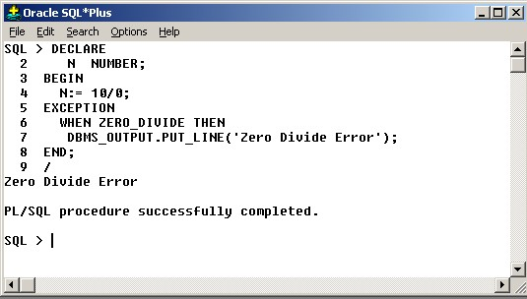

Exmpmple 2: I have explained the usage of NO\_DATA\_FOUND exception in the following   
  
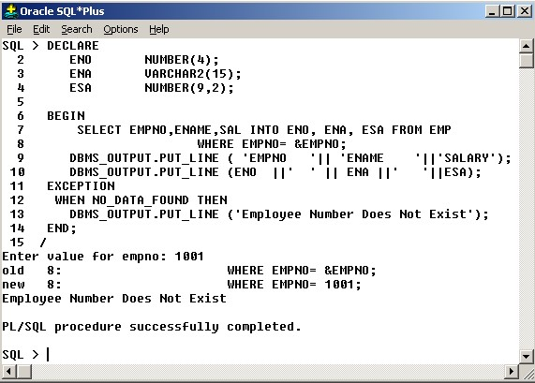

The **DUP\_VAL\_ON\_INDEX** is raised when a SQL statement tries to create a duplicate value in a column on which a primary key or unique constraints are defined.

Example to demonstrate the exception DUP\_VAL\_ON\_INDEX.

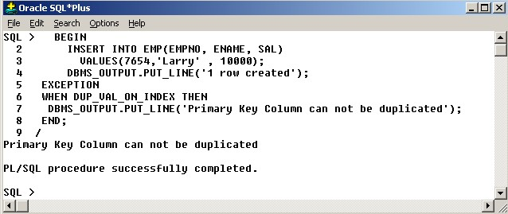  
  
More than one Exception can be written in a single handler as shown below.

*EXCEPTION   
When NO\_DATA\_FOUND or TOO\_MANY\_ROWS then   
Statements;   
END;*

**User-defined Exceptions**

A User-defined exception has to be defined by the programmer. User-defined exceptions are declared in the declaration section with their type as exception. They must be raised explicitly using RAISE statement, unlike pre-defined exceptions that are raised implicitly. RAISE statement can also be used to raise internal exceptions.   
  
**Declaring Exception:**   
  
*DECLARE   
myexception EXCEPTION;   
BEGIN   
------   
  
Raising Exception:   
  
BEGIN   
RAISE myexception;   
-------*

**Handling Exception:**   
  
*BEGIN   
------   
----   
EXCEPTION   
WHEN myexception THEN   
Statements;   
END;*

**Points To Ponder:**

* An Exception cannot be declared twice in the same block.
* Exceptions declared in a block are considered as local to that block and global to its sub-blocks.
* An enclosing block cannot access Exceptions declared in its sub-block. Where as it possible for a sub-block to refer its enclosing Exceptions.

The following example explains the usage of User-defined Exception

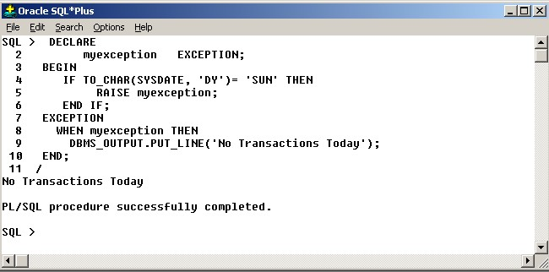

**RAISE\_APPLICATION\_ERROR**

To display your own error messages one can use the built-in RAISE\_APPLICATION\_ERROR. They display the error message in the same way as Oracle errors. You should use a negative number between –20000 to –20999 for the error\_number and the error message should not exceed 512 characters.   
The syntax to call raise\_application\_error is

**RAISE\_APPLICATION\_ERROR (error\_number, error\_message, { TRUE | FALSE });**

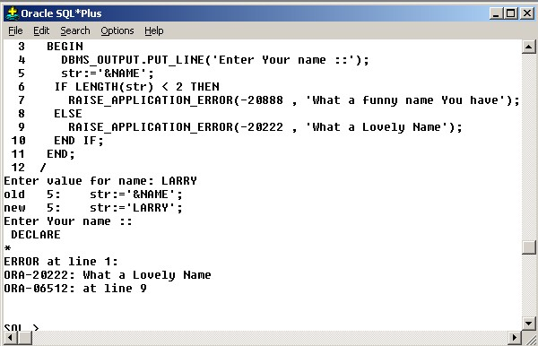

**Sponsored Links**

**Propagation of Exceptions**

When an exception is raised and corresponding handler is not found in the current block then it propagates to the enclosing blocks till a handler is found. If a handler is not found in its enclosing blocks also then it raises an unhandled exception error to the host environment.   
Exceptions cannot be propagated across remote procedure calls. i.e. a PL/SQL program cannot catch exceptions raised by remote subprograms   
  
**Reraising exceptions**

When you want an exception to be handles in the current block as well in its enclosing block then you need to use RAISE statement without an exception name.

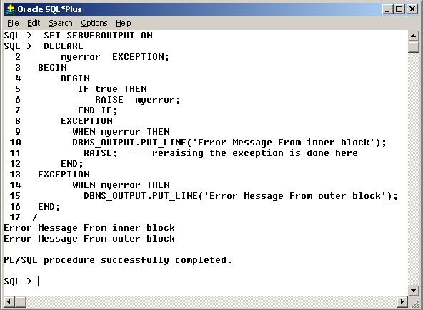

**[Download Sample Scripts](http://www.exforsys.com/images/oracle%209i/t11/Examples_T11.zip)**

**Read Next:** **[Tutorial 12: Oracle 9i: PL/SQL Collections](http://www.exforsys.com/tutorials/oracle-9i/oracle-pl-sql-collections.html)**

**Related Topics**

[Oracle Coherence: Implementing LookupValuesAggregator](http://www.exforsys.com/tutorials/oracle-coherence/implementing-lookupvalueaggregrator.html)

[Oracle Coherence: Built-in Aggregators](http://www.exforsys.com/tutorials/oracle-coherence/oracle-coherence-built-in-aggregators.html)

[Oracle Coherence: Aggregators](http://www.exforsys.com/tutorials/oracle-coherence/oracle-coherence-aggregators.html)

[Oracle Coherence: Query Limitations](http://www.exforsys.com/tutorials/oracle-coherence/oracle-coherence-query-limitations.html)

[Oracle Coherence: Creating Indexes](http://www.exforsys.com/tutorials/oracle-coherence/oracle-coherence-creating-indexes.html)

Top of Form



Bottom of Form

**Comments**

sathish24\_606 said: http://www.exforsys.com/images/spacer.gif

|  |  |
| --- | --- |
|  | informative............,excellent work |

July 11, 2006, 8:55 am

jam said: http://www.exforsys.com/images/spacer.gif

|  |  |
| --- | --- |
|  | Nice learning and nice to see such a website I have add this site to my favorites |

December 28, 2006, 5:35 am

D Thomas said: http://www.exforsys.com/images/spacer.gif

|  |  |
| --- | --- |
|  | This is just what I have been looking for...examples I can understand. Can you show an example of updating multiple records using cursor and/or fetch. Example, update salary for all employees due to new rate increase of 6%) |

January 19, 2007, 5:01 pm

asifcse said: http://www.exforsys.com/images/spacer.gif

|  |  |
| --- | --- |
|  | Exceptions cannot be propagated across remote procedure calls. i.e. a PL/SQL program cannot catch exceptions raised by remote subprograms   let me know wht does remote means here is it a object in other schema..if so than i have verified that my pl block catched exception raised in subprogram.  Thanks Asif |

May 14, 2007, 1:52 am

Mohammad Idrees Hussain said: http://www.exforsys.com/images/spacer.gif

|  |  |
| --- | --- |
|  | This is really very good tutorial, and very impressive work mentioned with examples that helps me to understand the p roblem with logic.  Thnks |

August 18, 2007, 1:32 am

Gasoline said: http://www.exforsys.com/images/spacer.gif

|  |  |
| --- | --- |
|  | This is the most smartest tutorial i've been seen int the world. Excellent explanations. Smart & Simple examples, script. Nothing I can say but THANKKKKKKSSSSSSSSSSSSSSSSSSSSSSSSSSSSSSSS |

August 29, 2007, 9:17 pm

Mukarram Shah said: http://www.exforsys.com/images/spacer.gif

|  |  |
| --- | --- |
|  | This is a very nifty, clean, and simple explanation of oracle exceptions. Good Job. |

September 28, 2007, 11:32 am

HamzeH said: http://www.exforsys.com/images/spacer.gif

|  |  |
| --- | --- |
|  | thank you very much this is what I need to understand  many thanks |

December 6, 2007, 2:15 am

Abhijit\_shinde said: http://www.exforsys.com/images/spacer.gif

|  |  |
| --- | --- |
|  | This is most useful info I have fount on web. Cheers Team. Keep it up. |

January 7, 2008, 5:29 am

Brutus I said: http://www.exforsys.com/images/spacer.gif

|  |  |
| --- | --- |
|  | I feel still Explination is needed on Exception handling in Procedural PLSQL Block..... |

February 22, 2008, 4:03 am

GirishD said: http://www.exforsys.com/images/spacer.gif

|  |  |
| --- | --- |
|  | Thanks, this is really Good as a start... Thanks again |

June 12, 2008, 7:47 am

Gaivij said: http://www.exforsys.com/images/spacer.gif

|  |  |
| --- | --- |
|  | This explaination is really simple and catchy. Thanks |

August 19, 2008, 1:20 am

Gaivij said: http://www.exforsys.com/images/spacer.gif

|  |  |
| --- | --- |
|  | This explanation is really simple, catchy and informative. Thanks :-) |

August 19, 2008, 1:22 am

Aishwarya\_V said: http://www.exforsys.com/images/spacer.gif

|  |  |
| --- | --- |
|  | Can you show me how to handle when a table does not exist |

September 15, 2008, 5:14 pm

arikatla said: http://www.exforsys.com/images/spacer.gif

|  |  |
| --- | --- |
|  | Keep posting |

October 10, 2008, 12:41 am

Maulin Thaker said: http://www.exforsys.com/images/spacer.gif

|  |  |
| --- | --- |
|  | Nice one but u can add more info about pragam exceptions   The PRAGMA EXECPTION\_INIT tells the complier to associate an exception with an oracle error. To get an error message  of a specific oracle error.  e.g. PRAGMA EXCEPTION\_INIT (exception name, oracle error number)   Example  declare salary number; FOUND\_NOTHING exception; Pragma exception\_init(FOUND\_NOTHING ,100); begin select sal in to salaryfrom emp where ename ='ANURAG'; dbms\_output.put\_line(salary); exception WHEN FOUND\_NOTHING THEN dbms\_output.put\_line(SQLERRM); end; |

December 3, 2008, 12:00 pm

mahesh said: http://www.exforsys.com/images/spacer.gif

|  |  |
| --- | --- |
|  | Exception type :-  1) Predefined -- Implicitly raise . Non-predefined -- declare and Implicitly raise .   2) Unser Defined -- declare and raise expilctly |

September 26, 2009, 8:47 am

Oralover said: http://www.exforsys.com/images/spacer.gif

|  |  |
| --- | --- |
|  | Both tables have same structure will this generate any Exception when ABC have NO DATA:  SET SERVEROUTPUT ON  Begin Insert into ABC Select \* from XYZ; End;  if its, what Exception it will raise as i tried this but its saying "PL/SQL procedure successfully completed"  any help?? thanks |

October 28, 2009, 2:31 am

taabu justine said: http://www.exforsys.com/images/spacer.gif

|  |  |
| --- | --- |
|  | so nice among all is this |

May 17, 2010, 1:13 am

NATUJUNA DANSON said: http://www.exforsys.com/images/spacer.gif

|  |  |
| --- | --- |
|  | Thanks. Good answers. |

June 24, 2010, 3:02 pm

Top of Form

**Post Your Comment:**

**[Members Please Login](http://www.exforsys.com/vblogin.php?redirect=http://www.exforsys.com/tutorials/oracle-9i/oracle-exception-handling.html)**  


Your Name:\*  


e-mail ID:(required for notification)\*  


Image Verification:

http://www.exforsys.com/lib/randmimgn.php  



 Subscribe     

Bottom of Form

**Sponsored Links**

[Get Daily Updates via](http://feeds.feedburner.com/Exforsyscom) [Subscribe to Exforsys Free Training via email](http://www.feedburner.com/fb/a/emailverifySubmit?feedId=524219&loc=en_US)

Top of Form

Get Latest Free Training Updates delivered directly to your Inbox...   
  
Enter your email address:   
  


Bottom of Form

[Subscribe to Exforsys Free Training via RSS](http://feeds.feedburner.com/Exforsyscom)

**[Partners](http://www.exforsys.com/partners.html) -  [Privacy and Legal Policy](http://www.exforsys.com/privacy-and-legal.html) -  [Site News](http://www.exforsys.com/bb/site-news.html) -  [Contact](http://www.exforsys.com/contact.html)   [Sitemap](http://www.exforsys.com/sitemap.html)**

Copyright © 2000 - 2010 exforsys.com. All Rights Reserved   
  
[Page copy protected against web site content infringement by Copyscape](http://www.copyscape.com/)