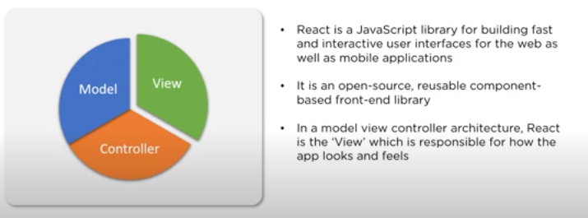

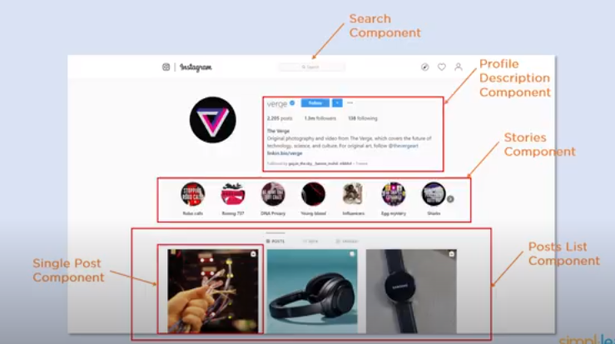

Easy to maintain as the page is made up of various components, multiple developer can work on mutipler componenet at same tome, so development is fast.

Adavantages:

Faster:as it uses Virtual dom and one way data binding

We can reuse the component so kess development

Simple than angular

NativeReact is used for mobile application.

,

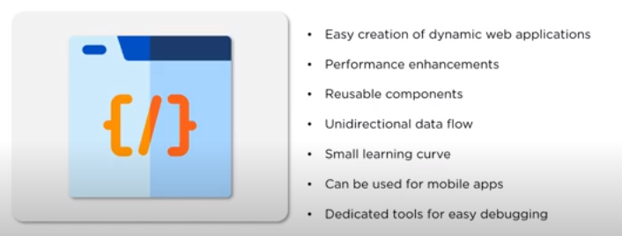

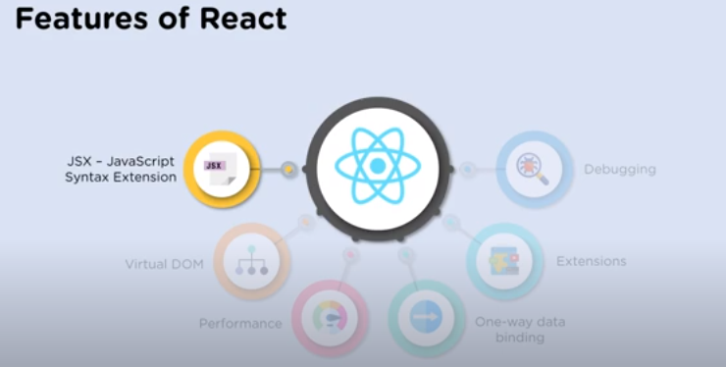

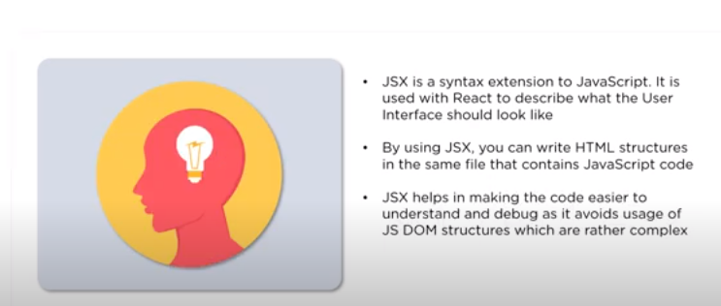



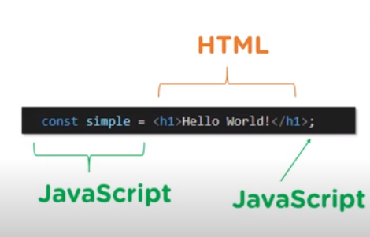

Virtual DOM(Data Object Model):

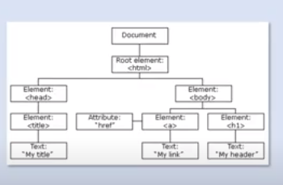

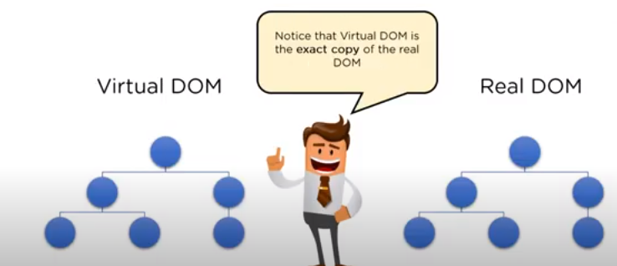

Traditionally when there is a change in web application it updates the entire Real DOM.This makes this extriemly slow.where as in Virtual



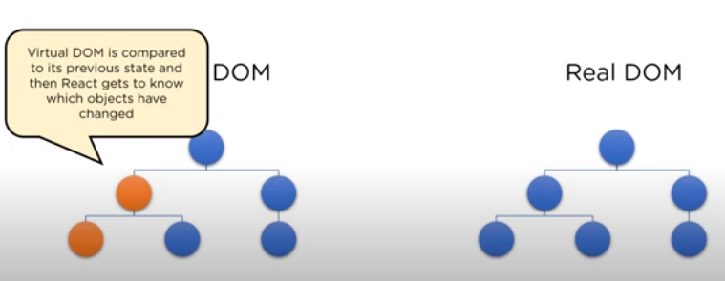

And accordingly it will update only the changed objects in real DOM which makes it faster.

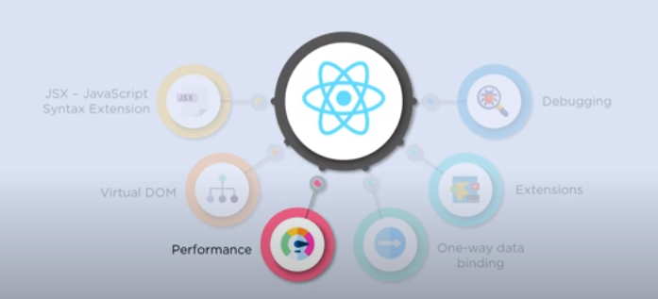

1. Uses virtual dom
2. Parallel development of multiple component.
3. One way data binding.

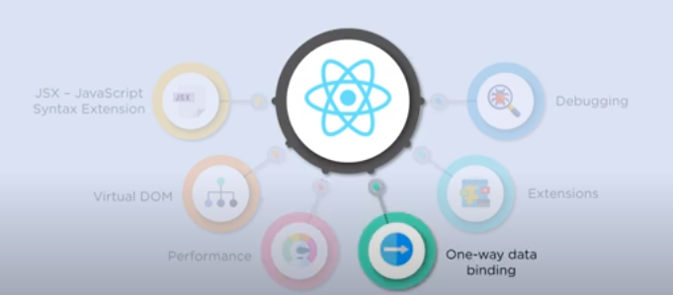

1. Information flows only in 1 direction.
2. Is used when information is displayed and not updated.
3. Components in react are functional in nature ie, they receive the information in the form of argument and passinformation as return value.

Extension:

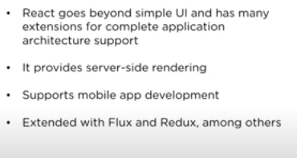

Example React Native🡪Mobile applicatoions

Flux and redux –facebook

Debugging:

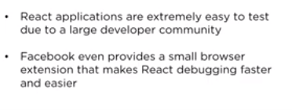

Building Blocks of React:

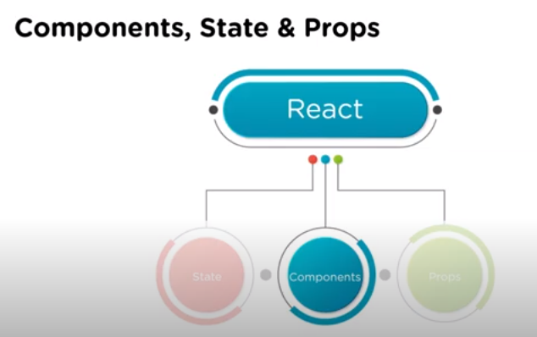

Component;

1. Reusable
2. Building block of React Applicatons
3. UI is divided into multiple component ,each component is independent.

State:is an object that holds some data, every time when object changes the component is re rendered.

Props: Properties that allow us to pass arguments or data to component.

<https://www.youtube.com/watch?v=yZVQJkKY_p0&list=PLEiEAq2VkUUKMie-cEUnkHRxiFKDZJGqO>

Installation on React on windows.

Install node and editor

<https://nodejs.org/en/download/>

install editor visual code studio,

command to create first all

npm install –g create react app1

Componet:

SPA

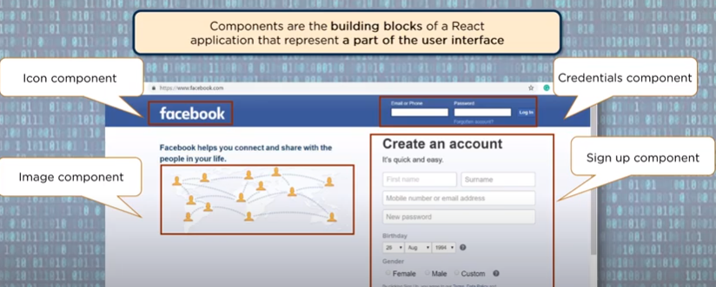

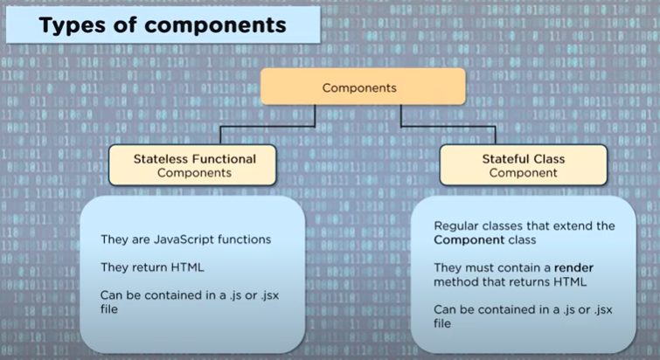

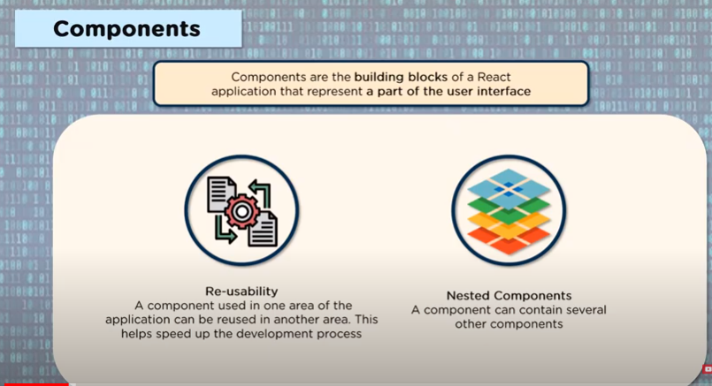

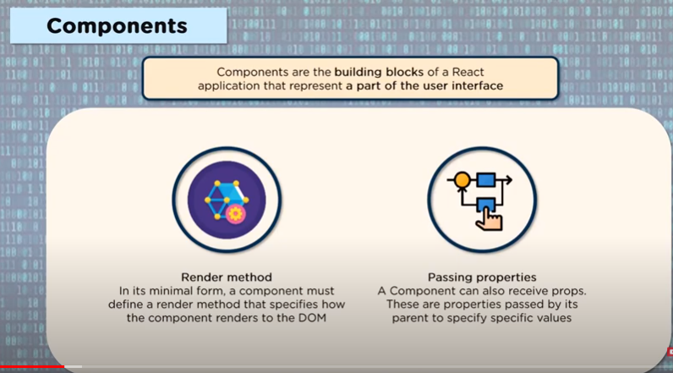

<https://www.youtube.com/watch?v=kIgboyKEEyc>

<https://youtu.be/uGgPINlKqBs>

<https://www.sitepoint.com/getting-started-react-beginners-guide/>

sunction and class compoenent:

State and prop: <https://www.youtube.com/watch?v=uGgPINlKqBs&feature=youtu.be>

<https://youtu.be/DJtI3Pogd88>

