Salesforce has two different desktop user interfaces: Lightning Experience and Salesforce Classic. This module is designed for **Salesforce Classic**.

What is a report?

A report is a list of records that meet the criteria you define. It’s displayed in Salesforce in rows and columns, and can be filtered, grouped, or displayed in a graphical chart.

Every report is stored in a folder. Folders can be public, hidden, or shared, and can be set to read-only or read/write. You control who has access to the contents of the folder based on roles, permissions, public groups, and license types. You can make a folder available to your entire organization, or make it private so that only the owner has access.

A dashboard is a visual display of key metrics and trends for records in your org. The relationship between a dashboard component and report is 1:1; for each dashboard component, there is a single underlying report.

## Different types of reports

There are four types of reports you can create in Salesforce, Tabular, Summary,Matrix and Joined Reports. Each are best suited for showing different types of data depending on what you want out of a report. Tabular – The images that I have shown you in this post have all been from a tabular report. This is the simplest of reports and is suited to just showing lines of data and nothing else. If you just want to show data with no preference to seeing totals, calulations or groups of data then this is the report for you just to keep it simple. It is also best to use this report type if you are planning to use it to export data. Summary – As soon as you click “Group by this field” as shown in the above image, you will turn the report into a summary report. Summary reports are probably the most commonly used and are great for showing groups of data e.g. If you want to see your recent accounts opportunities they will be grouped by account and you can see each opportunity under the account. From then you can do calculations, you can see the total amount of sales under an account, you can see the maximum, minimum and also average amount. You can also sub group fields by dragging them under the initial group. Matrix – Matrix reports are very similar to Summary but they allow you to group by rows as well as columns to see different totals. Matrix reports aren’t commonly used unless you have to display lots of complex data. Joined Reports – Joined reports allow you to create two separate reports so that you can compare data. Again not most commonly used.

Create a report with Report Builder

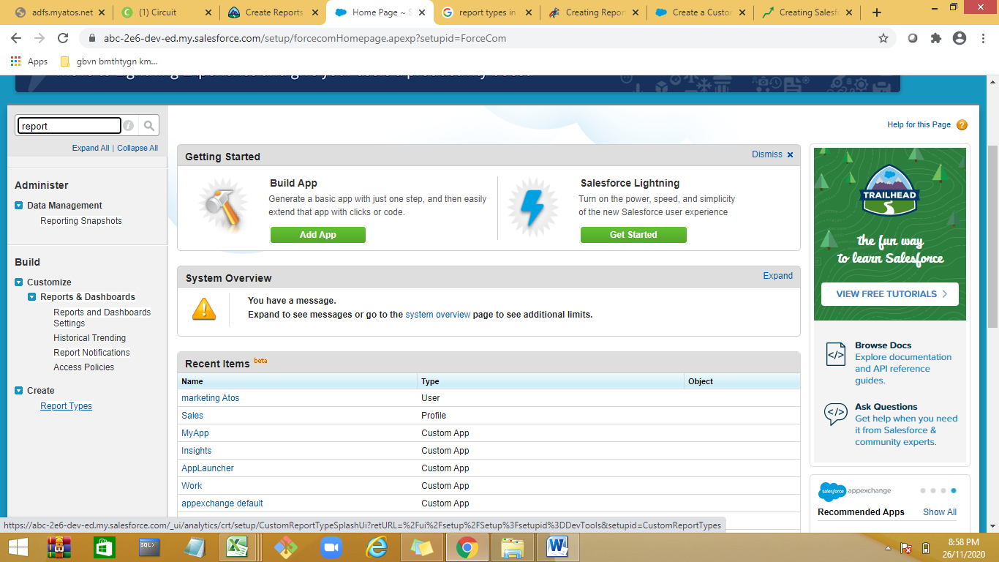

Select Report Types

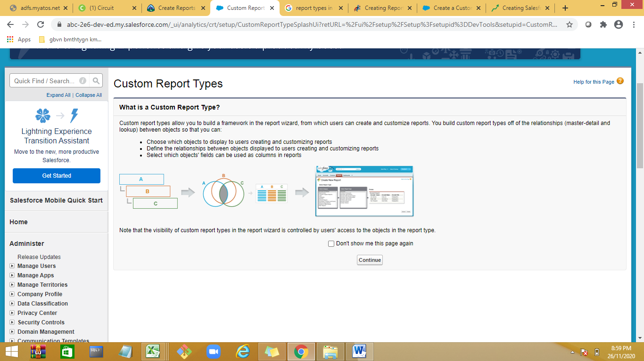

https://www.salesforcetutorial.com/creating-custom-reports-in-salesforce/