Apex: language is used to add custom business logic.it is a object oriented programming language.
Conditional statements
casesensitive
loops
Queries –SOQL- salesforceobject query language
Sosl –salesforceobject search language
Primitive -→sObject→Collections
- Primitive data types:
Blob,Boolean,Date,DateTime,Decimal,Double,Integer,Long,Object,String ,Time
- sObject→refers to any object that can be stored in the database.sObject variable represents a row of data;
Account a=new Account();
AOrder__c o=new AOrder__c();
AOrder__c o=new AOrder__c(Orderid=’10’,customer=’ABC Ltd’);//object with values
- Collection
- List
- Set
- Map

Class:

private | public | global
[virtual | abstract | with sharing | without sharing]
class ClassName [implements InterfaceNameList] [extends ClassName] {
// Classs Body
}

Global –available across org

Public – available with in org

Private –available with in class

With sharing -- When the class will get executed, it will respect the User's access settings and profile permission. Suppose, User's action has triggered the record update for 30 records, but user has access to only 20 records and 10 records are not accessible. Then, if the class is performing the action to update the records, only 20 records will be updated to which the user has access and rest of 10 records will not be updated. This is also called as the User mode.

Without sharing Even if the User does not have access to 10 records out of 30, all the 30 records will be updated as the Class is running in the System mode, i.e., it has been defined with Without Sharing keyword. This is called the System Mode.
Virtual --If you use the 'virtual' keyword, then it indicates that this class can be extended and overrides are allowed. If the methods need to be overridden, then the classes should be declared with the virtual keyword.

Abstract
If you declare the class as 'abstract', then it will only contain the signature of method and not the actual implementation.

Class Variables
Syntax
[public | private | protected | global] [final] [static] data_type
variable_name [= value]

Class Methods
There are two modifiers for Class Methods in Apex – Public or Protected. Return type is mandatory for method and if method is not returning anything then you must mention void as the return type. Additionally, Body is also required for method.
Syntax
[public | private | protected | global]
[override]
[static]

return_data_type method_name (input parameters) {
// Method body goes here
}

https://www.salesforcetutorial.com/apex-programming-tutorial/

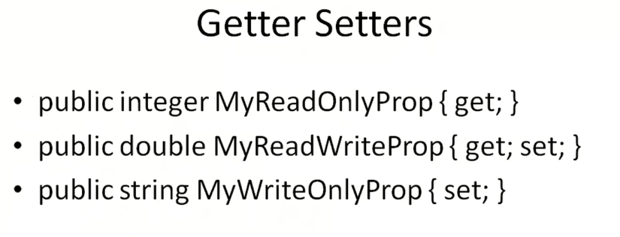

Inheritance
Class A extends B
{
}
Super keyword is also used

Demo 1;
Create a simpe class
public class Demo1 {
public static String sayHello(String name)
{
return 'Hello'+name;}
}

