**TITLE: HR AUTOMATION REPORT**

**SOFTWARE REQUIRED:** Java 8 and above, windows operating system (64 bit only), netbeans, scene builder.

**WORKING:**

1. When you want data from particular date to date you just have to use

Start date and End date column and select the specific date range and then just click on print button and you will get report in excel format.

For example we want to take report of February month then we can have the report as follow.

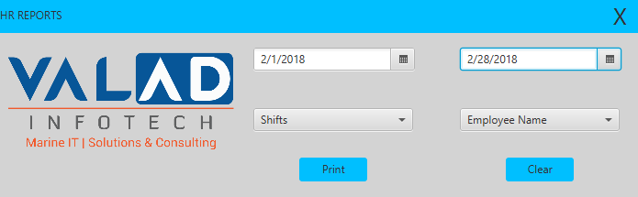

So it will generate data of all the employees of February month in excel format.

**2**.When you want data of specific shifts from particular date to date you just have to use start date and End date and Shifts column and then select specific Shift from shifts column and then click on print button and you will get report in excel format.

For example we want to take report of February month of specific Shifts we can have the report as follow.

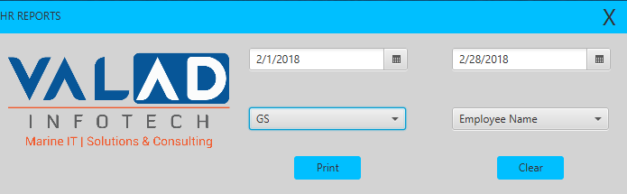

So it will generate data of specific shifts of February month in excel format

**3**.When you want data of specific employee from particular date to date you just have to use start date and End date and Shifts and Employee Name column and select specific shift of the employee and name and then click on print button to generate the report in excel format.

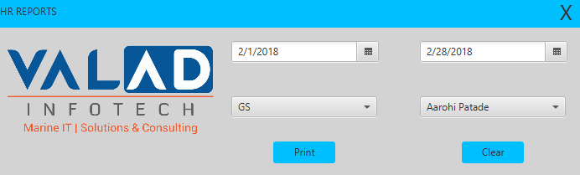

So it will generate report of specific employee of February month in excel format.

*Clear button is there to clear Shifts and Employee Name column if HR wants to take any other report at same time.

*This application is designed in such a way that it will only generate report in HR System other than that it will not generate any report for confidentiality purpose.