**Hackathon**

**Spring 2015**

**Project Title: Proxy-Mail**

**Team Name: Networ-KING**

**Team Members:**

Bala Sai Teja Gaddam (Class Id: 15)

Teja Mosali (Class Id: 34)

Manisha Kattukuri (Class Id: 27)

Tejaswini Nalamotu (Class Id: 35)

When a request is made to gmail.com interface by the user, that request is directed to a Gmail proxy server. This Gmail proxy requests the gmail.com interface on behalf of the users. As Gmail has a proxy server, we cannot actually derive whether the request is made from a mobile or a desktop device. In this project, we tried to find whether the request is made from mobile or desktop device based on the Mac address of the device by using browser fingerprinting (invisible cookies which we cannot erase).

* At first, we changed the Local Area Network Settings to use the proxy server. By giving the IP address and port number, we are enabling the proxy server. But, after proxy server is enabled when we try to browse a webpage an error message will be shown as unable to connect to the proxy server (ERR_PROXY_CONNECTION_FAILED) and we cannot access the web page.

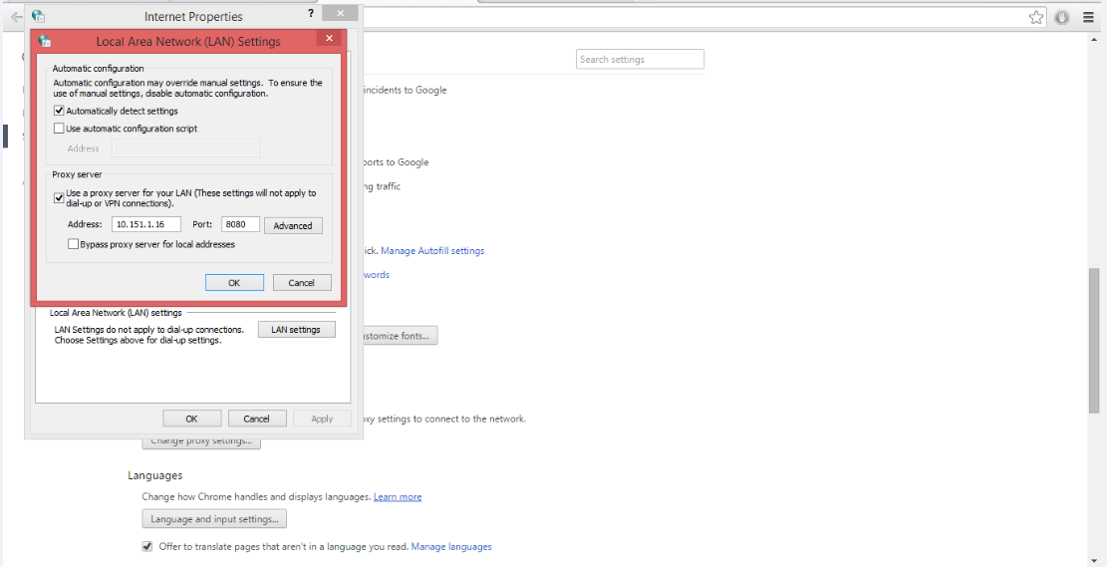

* After running the java program that we developed for the proxy server (EmailProxy.java), proxy server will be created. The following is the Java program for proxy server,

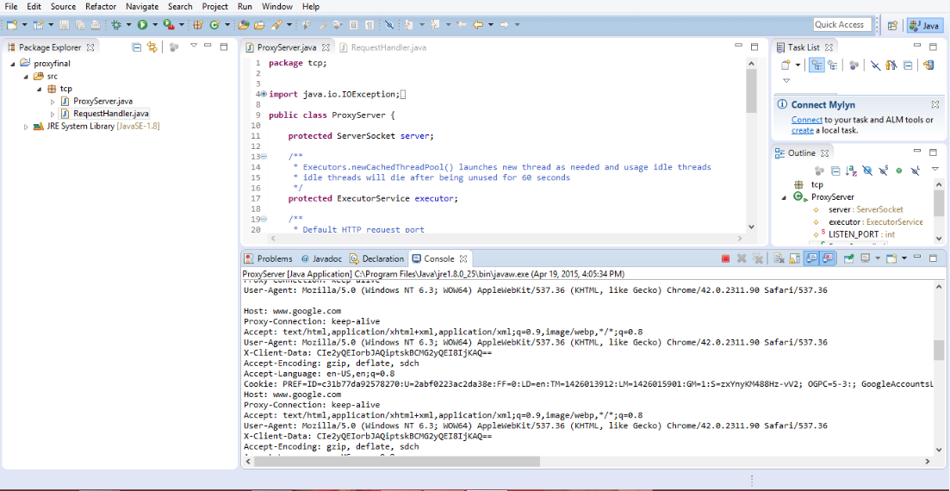

* Now, when we make a request for a webpage or website, the server will show the requested webpage or website as follows,

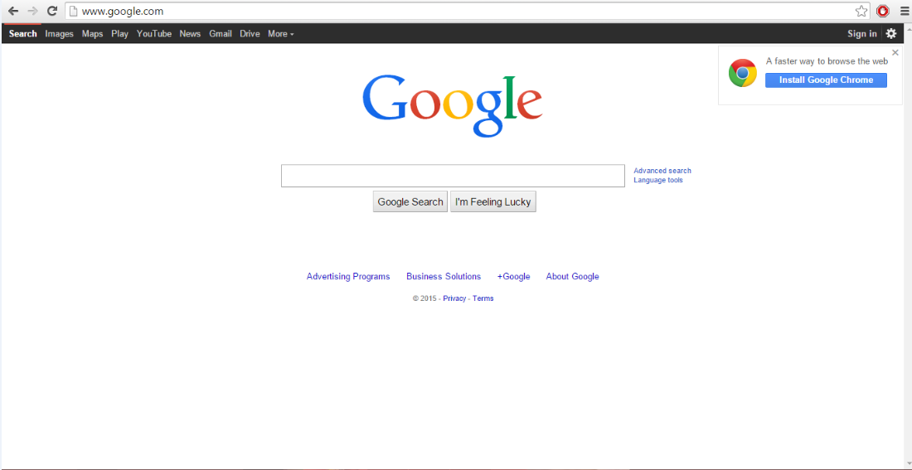

* By using a java application we are creating a MailJavaApp. This MailJavaApp uses a Local mail server such as [www.gmail.com](http://www.gmail.com), [www.mail.yahoo.com](http://www.mail.yahoo.com), [www.rediffmail.com](http://www.rediffmail.com), etc. It contains From (from which mail Id you want to send the mail), Password (same as the password used for the sender mail Id), To (to which mail Id you want to send the mail), Cc, Bcc, subject of the mail and the message. We are using a sample data for the testing purpose, after deployment of the project we can use the same procedure for the images.

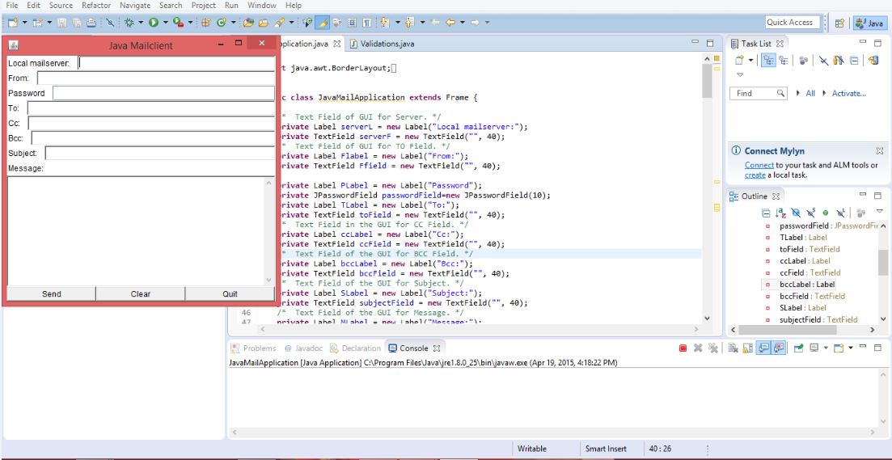

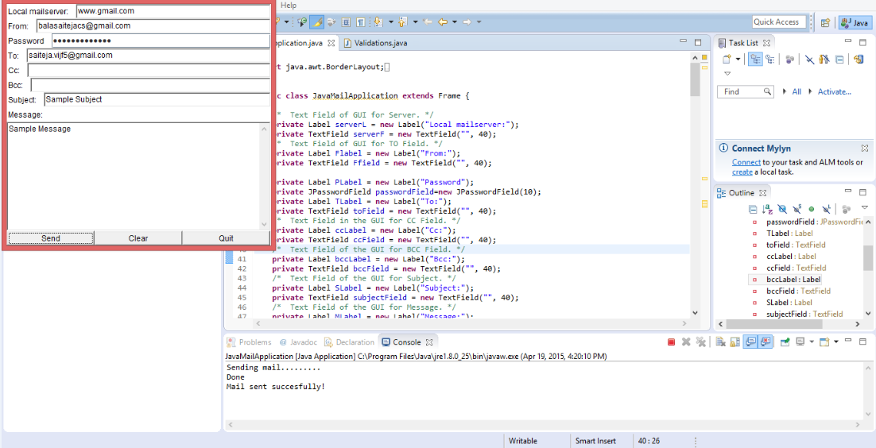

* After giving the required information in the fields of the MailJavaApp, mail will be delivered to the given mail Id. For the first time a warning mail will be delivered to the sender’s mail saying somewhere someone is using your account. If you confirm that you are the one using it, then from the second time onwards mail will be send directly to whom so ever you want to send the message.

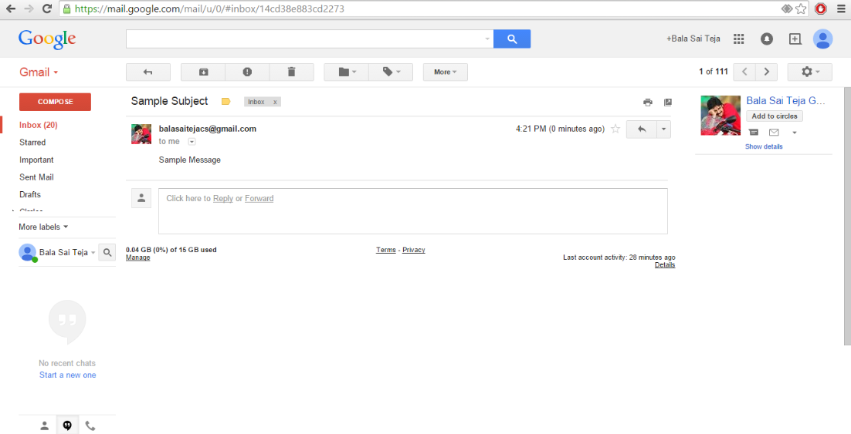

* We are trying to implement the program such that, when user opens the mail from a mobile then a message box will be displayed with a message “It is opened on mobile device” and when user opens the mail from a desktop device then a message box will be displayed with a message “It is opened on desktop device”. But we are experiencing some errors in the deployment, we have resolved some of them but couldn’t resolve all because of the time constraint.