# **Hacker Rank Challenge in C++ -** **Counting Valleys**

Gary is an avid hiker. He tracks his hikes meticulously, paying close attention to small details like topography. During his last hike he took exactly n steps. For every step he took, he noted if it was an *uphill*, U, or a *downhill*, D step. Gary's hikes start and end at sea level and each step up or down represents a 1 unit change in altitude. We define the following terms:

* A *mountain* is a sequence of consecutive steps *above* sea level, starting with a step *up* from sea level and ending with a step *down* to sea level.
* A *valley* is a sequence of consecutive steps *below* sea level, starting with a step *down* from sea level and ending with a step *up* to sea level.

Given Gary's sequence of *up* and *down* steps during his last hike, find and print the number of *valleys* he walked through. For example, if Gary's path is s = [DDUUUUDD], he first enters a valley 2 units deep. Then he climbs out an up onto a mountain 2 units high. Finally, he returns to sea level and ends his hike.

**Function Description**

Complete the *countingValleys* function in the editor below. It must return an integer that denotes the number of valleys Gary traversed.

countingValleys has the following parameter(s):

* *n*: the number of steps Gary takes
* *s*: a string describing his path

**Input Format**

The first line contains an integer n, the number of steps in Gary's hike.   
The second line contains a single string s, of n characters that describe his path.

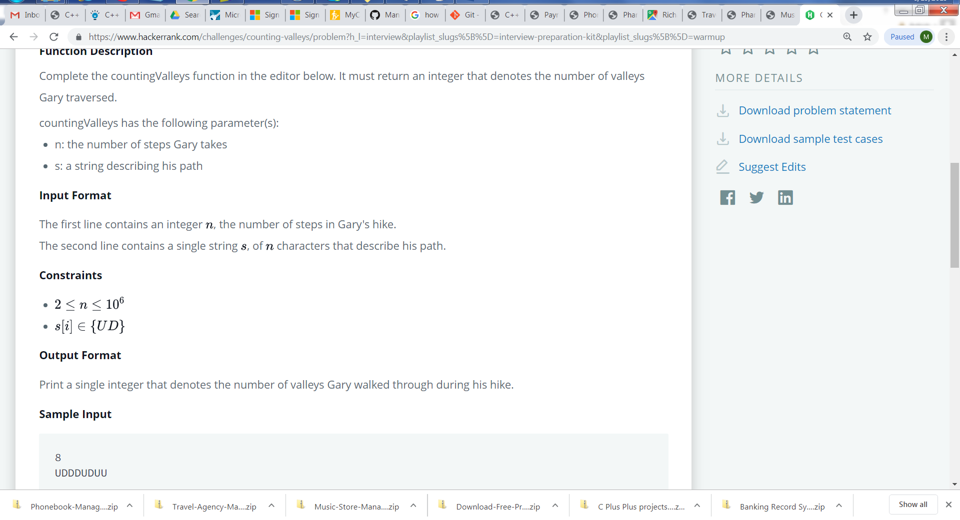

**Output Format**

Print a single integer that denotes the number of valleys Gary walked through during his hike.

**Sample Input**

8

UDDDUDUU

**Sample Output**

1

**Explanation**

If we represent _ as sea level, a step up as /, and a step down as \, Gary's hike can be drawn as:

_/\ _

\ /

\/\/

He enters and leaves one valley.