Day -5:Expressway: Trouble spots

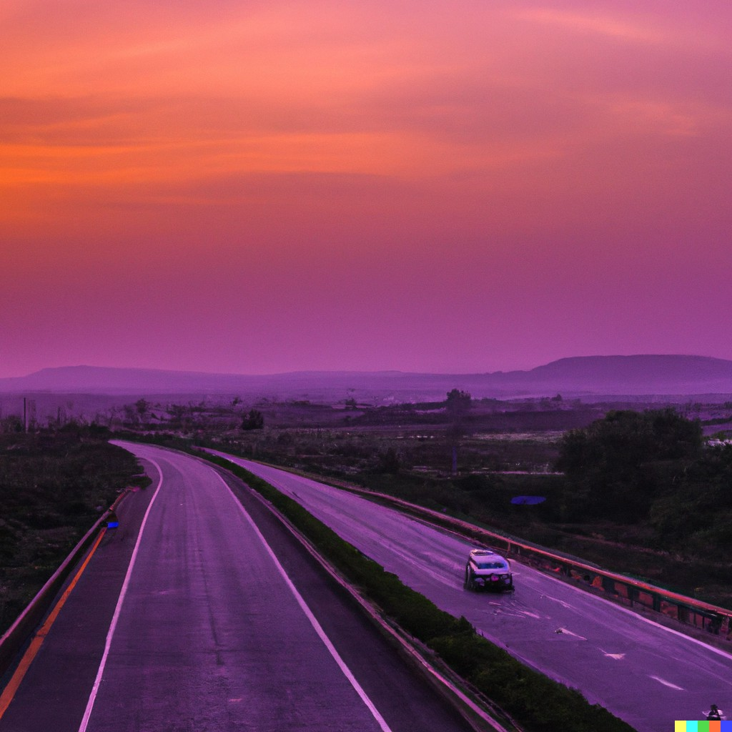A new expressway connecting Bengaluru with Mysore has been having lots of accidents lately. Even though the expressway was built to make traffic better and help the city grow, the accidents are causing problems. Now, people are talking about what can be done to stop more accidents from happening.

The new expressway was supposed to make it easier for people to get around and help businesses. But the recent accidents have made people wonder if the road is really safe. It's not just the accidents that are a problem. They also slow down traffic and damage things. To fix the problems, we need

to look at many different things and work together to find solutions.

People are starting to find out why the accidents are happening. It could be because signs and markings on the road aren't clear enough, or because some parts of the road are too dangerous. Other reasons might include tired or distracted drivers, people driving too fast, or not enough rules being enforced. To figure out what's causing the accidents, we need to look at all the information we have about traffic, accidents, and

how people drive.

To make the road safer, everyone needs to help out. This means the government, the people who built the road, the police, and other groups all working together. We can do things like make the signs and markings on the road clearer, fix dangerous parts of the road, and use technology to keep an eye on things. We also need to teach people about safe driving and make sure rules are followed.

Practice Tasks

Following are the tasks in increasing order of complexity.

The first few are directly related to reading and comprehending the passage.

* Why are people worried about the new expressway? 1

Ans: People are worried about the accident happening on the new expressway .

* What are some possible reasons for the accidents on the expressway? 1
* What are some ways mentioned in the passage to make the expressway safer? 1 The next set of questions are slightly different:
* Risk Assessment: What do you think would happen if we don't make the expressway safer, and how would you explain this to people so they understand why it's important to take action? 3
* Decision-Making: If you were in charge of making the expressway safer, how would you decide where to spend money and what changes to make first? Which additional data would you collect? Which questions will you ask? Justify your answer. (50 words) 3
* After solving the problem, you have to make a report for the newspaper explaining what was done. Please write a 150 word report.5
* Problem-Solving: If you were asked to figure out why there are so many accidents on the expressway, what information would you need, and how would you use it to find solutions?3

—