1. Verify New Computer can be added entering all the mandatory fields
CRUD Operation: Create
Given I click on Add a new Computer
When I enter only computer name with valid name
And I click on Create this computer
Then the above computer name is added
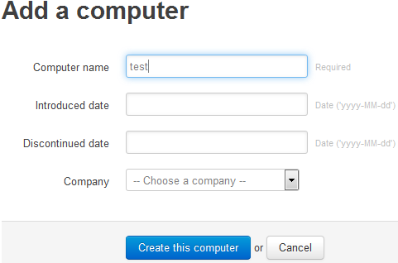
Expected Result:


2. Verify New Computer can be added entering special characters for computer Name
CRUD Operation: Create
Given I click on Add a new Computer
When I enter only computer name with special characters
And remaining fields with valid details
And When I click on Create this computer
Then the above computer name is added
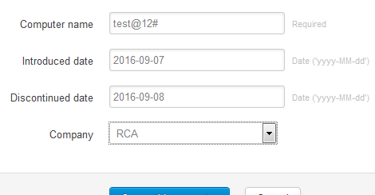
Expected Result:


3. Verify New Computer can be added entering symbols for computer Name
CRUD Operation: Create
Given I click on Add a new Computer
When I enter only computer name with special characters
And remaining fields with valid details
And When I click on Create this computer
Then the above computer name is added
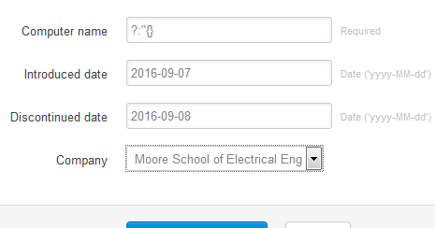
Expected Result:


4. Verify New Computer can be added entering alpha numeric for computer Name
CRUD Operation: Create
Given I click on Add a new Computer
When I enter only computer name with alpha numeric text
And remaining fields with valid details
And When I click on Create this computer
Then the above computer name is added
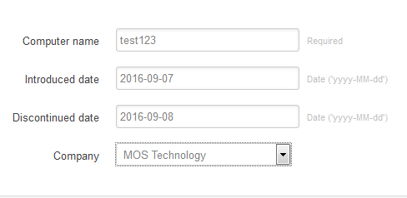
Expected Result:


5. Verify New Computer can be added entering long name for computer Name
CRUD Operation: Create
Given I click on Add a new Computer
When I enter only computer name
And remaining fields with valid details
And When I click on Create this computer
Then the above computer name is added
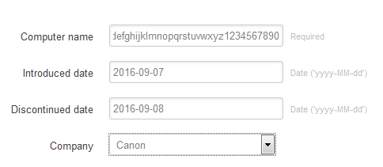
Expected Result:

6. Verify the result when no values are entered for any of the fields
CRUD Operation: Create
Given I click on Add a new Computer
When I do not enter any values
And I click on Create this computer
Then mandatory fields are highlighted to have values
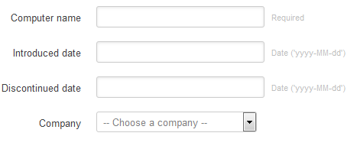
Expected Result:
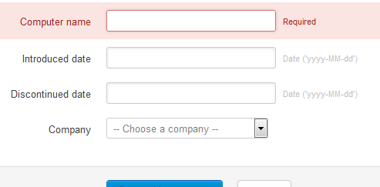

7. Verify New Computer can be added entering all the mandatory fields
Given I click on Add a new Computer
When I enter only computer name with valid name
And I click on Cancel
Then the user is navigated to the first screen
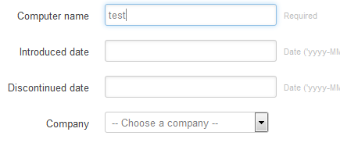
Expected Result:
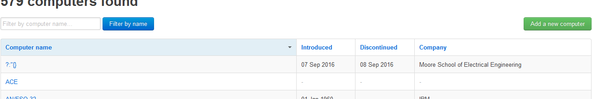
8. Verify Search functionlity for blanket search
CRUD Operation: Retreive
Given I do not enter any values in Filter by Name field
When I click Filter by Name field button
Then All the Computer names are displayed

Expected Result:
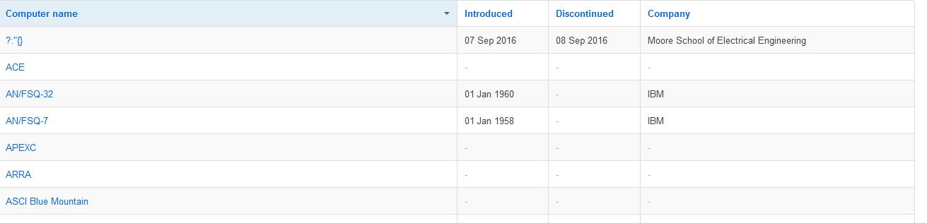

9. Verify the Search functionality for valid Computer Name
CRUD Operation: Retreive
Given I enter 'test' in the Filter by Name field
When I click Filter by Name button
Then All the Computer names with 'test' in their name are displayed
Expected Result:
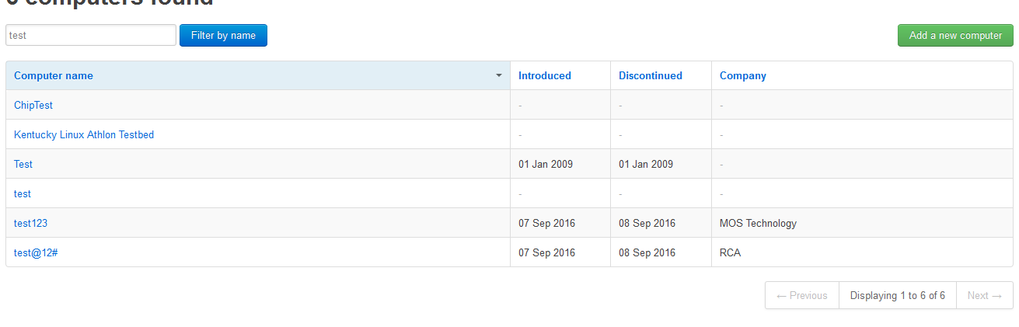

10. Verify the Search functionality for invalid Computer Name
CRUD Operation: Retreive
Given I enter 'zzzzzz' in the Filter by Name field
When I click Filter by Name button
Then No Computer names are displayed

Expected Result:
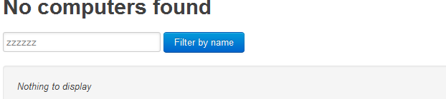

11. Verify Edit functionality for existing Computer Names
CRUD Operation: Retreive
pre-req: A record with computer name 'ASCI Red' exists
Given I select an existing record
When I click on Delete this computer button
Then this record no longer exists
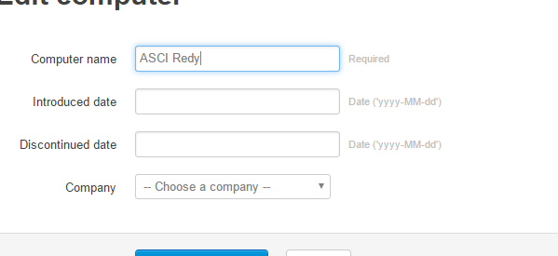
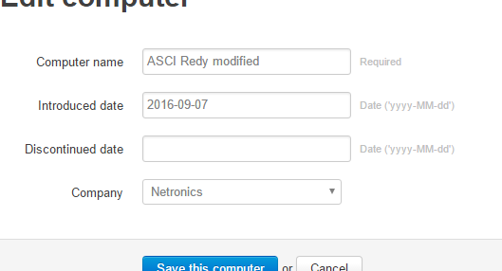
Expected Result:
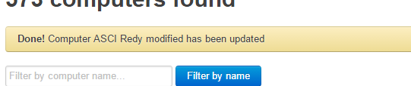

12. Verify valid format for Introduced Date Field
Given I click on Add a new Computer
When I enter value for Introduced Date field as '2016-09-07'
And remaining fields with valid details
And When I click on Create this computer
Then the above record is added successfully
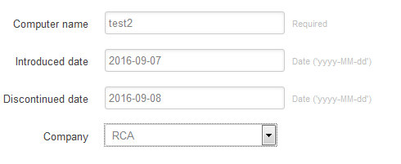
Expected Result:

13. Verify invalid format for Introduced Date Field
Given I click on Add a new Computer
When I enter value for Introduced Date field as '07-09-2016'
And remaining fields with valid details
And When I click on Create this computer
Then Cannot proceed as error in format for Introduced Date field
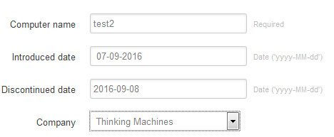
Expected Result:
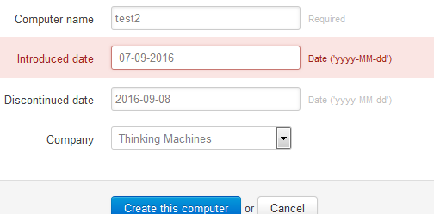

14. Verify valid format for Discontinued Date Field
Given I click on Add a new Computer
When I enter value for Discontinued Date field as '2016-09-07'
And remaining fields with valid details
And When I click on Create this computer
Then the above record is added successfully
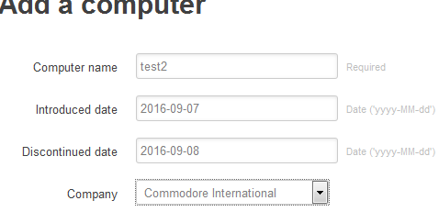
Expected Result:


15. Verify invalid format for Discontinued Date Field
Given I click on Add a new Computer
When I enter value for Discontinued Date field as '07-09-2016'
And remaining fields with valid details
And When I click on Create this computer
Then Cannot proceed as error in format for Discontinued Date field
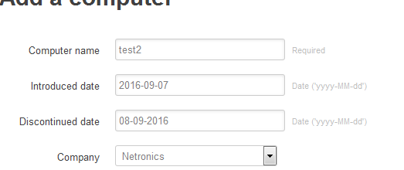
Expected Result:
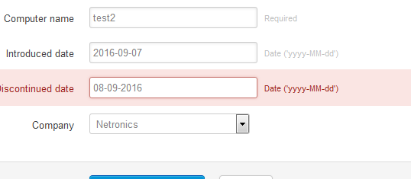

16. Verify when same values are entered for Introduced and Discontinued Date Fields
Given I click on Add a new Computer
When I enter same values for Introduced and Discontinued Date Fields
And remaining fields with valid details
And When I click on Create this computer
Then the above record is added successfully
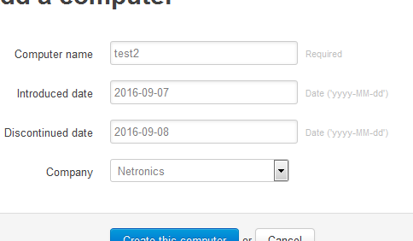
Expected Result:

Note: This currently does not work, Looks like a bug to me.

17. Verify when Introduced Date is later than Discontinued Date
Given I click on Add a new Computer
When I enter Introduced date later than Discontinued Date
And remaining fields with valid details
And When I click on Create this computer
Then the above record is added successfully
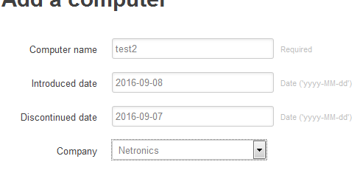
Expected Result:

Note: This currently does not work, Looks like a bug to me.

18. Verify the sorting of columns with arrow symbols

Given I navigate to the list of records
When I click on the arrow symbol against Introduced Date Field
Then the records should be sorted in ascending/ decending order considering the values in the column.
Note: This currently does not work, Looks like a bug to me.

19. Verify when Duplicate values are entered for Computer Name
pre-req: A record with computer name 'test' exists
Given I click on Add a new Computer
When I enter computer name as 'test'
And remaining fields with valid details
And When I click on Create this computer
Then the above computer name is added

20. Verify Delete functionality for existing Computer Names
CRUD Operation: Delete
pre-req: A record with computer name 'ACE' exists
Given I select an existing record
When I click on Delete this computer button
Then this record no longer exists
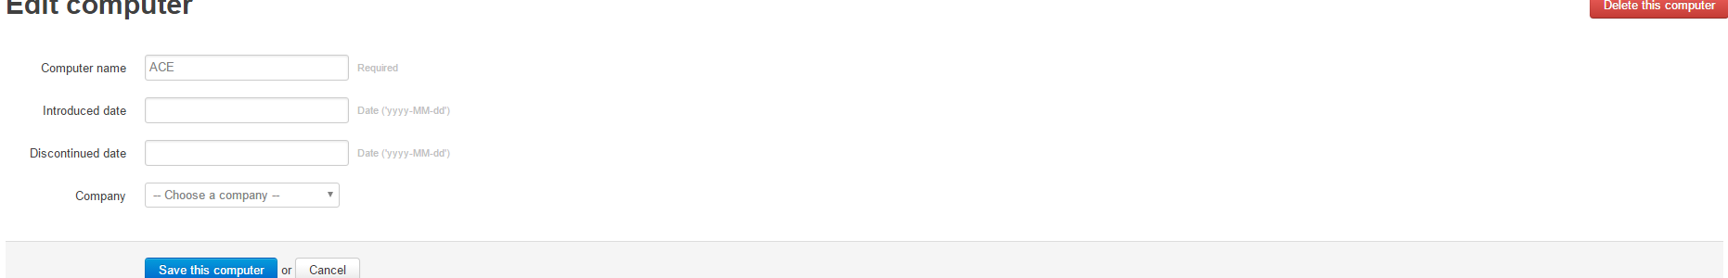
Expected Result:
