A
Industrial Project Report
on
“TODO APPLICATION”
Submitted in partial fulfilment
for the award of the Degree of
Master of Computer Applications
(Rajasthan Technical University, Kota)

Session (2018-2019)
Submitted To: Submitted By:
Mr. Sudarshan Maurya Manisha Kapila
(HOD ) 16CEMXX605
MCA VI SEM

DEPARTMENT OF COMPUTER ENGINEERING
GOVT. MAHILA ENGINEERING COLLEGE AJMER
NASIRABAD ROAD, MAKHUPURA, AJMER-305002

GOVT. MAHILA ENGINEERING COLLEGE AJMER
NASIRABAD ROAD, MAKHUPURA, AJMER-305002

Certificate

This is to certify that Manisha Kapila of VI semester, MCA session 2018-19 has presented a Industrial major report titled “To-Do Application” in partial fulfilment of the degree of Master of Computer Application under Rajasthan Technical University, Kota.

Date:

Signature of HOD Signature of External Examiner
Mr. Sudarshan Maurya Dr.Amit chaturvedi
(Dept. of Computer engineering)

Candidate’s Declaration

I hereby declare that the work, which is being presented in the industrial project, entitled “TO-DO APPLICATION” in partial fulfillment for the award of Degree of “Masters of Computer Applications” in Department of Masters of Computer Applications, Govt. Mahila Engineering College, Ajmer, from Rajasthan Technical University, Kota is a record of my own investigations and experiments carried for this training and project.
I have not submitted the matter presented in this report anywhere else for the award of any other degree.

Manisha Kapila
MCA VI Sem
16CEMXX605

ACKNOWLEDGEMENT

With my immense pleasure, I would like to present this Industrial project report for “TO-DO APPLICATION”. It has been an enriching experience for me to undergo my Internship at “C-DAC ATC NETCOM”, which would have not been possible without the goodwill and support of the people around. As a student of Govt. Mahila Engineering College, Ajmer. I would like to extend my sincere gratitude and thanks to Mr. Gunjan Sharma (Technical Lead, C-DAC ATC NETCOM, Jaipur).

I want to give sincere thanks to the principal, Dr. J.K Deegwal for his valuable support, Mr. Sudarshan Maurya (Head of Department), to shape my understanding towards the project. It was because of their immense help and support that this project has been duly completed.

Yours Sincerely
Manisha Kapila
MCA VI Sem
16CEMXX605

Table of Contents

Chapter No. | Contents |  |  | Page No.
 | Certificate
 | Candidiate’s Declaration
 | Acknowledgement
1 | Introduction to technology |  |  | 6
2 | Project Introduction |  |  | 10
 | 2.1 | Why do we use? |  | 11
 | 2.2 | Features |  | 11
 | 2.3 | Advantages |  | 12
 | 2.4 | Disadvanatges |  | 12
 | 2.5 | Project Specifications |  | 13
3 | Design Document |  |  | 14
 | 3.1 |  | Use Case Diagram
 | 3.2 |  | Activity Diagram
4 | Implementation |  |  | 16
5 | Coding |  |  | 34
6 | Conclusion |  |  | 40
7 | References |  |  | 41
Chapter-1

Introduction to technology

- Angular
Angular is a platform that makes it easy to build applications with the web. Angular empowers developers to build applications that live on the web, mobile, or the desktop.
Angular7 is a JavaScript (actually a TypeScript based open-source full-stack web application) framework which makes you able to create reactive Single Page Applications (SPAs). Angular 7 is completely based on components. It consists of several components which forms a tree structure with parent and child components. Angular's versions beyond 2+ are generally known as Angular only. The very first version Angular 1.0 is known as AngularJS.
A single page application is a web application or a website which provides users a very fluid, reactive and fast experience similar to a desktop application. It contains menu, buttons and blocks on a single page and when a user clicks on any of them; it dynamically rewrites the current page rather than loading entire new pages from a server. That's the reason behind its reactive fast speed.
Features:
- Angular is a efficient framework that can create Rich Internet Applications .
- Angular provides developers an options to write client side applications using JavaScript in a clean Model View Controller (MVC) way.
- Applications written in Angular are cross-browser compliant. Angular automatically handles JavaScript code suitable for each browser.

- Node.js
Node.js is open source, cross-platform, and since its introduction in 2009, it got hugely popular and now plays a significant role in the web development scene. A Node.js app is run by a single process, without creating a new thread for every request. Node provides a set of asynchronous I/O primitives in its standard library that will prevent JavaScript code from blocking and generally, libraries in Node.js are written using non-blocking paradigms, making a blocking behavior an exception rather than the normal.
Node.js has a unique advantage because millions of frontend developers that write JavaScript for the browser are now able to run the server-side code and frontend-side code without the need to learn a completely different language.

Features
- It’s easy to get started and can be used for prototyping and agile development
- It provide fast and highly scalable services
- It uses JavaScript everywhere so it’s easy for a JavaScript programmer to build back-end services using Node.js
- Source code more cleaner and consistent.
- Large ecosystem for open source library.
- It has Asynchronous or Non blocking nature.

- Ionic

Ionic is a toolkit, which provides us functionality to create mobile apps, using Web technologies like HTML, CSS, JavaScript and AngularJS for both Android and iOS mobiles. Ionic provides tools and Services to create a hybrid mobile application but look like a native application.
Ionic is a front end tool, which is built over Cordova platform. Cordova provides API for Native devices to interact with JavaScript code and Ionic framework is like a front end tool, which handles how a native app looks and feels.
Before hybrid applications, if we wanted to create any Application for Android platforms, then we needed the knowledge of Java language or if we wanted to create any Application for iOS, then we needed knowledge of Objects of C or Swift programming language.
If we had a need to create mobile Applications, we were required to hire a developer for an Android platform and also one developer for iOS , which was expensive and time consuming. Now, we can create a hybrid Application, which can run on multiple platforms.
Features
- Ionic is a cross platform, which means we can write single code for the multiple platforms.
- To create an Ionic Application, we require basic Web technologies like HTML5, CSS, JavaScript, which means we don’t require knowledge of any platform specific language.
- We can change the look of the Application to match the native standards for each platform.
- Ionic Application is a simple, easy interface, easy to update and maintain.

- Mongo DB
MongoDB is an open-source document database and leading NoSQL database. MongoDB is written in C++. MongoDB is a cross-platform, document oriented database that provides, high performance, high availability, and easy scalability. MongoDB works on concept of collection and document.
MongoDB also provides the feature of Auto-Scaling. Since, MongoDB is a cross platform database and can be installed across different platforms like Windows, Linux etc.

Features
- MongoDB provides high performance. Input/Output operations are lesser than relational databases due to support of embedded documents(data models) and Select queries are also faster as Indexes in MongoDB supports faster queries.
- MongoDB has a rich Query Language, supporting all the major CRUD operations. The Query Language also provides good Text Search and Aggregation features.
- Auto Replication feature of MongoDB leads to High Availability. It provides an automatic failover mechanism, as data is restored through backup(replica) copy if server fails.
- Sharding is a major feature of MongoDB. Horizontal Scalability is possible due to sharding.
- MongoDB supports multiple Storage Engines. When we save data in form of documents(NoSQL) or tables(RDBMS) who saves the data? It's the Storage Engine. Storage Engines manages how data is saved in memory and on disk.

Chapter-2

Project Introduction
TODO Application

We all have those days when there are a million things to do, and we don't know how we're going to get it all done. It's easy to become overwhelmed by the vast quantity of tasks that we must do from day to day. Sometimes we have so many balls in the air, that we may even lose track of some loose ends and forget to do important things. When we get too busy, we end up feeling like we are barely able to keep our heads above water.
To-Do is a new, intelligent task management app that makes it easy to plan and manage your day. To-Do helps you create a list for anything—for work, home projects or just your groceries. You can keep track of deadlines by adding reminders, due dates and notes, and personalize each list with colorful themes.
Plan your day with intelligent Suggestions
Managing your to-dos and lists can sometimes take as much effort as completing them. To-Do helps you focus and plan your day from the moment you open the app. Every morning, your My Day list starts out with a clean slate, allowing you to be more intentional about what you want to get done.
Todo Application lets you keep track of everything in one place, so you can get it all done and enjoy more peace of mind along the way. This Application will keep track of your tasks,reminders. Todo Application is built using Ionic,Angular & Node JS

2.1 Why do we use Todo Application?

Organization
One of the most important reasons for keeping a to-do list is the organization. Organizing your tasks with a list can make everything much more manageable and make you feel grounded. Seeing a clear outline of your completed and uncompleted tasks will help you feel organized and stay mentally focused.

Improved Memory
Feeling forgetful? Nobody is capable of remembering everything at all times. To-do lists are a useful external memory aid that give you permission to forget. As long as you can remember to look at your to-do list, you will never lose anything that you have recorded on it.

2.2 Features:
- Add Tasks.
- View a list of all tasks added.
- Add new reminders.
- Show Reminders.
- Sort the tasks alphabetically.
- We can also change the theme for our Application. like Dark Mode.
- Manage a admin panel to show the total number of users registered and show their details.

2.3 Advantages of TODO Application:
- The Major advantage of this hybrid apps is that it can be run on both iOS and Android
- The code is written once and deployed across all mobile platforms.
- The code is written once, which substantially reduces development time and costs compared to native apps which require development for iOS and development for Android.

  - Disadvantages of TODO Application:
- A limited user interface: hybrid apps have a design that doesn’t have a native feel. The user interface thus isn’t as seamless. Possibilities (3D for example) are also restricted due to the fact that WebView is used and that this doesn’t allow the exploitation of the devices’ full potential.
- The difficulty or impossibility to exploit the platforms’ capacities in full. Each platform, iOS or Android, has unique capacities that a developer may wish to exploit. If this is the case, a combination of specific plugins and code of the platform will be used to achieve this on a hybrid app. This further complicates the app development project.
- Slower performance and transition between pages.
- Dependency on the browser’s speed.

2.5 Project Sepecifications:

- Hardware Requirements

Processor : Intel core i3 CPU
Memory : 2 GB
Hard Disk Drive : 4 GB & above

- Software Requirements

Platform : Window 8 & above.
Language used : Angular7, Nodejs , Ionic
Designer tool : CSS, HTML,BOOTSTRAP
Software used : Visual Studio , MongoDB server , Robo3T
Browsers : All Internet Browsers

Chapter-3

3.1 Use Case Diagram:

Create new task list

User
Removes task from the list

Move it to the completed task list.

Set Reminders

Set todo entry status to completed & sort the task

3.2 Activity Diagram:

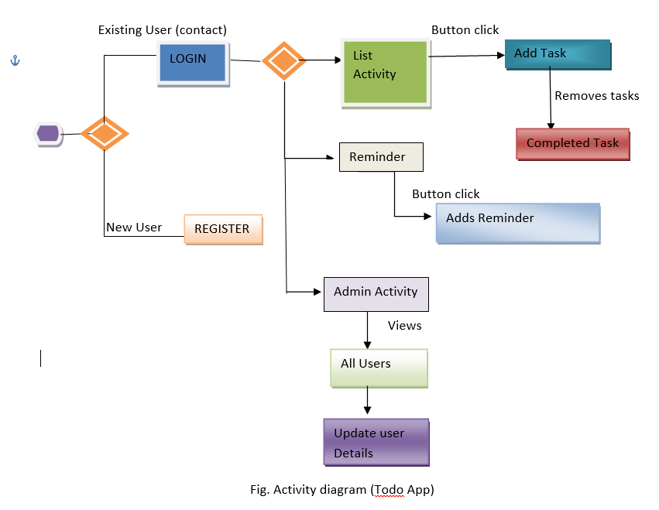

Chapter-4

Implementation

Forms Design

- Welcome Screen
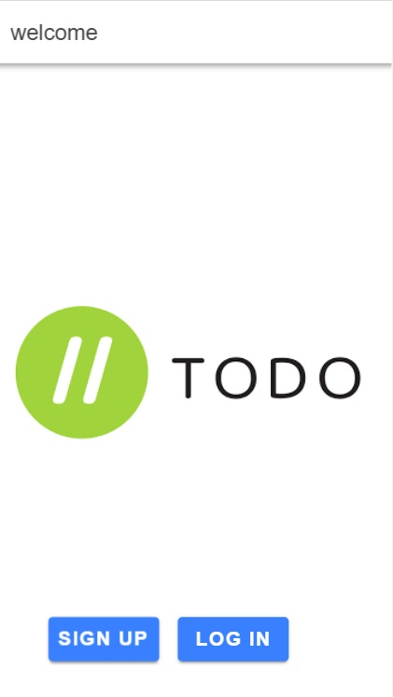

Fig 4.1 Main Home Screen

Description
This the first page of the To-Do Application which is loaded when the application is being executed when the application is first loaded.

- Menu Screen
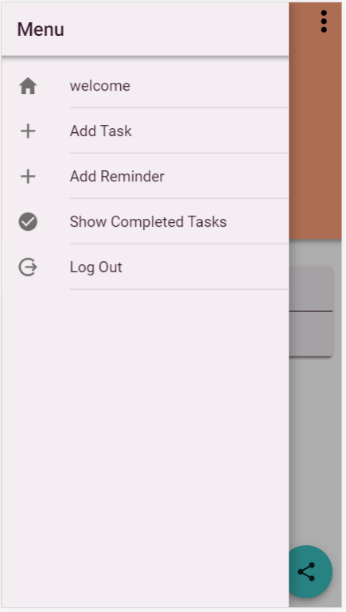

Fig 4.2 Menu Screen

Description
This the page through which user can easily navigate to different screen of the application like welcome,add tasks,add reminder,show completed tasks,log out.

- Login Page
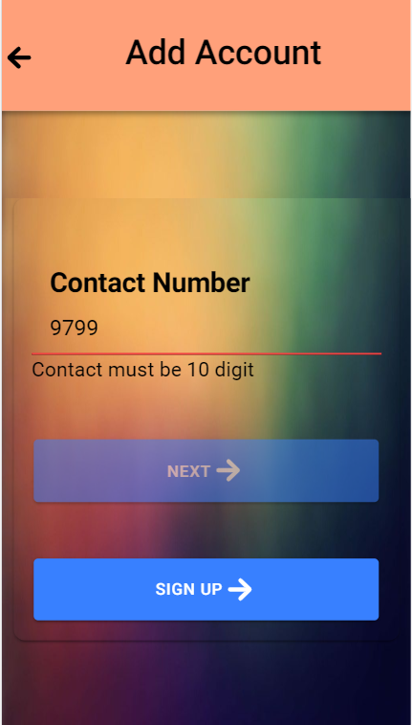

Fig 4.3 Login Screen

Description
Through this page the user which is being already registered into an application will directly logged in by using the valid contact number as credentials. If the details of that contact exists in the database it will be redirected to the add task page. If the details are not existing in the database then the user will be redirected to the sign-up page where he has to register to access the application.

- Registration Page
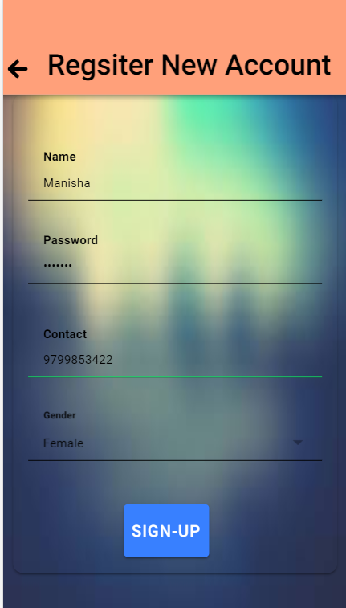

Fig 4.4 Registration Screen

Description
Through this page the user which is not already existing will enter the basic details like name, password, contact and gender and all the fields are mandatory to be field for the registration. After clicking on the SIGN-UP button the user will be redirected to the add task page.

AddTask Page
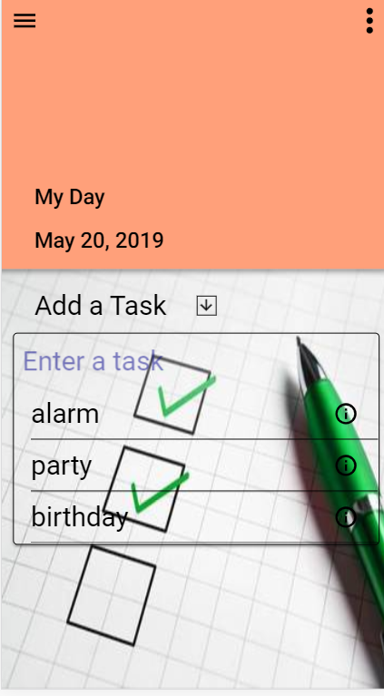

Fig 4.5 AddTask Screen

Description
With the help of this page the user can enter his or her day to day tasks by clicking on add a task with a arrow icon.when a user click on the arrow icon the task will be added to the task list.

- AddReminder Page
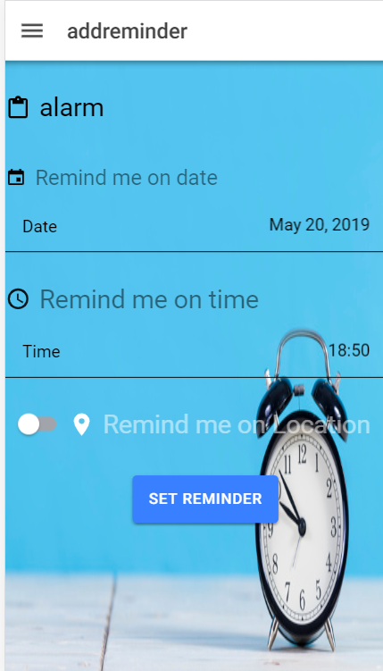

Fig 4.6 AddReminder Screen

Description
Through this page an user can add reminder for the task he has been added by entering the title for the title, date, time and location . The reminder can be added by clicking on the Set Reminder Button and will be stored in the database.

- Location Page

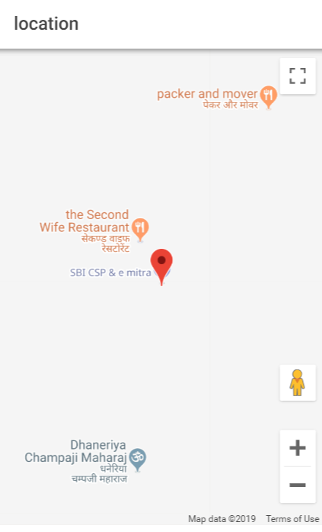

Fig 4.7 Location Screen

Description
Through this page the user can add location while setting up the reminder.

- ShowReminder Page

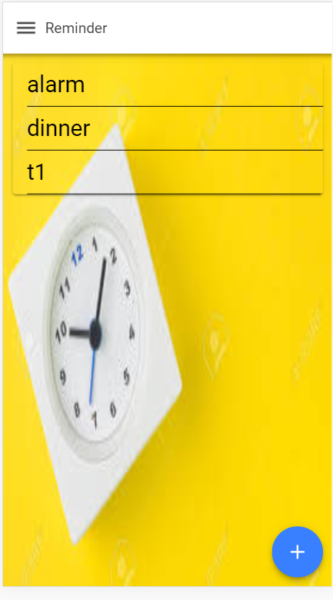

Fig 4.8 ShowReminder Screen

Description
The Show reminder page will display the reminders of a particular user which has been added on the Add Reminder page .The Fab button on this page will again redirect the user to the add reminder page if the user wants to add more reminders.

Theme Page
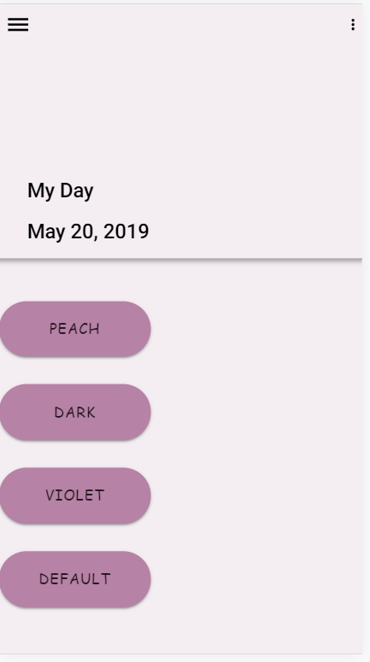

Fig 4.9 Theme Screen

Description
This page will help the user to change the theme of the whole application as per his requirements which can be day, night, neon or default mode. The by default , mode is default. The day mode will give enhance colors and the night mode will apply dark theme and neon theme will give the vibrant colors.

Popover Menu

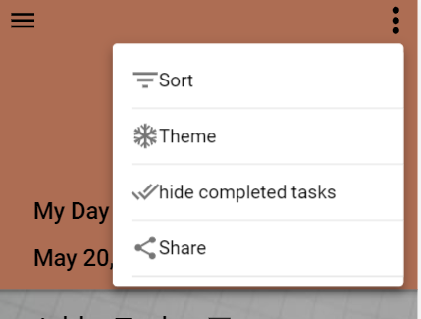

Fig 4.10 PopOver Menu

Description
This popover menu provides the various options to the user like:
Change theme- through which theme of whole application can be changed.
Sort- through sort the tasks which is being added is displayed in the sorted order.
Hide Completed tasks-this option will remove the task completed from the list and add them to completed task database.

Sort Page

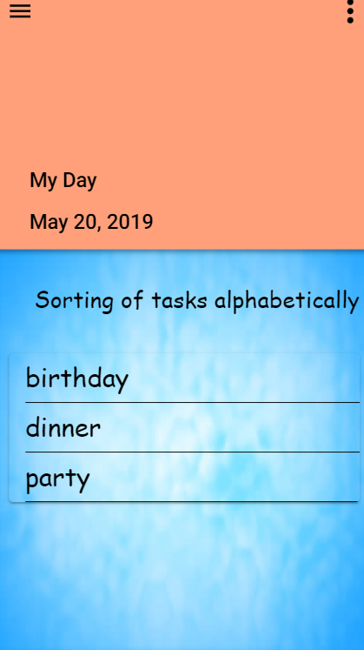

Fig 4.11 Sort Screen

Description
Through this page the task that will be added to the task list are sorted alphabetically.

Completed Task Page
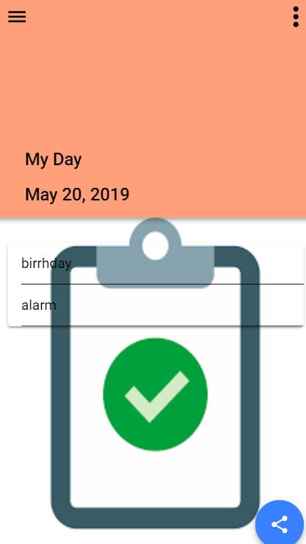

Fig 4.12 CompletedTask Screen

Description
Through this page the task that will be completed are shown.

Admin Panel

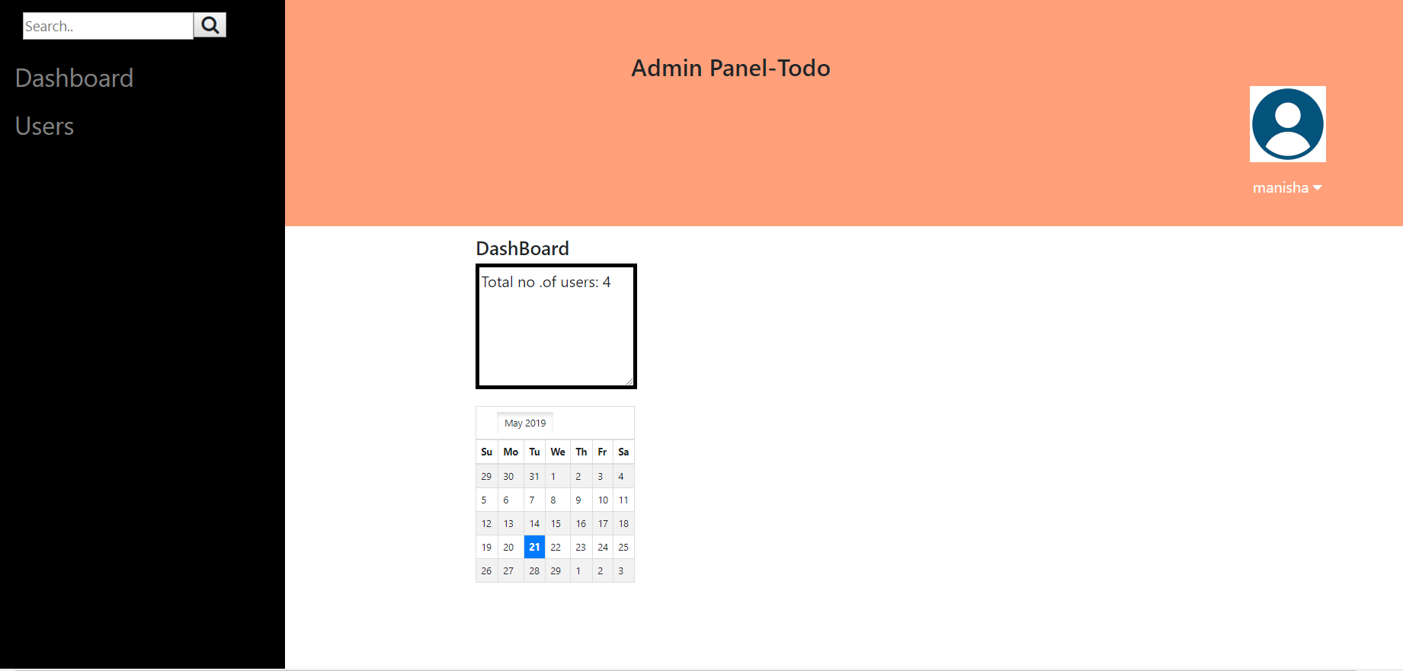
Dashboard Page

Fig 4.13 Dashboard Screen

Description
This page is the page which is controlled by the admin by which an admin can check the No. of Users which is being registered in the application. The admin can view the details of the registered users and can access the information.

- ViewUser Page

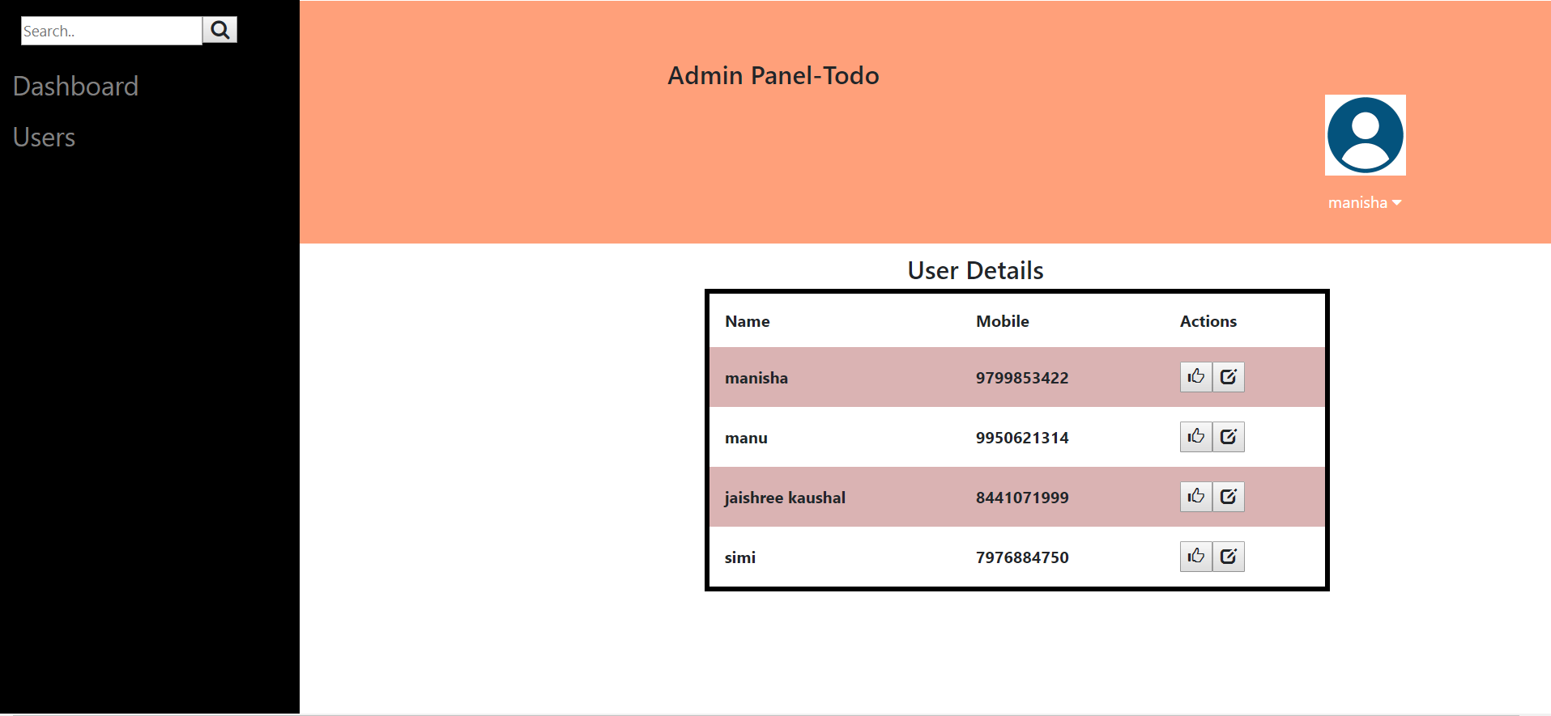
Fig 4.14 ViewUser Screen

Description

This page will display the registered users information i.e., there names and the contact number which they used at the time of the registration. And also provide the action buttons for updating the information.

- UpdateUser Page
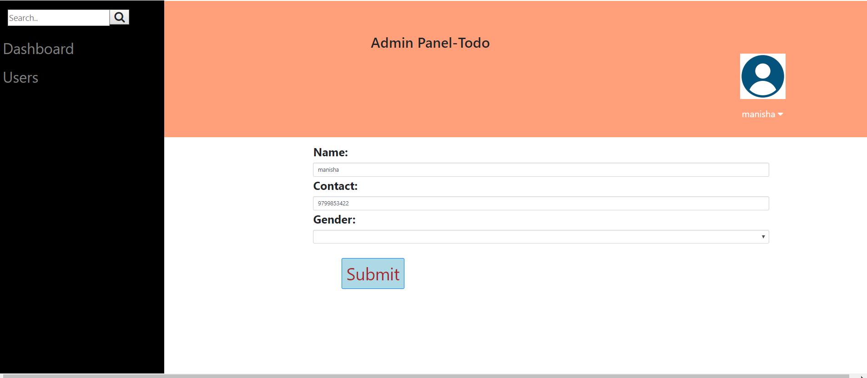

Fig 4.15 UpdateUser Screen

Description
This page will allow the user to update his existing information such as name, contact and gender. All the updating of details will be performed on this page.

Schema Details

- Login Details Schema
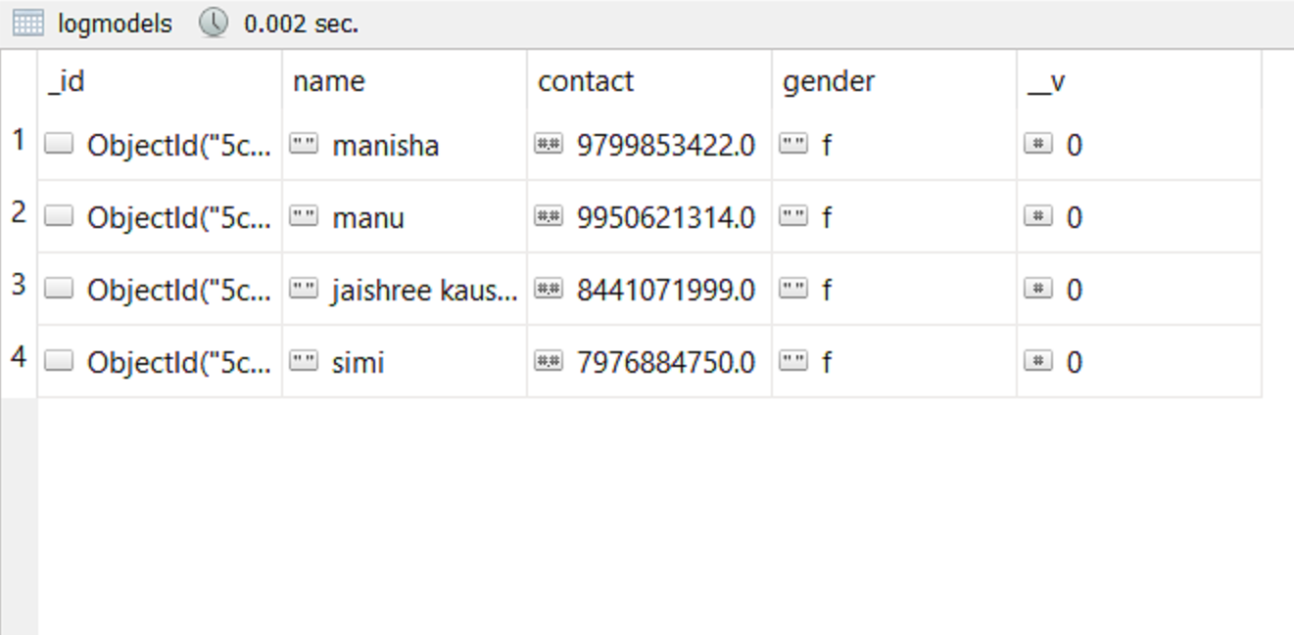

Fig 4.16 Login Schema

Description
Through this schema the users that are registered into the application are stored.

- Task Details Schema
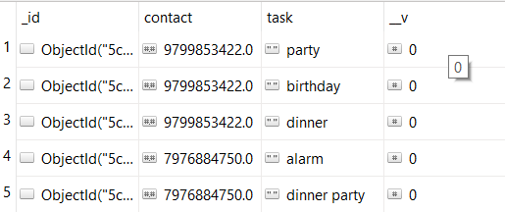

Fig 4.17 Task Details Schema

Description
Through this schema the tasks that are added into the application are stored.

- Reminder Details Schema
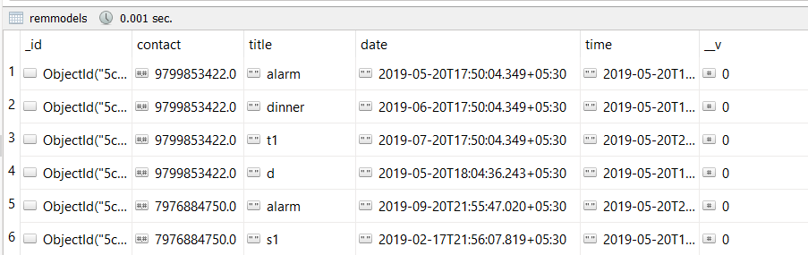

Fig 4.18 Reminder Details Schema

Description
Through this schema the reminders that are added into the application are stored.

Chapter-5

Coding

Server.js File

var express=require('express');
var bodyParser=require('body-parser');
var {mongoose} = require('../backend/db/db');
var {todoModel} = require('../backend/model/todo');
var {logmodel} = require('../backend/model/login');
var {addmodel} = require('../backend/model/add');
var {remmodel} =require('../backend/model/reminder');
var {admodel}=require('../backend/model/admin');
var {accmodel}=require('../backend/model/addaccount');
var {statusmodel}=require('../backend/model/status');
var app = express();
app.use(bodyParser.json());
app.use((req, res, next) => {
res.setHeader("Access-Control-Allow-Origin", "*");
res.setHeader("Access-Control-Allow-Headers", "Origin, X-Requested-With, Content-type, Accept, X-Token");
res.setHeader("Access-Control-Allow-Methods", "POST,GET,PUT,DELETE");
next();

});

- For Creating an API
app.use(bodyParser.json());
app.post('/logins', (req, res) => {
console.log(req.body);
var newdata = new logmodel(req.body);
// console.log(req.body);
newdata.save().then((result) => {
res.status(200).send(result);
}).catch((err) => {
res.status(400).send(err);
});
});
var port=3002;
app.listen(port,(res)=>{
console.log("listening on port");
});

- For Retrieving the data
app.post('/search',(req,res)=>{
console.log(req.body);
var query=req.body['number'];
console.log(query);
todoModel.find().then((doc)=>{
res.send(doc);
}).catch((err)=>{
res.send(err);
});
});

- Creating Services for Accessing Data

import { Injectable } from '@angular/core';

import { HttpClient } from '@angular/common/http';

@Injectable({

providedIn: 'root'

})

export class MainService {

url='http://localhost:3002/';

constructor(public http:HttpClient) { }

register(name,password,contact,gender)

{

return this.http.post(this.url+'logins',{

"name":name,

"password":password,

"contact":contact,

"gender":gender

});

}

find(contact){

this.http.post(this.url + 'search',{contact});

}

add(contact,task)

{

return this.http.post(this.url+'add',{

"contact":contact,

"task":task

});

}

addreminder(contact,title,date,time)

{

return this.http.post(this.url+'addremind',{

"contact":contact,

"title":title,

"date":date,

"time":time

});

}

addac(contact)

{

return this.http.post(this.url+'addacc',{

"contact":contact

});

}

stask(contact)

{

console.log("search task"+contact);

return this.http.post(this.url+'searchtask',{contact});

}

srem(contact)

{

console.log("search reminder"+contact);

return this.http.post(this.url+'searchreminder',{contact});

}

completeTask(contact,task)

{

return this.http.delete(this.url+'delete-task?contact='+contact+'&task='+task);

}

showcomplete(contact){

console.log("find task"+contact);

return this.http.post(this.url+'showcomplete',{contact});

}

}

- Schema File for the database:

User registration Schema
const mongoose = require('mongoose');
const_= require('lodash');
var log=mongoose.Schema
({

name:{type:String},
password:{type:String},
contact:{type:Number},
gender:{type:String},
});
var logmodel=mongoose.model('logmodel',log);
module.exports={logmodel};

Chapter-6

Conclusion

Digital devices such as smartphones and tablets have become constant companions and are often used by people to operate Todo apps to remember their future tasks, and also manage their busy time schedule effectively. Many daily tasks need to be tracked, and many important events such as birthdays, appointments, assignment deadlines and anniversaries cannot be missed. Additionally, the users use Todo apps for remembering different types of tasks, such as times to wake up, remembering an assignment deadline, meeting friends or important business meetings.

The project titled as “TODO APPLICATION” is a web and mobile based application.. All modules in the system have been tested with valid data and invalid data and everything work successfully. Thus the application has fulfilled all the objectives identified.

The project has been completed successfully with the maximum satisfaction of the Client. The constraints are met and overcome successfully. The project gives good idea on developing a full-fledged application satisfying the user requirements.
The application is very flexible and versatile. This application has a user-friendly screen that enables the user to use without any inconvenience. Validation checks induced have greatly reduced errors.

References

- https://ionicframework.com/docs
- https://angular.io/docs
- https://getbootstrap.com/
- http://www.w3school.com
- http://www.stackoverflow.com
- https://nodejs.org/en/docs/
- https://www.joshmorony.com/

