A

Project Report

On

Automatic Transmssion

Submitted By : Manisha Sampat Tidake

Employee ID : 214855

**Introduction**

An **automatic transmission**  is multi-speed [transmission](https://en.wikipedia.org/wiki/Transmission_(mechanics)) used in [motor vehicles](https://en.wikipedia.org/wiki/Motor_vehicle)

 that does not require any driver input to change gears under normal driving conditions. The most common type of automatic transmission is the [hydraulic automatic](https://en.wikipedia.org/wiki/Automatic_transmission#Hydraulic_automatics), which uses a planetary gear set, hydraulic controls, and a torque convertor. Other types of automatic transmissions include [continuously variable transmissions](https://en.wikipedia.org/wiki/Continuously_variable_transmission) (CVT), Automated manual transmission (AMT), and [dual-clutch transmissions](https://en.wikipedia.org/wiki/Dual-clutch_transmission) (DCT).

An automotive transmission system by using the stateflow temporal logic operator duration to automatically shift gears based on the vehicle’s throttle requirements and speed.

**Model description**

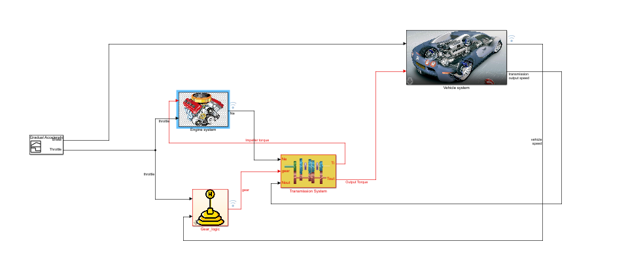

There are five major blocks in this model.

1. Signal builder : It provides two inputs to the model, that are brake and throttle.
2. Engine system :It calculates engine RPM based on impeller torque value and throttle.
3. GearLogic system :It calculates next gear based on current gear, throttle, and current vehicle speed.
4. Transmission system : It calculates impeller and output torque based on RPM, gear and transmission speed.
5. Vehicle system : It calculates vehicle and transmission speed based on output torque and brake.

**Gear Logic system description**

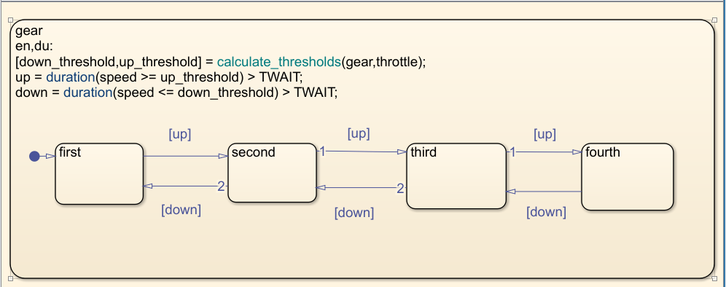

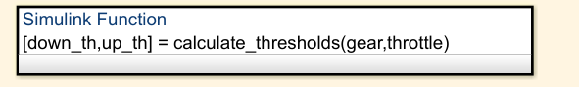

**Symbol pane:**

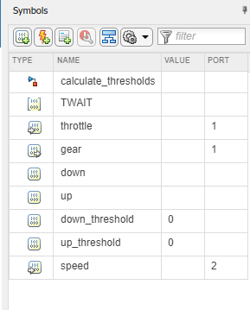

The Stateflow chart models the shifting of gears based on throttle and speed of the vehicle. The down_threshold and up_threshold outputs represent minimum and maximum speed values that throttle and current gear are able to handle. The Simulink function calculate_thresholds calculates these two values using throttle and gear as inputs. If the actual speed is higher than up_threshold for longer than TWAIT, then the chart transitions to higher gear. Conversely, if the actual speed is lower than down_threshold for longer than TWAIT, then the chart transitions to a lower gear. At each time step, the chart calls the duration operator to find the amount of time for which speed is higher than up_threshold. If this time exceeds TWAIT then boolean variable up is set which in turn transitions chart from current gear to a higher gear. Conversely the chart transitions to a lower gear based on the value of down_threshold.

Active State Data is the enumerated data that represents the current active state during simulation. In this chart, the output data gear maintains the current active state which in turn represents the current gear. This data automatically updates when a transition is taken. The data is used by downstream blocks as well as by the Simulink function calculate_thresholds.

**Simulated output**

**Gear Logic scope output**

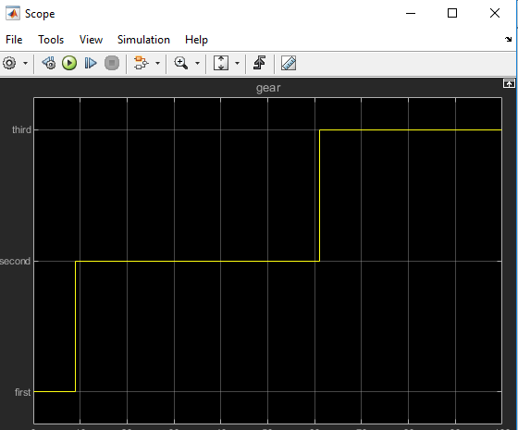

**Data Inspector output**

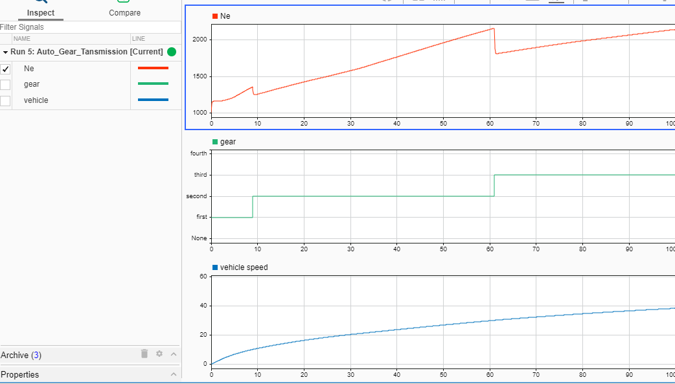

1. **Callbacks: Preload function**

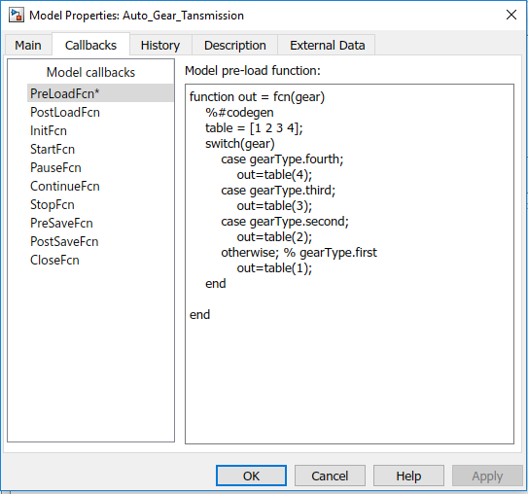

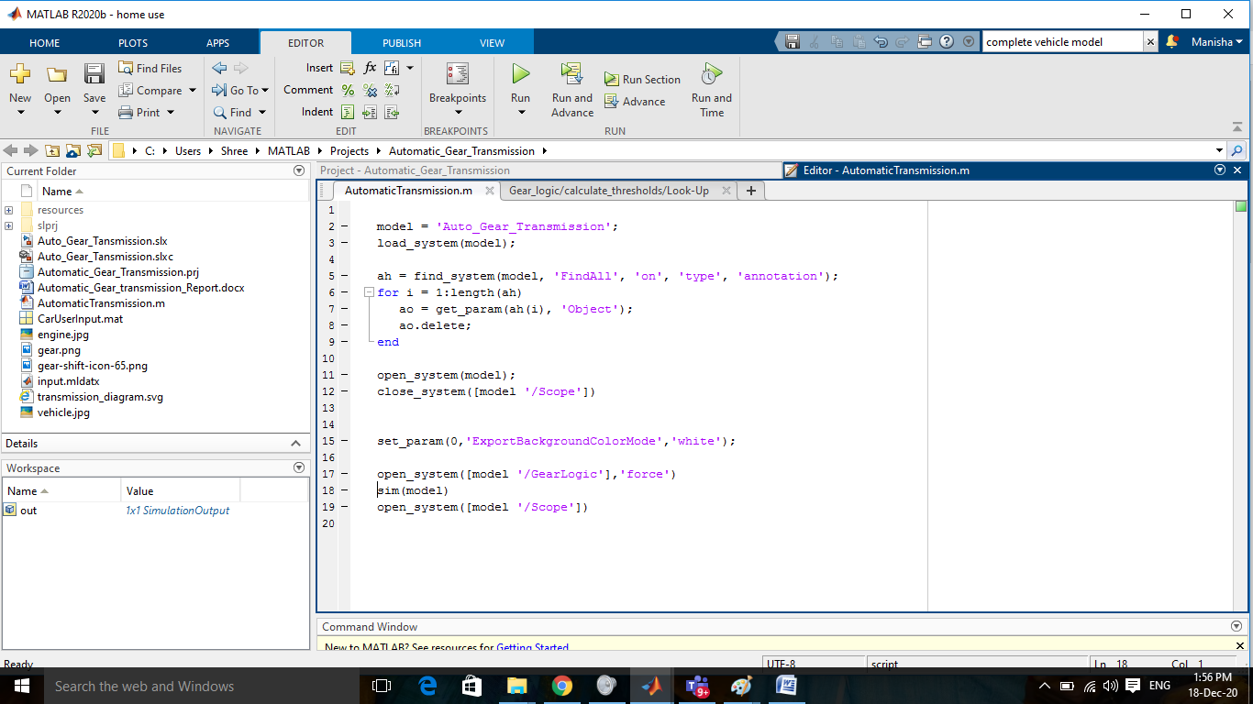

1. Data Inspector



1. Solver selection strategy : Fixed step ode5 (Dormand_Prince) Solver is slected with auto step size.

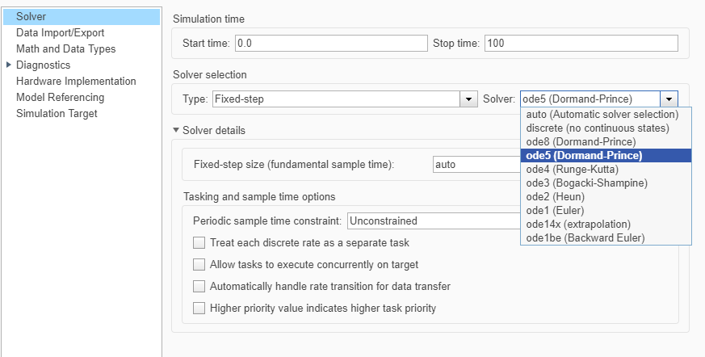

1. MATLAB function block

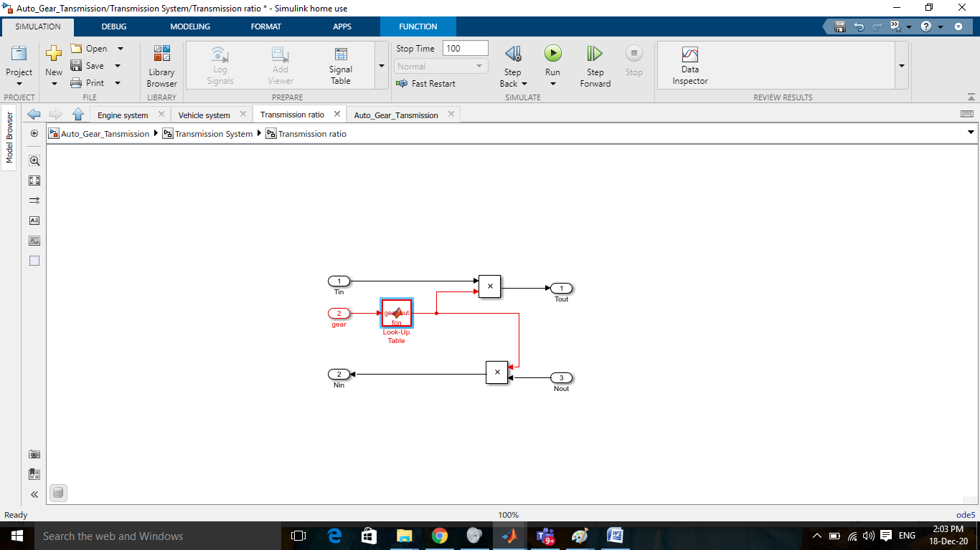

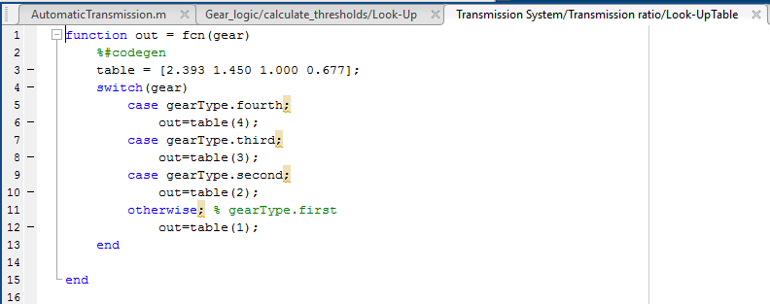

1. Look-up table

1-D look up table used for torque converter

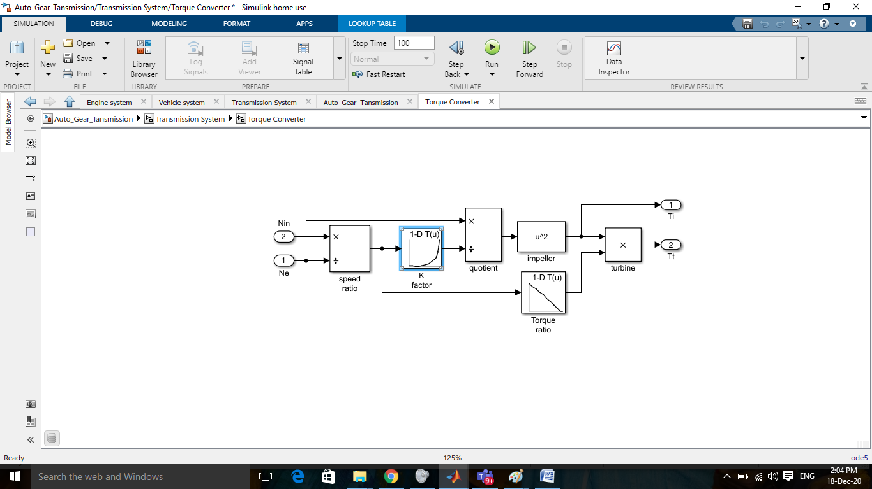

2-D look up table is used for engine torque.

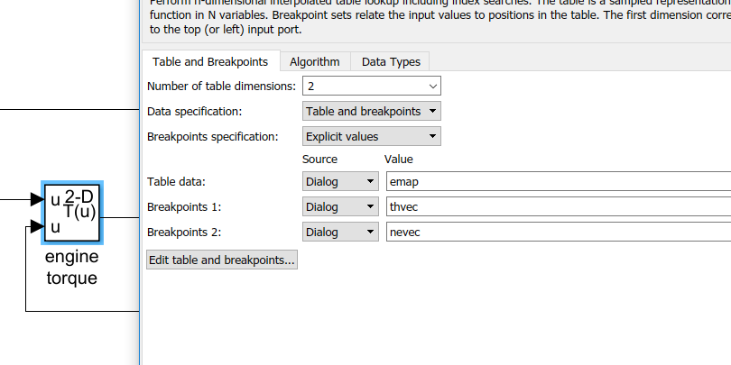

1. Signal Builder to generate test signals : Imported input sigal from mat file.

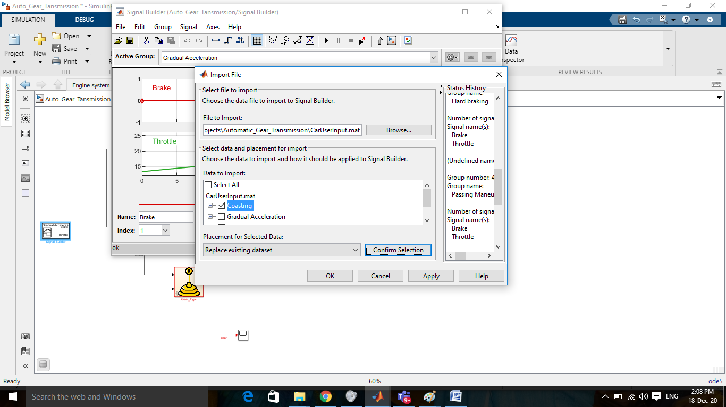

Signal builder input :1)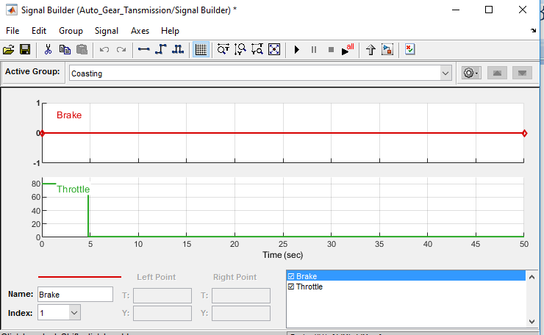

Output:

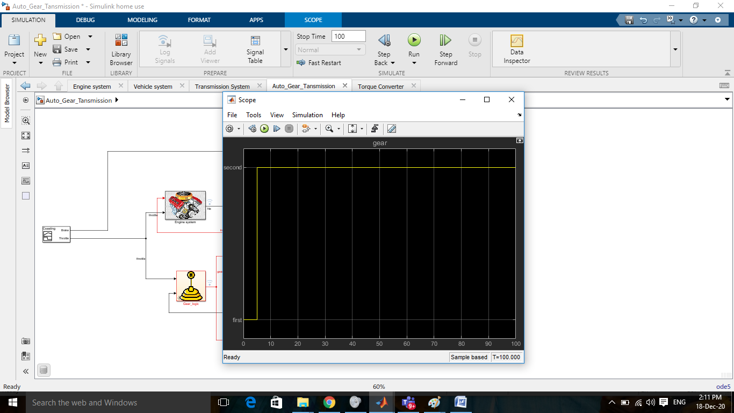

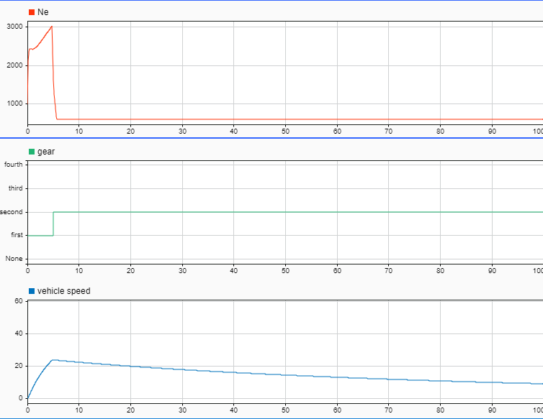

2) Input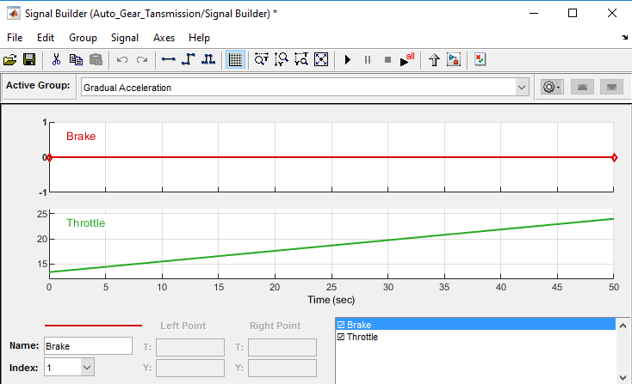

Output:

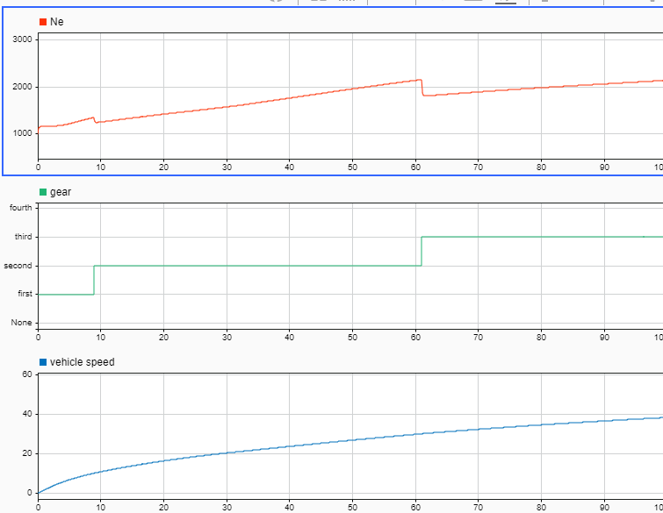

3)Input

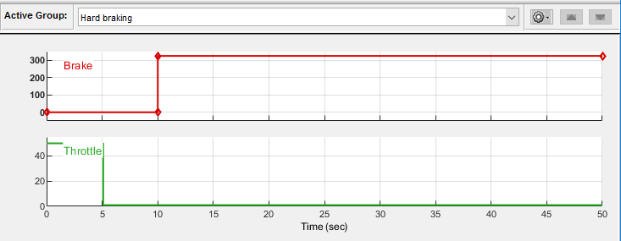

Output:

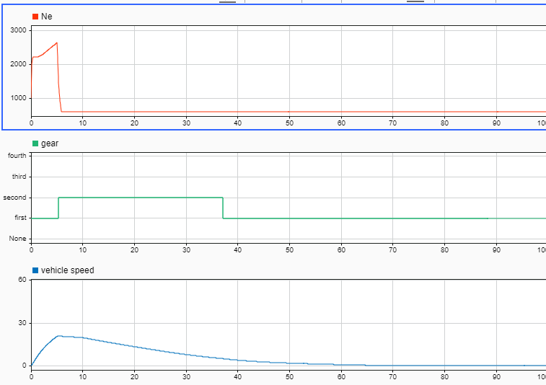

4)Input:

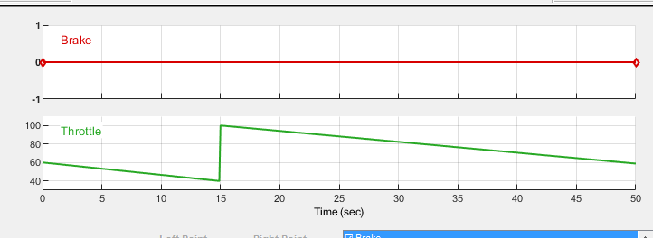

Output:

