Yes, it is possible to do method overloading with functions having the same return type.
NOTE:
But, it is necessary to have different number of arguments in each of the functions.
EXAMPLE:
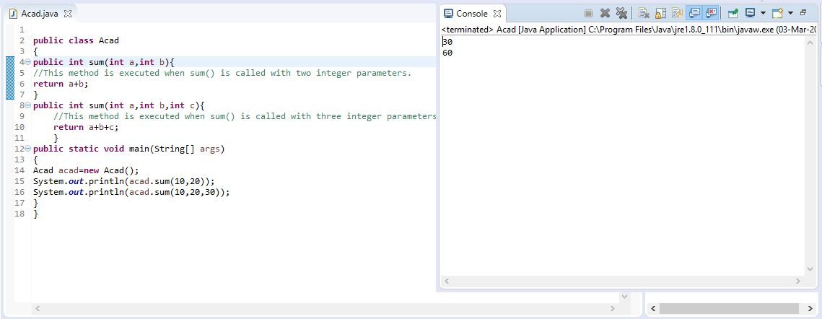

Here, I have two methods with the same name “sum”. However, it has different number of parameters.
The first sum method is called when sum() is called with two integer parameters. And the second sum method is called when sum() method is called with three integer parameters.
It is necessary to note that both the methods has the same return type “int”.

