MMM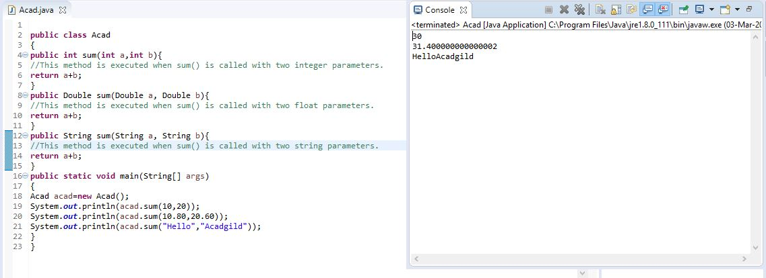
Method Overloading
Method Overloading is one of the Object Oriented Programming Concepts in java.
Method Overloading enables the user to have multiple functions with the same function name. However, each of the functions have different parameters.
Suppose you have to perform addition of the given numbers but there can be any number of arguments, if you write the method such as a(int,int) for two parameters, and b(int,int,int) for three parameters then it may be difficult for you as well as other programmers to understand the behaviour of the method because its name differs.
So, we perform method overloading to figure out the program quickly.

Advantage of method overloading
Method overloading increases the readability of the program.

Different ways to overload the method
There are two ways to overload the method in java
- By changing number of arguments
- By changing the data type

Here, we have 3 functions with the same name “sum”.
The first sum function has 2 parameters of int type and has its return type as int.
The second sum function has 2 parameters of Double type and has its return type as Double.
The third sum function has 2 parameters of String type and has its return type as String.
In the main() method, an object is created for the class “Acad”.
First time, sum() method is called with 2 integer parameters. Hence, the first sum() function is called and executed.
In line 20, sum() method is called with 2 Double parameters. Hence, the second sum() function is called that has two Double values as parameters in function definition and the Double value is returned.
Similarly , it happens for the string parameters.
Thus, method overloading is implemented

