Enterprise Identity Security Platform Design Document

Integrated Zero-Trust IAM, Non-Human Identity Governance, and Identity Threat Detection

1. Project Title & Version Control

Project Title
Enterprise Identity Security Platform (EISP)
A Zero-Trust IAM Architecture with Automated Identity Lifecycle, Machine Identity Governance, and Identity Threat Detection.

Version Control
Version: 1.0 – Draft
Date: 03/10/2026
Author: Manisha Gupta

Change Log
Version | Date | Description | Author
1.0 | 03/10/2026 | Initial Design Document | Manisha Gupta

2. Project Summary
The Enterprise Identity Security Platform (EISP) is a cloud-based identity and access management system designed to implement Zero Trust identity security architecture for modern organizations.
The platform integrates identity lifecycle management, role-based access control, cloud IAM, non-human identity governance, and identity threat detection into a unified automated system.
This project simulates a real-world enterprise environment where employees, applications, and services require secure access to multiple systems such as cloud infrastructure, internal applications, and SaaS platforms. The system automates user provisioning, enforces least privilege access, secures machine identities, and monitors identity activity to detect potential security threats.
The goal of this project is to design and implement an industry-standard identity security platform aligned with modern IAM practices used in cloud-native environments in 2026.

3. Problem Statement / Use Case
Modern organizations face increasing security risks due to the rapid growth of digital identities. These identities include both human users (employees, contractors) and non-human identities (service accounts, API tokens, applications).
Traditional security models relied on network-based trust, where users inside a corporate network were automatically trusted. However, with the adoption of cloud computing, remote work, and SaaS applications, this model is no longer secure.
Organizations now require an identity-centric security model, where identity becomes the primary security perimeter.
Several critical challenges exist:

Challenge 1 — Manual Identity Provisioning
Many organizations still rely on manual processes to create user accounts and assign permissions. This approach leads to:
- slow onboarding
- inconsistent access control
- increased risk of human error

Challenge 2 — Privilege Creep
Employees often accumulate unnecessary access over time due to role changes, resulting in excessive privileges that increase security risk.

Challenge 3 — Unsecured Machine Identities
Applications and services use credentials such as:
- API keys
- service accounts
- database passwords
These credentials are often stored insecurely, making them a common attack target.

Challenge 4 — Identity-Based Cyber Attacks
Most modern cyberattacks now focus on identity compromise, including:
- credential theft
- privilege escalation
- unauthorized access
Organizations must be able to detect identity threats quickly and respond automatically.

Solution
This project implements a Zero Trust identity platform that addresses these challenges through:
- automated identity lifecycle management
- centralized identity provider
- role-based access control
- machine identity governance
- automated threat detection

4. Goals and Objectives
The primary objective of this project is to design and implement a modern IAM architecture capable of securely managing identities across multiple systems.

Goal 1 — Implement Automated Identity Lifecycle Management
The system must automate the entire identity lifecycle, including:
- user provisioning
- role assignment
- access revocation
This automation should respond to events such as employee onboarding, department changes, and employee termination.

Goal 2 — Enforce Zero Trust Access Control
The system must implement Zero Trust security principles, ensuring that access decisions are based on identity verification, device trust, and contextual policies.
The platform must support:
- Single Sign-On
- multi-factor authentication
- passwordless authentication
- conditional access policies

Goal 3 — Secure Non-Human Identities
The system must implement governance for machine identities by securing service credentials and automating secret management.
This includes:
- secure storage of credentials
- automatic credential rotation
- dynamic secret generation

Goal 4 — Implement Identity Threat Detection and Response
The system must monitor identity activity and detect potential security threats such as:
- suspicious login behavior
- privilege escalation
- brute force login attempts
The platform must also support automated response mechanisms such as disabling compromised accounts.

5. Key Features / Functions
The Enterprise Identity Security Platform will include the following major features.

Feature 1 — Identity Provider Integration
The platform will integrate with a centralized identity provider such as:
- Microsoft Entra ID
or
- Okta
This identity provider will serve as the primary authentication system for all users and applications.

Feature 2 — Single Sign-On (SSO)
Users will authenticate once and gain access to multiple connected systems without re-entering credentials.
Supported authentication protocols include:
- SAML
- OAuth 2.0
- OpenID Connect

Feature 3 — Role-Based Access Control (RBAC)
Users will be assigned access permissions based on their job roles.
Example roles include:
Role | Access
Developer | EC2 and S3 access
Data Analyst | Read access to analytics systems
Security Admin | IAM management permissions

Feature 4 — Passwordless Authentication
The system will support passwordless authentication methods such as:
- FIDO2 security keys
- biometric authentication
- passkeys
Optional hardware authentication can be implemented using:
- YubiKey

Feature 5 — Automated Identity Lifecycle Management
User accounts will be automatically created, updated, or disabled based on changes in HR data.
Supported scenarios include:
- Joiner (new employee onboarding)
- Mover (department change)
- Leaver (employee termination)

Feature 6 — Non-Human Identity Governance
Machine identities such as API tokens and service credentials will be managed securely using:
- HashiCorp Vault
Vault will provide:
- secret storage
- credential rotation
- dynamic credential generation

Feature 7 — Identity Threat Detection
The platform will monitor identity logs and detect suspicious activity using security analytics tools such as:
- Microsoft Defender for Identity
- CrowdStrike Falcon

Feature 8 — Infrastructure as Code
Identity infrastructure will be deployed using:
- Terraform
This allows the IAM environment to be:
- version controlled
- automated
- reproducible

6. Tech Stack and Tools
The following technologies will be used to implement the system.

Programming Language
Python
Used for:
- automation scripts
- API integration
- security monitoring

Cloud Platform
- Amazon Web Services
Used for:
- cloud infrastructure
- IAM policies
- logging

Identity Platform
- Microsoft Entra ID or Okta

Infrastructure Automation
- Terraform

Secrets Management
- HashiCorp Vault

Security Monitoring
- Microsoft Defender for Identity

7. Architecture / Workflow Diagram
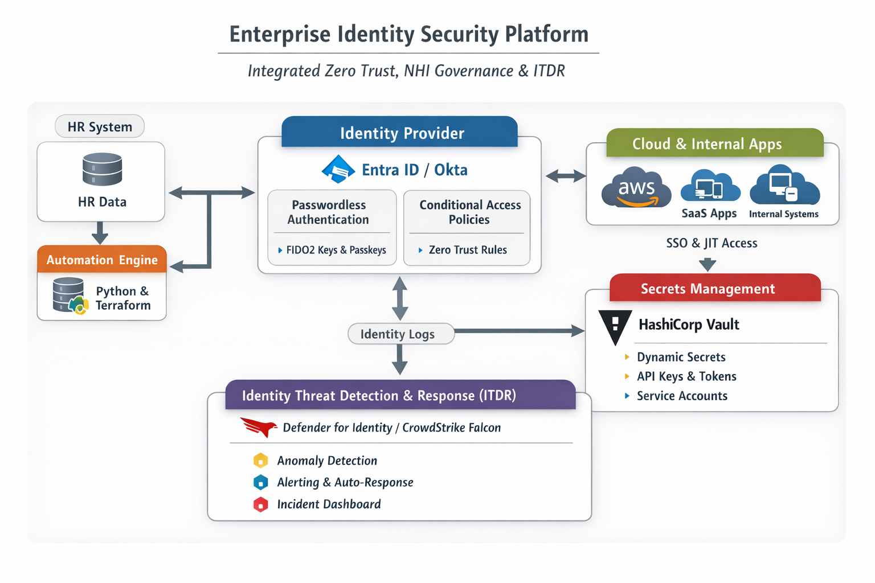

8. Timeline / Weekly Milestones

Month 1 — Identity Foundation
Week 1
Project planning and architecture design
Week 2
Identity provider setup and SSO integration
Week 3
RBAC model design and implementation
Week 4
AWS IAM integration

Month 2 — Identity Governance
Week 5
Automated user provisioning
Week 6
Lifecycle management implementation
Week 7
Secrets management implementation
Week 8
Credential rotation automation

Month 3 — Identity Security
Week 9
Identity log collection
Week 10
Threat detection rules
Week 11
Automated security response
Week 12
System testing and documentation

9. Risks and Risk Mitigation
Risk | Mitigation
Complex IAM configuration | Follow structured architecture
Limited access to enterprise tools | Use open-source alternatives
Integration complexity | Implement modules incrementally
Security misconfiguration | Follow least privilege principles

10. Evaluation Criteria
Success will be measured using the following criteria.
- Automated user lifecycle provisioning works correctly.
- RBAC permissions enforce least privilege access.
- Passwordless authentication successfully replaces password login.
- Machine identities are secured through Vault.
- Threat detection rules identify suspicious identity activity.

11. Future Considerations
Future enhancements may include:

Identity Governance Administration
Access certification workflows for periodic access reviews.

AI-Driven Identity Analytics
Using machine learning to detect abnormal user behavior.

Integration with additional SaaS applications
Such as:
- GitHub
- Slack
- Salesforce

Multi-Cloud IAM Integration
Support for multiple cloud providers beyond AWS.

