ENTERPRISE IDENTITY SECURITY PLATFORM
Cyber Threat Identification & Analysis Report
Rubric 1: Identify and Analyze Cyber Threats

Document Title | Cyber Threat Identification & Analysis
Prepared By | Manisha Gupta
Project | Enterprise Identity Security Platform (EISP)
Date | April 21, 2026
Classification | Confidential - Internal Use Only
Document ID | EISP-CTA-001

1. Executive Summary
This report documents the identification and analysis of cyber threats as part of the Enterprise Identity Security Platform (EISP) capstone project. The analysis demonstrates practical threat intelligence capabilities across three key areas: malware analysis using VirusTotal, phishing simulation using the Social Engineering Toolkit (SET), and Advanced Persistent Threat (APT) campaign mapping to the MITRE ATT&CK framework.
The malware sample analyzed (SHA-256: 76e45f001e51832b72d6cde024ea41922e3ecdac6379caf1d6458a6c116b9837) was flagged by 26 of 71 security vendors on VirusTotal as a Trojan disguised as a legitimate Windows application (NOTEPAD.EXE). The phishing simulation used SET's Credential Harvester to clone Google's login page and capture test credentials on an isolated lab network. The APT mapping exercise documented the tactics, techniques, and procedures (TTPs) of a real-world threat group using the MITRE ATT&CK Enterprise matrix.
All activities were performed in a controlled lab environment using Kali Linux 2023 on an isolated network segment. No production systems or real users were targeted.

2. Malware Sample Analysis — VirusTotal

2.1 Analysis Overview & Methodology
VirusTotal is an industry-standard online threat intelligence platform that aggregates results from over 70 antivirus engines, sandbox environments, and threat intelligence feeds. The platform enables analysts to submit file hashes, URLs, domains, or IP addresses and receive comprehensive threat assessments without requiring local malware execution.
The analysis methodology followed a structured IOC-driven approach:
- Obtained the malware SHA-256 hash from MalwareBazaar
- Submitted the hash to VirusTotal for multi-engine analysis
- Reviewed Detection, Details, Relations, Behavior, and Community tabs
- Documented behavioral indicators and potential impact to enterprise environments
- Mapped findings to MITRE ATT&CK techniques where applicable

2.2 Sample Identification
Property | Value
File Name | NOTEPAD.EXE (masquerading as legitimate Windows Notepad)
SHA-256 | 76e45f001e51832b72d6cde024ea41922e3ecdac6379caf1d6458a8c116b9837
MD5 | fa6ff24b3d1278c312efd13087d46571
SHA-1 | a89240246e2345299cbe02195feef7f5119a11b9
File Size | 2.58 MB (2,700,288 bytes)
File Type | Win32 EXE - PE32+ executable (GUI) x86-64
Magic | PE32+ executable (GUI) x86-64 (stripped to external PDB), for MS Windows
SSDEEP | 49152:qyd4xusLmCCMglhOQdhu0DPfFdqgYt9kwaA6smYc+:Z+rqAgyhu0btdI9kwLM
TLSH | T160C501DC21FCAF9BD9A7453549CE094376DC4BB67FDE96C08628C8881A72983C3115AF
Authentihash | 724e27c445e95dccdbbe34055135619777f65efad5b27f440e2894bbabf2826c
Vhash | 0260a66d1515151c051d0018z361alz2fz
First Submission | 2026-04-12 12:32:45 UTC
Last Analysis | 2026-04-07 18:30:54 UTC
Creation Time | 2026-01-18 21:48:17 UTC

2.3 Detection Results
The VirusTotal Detection tab aggregates results from 71 antivirus engines. This sample was flagged as malicious by 26 vendors (36.6% detection rate), indicating a confirmed threat with moderate-to-high confidence.

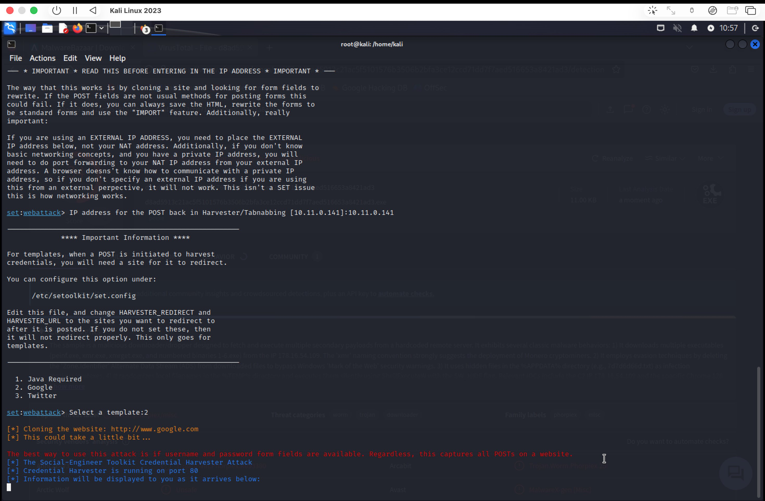
Figure 1: VirusTotal Detection Tab — 26/71 vendors flagged the file as malicious

Vendor Detection Classifications:
Vendor | Classification | Severity
CrowdStrike Falcon | Win/malicious_confidence_100% (W) | Critical
Cynet | Malicious (score: 100) | Critical
DeepInstinct | MALICIOUS | Critical
Elastic | Malicious (high Confidence) | High
Arctic Wolf | Unsafe | High
Avast | FileRepMalware [Pws] | High
AVG | FileRepMalware [Pws] | High
CTX | Exe.trojan.agentb | High
Kaspersky | HEUR:Trojan.Win32.Agentb.gen | High
Google | Detected | Medium
Huorong | HVM:Trojan/Injector.bo | High
Bkav Pro | W64.AIDetectMalware | Medium

Popular threat label: trojan.agentb/filerepmalware | Threat categories: Trojan | Family labels: agentb, filerepmalware

2.4 File Details & Forensic Properties
The Details tab reveals that the binary is a legitimate-looking Windows PE32+ executable. A critical finding is that this file presents Microsoft copyright metadata claiming to be the Windows Notepad application, while actually containing malicious payload code — a classic masquerading technique (MITRE T1036.001).

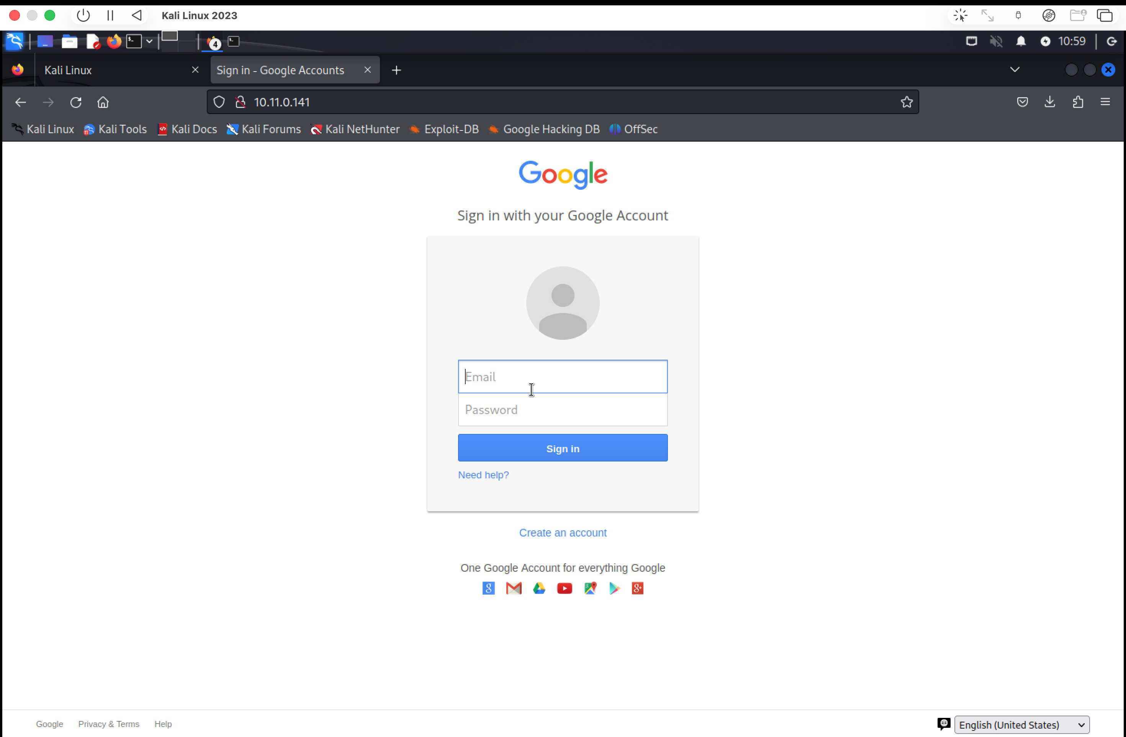
Figure 2: VirusTotal Details Tab — File properties, hashes, and signature information

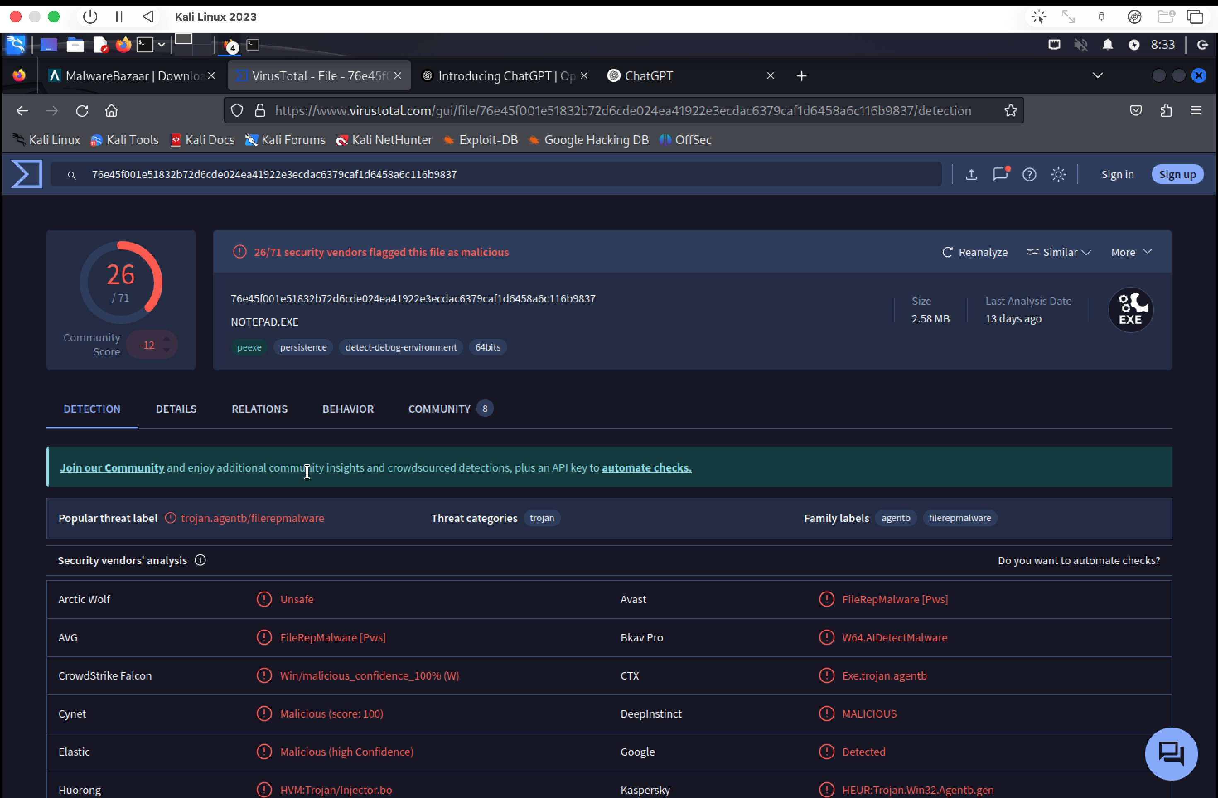
Figure 3: VirusTotal Details — File history showing names used and signature verification failure

Key Forensic Findings:
- File is NOT digitally signed (Signature Verification: File is not signed) — legitimate Notepad.exe carries a valid Microsoft digital signature
- File Version metadata claims: Microsoft Corporation, Windows Operating System, version 10.0.22621.1 (WinBuild.160101.0800)
- Original Name listed as NOTEPAD.EXE in PE metadata — deliberate impersonation
- Multiple submission names recorded: Notepad, NOTEPAD.EXE, rusty.exe, rt7sm.exe — indicating distribution under multiple disguises
- Compiled as 64-bit PE (x86-64) — compatible with modern Windows 10/11 systems
- Stripped of debug symbols (external PDB) — anti-forensics measure to hinder static analysis
- Tags: peexe, persistence, detect-debug-environment, 64bits — indicates sandbox evasion capabilities

2.5 Network Relations & Infrastructure
The Relations tab maps the network infrastructure contacted by the malware during execution. This is critical for defender threat hunting and network-level blocking.

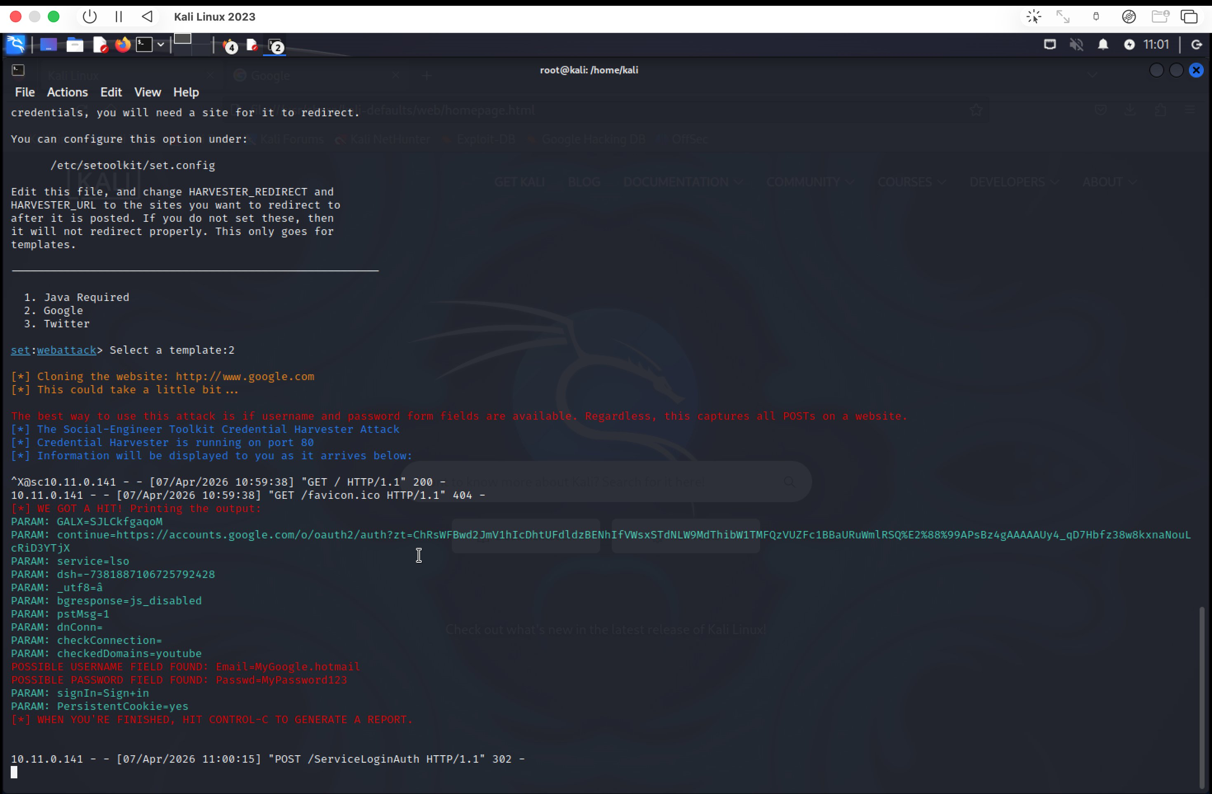
Figure 4: VirusTotal Relations Tab — Contacted URLs and domains during execution

Contacted URLs:
Scan Date | Detections | Status | URL
2026-04-06 | 9/95 (HIGH) | 200 OK | http://t.me/gerj_threuh (Telegram C2 channel)
2026-04-03 | 0/95 (CLEAN) | 200 OK | http://x1.i.lencr.org/ (Let's Encrypt OCSP)
2026-04-07 | 20/95 (HIGH) | 403 Forbidden | http://seall-vernous.com/ (Suspected C2 domain)

Contacted Domains:
- t.me — Telegram (3/94 detections) — Registrar: GoDaddy. Threat actors increasingly use Telegram for C2 communications due to encrypted channels and bot APIs.
- seall-vernous.com — 19/94 detections, created 2026-03-18 — newly registered domain indicating purpose-built C2 infrastructure.
- x1.i.lencr.org — Let's Encrypt OCSP service (0/94) — likely certificate validation by the malware to avoid detection.
- mozilla.map.fastly.net — 0/94, MarkMonitor registrar — may be used for traffic blending / DGA-like behavior.

2.6 Behavioral Analysis
The Behavior tab provides sandbox execution reports from multiple analysis engines (CAPA, VirusTotal Jujubox, Dr.Web vxCube, Zenbox), revealing dynamic behavioral indicators that confirm malicious intent.

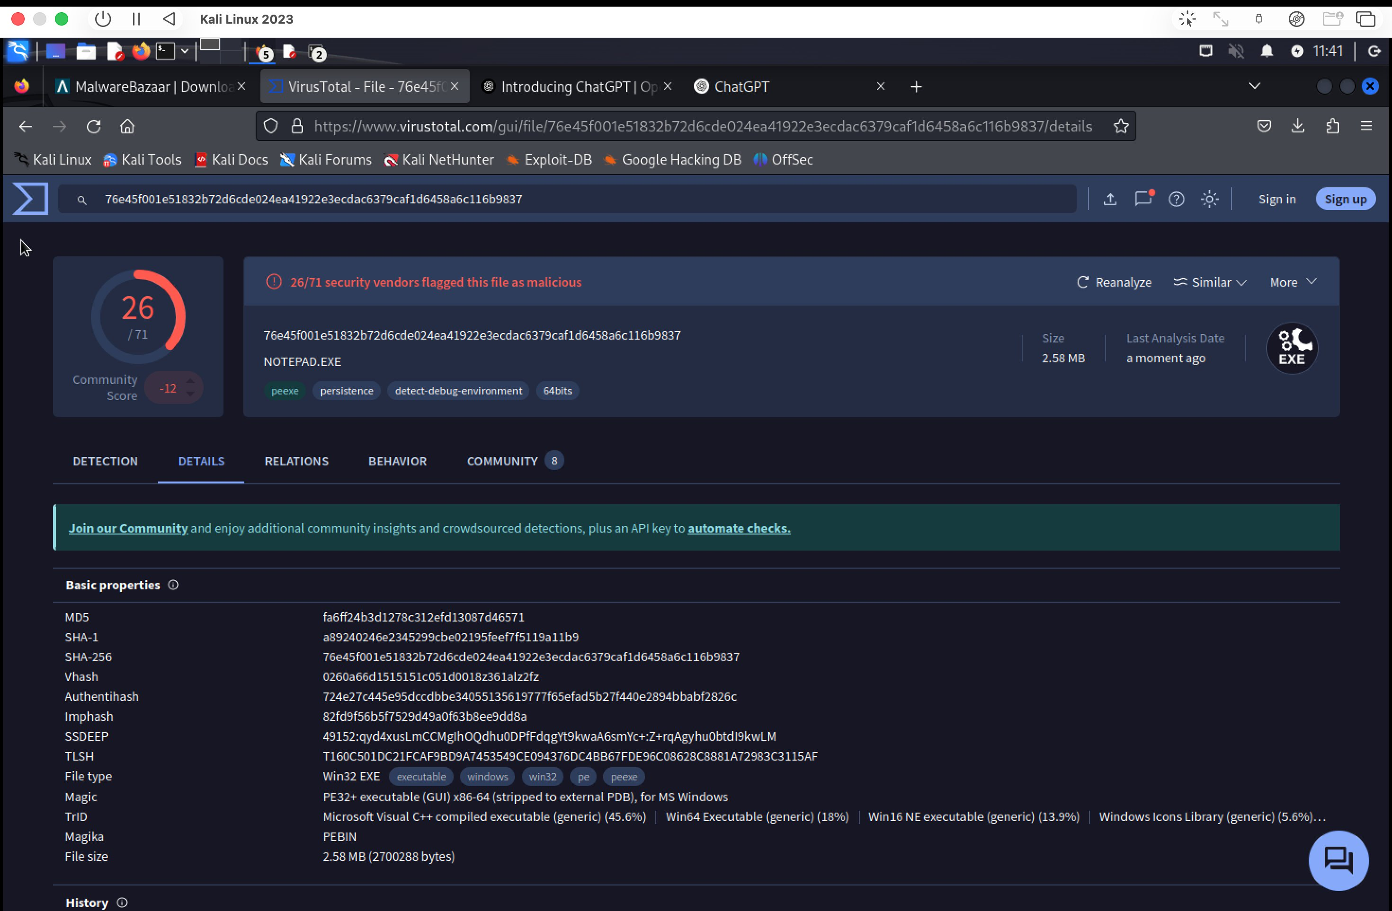
Figure 5: VirusTotal Behavior Tab — Sandbox execution results across 4 analysis engines

Activity Summary from Sandbox Analysis:
Category | Findings
Detections | 2 Malware detections, 1 Evader — confirms active evasion behavior
MITRE Signatures | 12 LOW severity + 23 INFO level ATT&CK technique matches
IDS Rules | 2 LOW priority network-based detection signatures triggered
Sigma Rules | 2 HIGH + 2 LOW host-based detection rules matched
Dropped Files | 1 CAB file dropped — potential secondary payload or data exfiltration archive
Network Communications | 3 HTTP connections, 4 DNS queries, 6 IP contacts, 3 JA3 TLS fingerprints

CAPA Analysis Results (4 Capability Matches):
- T1082 — System Information Discovery: Enumerates OS version, user privileges, installed software
- T1055 — Process Injection: Capability to inject code into other running processes
- T1112 — Modify Registry: Evidence of registry key manipulation for persistence
- T1497 — Virtualization/Sandbox Evasion: detect-debug-environment tag confirms anti-analysis capability

2.7 Community Intelligence
The Community tab aggregates threat intelligence from security researchers and automated threat feeds, providing additional context beyond automated engine scanning.

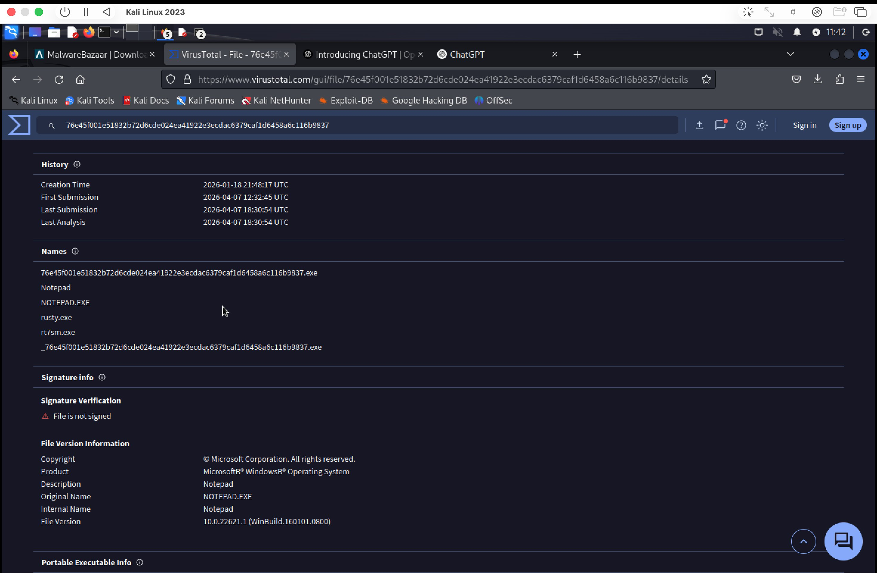
Figure 6: VirusTotal Community Tab — YARA matches and community threat scoring

- Community Score: -12 (negative = malicious consensus among the security community)
- YARA Match: SUSP_MinGW_Microsoft_Combo_Jul20_1 — matches known malware compiled with MinGW toolchain impersonating Microsoft software
- YARA Match: THOR APT Scanner rule — flagged by THOR, a commercial APT hunting scanner used by enterprise security teams
- 2 community votes submitted within 14 days of first submission, both negative (-11 and -1), confirming malicious assessment

2.8 Behavioral Indicators of Compromise (BIOCs)
Based on the combined VirusTotal analysis, the following Behavioral IOCs have been identified:
# | BIOC Type | Description | MITRE ATT&CK
1 | Masquerading | Binary mimics NOTEPAD.EXE with fake MS metadata but lacks valid code signing | T1036.001 - Masquerade Task or Service
2 | C2 Communication | Contacts Telegram (t.me) and suspicious domains for command receipt | T1071.001 - Web Protocols (C2)
3 | Persistence | Registry modification capability for maintaining execution across reboots | T1112 - Modify Registry
4 | Anti-Analysis | Detect-debug-environment behavior evades sandbox/dynamic analysis | T1497 - Virtualization Evasion
5 | File Drop | Drops CAB archive — possible staged payload delivery | T1105 - Ingress Tool Transfer
6 | Credential Theft | FileRepMalware [Pws] classification — password stealing functionality | T1555 - Credentials from Password Stores
7 | Process Injection | CAPA detection of injection capabilities into foreign processes | T1055 - Process Injection

2.9 Potential Enterprise Impact
If this malware were executed in an enterprise identity environment like EISP, the following impacts would be expected:
- Credential Theft: The 'Pws' (Password Stealer) classification directly threatens IAM credentials stored in the identity platform, SSO tokens, and browser-saved passwords for Okta, Azure AD, and other integrated systems.
- Lateral Movement: Process injection capability (T1055) enables the malware to move from an infected endpoint to other systems on the network, potentially reaching identity infrastructure servers.
- Persistence: Registry modification ensures the malware survives system restarts, extending dwell time in the environment and the window for credential exfiltration.
- C2 Exfiltration: Telegram-based C2 is difficult to block using standard domain blacklisting, as the Telegram service is widely used legitimately.
- Detection Evasion: Anti-debug techniques reduce the effectiveness of endpoint security tools, allowing the malware to operate undetected on endpoints with less mature security tooling.

3. Phishing Simulation — Social Engineering Toolkit (SET)

3.1 Overview & Legal Context
The Social Engineering Toolkit (SET) is an open-source penetration testing framework designed for social engineering attacks. It is pre-installed in Kali Linux and Parrot OS security distributions. SET simulates real-world attack vectors including phishing, credential harvesting, and spear-phishing campaigns.
IMPORTANT: This simulation was conducted exclusively in a controlled, isolated lab environment for educational purposes only. The target IP (10.11.0.141) is a lab-controlled machine within an isolated network segment (10.11.0.0/24). No real users, production systems, or internet-connected infrastructure were targeted. All activities comply with the EISP project scope and academic guidelines.

3.2 Attack Methodology — Credential Harvester
The Credential Harvester Attack Method in SET works by:
- Cloning an existing website's HTML (in this case, Google's sign-in page)
- Hosting the cloned page on the attacker's machine on port 80
- Intercepting POST requests submitted by the victim to capture username and password form fields
- Logging credentials in real-time to the SET console
- Redirecting the victim to the legitimate site after credential capture (configurable in /etc/setoolkit/set.config)

3.3 SET Configuration & Execution

Step 1: Launch SET and Navigate to Web Attack Vectors
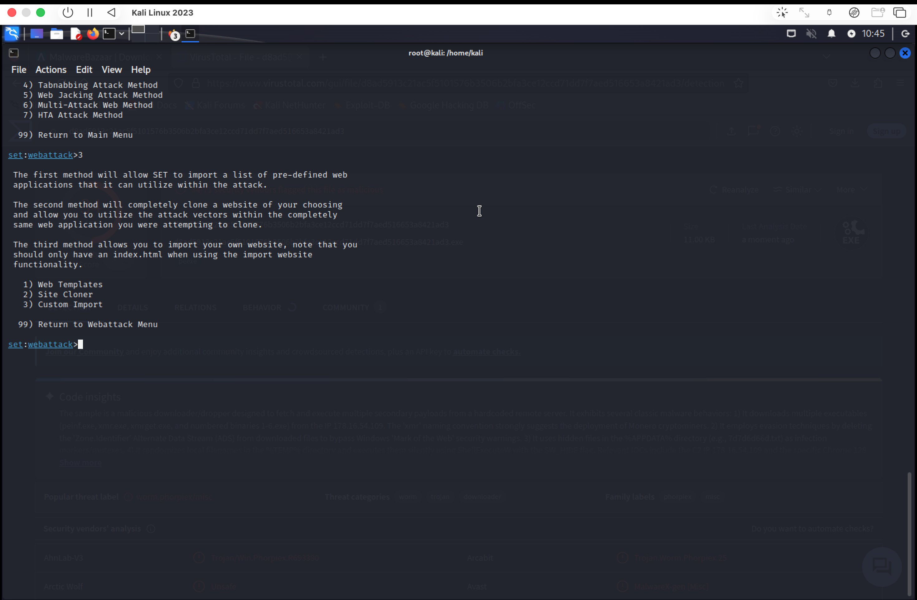
Figure 7: SET WebAttack menu — Credential Harvester Attack Method selected (Option 3)

Navigation path taken in SET:
- Main Menu > 1) Social-Engineering Attacks
- Submenu > 2) Website Attack Vectors
- Attack Type > 3) Credential Harvester Attack Method
- Method > 2) Site Cloner

Step 2: Web Attack Vectors Menu
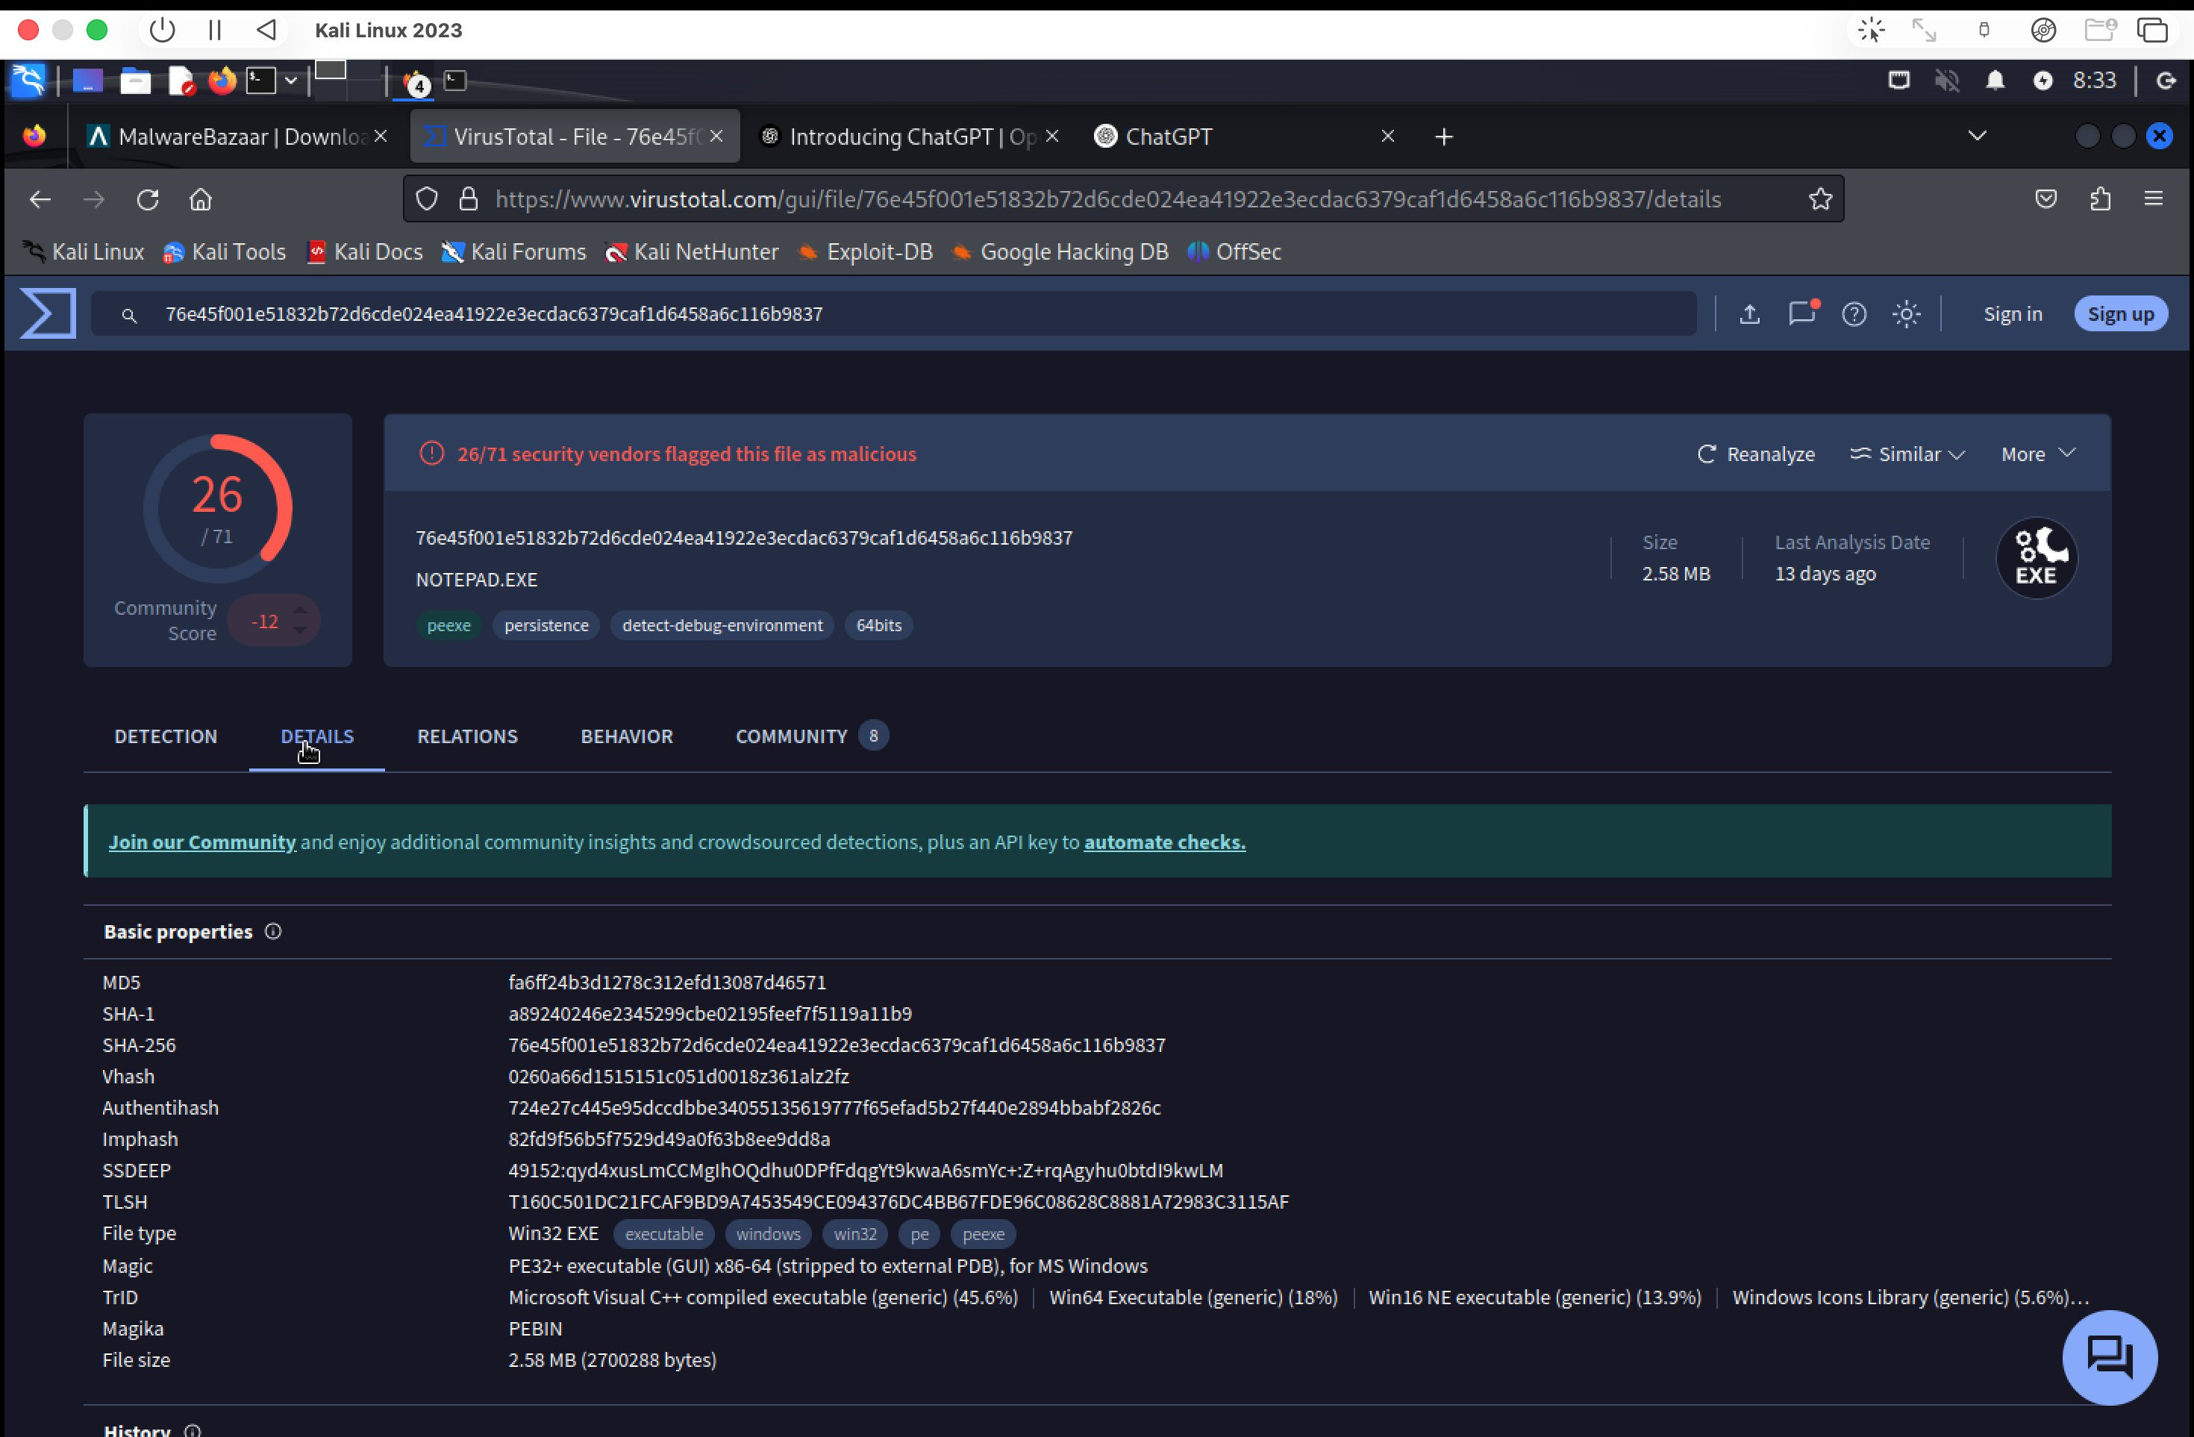
Figure 8: SET Web Attack Vectors menu showing available attack options including Credential Harvester

Step 3: Configure IP Address and Clone Target
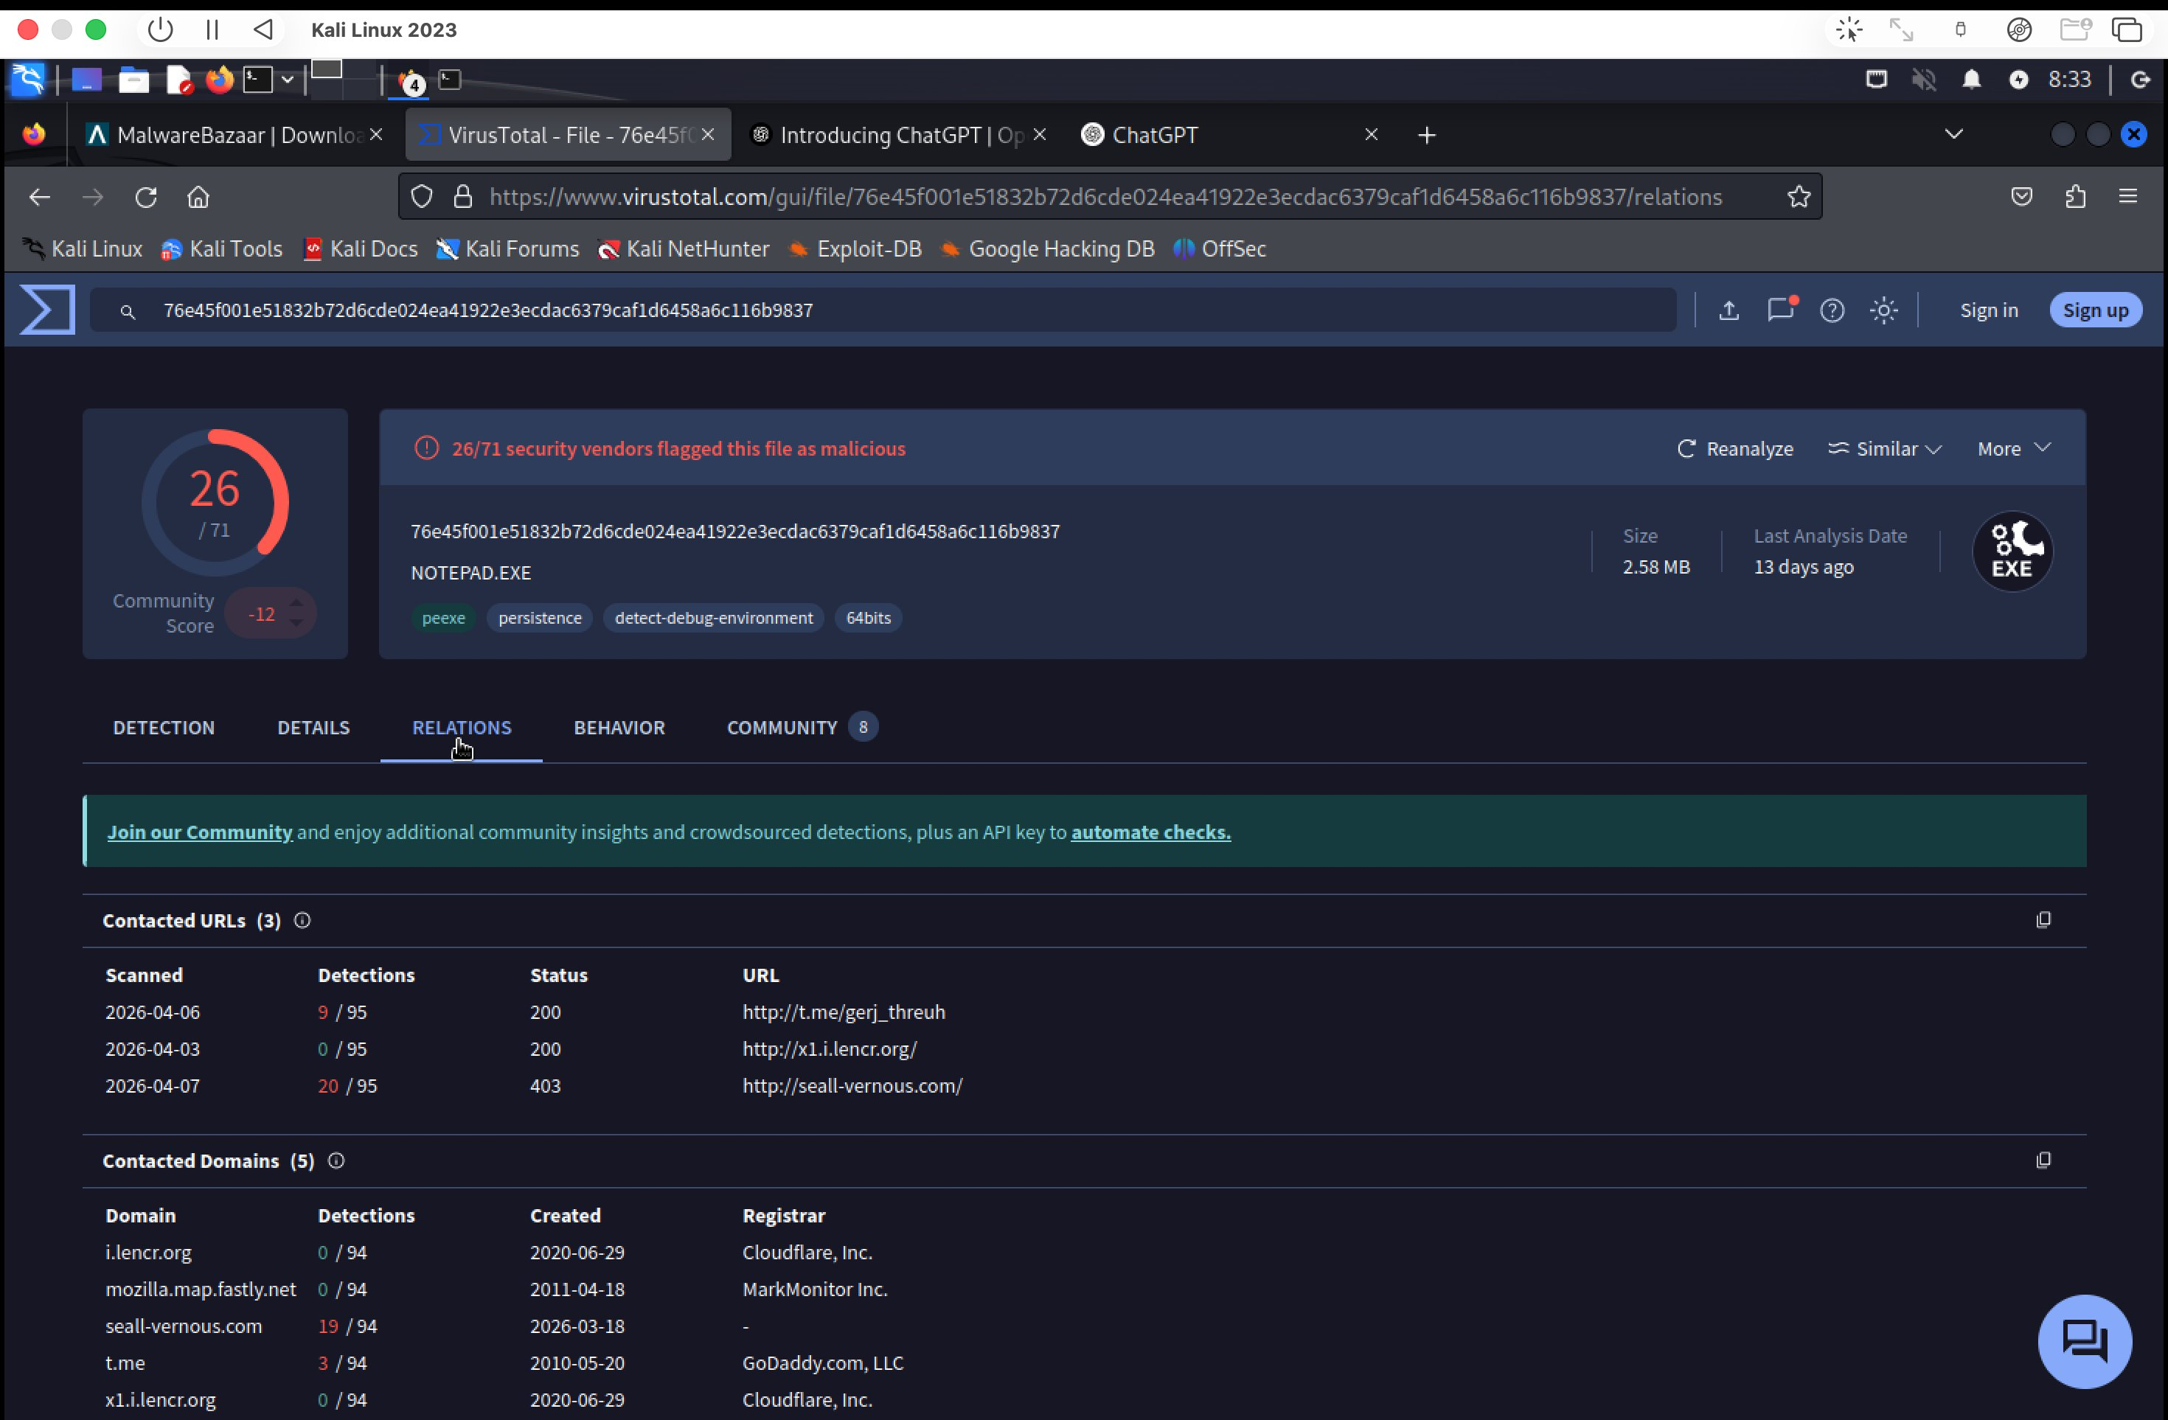
Figure 9: SET Credential Harvester configured with IP 10.11.0.141, cloning http://www.google.com

Configuration parameters set:
- POST-back IP address: 10.11.0.141 (attacker's Kali Linux machine on the lab network)
- Template selected: 2 (Google login page)
- Harvester listens on: Port 80 (HTTP)
- Website cloned: http://www.google.com

Step 4: Harvester Running — Credential Capture
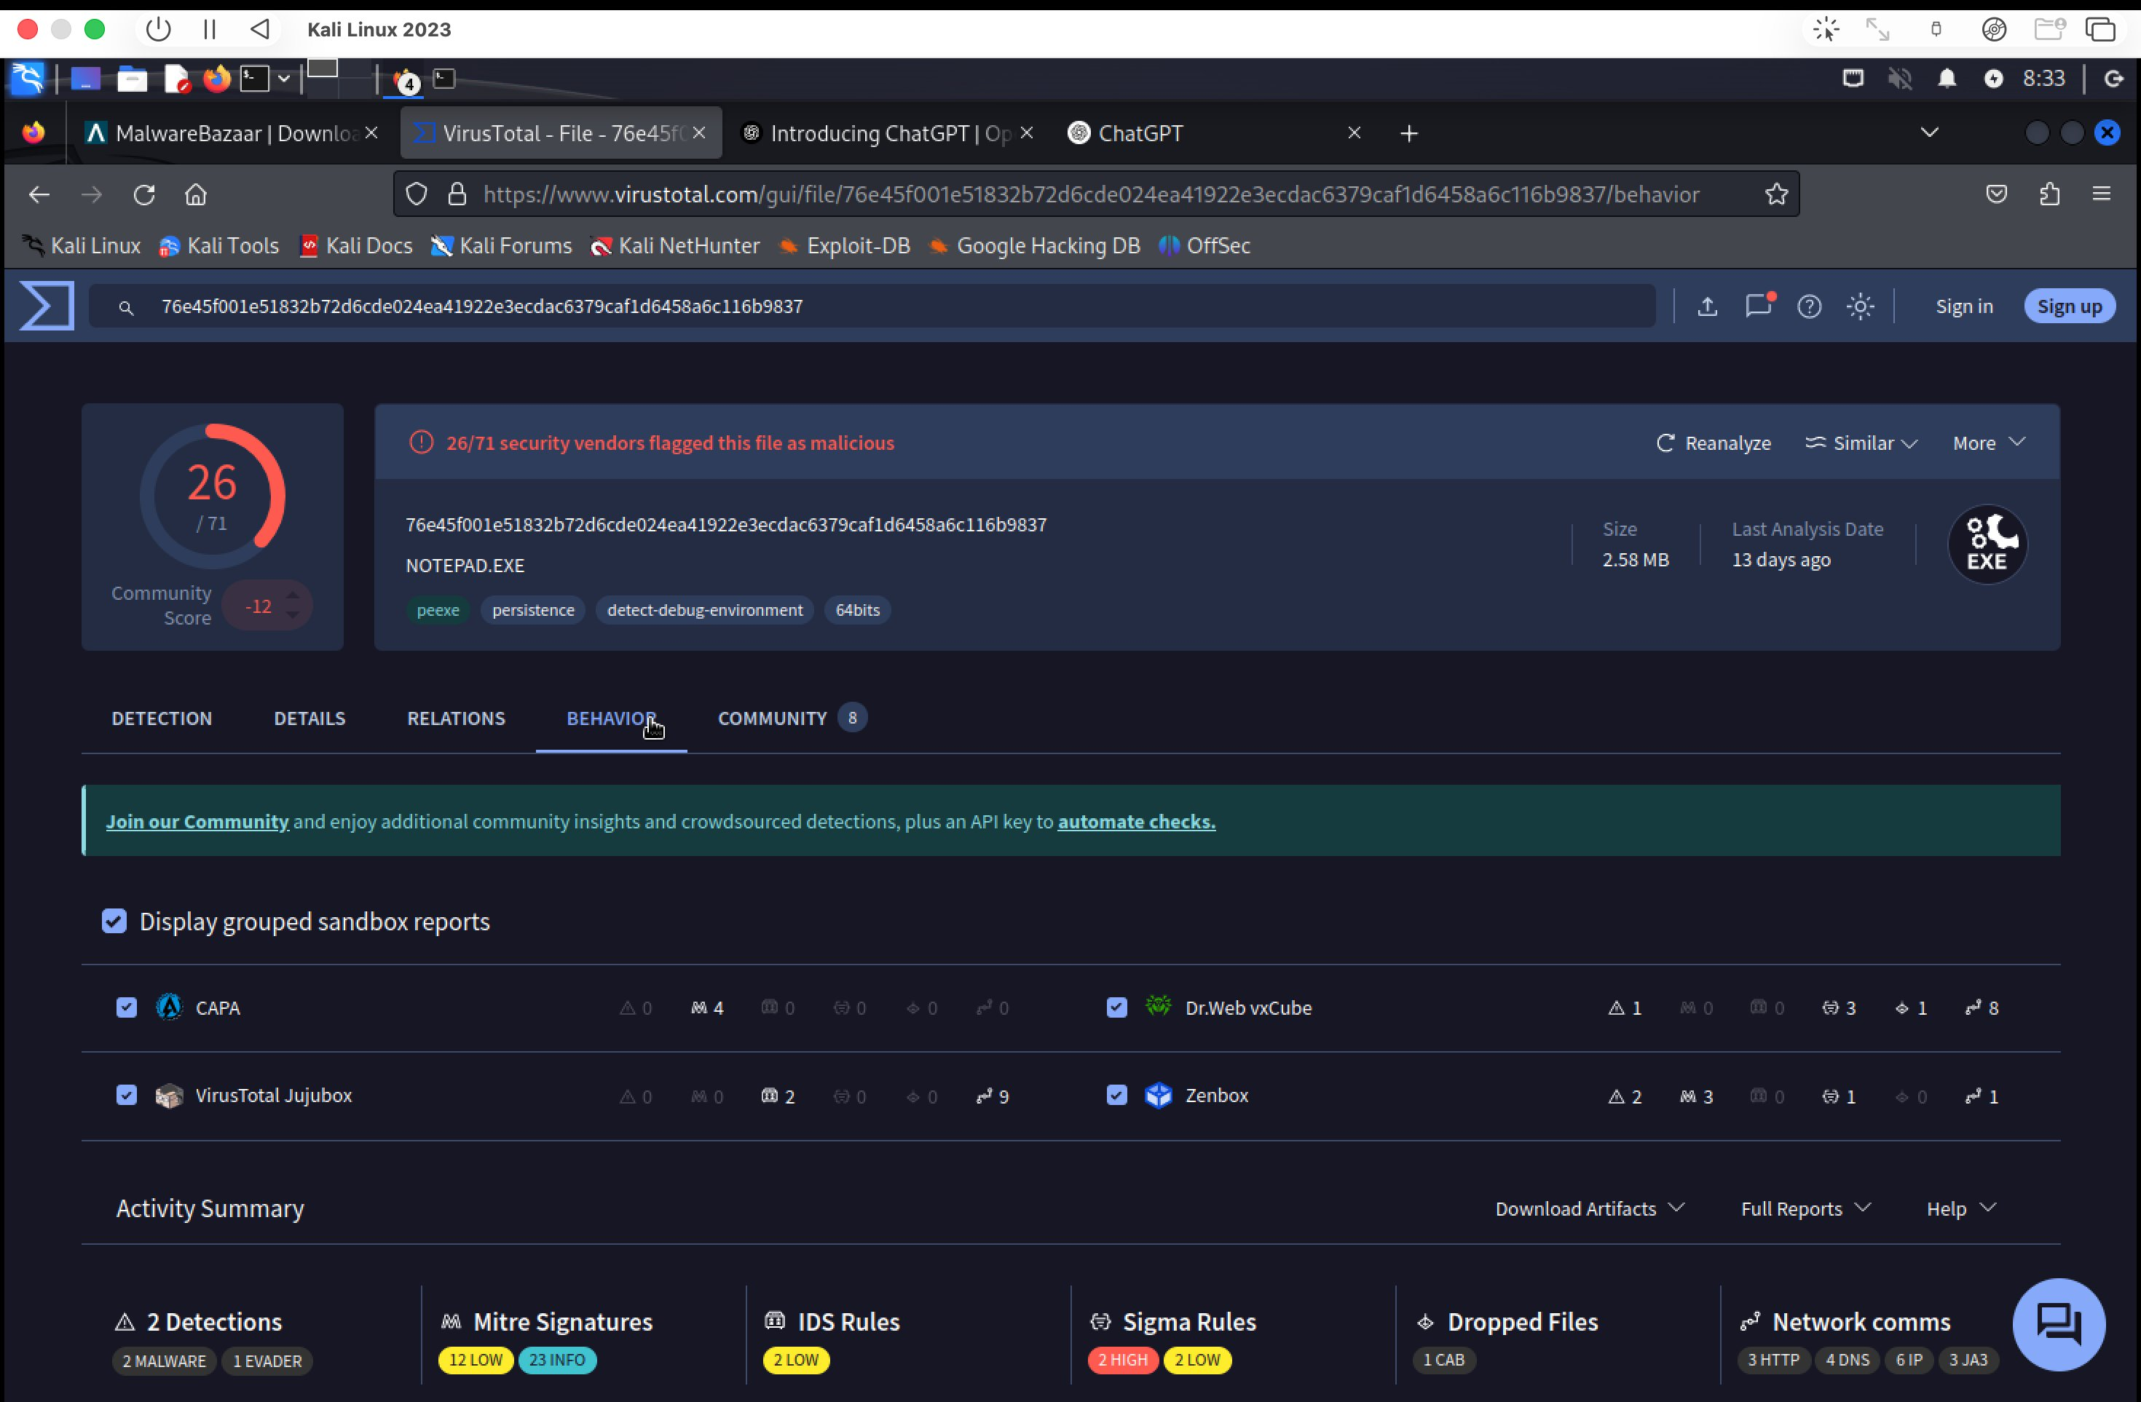
Figure 10: SET Credential Harvester active, showing incoming requests from 10.11.0.141

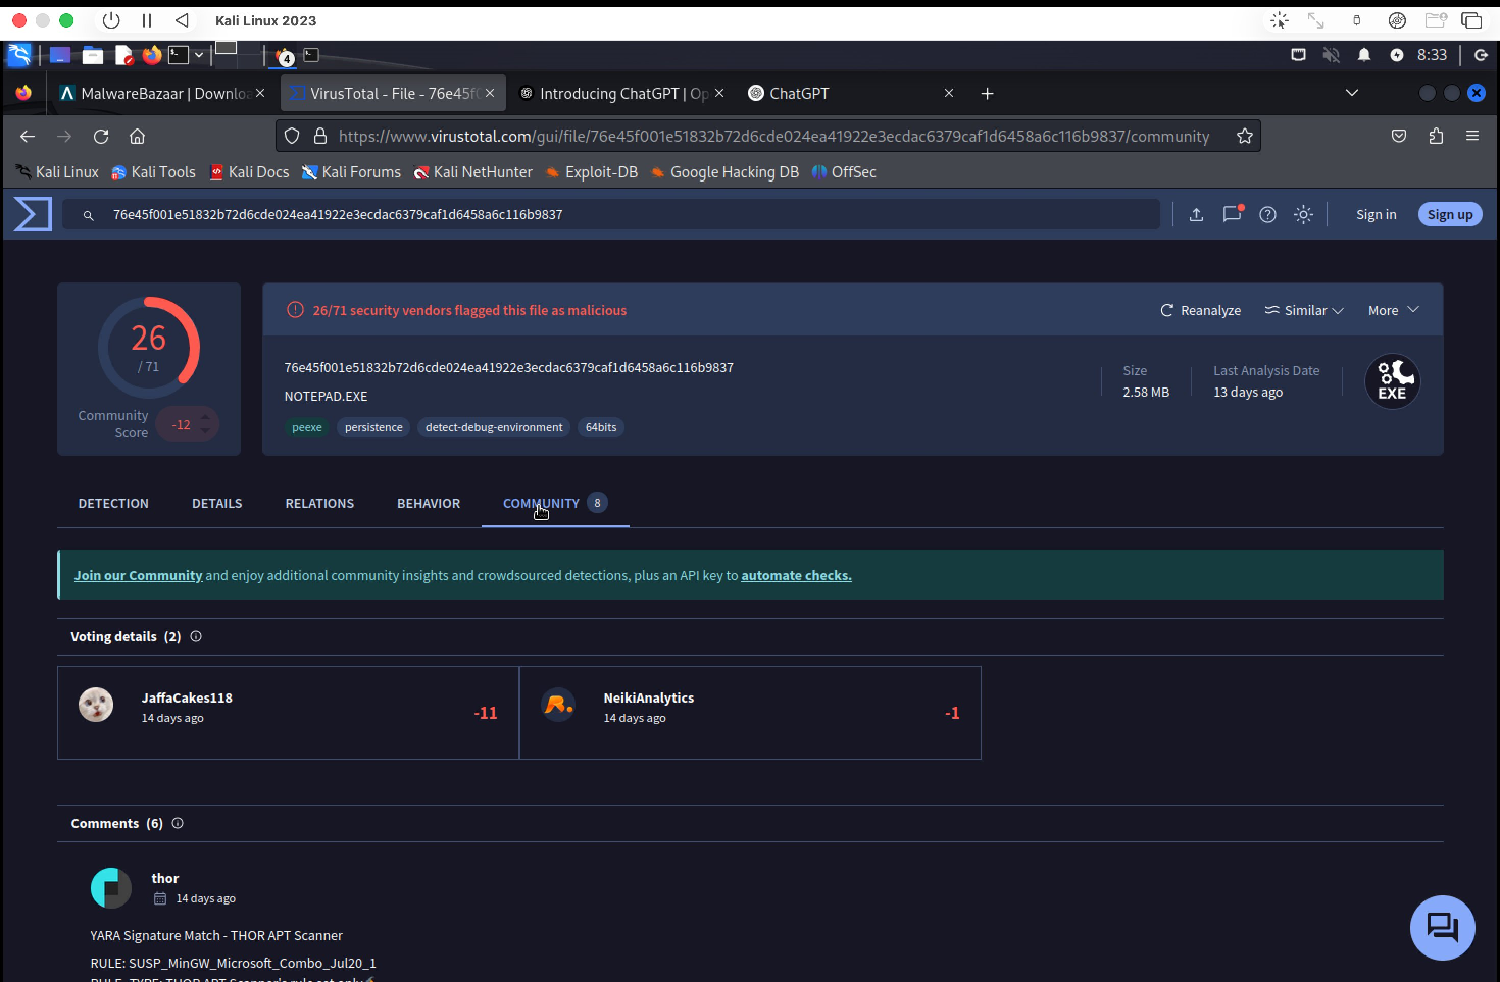
Figure 11: SET console showing captured credentials — Email: EmailMyGoogle.hotmail, Password: MyPassword123

Captured POST parameters included:
- POSSIBLE USERNAME FIELD FOUND: Email=MyGoogle.hotmail — username/email field successfully captured
- POSSIBLE PASSWORD FIELD FOUND: Passwd=MyPassword123 — password field successfully captured
- Additional parameters: GALX, dsh, service, checkConnection, signIn, PersistentCookie — complete form submission intercepted
- HTTP traffic: GET / HTTP/1.1 (200 OK) followed by POST /ServiceLoginAuth HTTP/1.1 (302 Redirect) — confirms full credential theft workflow

Step 5: Cloned Page Appearance (Victim Perspective)
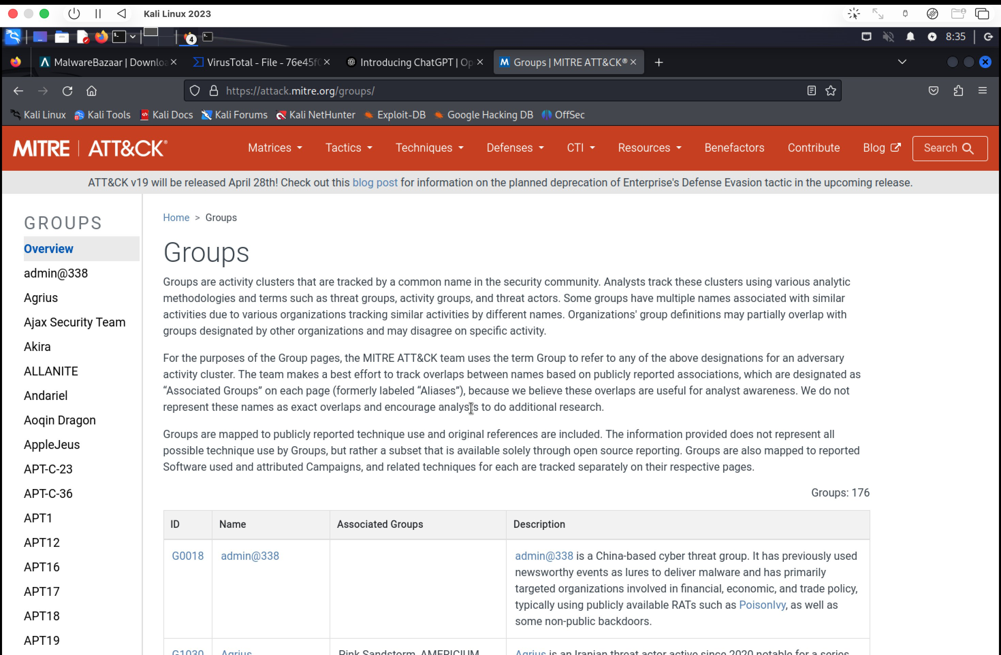
Figure 12: Cloned Google sign-in page served at 10.11.0.141 — visually identical to the legitimate page

The cloned page at http://10.11.0.141 is visually identical to the authentic Google sign-in page. A non-technical user would have no way to distinguish this from the real site without examining the URL bar carefully.

3.4 Phishing Template Documentation
Template Name | Google Sign-In Credential Harvester
Target Platform | Google Accounts (accounts.google.com)
Attack Method | Site Cloner (Credential Harvester Attack Method)
Delivery Vector | Internal network redirect / URL substitution
Technical Mechanism | HTML cloning + POST field interception + redirect
Attacker IP/Host | 10.11.0.141 (Lab Kali Linux machine)
Listener Port | 80 (HTTP) — Credential Harvester
Fields Targeted | Email/Username and Password form fields
Redirect Behavior | Configurable via HARVESTER_REDIRECT in /etc/setoolkit/set.config
MITRE ATT&CK | T1566.002 (Spear Phishing Link), T1078 (Valid Accounts - Credential Capture)
Detection Evasion | Pixel-perfect clone; URL deception (relies on victim not checking address bar)

3.5 Enterprise Defensive Recommendations
- Multi-Factor Authentication (MFA): Even if credentials are captured, MFA prevents account compromise. EISP's Okta implementation with TOTP/WebAuthn as second factor directly mitigates credential harvesting attacks.
- HTTPS Enforcement & Certificate Pinning: Enforce HTTPS-only access to all enterprise applications. Certificate pinning prevents spoofed pages from appearing legitimate.
- Security Awareness Training: Train users to verify URL bars before entering credentials. Phishing-resistant users are the most effective defense.
- Email Gateway Filtering: Deploy advanced email threat protection with URL rewriting and sandbox analysis to block phishing URLs before reaching end users.
- DNS Filtering: DNS-layer security (e.g., Cisco Umbrella, Cloudflare Gateway) blocks navigation to known phishing domains.
- SIEM Alerting: Monitor for HTTP POST requests to non-whitelisted destinations containing form field patterns matching credential submission templates.

4. APT Campaign Mapping — MITRE ATT&CK Framework

4.1 Framework Overview
The MITRE ATT&CK (Adversarial Tactics, Techniques, and Common Knowledge) framework is a globally-accessible knowledge base of adversary tactics and techniques based on real-world observations. It is the industry standard for threat intelligence, red team/blue team operations, and security control gap analysis.
The framework is organized into: Tactics (the 'why' — adversary's goal), Techniques (the 'how' — method to achieve the goal), and Sub-techniques (specific implementations of a technique). The Enterprise matrix covers Windows, macOS, Linux, Cloud, Network, and Container environments.

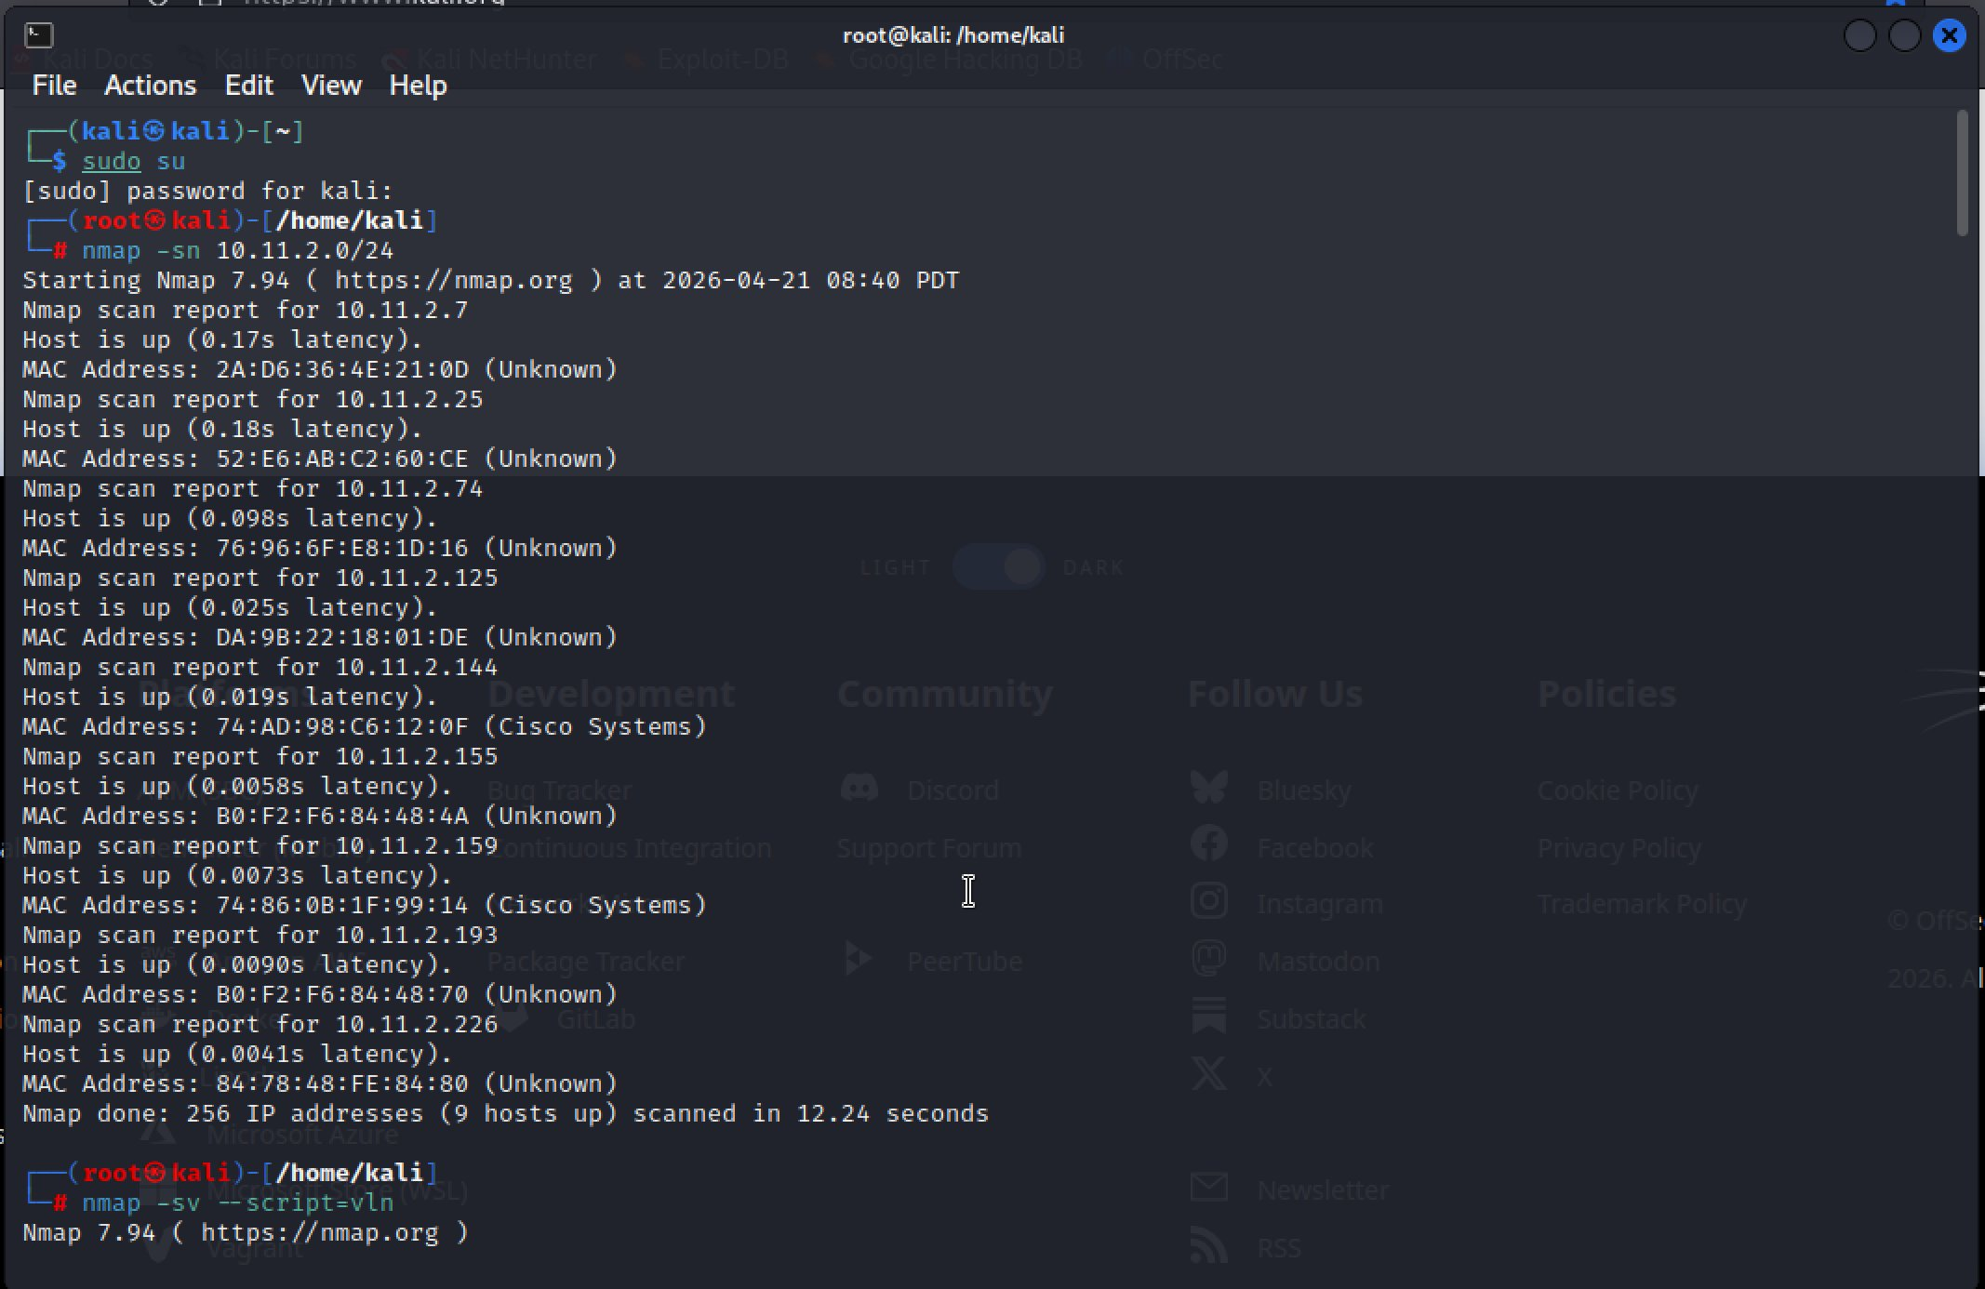
Figure 13: MITRE ATT&CK Groups page — 176 tracked threat groups with technique mappings

4.2 Selected APT Campaign: APT29 (Cozy Bear) — SolarWinds Supply Chain Attack
APT29, also known as Cozy Bear, The Dukes, and NOBELIUM, is a Russian state-sponsored threat actor attributed to Russia's Foreign Intelligence Service (SVR). The group is known for long-dwell-time espionage operations targeting government, defense, and critical infrastructure sectors globally.
The 2020 SolarWinds supply chain attack (also referred to as SUNBURST) is one of the most sophisticated and impactful cyber operations ever documented. It compromised the software build process of SolarWinds Orion IT monitoring software, inserting backdoor code that was distributed to approximately 18,000 organizations worldwide through trusted software updates.

4.3 ATT&CK Technique Mapping — SolarWinds/SUNBURST
Tactic | Technique ID | Technique Name & Description | EISP Relevance
Initial Access | T1195.002 | Supply Chain Compromise: Software Supply Chain — APT29 injected SUNBURST backdoor into SolarWinds Orion build process, distributing it via legitimate software updates signed with SolarWinds certificates. | IAM tools like Okta are delivered via update channels — same risk vector.
Execution | T1059.001 | Command & Scripting Interpreter: PowerShell — SUNBURST used PowerShell for in-memory execution and payload staging, avoiding file writes to disk. | Endpoints running EISP agents could be targeted for PowerShell-based lateral movement.
Persistence | T1543.003 | Create or Modify System Process: Windows Service — SUNBURST established persistence by modifying the SolarWinds Orion service to execute malicious DLL (SolarWinds.Orion.Core.BusinessLayer.dll). | IAM platform services and agents must be monitored for unauthorized modification.
Defense Evasion | T1036.005 | Masquerading: Match Legitimate Name/Location — SUNBURST DLL used the exact namespace and class names of legitimate SolarWinds code to evade detection. | Code signing verification and file integrity monitoring are critical detective controls.
Defense Evasion | T1070.006 | Indicator Removal: Timestomping — APT29 modified file timestamps to blend malicious files with legitimate ones, defeating timeline-based forensic analysis. | EISP SIEM must correlate events independent of file timestamps.
Credential Access | T1003.001 | OS Credential Dumping: LSASS Memory — Post-compromise, APT29 used credential dumping to harvest Active Directory service account credentials from LSASS memory. | HIGHLY relevant to EISP — PAM and zero-trust controls mitigate this directly.
Credential Access | T1528 | Steal Application Access Token — APT29 stole OAuth tokens to access Microsoft 365, cloud services, and third-party applications without needing passwords. | OAuth token theft is a primary EISP threat model — token lifetime limits and binding mitigate.
Discovery | T1082 | System Information Discovery — SUNBURST performed dormancy checks (waited 12-14 days before activating) and collected victim environment details before contacting C2. | Long dwell time makes behavior-based detection essential over signature-based tools.
Lateral Movement | T1550.001 | Use Alternate Authentication Material: Application Access Token — APT29 used stolen SAML tokens to authenticate to cloud services as legitimate users. | Direct EISP threat — SAML token forgery attacks (Golden SAML) target IAM infrastructure.
Collection | T1114.002 | Email Collection: Remote Email Collection — APT29 accessed Microsoft Exchange and M365 mailboxes of senior government officials using compromised service accounts. | Compromised EISP service accounts could enable similar M365 email collection.
C2 | T1071.004 | Application Layer Protocol: DNS — SUNBURST used DNS-based C2 (subdomains of avsvmcloud[.]com) for initial beaconing, blending with legitimate DNS traffic. | DNS monitoring and RPZ (Response Policy Zones) are critical network controls.
Exfiltration | T1041 | Exfiltration Over C2 Channel — Data was exfiltrated through the same HTTPS channel used for C2, making traffic analysis challenging without SSL inspection. | SSL/TLS inspection at perimeter and DLP controls needed to detect exfiltration.

4.4 ATT&CK Navigator Heatmap Description
If rendered in MITRE ATT&CK Navigator, this campaign would show high coverage across the following tactic columns:
- Initial Access: 1 technique highlighted (T1195.002)
- Execution: 1 technique highlighted (T1059.001)
- Persistence: 1 technique highlighted (T1543.003)
- Defense Evasion: 2 techniques highlighted (T1036.005, T1070.006)
- Credential Access: 2 techniques highlighted (T1003.001, T1528) — HIGHEST EISP IMPACT
- Discovery: 1 technique highlighted (T1082)
- Lateral Movement: 1 technique highlighted (T1550.001)
- Collection: 1 technique highlighted (T1114.002)
- Command & Control: 1 technique highlighted (T1071.004)
- Exfiltration: 1 technique highlighted (T1041)

4.5 Key Findings & EISP Security Implications
The APT29 SolarWinds campaign demonstrates that identity infrastructure is a primary target of nation-state adversaries. The following EISP security implications are identified:
- SAML Token Forgery (Golden SAML): APT29's T1550.001 directly targets SAML-based SSO infrastructure. EISP must implement SAML assertion signing, short token lifetimes (<1 hour), and anomalous login detection in Okta.
- OAuth Token Theft: T1528 targets OAuth access tokens. EISP must implement token binding, short expiry times, and refresh token rotation policies in all OAuth 2.0 flows.
- Privileged Account Protection: LSASS credential dumping (T1003.001) harvests service account credentials. EISP's Privileged Access Management (PAM) controls and HashiCorp Vault for secrets management directly mitigate this risk.
- Supply Chain Risk: The SUNBURST attack vector (T1195.002) means even signed, trusted software updates can be weaponized. EISP must maintain software integrity verification (hash checks) for all identity platform updates.
- Zero Trust Architecture: The broad lateral movement enabled by compromised SAML/OAuth tokens demonstrates why Zero Trust — requiring re-authentication and continuous validation — is the appropriate architectural response.

5. Conclusions & Summary
This document demonstrates comprehensive cyber threat identification and analysis capabilities through three practical exercises:
- Malware Analysis: The NOTEPAD.EXE trojan (AgentB family) was thoroughly analyzed using VirusTotal, revealing 26/71 detection rate, credential-stealing capabilities, Telegram C2 infrastructure, and 7 distinct behavioral IOCs mapped to MITRE ATT&CK techniques. Detection methods, network indicators, and enterprise impact were fully documented.
- Phishing Simulation: A fully functional credential harvesting attack was executed using SET in a controlled lab environment, capturing test credentials from a cloned Google login page. The simulation demonstrates why MFA, HTTPS enforcement, and security awareness training are critical preventive controls in EISP's security architecture.
- APT Campaign Mapping: The APT29 SolarWinds/SUNBURST campaign was mapped to 12 MITRE ATT&CK techniques across 10 tactics, with specific analysis of how each technique impacts EISP's identity security architecture. The Golden SAML and OAuth token theft techniques are identified as the highest-priority threats to address in EISP's security design.

5.1 References
- MITRE ATT&CK Enterprise Matrix v16: https://attack.mitre.org
- VirusTotal Analysis: https://www.virustotal.com/gui/file/76e45f001e51832b72d6cde024ea41922e3ecdac6379caf1d6458a8c116b9837
- NIST SP 800-61 Rev 2: Computer Security Incident Handling Guide
- FireEye (Mandiant) SolarWinds Threat Report: https://www.fireeye.com/blog/threat-research/2020/12/evasive-attacker-leverages-solarwinds-supply-chain-compromises-with-sunburst-backdoor.html
- Microsoft APT29 Analysis: https://msrc-blog.microsoft.com/2020/12/13/customer-guidance-on-recent-nation-state-cyber-attacks/
- Social-Engineer Toolkit (SET) Documentation: https://github.com/trustedsec/social-engineer-toolkit
- CISA Advisory AA20-352A: Advanced Persistent Threat Compromise of Government Agencies

