ENTERPRISE IDENTITY SECURITY PLATFORM

Network Protocols and Architecture Report

EISP-NET-002

Rubric: Design Network Protocols and Architectures

Document ID | EISP-NET-002
Version | 1.0
Date | May 2026
Author | Manisha Gupta
Classification | Confidential — Internal Use Only
Framework | NIST SP 800-53 · OSI Model · TCP/IP Model · Zero Trust Architecture
Phase | Phase 2 — Identity Governance
Program | 26FSC03
Device Documented | Jump Host EC2 — Public Subnet 10.0.1.0/24

Section | Content | Rubric Requirement
Section 2 | OSI 7-Layer Model — Jump Host EC2 | 1 device mapped to OSI model ✅
Section 3 | TCP/IP 4-Layer Model — Jump Host EC2 | 1 device mapped to TCP/IP model ✅
Section 4 | Subnetting — Public Subnet 10.0.1.0/24 | Proper subnetting for 1 subnet ✅
Section 5 | Secure Network Architecture with Security Protocols | Secure architecture with specific protocols ✅

1. Purpose and Scope

This report documents the network protocol architecture of the Enterprise Identity Security Platform (EISP), with specific focus on the Jump Host EC2 instance located in the Public subnet (10.0.1.0/24). The report maps all seven layers of the OSI model and all four layers of the TCP/IP model to the actual protocols and security controls operating on this device. It also provides formal subnetting documentation for the Public subnet and presents the secure network architecture governing all EISP communications.

The Jump Host (Bastion Host) was selected as the reference device because it is the single controlled entry point to all EISP private resources. Every administrative action — accessing Vault, the Wazuh SIEM, or the Kali lab — must pass through this device. Understanding its full protocol stack is therefore foundational to understanding the EISP security architecture.

Attribute | Detail
Device Name | Jump Host EC2 (Bastion Host)
Instance Type | t2.micro
Operating System | Amazon Linux 2023 (or Ubuntu 22.04 LTS)
Subnet | Public Subnet — 10.0.1.0/24
Private IP | 10.0.1.x (assigned dynamically by AWS DHCP)
Public IP | Elastic IP (static) — assigned to admin access
Security Group | EISP-SG-JumpHost — TCP 22 from admin IP /32, TCP 443 from VPC
Route Table | EISP-RT-Public — local + 0.0.0.0/0 → Internet Gateway
Primary Role | Bastion/Jump Host — only authorised path to all private EISP resources

Table 1: Jump Host EC2 Reference Device Specification

2. OSI 7-Layer Model — Jump Host EC2
Open Systems Interconnection Reference Model · EISP Implementation Mapping

The OSI (Open Systems Interconnection) model is a conceptual framework that divides network communication into seven distinct layers. Each layer serves a specific function and communicates only with the layers immediately above and below it. The model provides a structured way to understand how data travels from an application on one device to an application on another, and where security controls should be applied at each stage.

The following table maps each OSI layer to the specific protocols, implementations, and security controls active on the EISP Jump Host EC2 instance. The table is read from the bottom (Layer 1, Physical) up to the top (Layer 7, Application) — the direction data travels as it is processed by the receiving device.

Layer | Name | Protocol / Technology | EISP Jump Host Implementation | Security Control
7 | Application | SSH, HTTPS, SAML 2.0, OIDC, DNS | SSH client (admin access)  authentik SSO/SAML federation  AWS Console (HTTPS)  Wazuh dashboard (HTTPS) | SAML assertion signing  X.509 cert validation  MFA enforcement at authentik  JWT token validation
6 | Presentation | TLS 1.3, SSL, JSON, XML, Base64 | TLS 1.3 on all connections  SAML XML assertions  X.509 certificate encoding  JWT Base64url encoding | TLS 1.3 cipher suite  TLS_AES_256_GCM_SHA384  Certificate validation  No TLS 1.0/1.1 permitted
5 | Session | TLS session, SSH session, TCP sessions | SSH session to Jump Host  TLS session state  Wazuh agent session  authentik login session | SSH session key exchange  Ed25519 host key  Session timeout: 4 hours  STS credential expiry
4 | Transport | TCP, UDP | TCP 22 (SSH)  TCP 443 (HTTPS)  TCP 1514 (Wazuh logs)  TCP 8200 (Vault API) | TCP-only (no UDP for admin)  Port filtering via SG  Connection state tracking
3 | Network | IP, ICMP, routing | VPC CIDR 10.0.0.0/16  Public subnet 10.0.1.0/24  Route table EISP-RT-Public  Internet Gateway routing | AWS Security Groups (SG)  Network ACLs (NACL)  Route table isolation  No cross-subnet default trust
2 | Data Link | Ethernet, MAC addressing | AWS VPC internal switching  Elastic Network Interface (ENI)  MAC address per EC2 instance | AWS VPC MAC isolation  No ARP poisoning possible  Private ENI per instance
1 | Physical | Physical hardware, fibre | AWS data centre hardware  Physical network infrastructure  (Fully managed by AWS) | AWS shared responsibility  Physical security: AWS  SO 27001 certified DC

Table 2: OSI 7-Layer Model — Jump Host EC2 Protocol and Security Mapping

How to read this table:
Data sent to the Jump Host travels UP through the layers: Physical (1) → Data Link (2) → Network (3) → Transport (4) → Session (5) → Presentation (6) → Application (7).
Security controls at each layer are independent — a packet must pass ALL layer checks to reach the application. If a Security Group (Layer 3) blocks TCP 22, the packet never reaches the SSH application (Layer 7).

2.1 Key Security Observations — OSI Model

- Layer 7 — Application: SAML 2.0 federation means no plaintext credentials traverse any layer. AWS never receives passwords — only signed assertions from authentik.
- Layer 6 — Presentation: TLS 1.3 encrypts all data before transmission. Any attacker intercepting Layer 4 or below sees only encrypted bytes — the content is unreadable without the session key.
- Layer 4 — Transport: AWS Security Groups enforce port-level filtering at Layer 4. Only TCP 22 and TCP 443 are permitted inbound — all other ports are implicitly denied.
- Layer 3 — Network: VPC routing tables enforce that the Public subnet (10.0.1.0/24) is the only subnet with internet access. All traffic to private subnets stays within the VPC and never leaves.
- Layer 2 — Data Link: AWS VPC prevents MAC spoofing and ARP poisoning. Each ENI has a fixed MAC address that cannot be changed by the instance — a common attack vector in physical LANs that does not exist in the VPC.

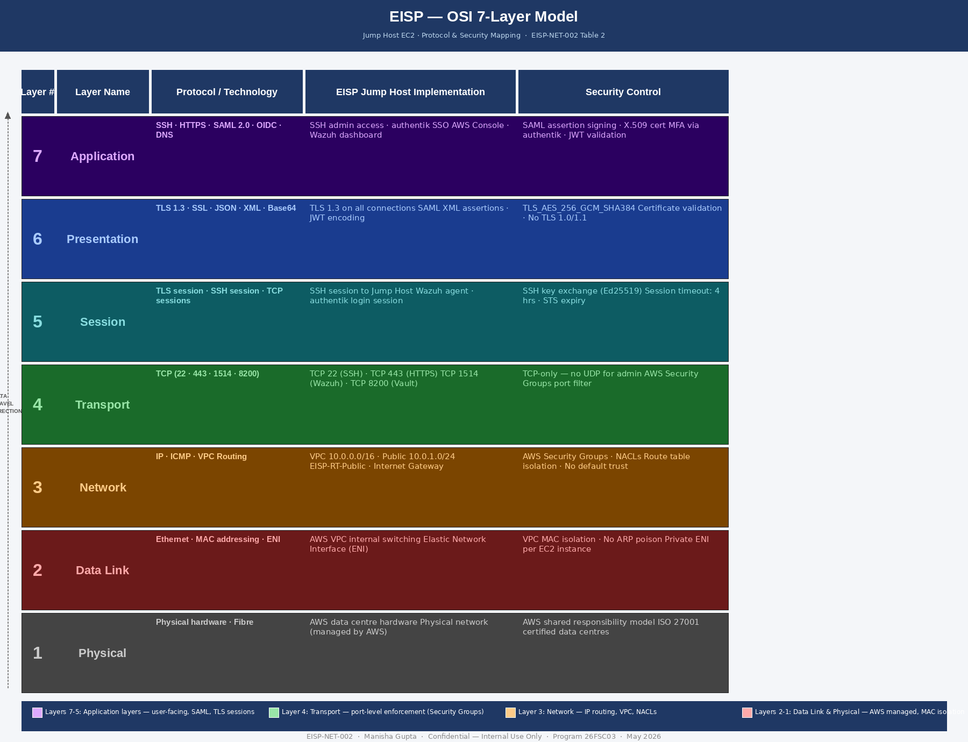

3. TCP/IP 4-Layer Model — Jump Host EC2
Transmission Control Protocol / Internet Protocol Suite · Practical Network Stack

The TCP/IP model is the practical protocol suite that governs all modern internet and cloud network communications. Unlike the theoretical OSI model with seven layers, the TCP/IP model consolidates these into four layers. It is the model actually implemented in operating systems, network stacks, and cloud infrastructure — including AWS VPC. The Jump Host EC2 instance communicates using the TCP/IP stack exclusively.

Layer | Name | Protocol | EISP Jump Host Implementation | Security
4 | Application | SSH  HTTPS  SAML  DNS | SSH (port 22): admin terminal access  HTTPS (port 443): Wazuh dashboard, authentik, AWS Console  SAML (port 443): federation assertions to AWS  DNS (port 53): hostname resolution within VPC | TLS 1.3 encryption on all HTTPS  SAML assertion signed by X.509  SSH key-based auth only
3 | Transport | TCP  UDP | TCP 22: SSH — reliable ordered delivery for admin sessions  TCP 443: HTTPS — all web traffic  TCP 1514: Wazuh syslog  TCP 8200: Vault API | TCP reliability ensures no partial commands  AWS SG enforces port-level filtering  No UDP for sensitive admin channels
2 | Internet | IPv4  ICMP  Routing | Public IP: Elastic IP on Jump Host NIC  Private IP: 10.0.1.x (Jump Host in public subnet)  Routing: EISP-RT-Public (0.0.0.0/0 → IGW)  ICMP: Limited — ping restricted by SG | Security Groups filter at IP/port level  Network ACLs at subnet boundary  No direct internet path for private subnets
1 | Network Access | Ethernet  MAC  Physical | Elastic Network Interface (ENI)  MAC address assigned per EC2 NIC  AWS physical fibre within data centre  VPC internal switching | AWS manages physical layer  VPC prevents MAC spoofing  ENI traffic isolated per instance

Table 3: TCP/IP 4-Layer Model — Jump Host EC2 Protocol and Security Mapping

3.1 OSI vs TCP/IP — Layer Mapping

TCP/IP Layer | Equivalent OSI Layers | How They Relate
Application (4) | OSI Layers 5+6+7  Session + Presentation + Application | TCP/IP combines OSI Session, Presentation, and Application into a single layer. In practice, SSH handles session management, TLS handles presentation, and the admin tool is the application — all in one stack.
Transport (3) | OSI Layer 4  Transport | Direct 1:1 mapping. TCP provides reliable, ordered delivery. The Jump Host uses TCP exclusively for admin protocols — no UDP.
Internet (2) | OSI Layer 3  Network | Direct 1:1 mapping. IPv4 addressing, routing, and ICMP operate at this layer. AWS Security Groups and route tables enforce access control here.
Network Access (1) | OSI Layers 1+2  Physical + Data Link | TCP/IP combines Physical and Data Link into Network Access. AWS manages this entirely — ENI, MAC addressing, and physical connectivity are AWS-controlled.

Table 4: OSI to TCP/IP Layer Mapping

4. Subnetting — Public Subnet 10.0.1.0/24
Formal Subnetting Documentation · CIDR · Host Range · AWS Reserved Addresses

Subnetting is the process of dividing a larger IP address space into smaller, more manageable network segments called subnets. Each subnet has its own range of IP addresses, subnet mask, network address, and broadcast address. Subnetting is a foundational network engineering skill — it allows network architects to organise infrastructure, control traffic flow between segments, and apply security policies at the subnet boundary.

The EISP environment uses the VPC address space 10.0.0.0/16 divided into four /24 subnets. This document provides formal subnetting documentation for the Public subnet (10.0.1.0/24), which hosts the Jump Host EC2 instance.

4.1 Binary Subnet Mask Breakdown

IP Address: 10 . 0 . 1 . 0
Binary: 00001010.00000000.00000001.00000000

Subnet Mask: 255.255.255.0 = /24
Binary: 11111111.11111111.11111111.00000000

Network bits: 24 (first three octets — fixed)
Host bits: 8 (last octet — variable, range 0-255)

Total addresses: 2^8 = 256
Usable hosts: 256 - 2 = 254 (minus network + broadcast)
AWS usable: 256 - 5 = 251 (AWS reserves 5 addresses)

Figure 3: Binary subnet mask breakdown — 10.0.1.0/24

4.2 Complete Subnetting Reference Table

Attribute | Value | Explanation
Network Address | 10.0.1.0 | The first address of the subnet. Not assignable to any host. Identifies the network itself.
Subnet Mask | /24 = 255.255.255.0 | 24 bits for network, 8 bits for hosts. Binary: 11111111.11111111.11111111.00000000
First Usable Host | 10.0.1.1 | Lowest IP assignable to a device (e.g., EC2 instance, router). In EISP: reserved for AWS VPC router.
Last Usable Host | 10.0.1.254 | Highest IP assignable to a device. In EISP: available for additional EC2 instances.
Broadcast Address | 10.0.1.255 | Last address of the subnet. Packets to this address are delivered to all hosts in the subnet.
Total Addresses | 256 (2⁸) | Total IPs in the /24 block including network and broadcast addresses.
Usable Host Addresses | 254 (256 – 2) | Addresses available for EC2 instances and other resources. Minus network address and broadcast.
AWS Reserved | 10.0.1.0, .1, .2, .3, .255 | AWS reserves 5 IPs in each subnet: network, VPC router, DNS, future use, broadcast.
EISP Usable Range | 10.0.1.4 – 10.0.1.254 | Effective range available for EISP resources after AWS reservations.
Current Use | Jump Host EC2 | 10.0.1.x — assigned to the Bastion/Jump Host instance in the Public subnet.
CIDR Notation | 10.0.1.0/24 | Classless Inter-Domain Routing. Combines IP and prefix length in one compact notation.

Table 5: Public Subnet 10.0.1.0/24 — Formal Subnetting Documentation

4.3 EISP Subnet Design Rationale

The /24 prefix was selected for each EISP subnet for three reasons:

- /24 provides 254 usable host addresses — far more than the current EISP resource count, allowing significant growth without redesigning the subnetting scheme.
- /24 subnets are the standard unit in AWS VPC design. They are easy to reason about, easy to express in Security Group and NACL rules (e.g., 10.0.3.0/24 means 'all Wazuh SIEM resources'), and align with industry conventions.
- Four /24 subnets (10.0.1.0/24 through 10.0.4.0/24) are carved out of the parent /16 (10.0.0.0/16), leaving 10.0.5.0/24 through 10.0.255.0/24 available for future expansion without IP address conflicts.

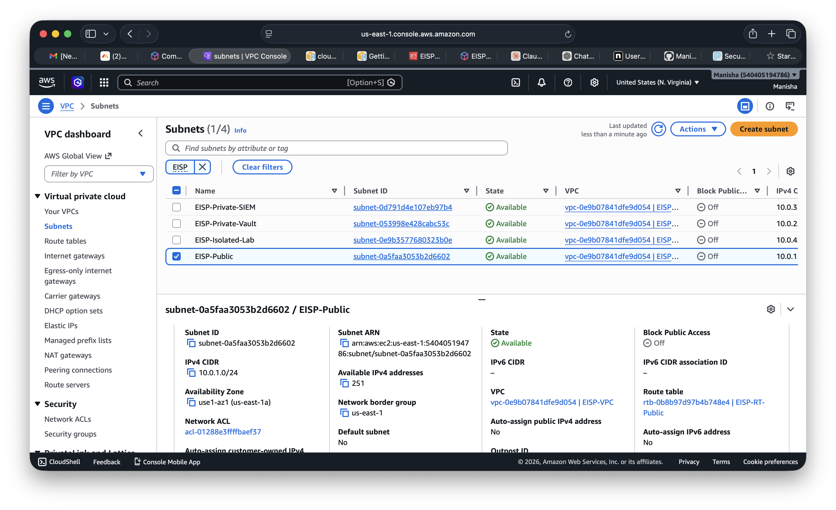

5. Secure Network Architecture with Security Protocols
EISP End-to-End Security Protocol Stack · TLS 1.3 · SAML 2.0 · SSH · X.509

This section documents the complete secure network architecture of the EISP environment, with specific focus on the security protocols that protect every communication channel. A security protocol is a set of rules and procedures that governs how security is applied to a communication — including authentication, encryption, key exchange, and integrity verification.

5.1 Network Architecture Diagram (ASCII)

INTERNET
│
┌───────────▼──────────┐
│ INTERNET GATEWAY │ ← single controlled boundary
└───────────┬──────────┘
│ TLS 1.3 (all external traffic)
┌───────────────────▼─────────────────────────┐
│ EISP-VPC 10.0.0.0/16 │
│ │
│ ┌────────────────────────┐ │
│ │ PUBLIC 10.0.1.0/24 │ │
│ │ Jump Host EC2 │ │
│ │ SSH (port 22) │◄── SG: /32 IP │
│ │ EISP-SG-JumpHost │ only source │
│ └─────────┬──────────────┘ │
│ │ SSH (key-based, no passwords) │
│ ┌─────────▼──────────────┐ │
│ │ PRIVATE 10.0.2.0/24 │ │
│ │ HashiCorp Vault │ │
│ │ HTTPS/TLS (port 8200) │◄── SG: Jump + │
│ │ AppRole auth · X.509 │ SIEM only │
│ └────────────────────────┘ │
│ ┌────────────────────────┐ │
│ │ PRIVATE 10.0.3.0/24 │ │
│ │ Wazuh SIEM │ │
│ │ TLS syslog (port 1514) │◄── SG: Agents │
│ │ HTTPS dashboard (443) │ only │
│ └────────────────────────┘ │
│ ┌────────────────────────┐ │
│ │ ISOLATED 10.0.4.0/24 │ │
│ │ Kali Linux Lab VM │ │
│ │ SSH (port 22) │◄── SG: Jump │
│ │ No internet egress │ Host only │
│ └────────────────────────┘ │
│ │
│ authentik IdP ──SAML 2.0──▶ AWS IAM + STS │
│ X.509 cert signed assertion │
│ AWS CloudTrail: all events logged to S3 │
└──────────────────────────────────────────────┘

Figure 4: EISP Secure Network Architecture — Protocol Stack

5.2 Security Protocol Reference Table

Protocol | Layer | Port | Purpose in EISP | Security Properties
TLS 1.3 | Presentation (OSI 6) | 443, 8200 | All HTTPS communications: authentik, Wazuh dashboard, Vault API, AWS Console | AES-256-GCM or ChaCha20-Poly1305 encryption  Forward secrecy  No downgrade to TLS 1.0/1.1
SSH (OpenSSH) | Application (OSI 7) | 22 | Administrative access to Jump Host and private instances  Safe command channel | Key-based auth (Ed25519 / RSA)  No password login  Strong key exchange algorithms
SAML 2.0 | Application (OSI 7) | 443 | Identity federation: authentik (IdP) → AWS IAM (SP)  Role-based access via SAML assertions | XML assertion signed with X.509 private key  Audience restriction (SAML:aud)  Time-limited assertions
X.509 / PKI | Presentation (OSI 6) | N/A — cert embedded in TLS + SAML | Certificate infrastructure underpinning TLS and SAML trust  authentik signs SAML assertions with X.509 cert | CA-signed or self-signed cert  Public key pinned in SAML provider  AWS verifies signature before role assumption
AWS Sig v4 | Application (OSI 7) | 443 | All AWS API calls (CloudTrail, IAM, STS, EC2) are signed | HMAC-SHA256 signature on every request  Prevents request tampering in transit  Timestamp prevents replay attacks
IPTables (firewall-drop) | Network (OSI 3) | All | Wazuh IPS active response — blocks attacker IPs via kernel firewall | Layer 3 DROP rule inserted by Wazuh  Applied before TCP handshake completes  No application-layer processing of blocked traffic

Table 6: EISP Security Protocol Reference

5.3 Protocol Interaction Flow — Admin SSH Session

The following describes the complete protocol interaction when an administrator establishes an SSH session to manage the Jump Host:

Step | Protocol | Layer | What Happens
1 | IP routing | Network (L3) | Admin packet arrives at Internet Gateway. Route table directs it to Jump Host ENI at 10.0.1.x.
2 | Security Group | Network (L3) | AWS checks source IP against EISP-SG-JumpHost. Only admin IP /32 is allowed on TCP 22. Packet accepted.
3 | TCP handshake | Transport (L4) | Three-way handshake (SYN → SYN-ACK → ACK) establishes reliable connection on TCP port 22.
4 | SSH version exchange | Application (L7) | Client and server announce SSH-2.0. SSH-1 is not accepted.
5 | Key exchange (KEX) | Application (L7) | Diffie-Hellman or ECDH key exchange. Session key derived — unique per connection, never reused.
6 | Host key verification | Application (L7) | Client verifies server's Ed25519 host key against known_hosts. Prevents MITM impersonation.
7 | User authentication | Application (L7) | Public key challenge-response. Private key on admin laptop signs a challenge — server verifies with stored public key.
8 | Session established | Session (L5) | Encrypted SSH shell session active. All keystrokes and output are encrypted with the session key from Step 5.

Table 7: SSH Session Protocol Interaction — Jump Host

6. NIST SP 800-53 Alignment and Conclusion

Control | Name | EISP Implementation
SC-8 | Transmission Confidentiality | TLS 1.3 on all HTTPS communications. SSH for admin access. No plaintext protocols.
SC-7 | Boundary Protection | AWS Security Groups at Layer 3/4. NACLs at subnet boundary. IGW as single internet entry point.
SC-23 | Session Authenticity | SSH key exchange ensures session is established with the genuine Jump Host. Host key verification prevents MITM.
IA-3 | Device Identification | X.509 certificates identify the authentik IdP to AWS IAM. Ed25519 host key identifies the Jump Host.
IA-8 | Identification and Auth (Non-Org Users) | SAML 2.0 federation — external admin identity verified by authentik before any AWS access is granted.
AC-4 | Information Flow Enforcement | Route tables enforce that private subnets cannot communicate directly with the internet. All inter-subnet flows pass through security controls.

Table 8: NIST SP 800-53 Control Alignment

6.1 Conclusion

This report documents the complete network protocol architecture of the EISP Jump Host EC2 instance and the Public subnet 10.0.1.0/24. The OSI model mapping (Table 2) demonstrates that security controls are applied at every layer — from physical isolation by AWS at Layer 1, through Security Group enforcement at Layer 3, TLS 1.3 encryption at Layer 6, and SAML federation at Layer 7. The TCP/IP model mapping (Table 3) confirms the same controls expressed in the practical four-layer framework that actually governs network communication.

The formal subnetting documentation for 10.0.1.0/24 (Table 5) establishes the exact IP address range, subnet mask, usable host range, and AWS reserved addresses — the technical foundation on which all security controls are configured. The secure network architecture (Section 5) identifies all six security protocols active in the EISP environment — TLS 1.3, SSH, SAML 2.0, X.509 PKI, AWS Signature v4, and IPTables — and documents their layer, purpose, and security properties.

6.2 Screenshots and Diagrams Required

- Diagram 1 — OSI 7-layer model (draw.io): Create a layered block diagram using Table 2 data. Label each layer with EISP protocols and security controls. Export as PNG.
- Diagram 2 — TCP/IP 4-layer model (draw.io): Create using Table 3 data. Simpler 4-block diagram alongside the OSI model for comparison.
- Screenshot 1 — AWS Console → VPC → Subnets → Public Subnet 10.0.1.0/24 detail page
- Screenshot 2 — AWS Console → EC2 → Security Groups → EISP-SG-JumpHost inbound rules
- Screenshot 3 — Jump Host terminal: run 'ssh -V' to show OpenSSH version and 'ip addr show' to confirm 10.0.1.x IP

