**Assignment-5**

**Design an XML document to store information about a student in an engineering college affiliated to VTU. The information must include USN, Name, and Name of the College, Program, Year of Joining, and email id. Make up sample data for 3 students. Create a CSS style sheet and use it to display the document.**

<?xml-stylesheet type="text/css" href="prog5.css"?>

<!DOCTYPE HTML>

<html>

<head>

<h1> STUDENTS DESCRIPTION </h1>

<style>

student {

display: block;

margin-top: 10px;

color: Navy;

}

USN {

display: block;

margin-left: 10px;

font-size: 14pt;

color: Red;

}

name {

display: block;

margin-left: 20px;

font-size: 14pt;

color: Blue;

}

college {

display: block;

margin-left: 20px;

font-size: 12pt;

color: rgb(248, 21, 21);

}

branch {

display: block;

margin-left: 20px;

font-size: 12pt;

color: rgb(59, 5, 59);

}

year {

display: block;

margin-left: 20px;

font-size: 14pt;

color: Green;

}

e-mail {

display: block;

margin-left: 20px;

font-size: 12pt;

color: Blue;

}

</style>

</head>

<students>

<student>

<USN>ID : 1JT21IS001</USN>

<name>Name : SNEHA MALOJI</name>

<college>COLLEGE : JIT</college>

<branch>BRANCH : Information Science and Engineering</branch>

<year>YEAR : 2022</year>

<e-mail>E-Mail : snehamaloji@gmail.com</e-mail>

</student>

<student>

<USN>USN : 1JT21IS045 </USN>

<name>NAME : RAMAYA </name>

<college>COLLEGE : JIT</college>

<branch>BRANCH : Information Science and Engineering</branch>

<year>YEAR : 2022</year>

<e-mail>E-Mail : ramya@gmail.com</e-mail>

</student>

<student>

<USN>USN : 1JT21IS055</USN>

<name>NAME :ANJU</name>

<college>COLLEGE : JIT</college>

<branch>BRANCH : Information Science and Engineering</branch>

<year>YEAR : 2022</year>

<e-mail>E-Mail : anju@gmail.com</e-mail>

</student>

</students>

</html>

**Output :**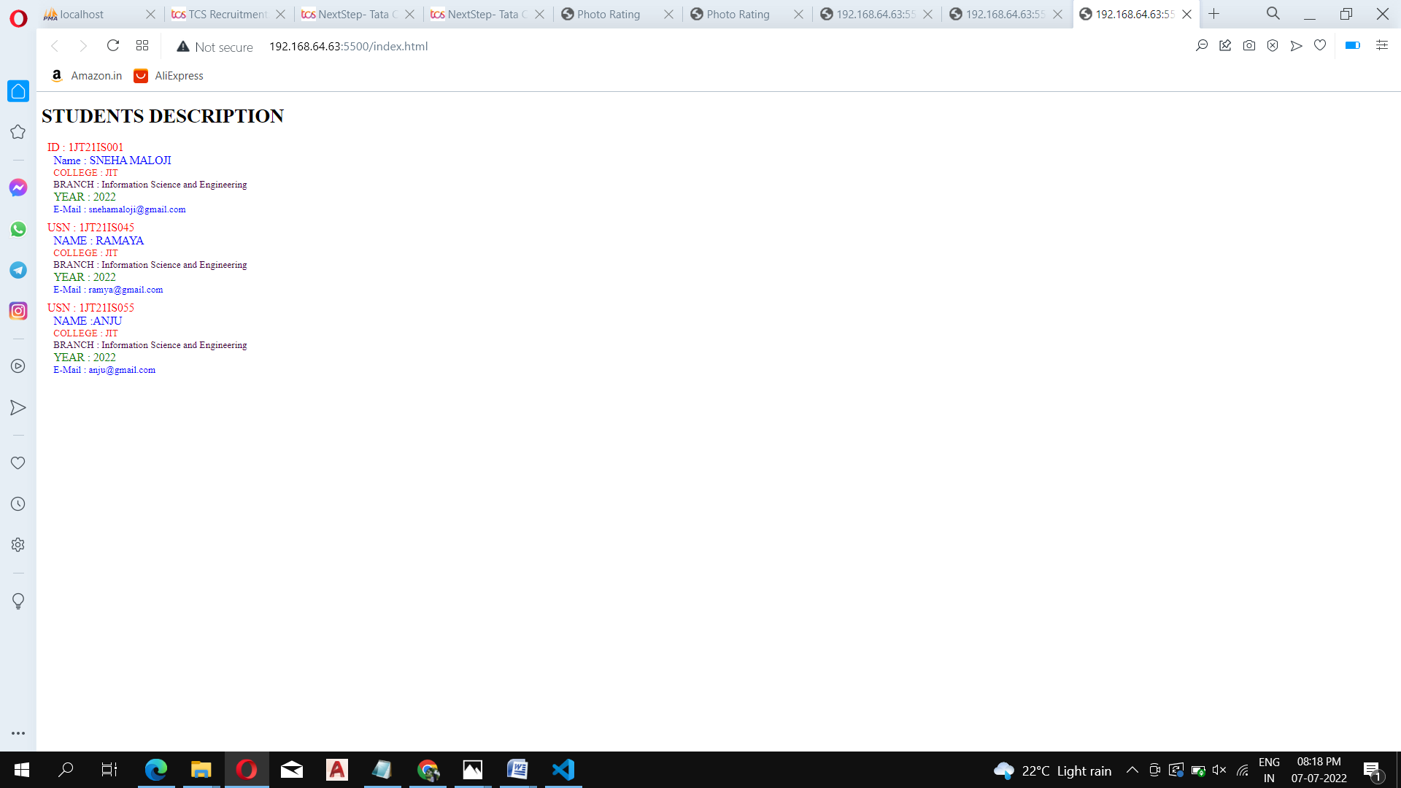

**CHALLENGE-5**

<!DOCTYPE HTML>

<html>

<head>

<h1> STUDENTS DESCRIPTION </h1>

<style>

student {

background-color: rgb(233, 219, 92);

margin-left: 5px;

text-align: center;

border: 1.5px solid rgb(230, 10, 10);

height: 100%;

width: 50%;

display: block;

margin-top: 10px;

color: Navy;

}

USN {

display: block;

margin-left: 10px;

font-size: 14pt;

color: Red;

}

name {

display: block;

margin-left: 20px;

font-size: 14pt;

color: Blue;

}

college {

display: block;

margin-left: 20px;

font-size: 12pt;

color: Maroon;

}

branch {

display: block;

margin-left: 20px;

font-size: 12pt;

color: Purple;

}

year {

display: block;

margin-left: 20px;

font-size: 14pt;

color: Green;

}

e-mail {

display: block;

margin-left: 20px;

font-size: 12pt;

color: Blue;

}

h1{

margin-left: 5px;

}

</style>

</head>

<students>

<student>

<USN>USN: 2TG18CS024</USN>

<name>Name : SNEHA MALOJI</name>

<college>COLLEGE : TCE Gadag</college>

<branch>BRANCH : Computer Science and Engineering</branch>

<year>YEAR : 2019</year>

<e-mail>E-Mail : snehamaloji@gmail.com</e-mail>

</student>

<student>

<USN>USN : 3MT21IS999 </USN>

<name>NAME : SONU </name>

<college>COLLEGE : MIT</college>

<branch>BRANCH : Information Science and Engineering</branch>

<year>YEAR : 2018</year>

<e-mail>E-Mail : sonu@gmail.com</e-mail>

</student>

<student>

<USN>USN : 5RV21IS777</USN>

<name>NAME :BABU</name>

<college>COLLEGE : RVC</college>

<branch>BRANCH : Information Science and Engineering</branch>

<year>YEAR : 2018</year>

<e-mail>E-Mail : babu@gmail.com</e-mail>

</student>

</students>

</html>

**Output :**

