**IMPLEMENTATION OF THE AUTOMATED CAR DAMAGE DETECTION SYSTEM USING PYTHON**

**Submitted by**

**Narendra Kolla**

**Lok Sundeep Pulukuri**

**Kalyan Kumar M**

**Shankar Perumalla**

**Submitted to**

**Prof.Syed Jawad Hussain Shah**

**Table of Contents**

Introduction 2

Result and discussion 2

Conclusion 8

Reference 9

# Introduction

This research paper is discussing the car damage detection system and its implementation over the “automated car damage detection system”. A system for the detection of car damage is going to be created with the use of the programming language python. The python programming language will be written on the software platform Jupyter Notebook. The automobile industry is expanding day by day with its advanced technologies along with the growing insurance market for automobiles. As with the advanced technologies of automobiles, the accidents and damages of cars are an important topic that needs to be observed. In any occurrence of any accident, the claims for the damaged car are filled in a traditional way of form fill up. In the traditional process, an inspector needs to physically analyze the car for assessing the entirety of the damage and the estimation of the cost to repair the damaged car. In the traditional way, there are always chances of accusing errors as the process is manual, and chances of human error are high. And because of the mitigation of human error, an automatic detection system of car damage needs to be created using machine learning. This will make the process remote-controlled and as well as the process will be more convenient. The detection system for car damage will be developed with the use of Convolution Neural Networks(CNN).

# Result and discussion

The result of the research work is received by importing the dataset in python and writing the required codes. The model that is developed for the detection of car damage functions of four stages which are validating the provided images of cars, then this need to be validated that the car is damaged. After the validation of the damaged car, the location of the damage is detected whether in front, side, or rear. Then determination of the severity of the entire damage is calculated whether it is moderate, minor, or severe (Patil *et al.* 2019). A few tools and techniques of machine learning are used during the project work for collecting the dataset and the development of the system for detecting car damage automatically. The dataset is collected from the website “Kaggle”. In order to develop the system multiple libraries are imported from python. The techniques that are used here during the project work are “tensor flow”, “NumPy”, “Keras”, and “Panda”. “Tensor flow” and “Keras” is used here as deep learning library and the “NumPy” is the library for the calculation of scientific numerals. Other multiple libraries are also used and imported in python during the project wo0rk such as NumPy, Pandas, Matplotlib, Sklearn, Seaborn, Pickle, and IPython.

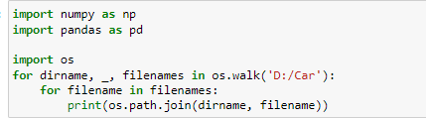

**Figure 1: Importing of libraries in Python**

(Source: Created by the learner in “Jupyter Notebook”)

At first, the libraries are imported and the filename is created. This is done on the software platform “jupyter notebook”.

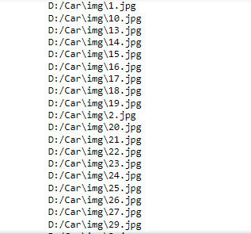

**Figure 2: Output of the images Of the Dataset**

(Source: Created by the learner in “Jupyter Notebook”)

The above figure is representing the output of the images of the dataset.

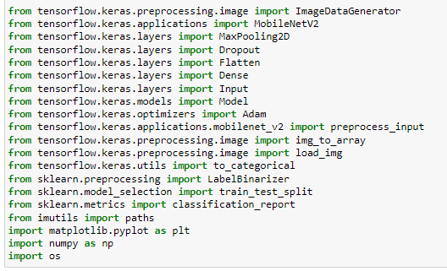

**Figure 3: Importing of libraries in Python**

(Source: Created by the learner in “Jupyter Notebook”)

The above image is representing the libraries that are imported during the writing of codes in order to create the model of detection of the car damage system (Murshed and Chowdhury 2019).

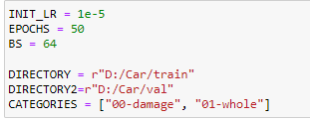

**Figure 4: Directory and category and batch size**

(Source: Created by the learner in “Jupyter Notebook”)

The above figure is representing the batch size which includes the number of epochs and the number of BS.

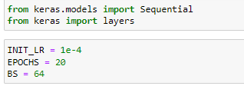

**Figure 5: Importing of libraries and batch size**

(Source: Created by the learner in “Jupyter Notebook”)

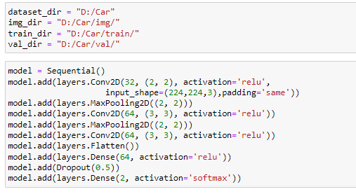

**Figure 6: Dataset folders**

(Source: Created by the learner in “Jupyter Notebook”)

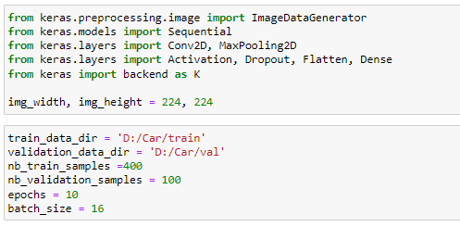

**Figure 7: Importing of libraries and the number of samples**

(Source: Created by the learner in “Jupyter Notebook”)

The above figure is visualizing the number of samples as well as the number of epochs and the size of the batch. The number of train samples is 400, and the number of validation samples is 100. The batch size is 16 and the number of epochs is 10.

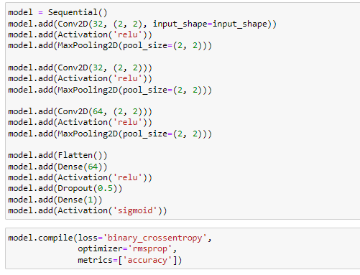

**Figure 8: Compilation of model**

(Source: Created by the learner in “Jupyter Notebook”)

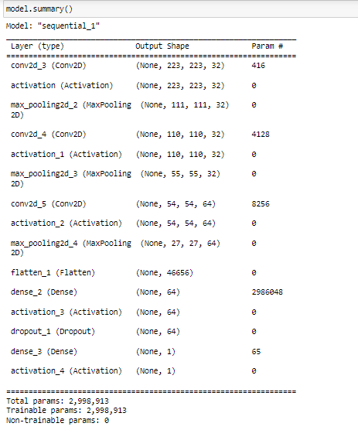

**Figure 9: Summary of model**

(Source: Created by the learner in “Jupyter Notebook”)

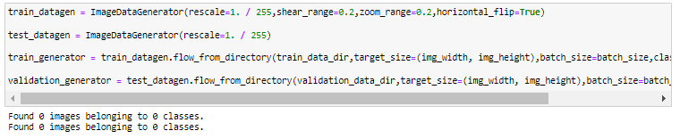

**Figure 10: Classes of images of the dataset**

(Source: Created by the learner in “Jupyter Notebook”)

A few challenges need to be faced during the research work as the dataset that is used here is limited and does not contain a wide range of images and information (Heidari *et al.* 2022). Along with that, the images that are in the dataset contain some pictures with improper angles, low lighting, and low resolution. These factors of images are important in the classification of images as well as for performing Convolution Neural Networks(CNN) on the image dataset (Pathik *et al.* 2022).

# Conclusion

This report on the topic of “automated car damage detection system” is created and discussed. The creation of the system for implementation of the detection system of car damage is automated and there is no requirement for any manual or human effort. The dataset that is used in this project is attached to this report. The entire system for the detection of damaged cars is based on the dataset. The codes that are required for developing this system are written using python programming language on the jupyter notebook. The libraries of python are used here such as NumPy, panda, and more. In addition to that, this research work on system development is developed with consideration of all the legal, ethical, and commercial issues. It can be stated that this report does not evaluate any rules or regulations that are made for the development of any system using machine learning. The model that is created in this research work can be further improved. In order to improve the developed system another dataset can be used which contains a wider range of information or data. The entire system can be developed on the cloud with the use of more durable and secure hardware.

# Reference

Patil, D.D., Shah, T., Konuri, S., Challa, A.K. and Rawool, R., 2019. Car Accident Detection and Car Health Monitoring using IoT. International Journal of Research in Engineering, Science and Management, 2(4), pp.22-26.

Pathik, N., Gupta, R.K., Sahu, Y., Sharma, A., Masud, M. and Baz, M., 2022. AI enabled accident detection and alert system using iot and deep learning for smart cities. Sustainability, 14(13), p.7701.

Azimi, M., Eslamlou, A.D. and Pekcan, G., 2020. Data-driven structural health monitoring and damage detection through deep learning: State-of-the-art review. Sensors, 20(10), p.2778.

Heidari, M.J., Najafi, A. and Borges, J.G., 2022. Forest Roads Damage Detection Based on Objected Detection Deep Learning Algorithms.

Murshed, M. and Chowdhury, M.S., 2019, January. An IoT based car accident prevention and detection system with smart brake control. In Proc. Int. Conf. Appl. Techn. Inf. Sci.(iCATIS) (Vol. 23).