Project

Online Doctor Appointment System

Naviri Manish Chandra

Employee id – 200708

1. **Introduction**

This project primarily revolves around a console-based doctor appointment system.

Its main purpose is to assist customers/patients in booking appointments with doctors.

In this system, customers/patients have the capability to view the available doctors according to their requirements or preferences.

They can then proceed to select a doctor and book an appointment with them for a specific date and time.

1. **Technologies Used**

In this project, we primarily utilized Eclipse Java for developing the Java code.

This choice was made to ensure a streamlined structure for better code readability.

For the database aspect, MySQL was employed to create the necessary tables.

To establish a connection between Eclipse and the MySQL database, the JDBC connector was employed. JDK also used .

1. **System Design**

This discussion primarily revolves around system design, comprising two key components: user interface and MySQL database.

The user interface encompasses the design of the main menu for a doctor appointment system.

On the other hand, the SQL database entails the creation of tables for doctors, patients, and appointments.

1. **SQL Tables and Columns**

**4.1 Doctor Table and column**

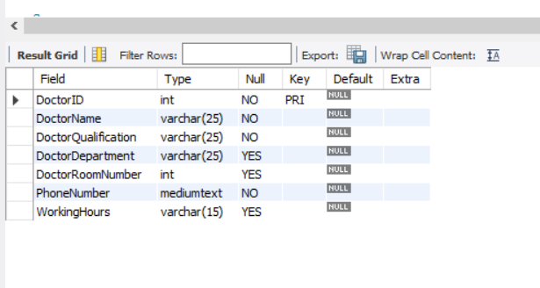

**4.2 Appointment Table and column**

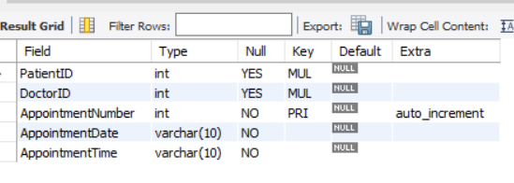

**4.3 Patient Table and column**

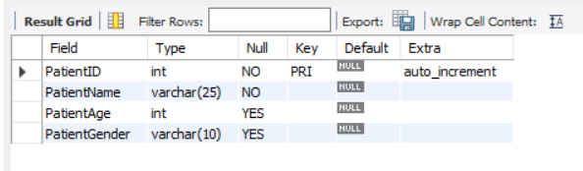

1. **Main Code and Output Snippets**

**Main Menu**

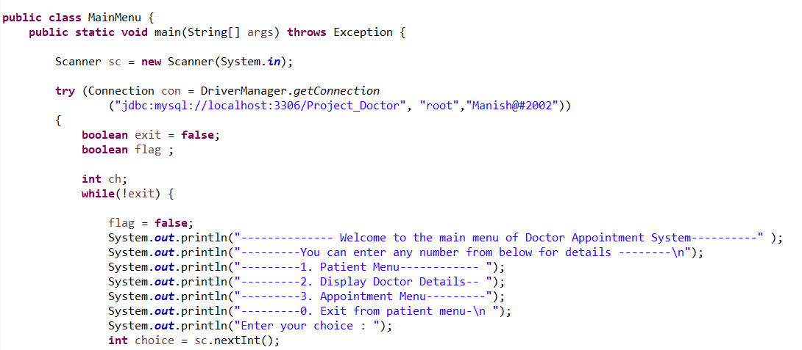

Here u can see main menu of the Doctor Appointment System and see various Choices

In console it looks like

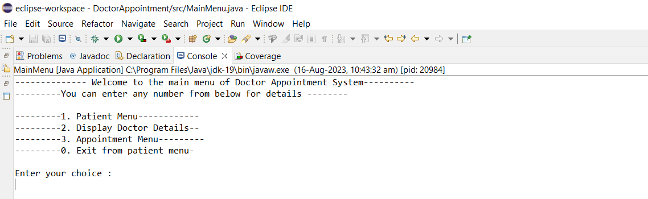

After entering your choice if it is 1 it shows Patient Menu and code for 1 mentioned below

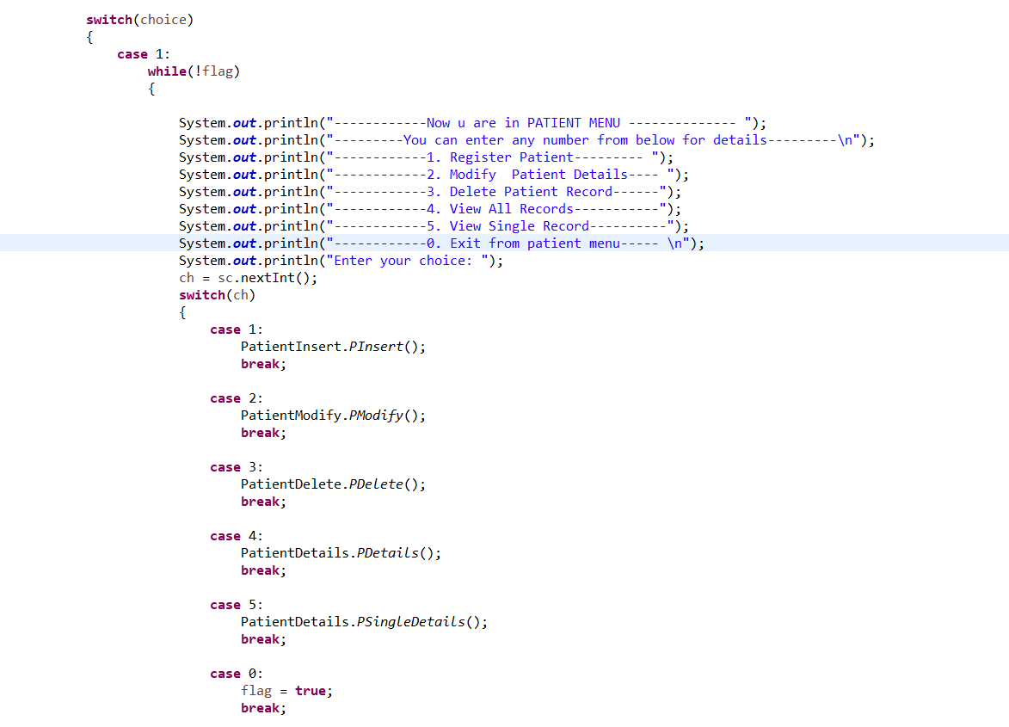

In console it looks like

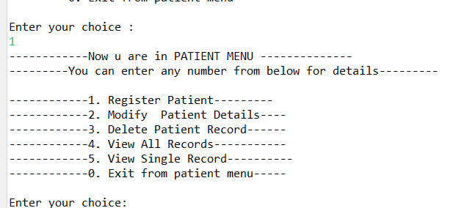

Here the subdivision of the patient menu and different choices are there

If u are entering 1 it shows

Register patient code snippet is

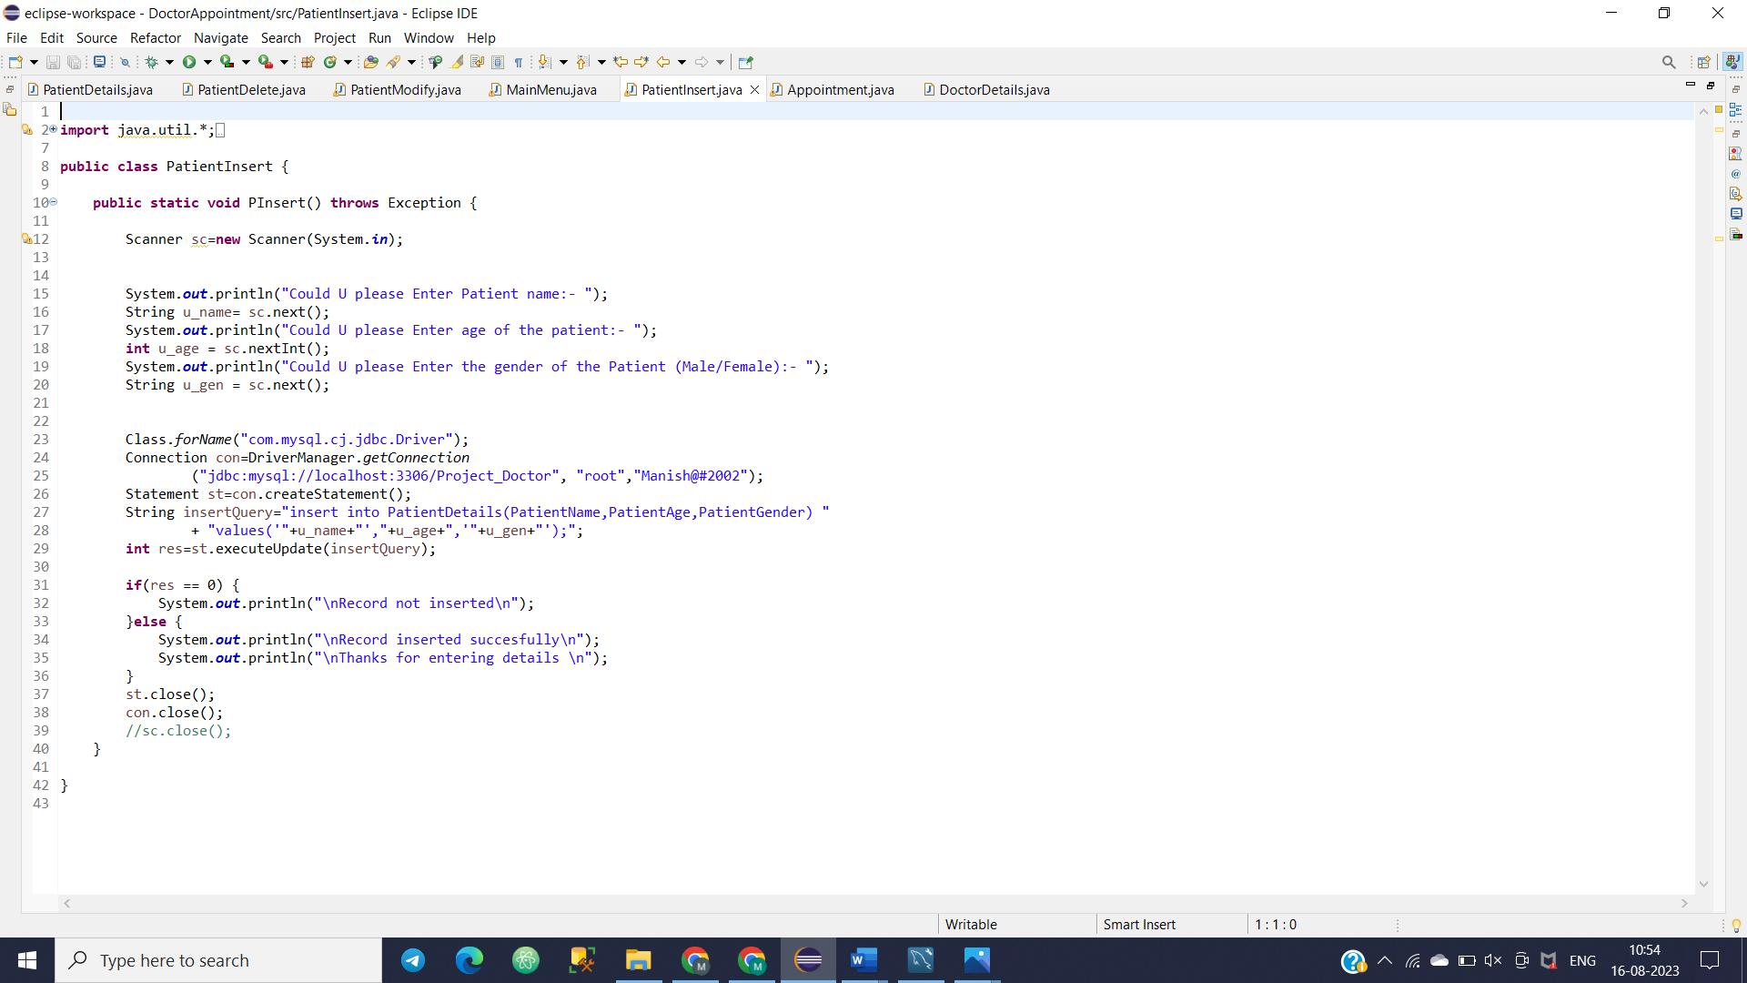

Output

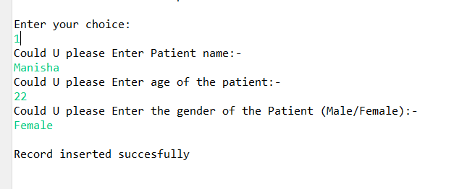

If u enter 2 then u can modify patient details based on id u can change name , age ,gender

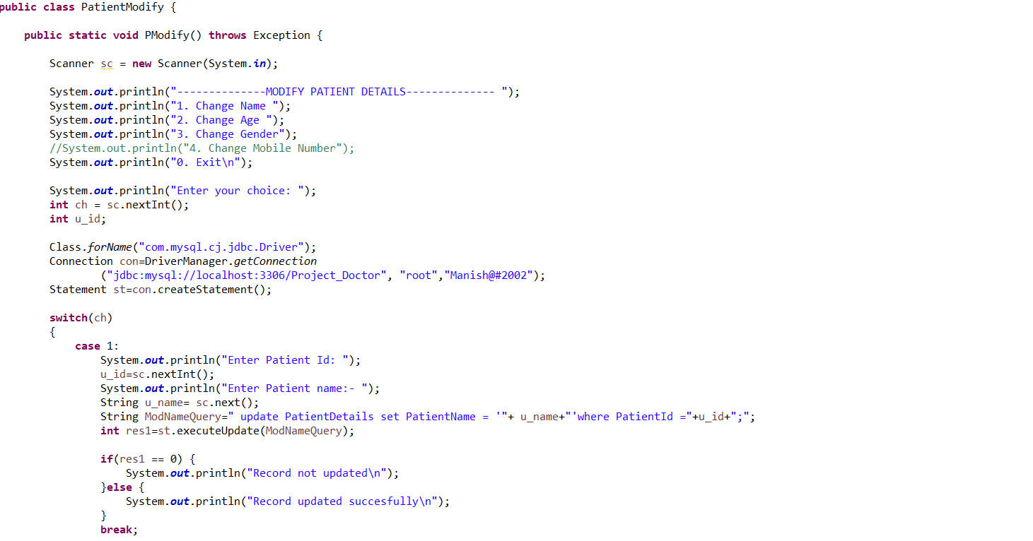

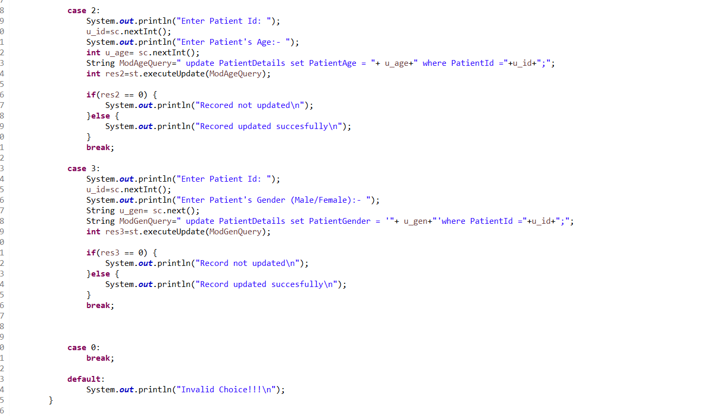

Output

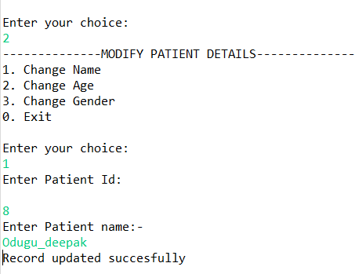

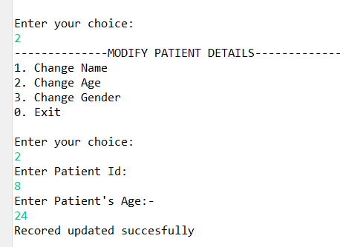

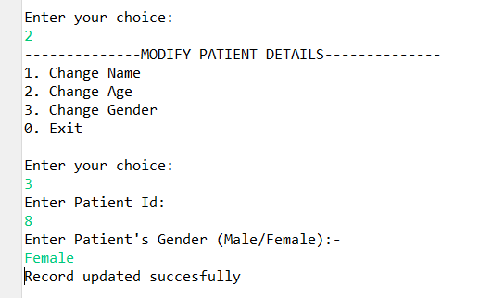

If u enter 3 it shows to delete the code is

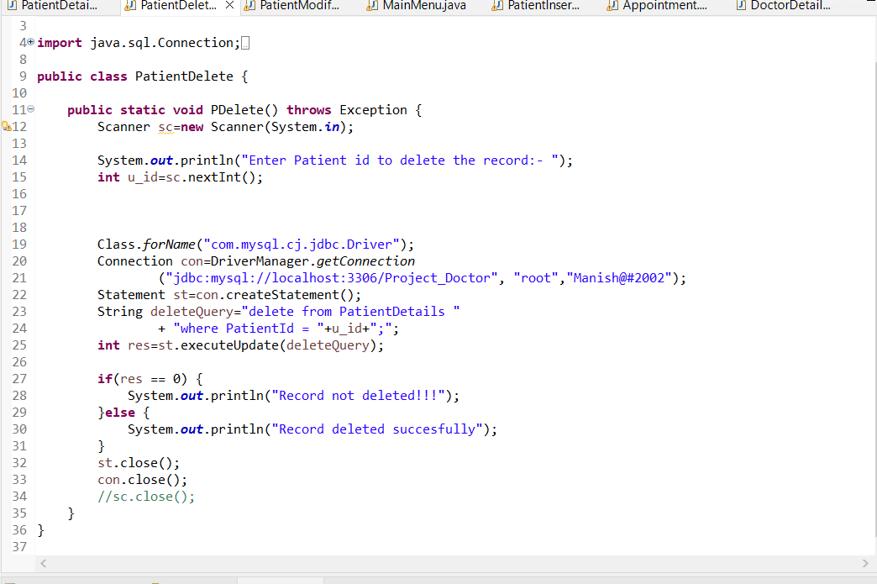

Output Snippet will be

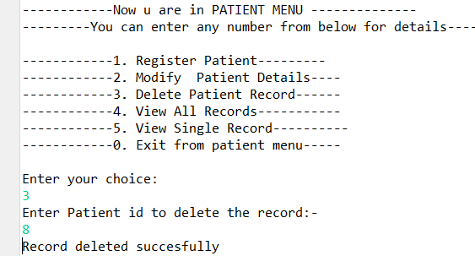

If u enter 4 it displays all records

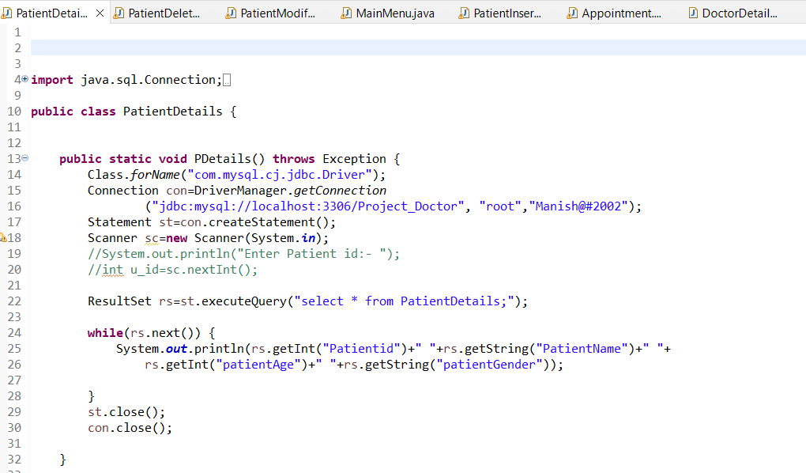

Output snippet

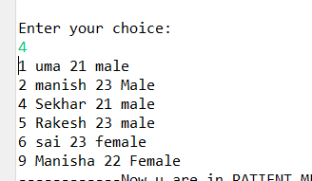

View Single details

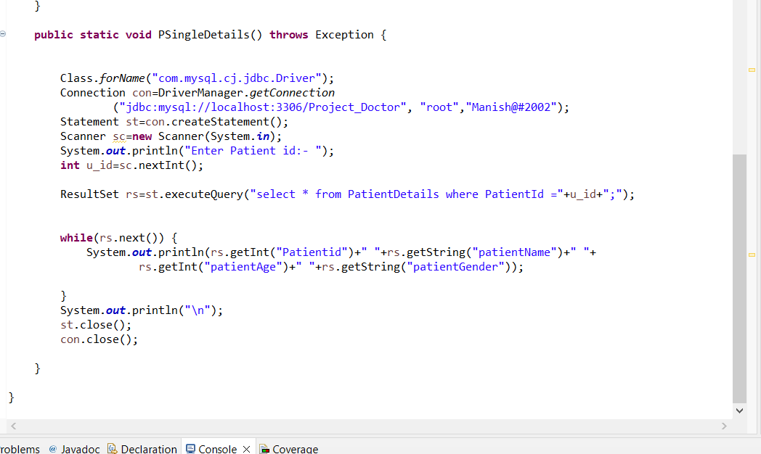

Output

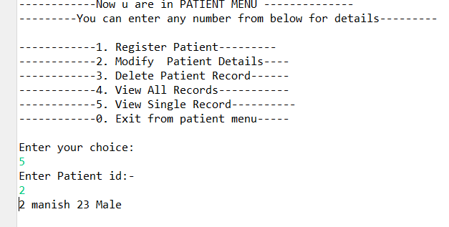

After entering 0 it will exist from patient menu and it reconnects to main menu

If we enter 2 in main menu it shows doctor details

Code is

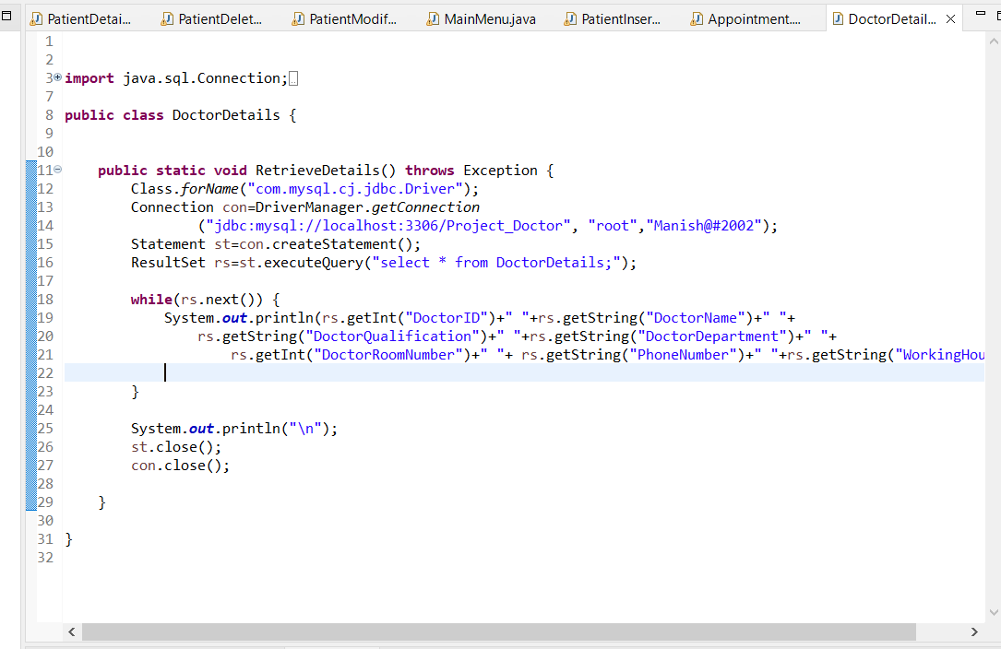

Output of the code snippet is

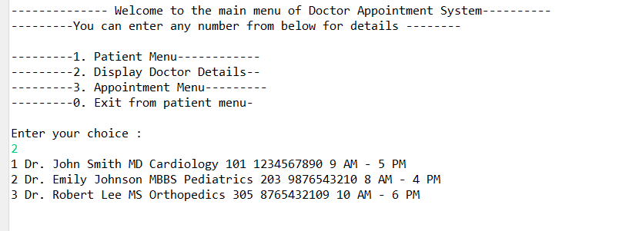

Again returning to the main menu if we enter 3 it enters appointment menu

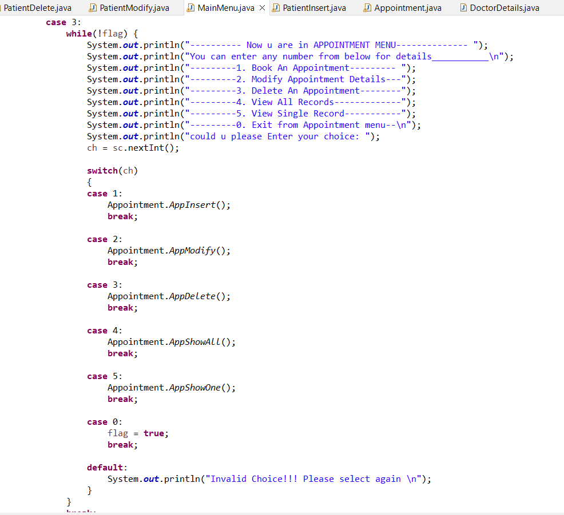

Output is

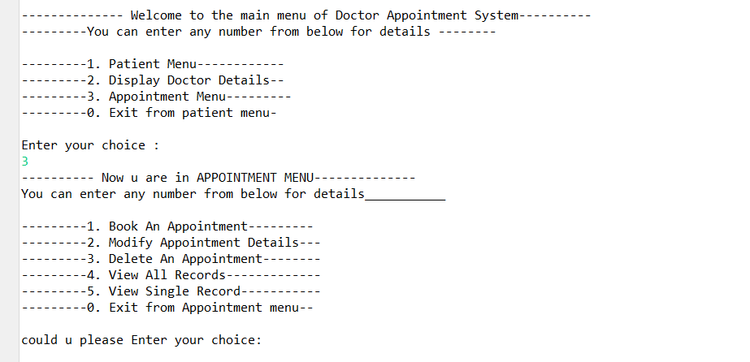

If we enter 1 we can book an appointment code will be

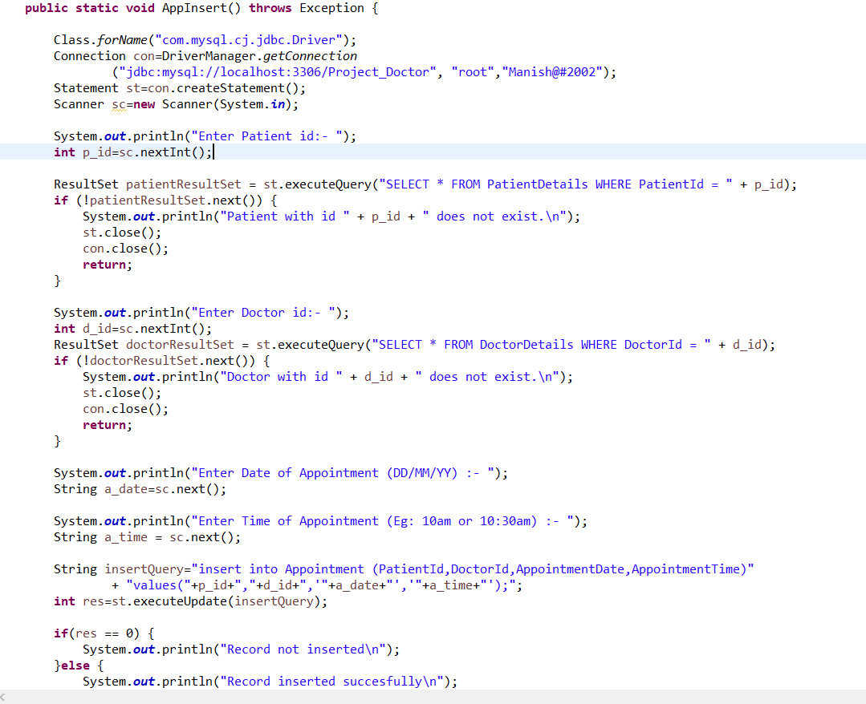

Output of the code will be

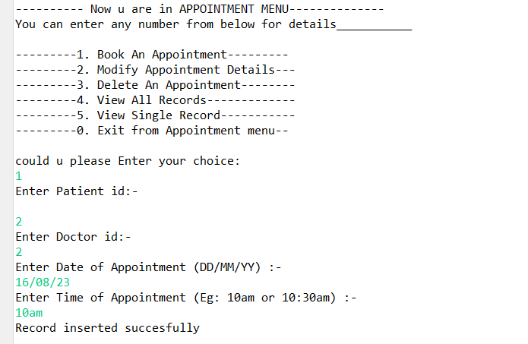

After entering 2

Code will be

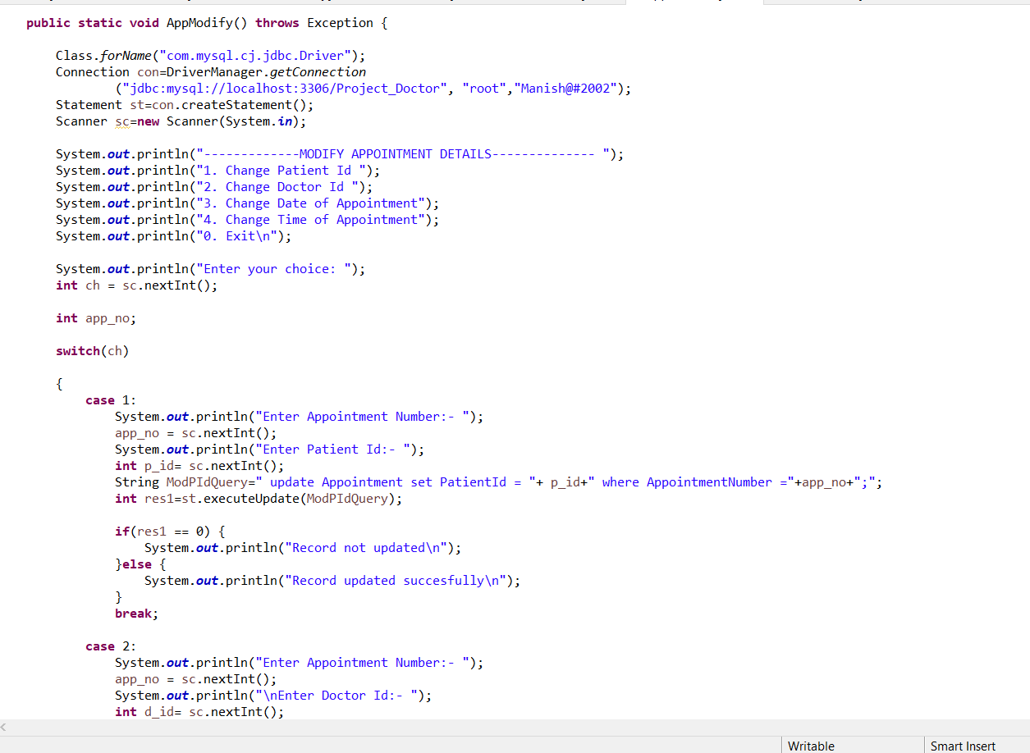

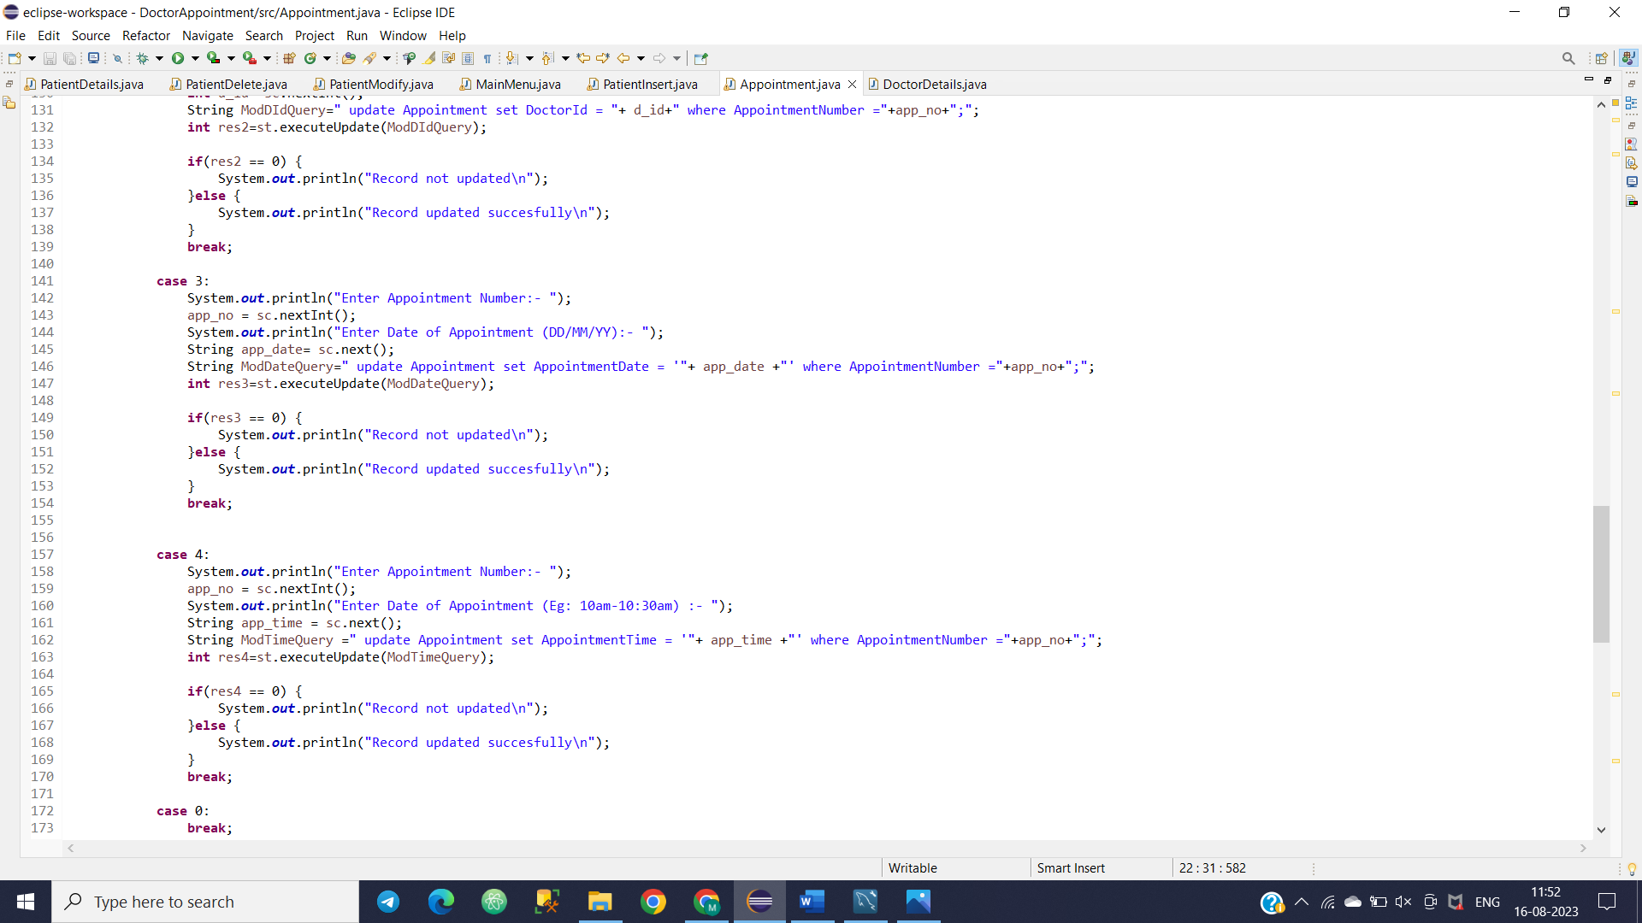

Output snippet is

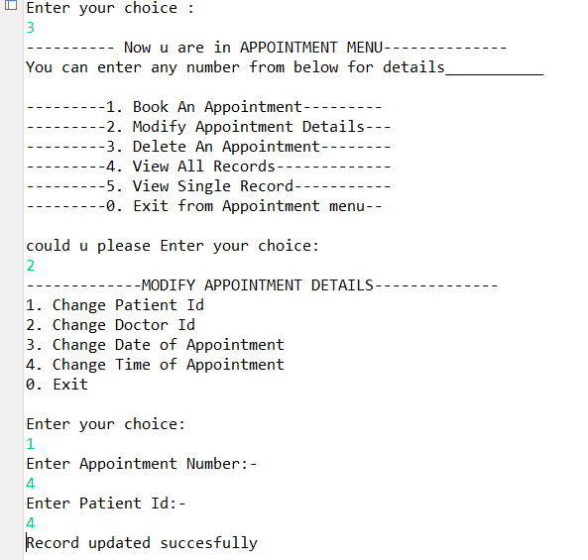

To view all records and view single record total code is

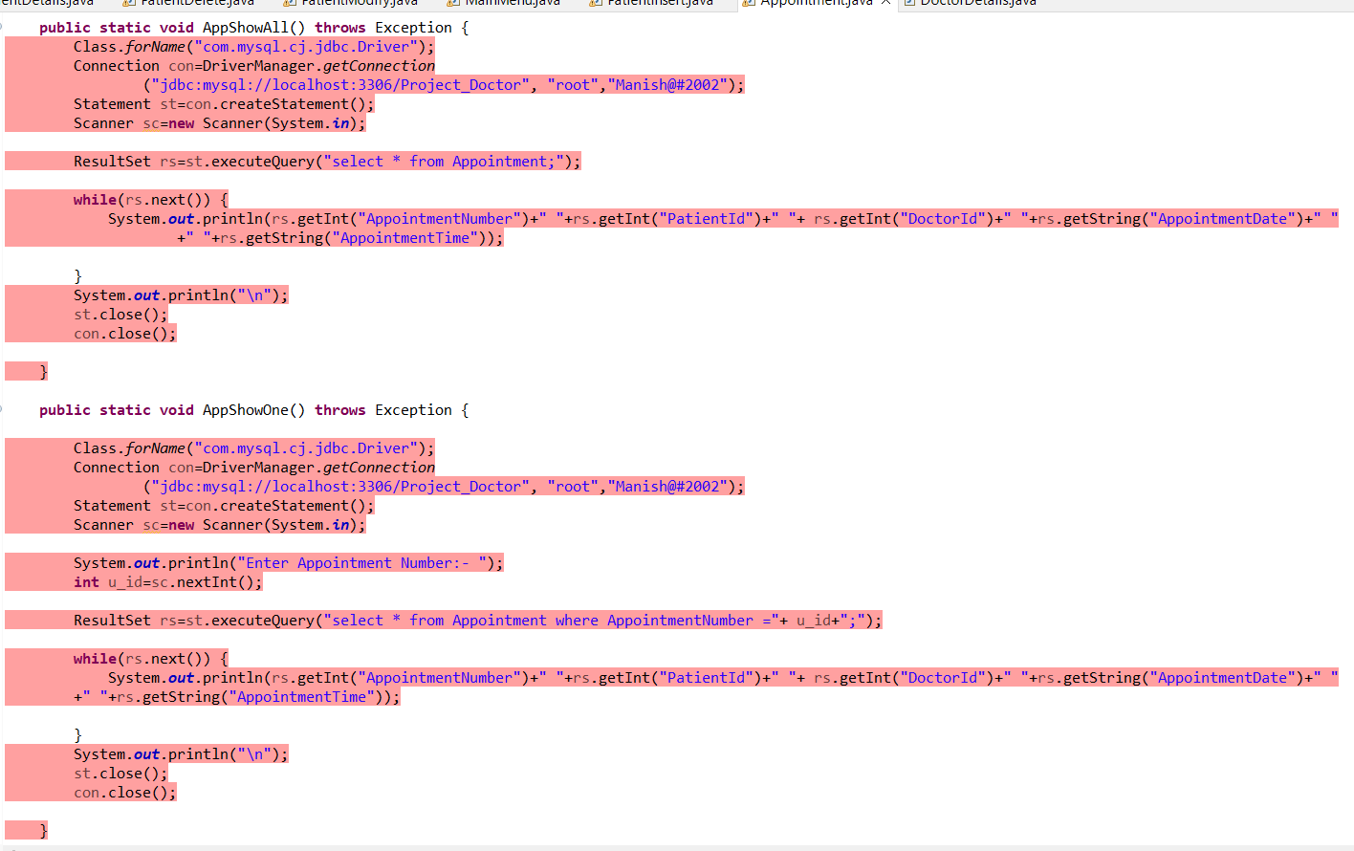

Code out put is

