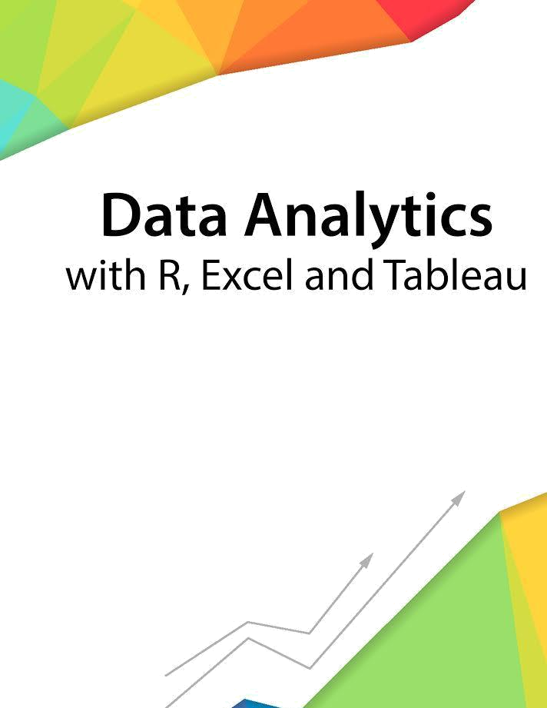

Session 1 - Introduction

Assignment - 1



––

Contents

1. Introduction 2

2. Objective 2

3. Prerequisites 2

4. Associated Data Files 2

5. Problem Statement 2

6. Expected Output 2

Copyrights© 2017, AcadGild. All Rights Reserved | 1

Introduction
This assignment will help you to understand the key concepts learnt in this session.

Objective
This assignment will test your skills on the basics of Data Analytics

Prerequisites
Not Applicable

Associated Data Files
Not Applicable

Problem Statement
1. Say True or False for the below statements:
- Prescriptive Analytics used to predict the future outcomes?
Answer: TRUE
Prescriptive (optimization and simulation) Analytics is used to determine the possible outcomes on “What should we do?” rather “What has happened?” which is done in Predictive Analysis
- Base R packages installed automatically?
Answer: TRUE
R Base package is automatically installed at the time of R Programming Environment setup.

2. What is Recycling of elements in a vector?
Recycling of elements in a vector means that when an operation is performed on two
different vectors of different length, elements of the shorter length vector repeats itself in a loop till
the time it gains the length of a bigger vector, in order to complete the operation.

3. Give an example of recycling of elements.
Example1 > c(1,2,3,4,5,6) + c(1,2)
In case the longer vector is not a multiple of shorter vector, it will give an error message, but the
elements will still repeat itself in a loop or sequence to give the results:
Example2 > c(1,2,3,4,5,6) + c(1,2,3,4)

Expected Output
Output1 [1] 2 4 4 6 6 8
So, now c(1,2) has recycled itself to c(1,2,1,2,1,2) to match the length of c(1,2,3,4,5,6) and the output will be c(1+1,2+2,3+1,4+2,5+1,6+2) = c(2,4,4,6,6,8)

Output2 [1] 2 4 6 8 6 8
Warning message:
In c(1, 2, 3, 4, 5, 6) + c(1, 2, 3, 4) :
longer object length is not a multiple of shorter object length

Copyrights© 2017, AcadGild. All Rights Reserved | 2

