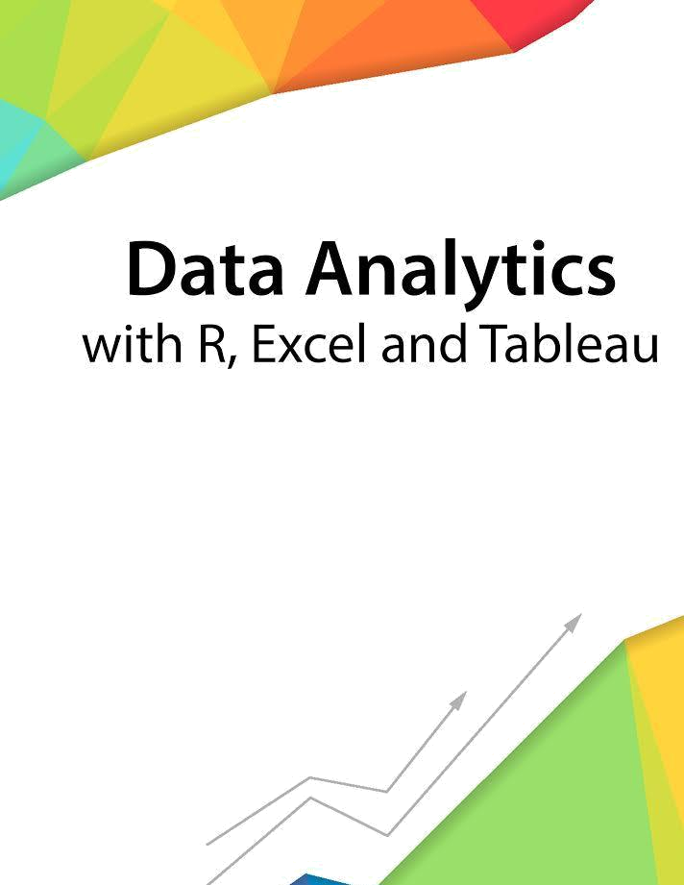

Session 1 – Introduction to Working with R

Assignment - 2


Contents

1. Introduction 2

2. Objective 2

3. Prerequisites 2

4. Associated Data Files 2

5. Problem Statement 2

6. Expected Output 2

Copyrights© 2017, AcadGild. All Rights Reserved | 1

Introduction

This assignment will help you to understand the key concepts learnt in this session.

Objective

This assignment will test your skills on the basics of R.

Prerequisites

Not Applicable

Associated Data Files

Not Applicable

Problem Statement

1. What should be the output of the following Script?

- <- c( 2,5.5,6) t <- c(8, 3, 4) print(v%/%t)
Answer:
> v<-c(2,5.5,6)
> v
[1] 2.0 5.5 6.0
> t<-c(8,3,4)
> t
[1] 8 3 4

> print(v%/%t)
[1] 0 1 1

- You have 25 excel files with names as xx_1.xlsx, xx_2.xlsx,……..xx_25.xlsx in a dir.

Write a program to extract the contents of each excel sheet and make it one df.
Answer:
install.packages("xlsx")
library(xlsx)
> xlsx.writeMultipleData <- function (xx_1.xlsx, xx_2.xlsx, xx_3.xlsx,....xx_25.xlsx)
+ {
+ require(xlsx, quietly = TRUE)
+ objects <- list(...)
+ fargs <- as.list(match.call(expand.dots = TRUE))
+ objnames <- as.character(fargs)[-c(1, 2)]
+ nobjects <- length(objects)
+ for (i in 1:nobjects) {
+ if (i == 1)
+ write.xlsx(objects[[i]], file, sheetName = objnames[i])
+ else write.xlsx(objects[[i]], file, sheetName = objnames[i],
+ append = TRUE)
+ }
+ }
>

- If the above 25 files were csv files, what would be your script to read?
Answer:
> path <- " C:/Users/Manish Chugh/Desktop/New folder"
> files <- c(paste("0",1:9,".csv",sep=""),
+ paste(10:19,".csv",sep=""),
+ paste(19:25,".csv",sep="")
+ )
# read 1st data file
> data <- read.csv(paste(path,"01.csv",sep="/"))

#read remaining file and rbind them to dataset
>for (f in files) {
+ data <- rbind(data,read.csv(paste(path, files, sep="/")))
+ }
OR

> file_names <- dir("C:/Users/Manish Chugh/Desktop/New folder")
> your_data_frame <- do.call(rbind,lapply(file_names,read.csv))

Expected Output

Not Applicable

Copyrights© 2017, AcadGild. All Rights Reserved | 2

The Approximate time to complete this task is 20 Minutes.

Copyrights© 2017, AcadGild. All Rights Reserved | 3

