**--------------------------------------2021----------------------------------------**

**Oracle Integration Cloud (OIC) provides the File Server component--an embedded SFTP server that enables organizations to focus on building integrations without needing to host and maintain a separate SFTP server.**

**Which statement is NOT true about the OIC File Server component?**

A) Access to the File Server REST APIs is limited to only users with the ServiceAdministrator role.

B) Any external SFTP client can access File Server as long as an OIC administrator has configured specific folder access permissions for those clients.

C) To access File Server from an internal OIC integration flow, a Connection resource of FTP adapter type or REST adapter type is used.

D) The File Server component is a feature that is disabled by default in a newly provisioned OIC instance.

**Answer: A -21**

**Which statement is valid regarding Connection components in Oracle Integration Cloud Service (OIC)?**

A) All Connection component configurations require the association of an active OIC Connectivity Agent group.

B) All Connection components must be associated with an adapter type regardless of role configuration.

C) Each Connection component associated with a SaaS adapter type will also require a Lookup component configuration.

D) Connection components can be configured with either a Trigger role or an Invoke role, but not both.

**Answer: B -21**

**With regard to the Oracle API Platform Cloud Service, which two tasks can a user with the Application Developer role perform?**

A) Register gateways

B) Manage applications using Developer Portal

C) Manage service accounts and services

D) Manage Plans

E) Register APIs

**Answer: B, E**

**Your design of an asynchronous OIC integration flow includes the requirement for additional processing logic that is conditionally based on the results returned to the integration instance from earlier external service invocations. You have decided to leverage the switch action to facilitate this implementation.**

**Which is a valid consideration concerning the configuration and capabilities of the switch action?**

A) XPath version 2.0 functions can be used to create more complex conditional expressions for a switch action branch if the function returns a Boolean result.

B) Nested switch actions are not supported, therefore you may need to create more complex conditional expressions if necessary.

C) All branches within the switch action must have a conditional expression defined to include the otherwise branch.

D) Data objects returned from actions within a branch of a switch action will not be visible in the main flow of the integration after the switch action.

**Answer: C -21**

**In the Oracle Integration Cloud (OIC) Process web forms editor, which three background colors are displayed?**

A) Orange for unmatched binding names

B) Red for invalid binding names

C) Blue for unmatched binding names

D) Blue for complex binding names

E) Purple for complex binding names

F) Green for valid binding names

**Answer: B, D, F -21**

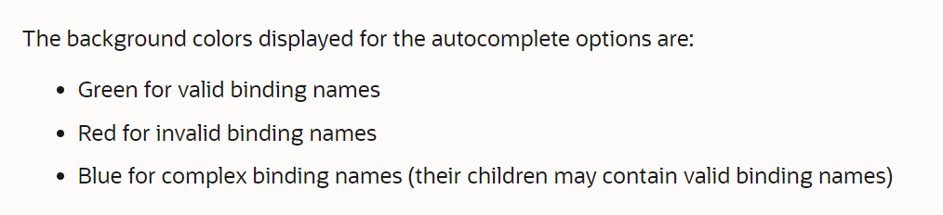

**Which two are valid execution modes supported by the gateway node in API Platform Cloud Service?**

A) Testing

B) Staging

C) Development

D) Production

E) Retired

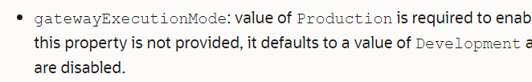

**Answer: C, D**

**With regards to Oracle Integration Cloud (OIC) Lookups, which two are valid statements?**

A) Lookup values are retrieved from a backend database at runtime.

B) Changes that are made to Lookups referenced in active integrations will take effect immediately without reactivating those integrations.

C) A custom OIC XPath function must be used to retrieve data from a Lookup in the Data Mapper.

D) Lookups values must include two or more domains associated with corresponding SaaS applications.

E) You cannot clone an existing Lookup if it is being currently referenced in one or more active OIC integrations.

**Answer: B, D -21**

**You are tasked with creating an Oracle Integration Cloud (OIC) orchestrated integration flow that supports a B2B document exchange. When configuring the B2B action (formerly known as the EDI Translate action), there are several capabilities as well as limitations.**

**Which statement is NOT true about OIC B2B capabilities?**

A) Performing validations on EDI documents is required for inbound translations, but optional for outbound translations.

B) You can customize standard EDI documents by adding new schema constructs or by editing existing constructs.

C) When defining the EDI message type, both the document version and document type must always be explicitly selected.

D) A previously created Trading Partner Agreement is optional when configuring the inbound or outbound translation.

**Answer: D -21**

**In Oracle Integration Cloud (OIC) Process, you can configure a human task that enable you to model approval task interactions. What are the available options when configuring the Escalation and Expiration tab of a human task?**

A) Never expire, Expire, Renew, Escalate

B) Never expire, Expire, Never Escalate, Escalate

C) Expire, Reset, Escalate

D) Expire, Escalate, Skip, Reset

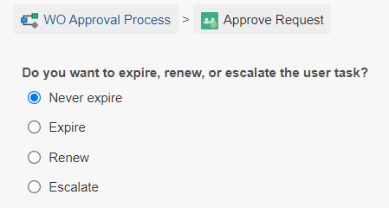

**Answer: A -21**

**You are designing an OIC integration that will be processing files in a shared file system located within your on-premises data center. You have decided to leverage various Stage File Action operations within the integration flow in conjunction with an on-premises OIC connectivity agent.**

**With regard to the restrictions on using Stage File Action operations with the file and attachment features of the Connectivity agent, which statement is NOT valid concerning file operation capabilities?**

A) Files uploaded through the connectivity agent are not available with the List File operation.

B) Files uploaded through the connectivity agent cannot be unzipped using a file reference.

C) Files uploaded through the connectivity agent are not available with the Zip File operation. .

D) With regard to both the Read Entire file and Read File in Segments operations, files uploaded through the connectivity agent can only be read with a file reference.

**Answer: B -21**

**The Oracle Integration Cloud (OIC) integration design editor provides a data mapper UI tool that is available for Map actions.**

**Which two statements are TRUE regarding the use of mapper tool?**

A) You cannot drag and drop a source data element to a target node element that is already mapped.

B) You cannot drag and drop an XPath function activity directly to a target node element.

C) You cannot drag and drop an XSLT flow control statement directly to a target node element.

D) You can drag and drop a source data element to multiple target node elements.

**Answer: A, D -21**

**Integration Insight in Oracle Integration Cloud (OIC) dramatically simplifies the process of modeling and extracting meaningful business metrics, allowing business executives to understand, monitor, and react quickly to changing demands.**

**After a model has been activated, which is NOT a valid model instance state?**

A) Recoverable

B) Failed

C) Healthy

D) Successful

E) Terminated

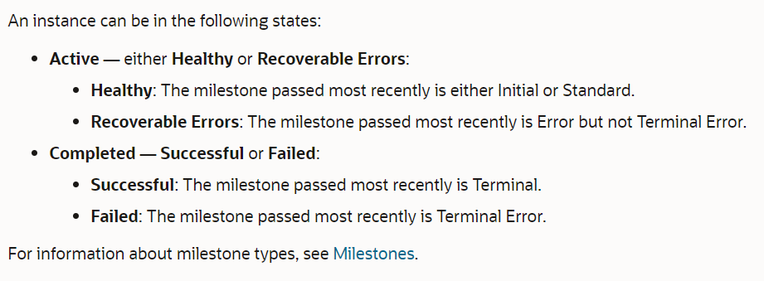

**Answer: E -21**

**When defining the frequency for scheduled orchestration style integration runs you can choose either Basic or Advanced options.**

**Which expression language is used for defining advanced scheduled runs?**

A) XSLT

B) Groovy

C) JavaScript

D) iCal

E) XPATH

**Answer: D -21**

**One of your downstream applications is becoming overwhelmed with too many individual synchronous invocations from your current Oracle Integration Cloud (OIC) integration. It has been recommended that you redesign the integration to take advantage of the batch processing capabilities of the application.**

**Which is the MOST appropriate approach for implementing this OIC design best practice?**

A) Throttle the individual synchronous calls by adding a wait activity prior to each invocation to the application within the loop.

B) Create a custom batch call function, register the function as a Library in your OIC environment, then use the JavaScript action to invoke the application.

C) Reactivate the integration and use the disable tracing and message tracking option which will optimize performance for each invocation to the application.

D) Use the Append option in the write File operation of the stage File action within a loop to create a single batch file to be sent to the application.

**Answer: D -21**

**In Oracle Integration Cloud (OIC) Process, you create web forms to interact with end users. As part of creating a web form, you add its controls, configure its data, and define form behavior.**

**Which statement is true about creating web forms?**

A) You can assign one or more stylesheets and only one presentation to a web form.

B) You can assign one or more stylesheets and one or more presentations to a web form.

C) You can assign only one stylesheet and only one presentation to a web form.

D) You can assign only one stylesheet and one or more presentations to a web form

**Answer: B -21**

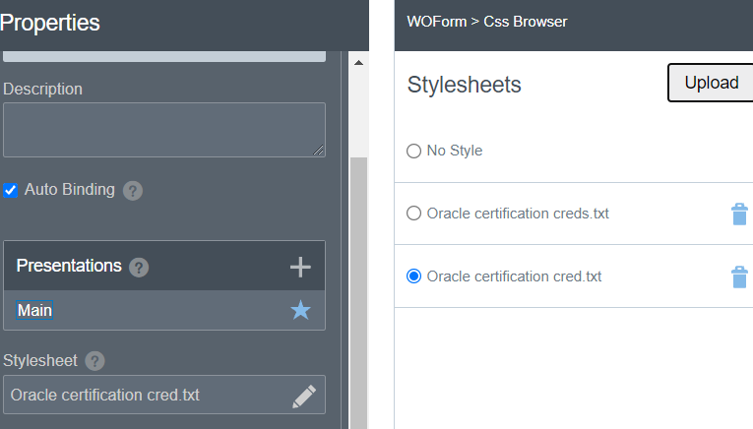

**Oracle Integration Cloud (OIC) integrations can be exported so that they can later be imported into another OIC instance environment. Which statement is NOT true about the import and export of OIC integrations?**

A) Imported integrations can be reconfigured to use different connection resources by using the OIC REST API.

B) Exported integrations will include all of their dependent connection resource information with the exception of URL and credentials.

C) Imported integrations cannot be immediately activated if their dependent connection resources are not already present in the target OIC environment.

D) Integrations must be exported as a package if you want to import them into another OIC environment.

Answer D -21

**Within the scope of an Oracle Integration Cloud (OIC) Process application, which TWO statements are valid concerning Decision Snapshots and Decision Models?**

A) Decision rules are expressed as rows within a table and consist of only one input entry and only one corresponding output entry.

B) Decision snapshots, once activated, cannot be used independently in multiple applications.

C) Decision snapshots are read-only copies of a decision model.

D) A decision model can be activated on a Decision Model and Notation (DMN) server.

E) A decision model snapshot cannot be deleted once it has been activated.

Ans: C, E -21

**Which statement is NOT true about decision models in Oracle Integration Cloud (OIC) Process?**

A) Decisions created using the Function notation return a value only when invoked from another decision.

B) In the Graph view, you can create decision requirement diagrams (DRDs) to visually represent your decision models, but only one DRD per decision model is supported.

C) A decision model must contain at least one decision service in order to be used in a Process application.

D) A decision service exposes output decisions of a decision model as private internal REST APIs to the Process application.

Ans: D -21

**Oracle Integration Cloud (OIC) is a fully managed cloud service that provides many components and use case capabilities when an OIC Enterprise Edition instance is provisioned. Which three capabilities does OIC Enterprise Edition provide?**

A) Model and extract business metrics in real time and gain insight into business processes by using dashboards.

B) Leverage an embedded continuous integration server to automate CI/CD workflow.

C) Leverage an embedded SFTP-compliant repository for storing and retrieving files.

D) Create digital assistants (chatbots) and skills using natural language conversations to facilitate integration with Oracle SaaS applications.

E) Create integrations that use B2B e-commerce, which support the EDI X12 business protocol.

F) Deploy SOA Composite Applications (SCA) developed with JDeveloper SOA Extension and BPEL constructs.

G) Create blockchain networks and deploy blockchain integration applications.

**Ans A, C, E -21**

**Within an Oracle Integration Cloud (OIC) Process application business process, the Integrations flow element provides you an option to easily integrate with other services.**

**Which THREE can be added and managed from the Integrations flow element? \*\*\***

A) OIC invokable dynamic processes hosted within the same OIC environment

B) OCI Functions deployed in the same OCI compartment hosting the OIC environment

C) OIC integrations hosted within the same OIC environment

D) REST Connectors

E) OIC reusable processes hosted within the same OIC environment

F) Web Service Connectors

**Ans C, D, F-21**

**Integration Insight in Oracle Integration Cloud (OIC) provides a business-friendly experience, allowing users to model, collect, and monitor metrics for their business processes.**

**Which statement is NOT true about Integration Insight models?**

A) The model identifier value must be unique and is extracted only once for a model instance and cannot be changed.

B) Model indicators are limited to only one of two types: Dimensions and Measures.

C) Each model instance is a unique occurrence based on the business process that is associated with the model.

D) A model must have both an initial milestone and a terminal milestone created in order to be activated.

E) Integration Insight models can define milestone activities in either OIC Integrations or OIC Process business processes.

F) The activity associated with an Integration Insight model is a model instance.

Ans A -21

**You are assigned to review the specifications of the SOA composite applications that have been deployed to your SOA Cloud Service instance. Part of this analysis requires you to catalog the Service Component Architecture (SCA) components that are implemented within each composite application.**

**Which is a valid SCA component in an Oracle SOA composite application?**

A) Mediator

B) MFT Adapter

C) BAM Adapter

D) B2B Agreement

E) Split-Join

**Ans A**

**To use Integration Insight to map milestones to actions in an Oracle Integration Cloud (OIC) business process implementation, certain prerequisites and conditions must be met. Which is NOT a valid consideration for models and mapping milestones?**

A) Milestones in a single model can be mapped to multiple business processes.

B) Extraction criteria for the milestone indicator is defined with an XPath expression.

C) A business process implementation can be mapped to milestones within only one model.

D) Extraction criteria for the instance unique identifier is defined with an XPath expression.

E) The model must be in Draft state in order to map a milestone to an integration action.

Ans C -21

**When creating integrations in Oracle Integration Cloud (OIC), a visual mapper enables you to map element nodes between applications by dragging source element nodes onto target element nodes.**

**Which statement is NOT true about the OIC data mapper functionality?**

A) When you navigate to the mapper, the Expression Builder launches in user-friendly mode by default when you select a target element.

B) All Source and Target data objects will be represented internally as JSON structures.

C) The data structure for the target service is always displayed on the right side in the Designer view.

D) In the Designer view, the Sources section contains the data structures of all available data objects to include integration metadata, tracking variables, global variables, and integration property values.

E) All transformation mappings use extensible Stylesheet Language (XSL).

Ans B -21

**﻿**

**Which adapter is NOT provided in the Oracle Cloud adapter pack bundled with the Oracle SOA Cloud Service?**

A) Oracle ERP Cloud Adapter

B) SuccessFactors Adapter

C) Salesforce Adapter

D) Oracle E-Business Suite Adapter

Ans D -21

**You can group one or more Oracle Integration Cloud (OIC) integrations into a single structure called a package. Which statement is NOT true about OIC packages?**

A) Packages cannot be locked to deny other users access to your integrations.

B) Integrations do not need to be part of a package.

C) You can import packages directly from the Oracle Marketplace.

D) New packages can be created by clicking the Create button on the Packages page in the OIC console.

F) Packages enable you to easily Import and export a group of Integrations to and from OIC.

F) All packages must include at least one integration.

Ans D

**You are creating a new Process application from scratch in Oracle Integration Cloud (OIC) and you now choose to create a new structured process. Although you can change the type by editing the process, what is the default Process Type if it is not changed?**

A) Asynchronous Service

B) Reusable Process

C) Synchronous Service

D) Manual Process

Ans C

https://docs.oracle.com/en/cloud/paas/integration-cloud/user-processes/structured-processes.html#GUID-2080743F-61AA-4D41-B5BA-B80E2F8F903A

**You are tasked with provisioning a Managed File Transfer (MFT) Cloud Service on Oracle Cloud Infrastructure (OCI). Which statement is valid concerning MFT provisioning?**

A) You must include the B2B cluster configuration since the MFT service runs within the B2B framework.

B) MFT requires creating an Oracle SOA Cloud Service instance and choosing "MFT Cluster" as the service type.

C) Defining virtual machines (compute nodes) for the WebLogic Server cluster is no longer required.

D) Because MET requires an Oracle ATP database, the database instance must first be provisioned in OCI.

Ans B -21

**When creating a new Oracle Integration Cloud (OIC) Connection resource, there are several steps that must be done before the Connection resource is fully configured and can be used in an integration flow. Which of task is NOT required in order to transition a new Connection resource from the Draft to the Configured slate?**

A) Configure the required Security properties

B) Specify the Connection role

C) Specify the corresponding Lookup

D) Configure the required Connection properties

E) Specify an adapter type

F) Execute a successful test of the Connection

Ans C

**Which statement is NOT true about Schedule Parameters in Oracle Integration cloud (OIC) Integration flows?**

A) Updates to Schedule Parameter values can be made manually when starting a schedule.

B) Updates to Schedule Parameter values made dynamically In an Assign action will not persist on to the next Instance run of the Integration.

C) Updates to Schedule Parameter values can be made manually before submitting an ad hoc request.

D) Schedule Parameters are always visible as an additional data source In the Sources section of the mappers and expression editors within the Integration.

E) Schedule Parameters can be used only in scheduled Orchestration style Integrations.

Ans B -21

**Which two are NOT start and end events when creating a structured process In an Oracle Integration Cloud (OlC) Process application?**

A) None start event and None end event

B) Message start event and None end event

C) SOAP start event and None end event

D) Task start event and Task end event

E) Form start event and None end event

Ans C , D -21

**Oracle Integration Cloud Service (OIC) Is available In two editions: Standard and Enterprise. Which OIC Enterprise edition capabilities are ALSO available In the OIC Standard Edition? (Select two).**

A) B2B Trading Partner Agreements

B) Integration Insight

C) Process Applications

D) Enterprise Application adapters (such as EBS, JOE, SAP, and Siebel)

E) File Server

F) Visual Builder

<https://docs.oracle.com/en/cloud/paas/integration-cloud/integration-cloud-auton/oracle-integration-editions.html?embed=1>

Ans E F

**You have a single synchronous integration flow updating systems with several external invocations within multiple loops. Several client applications are experiencing blocking timeouts waiting for confirmation of the complex processing logic.**

Which is a legitimate strategy to mitigate this issue?

A) Increase the blocking timeout within the OIC integration settings to allow for extended time

B) Change to an asynchronous flow that provides a notification when processing is complete

C) Split into smaller integration flows that can be orchestrated sequentially from a master synchronous flow.

D) Change the implementation logic to invoke multiple fine-grained external API calls within a single loop.

Ans D

**You are tasked with provisioning a Managed File Transfer (MFT) Cloud Service on Oracle Cloud Infrastructure (OCI). Which statement is valid concerning MFT provisioning?**

A) MFT requires creating an Oracle SOA Cloud Service instance and choosing "MFT Cluster" as the service type.

B) Because MFT requires an Oracle ATP database, the database instance must first be provisioned in OCI.

C) Defining virtual machines (compute nodes) for the WebLogic Server cluster is no longer required.

D) You must include the B2B cluster configuration since the MFT service runs within the B2B framework.

Ans A -21

**You can recover unsaved changes In an Oracle Integration Cloud (OIC) integration that crashes during design time because of a browser crash, loss of network connectivity, or a server going down. Which statement Is NOT true about this unsaved changes feature In OIC?**

A) Changes made while editing a Connections page cannot be recovered.

B) Changes made while working inside the data mapper cannot be recovered.

C) Only the person with the Service Developer role that made the changes or an admin with the service Administrator role can recover the unsaved changes.

D) Because a backup copy is created after each completed task, there is no time limit in which you need to log back in and recover your changes.

E) All OIC administrator with the service Administrator role can unlock an integration that has unsaved changes.

Ans C -21

**Which three actions once they have been configured are allowed to be repositioned from another location within the design canvas of an orchestration style integration flow?**

A) Stage File with Write File operation

B) Stage File with Read File operation

C) Switch

D) Stage File with Read File in Segments operation

E) For Each

F) JavaScript Call

Ans A, B F -21

**In Oracle Integration cloud (OIC) Process, you can use human tasks to model user interaction with the application. You can assign the task to a specific user, to a group of users, to users with a certain role, or to the same user that already acted on the instance for a certain role.**

When assigning the human task based on a dynamic expression, which is a valid option?

A) You can use an expression to calculate the user or group, but not a shared role.

B) You can use an expression to calculate the user, group, or a shared role.

C) You can use an expression to calculate a shared role, but not users or groups.

D) You can use an expression to calculate the group or shared role, but not specific users.

E) You can use an expression to calculate a specific user but not a group or a shared role.

Ans B

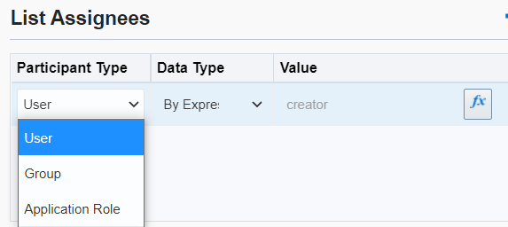

-21