FORWARD-BACKWARD-COUNTER
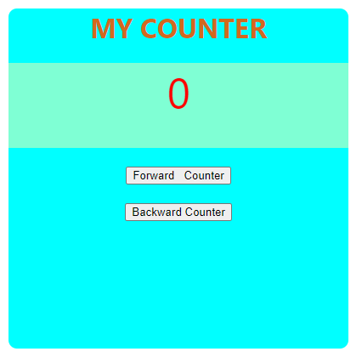
https://counter-1a5fa.firebaseapp.com/

TO DO LIST-WITHOUT DATABSE
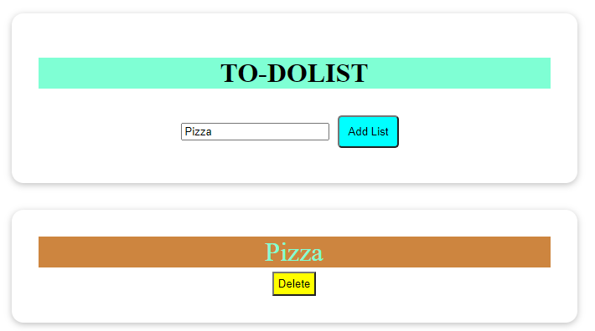
https://react-http-37a2c.firebaseapp.com/

EXPENSE TRACKER

https://expensetracker-3e27f.firebaseapp.com/

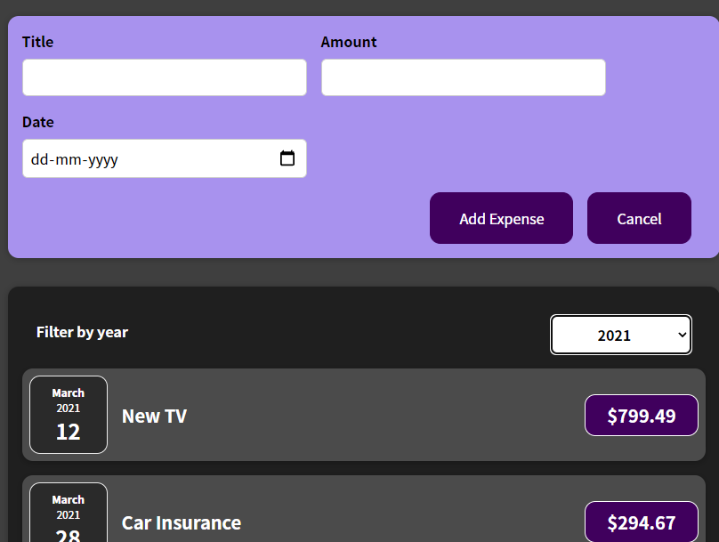
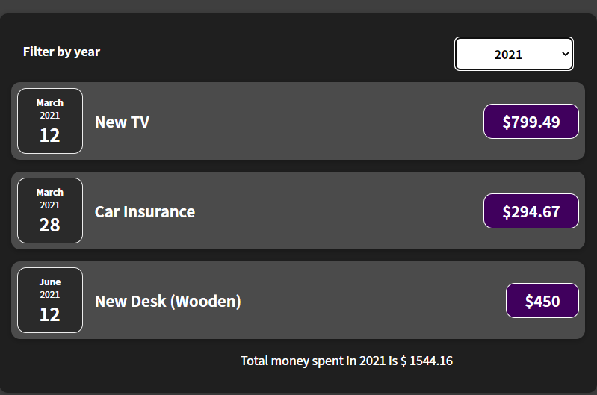

TODO LIST USING FIREBASE AS DATABASE
(*Link not given as I use it often*)
Clicking on Add list add the list,and refreshes the page to get list from database,
delete all delete all the list on the database, and refreshes the page and we see all item deleted.
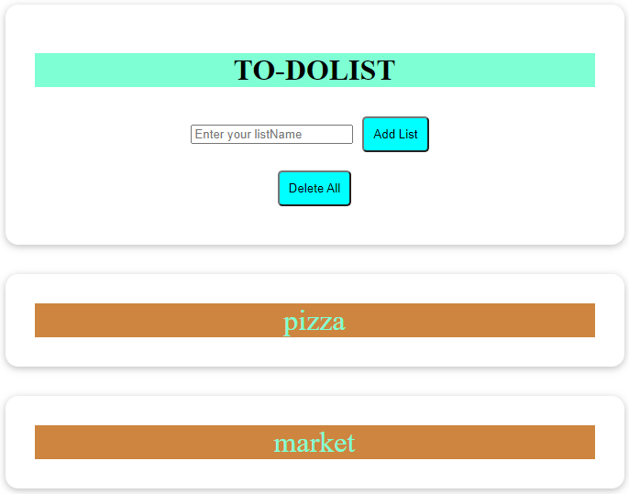
Post delete all
