Git Repository Details:
URL- https://github.com/Manishjoshi652/TestProject_Pharma.git
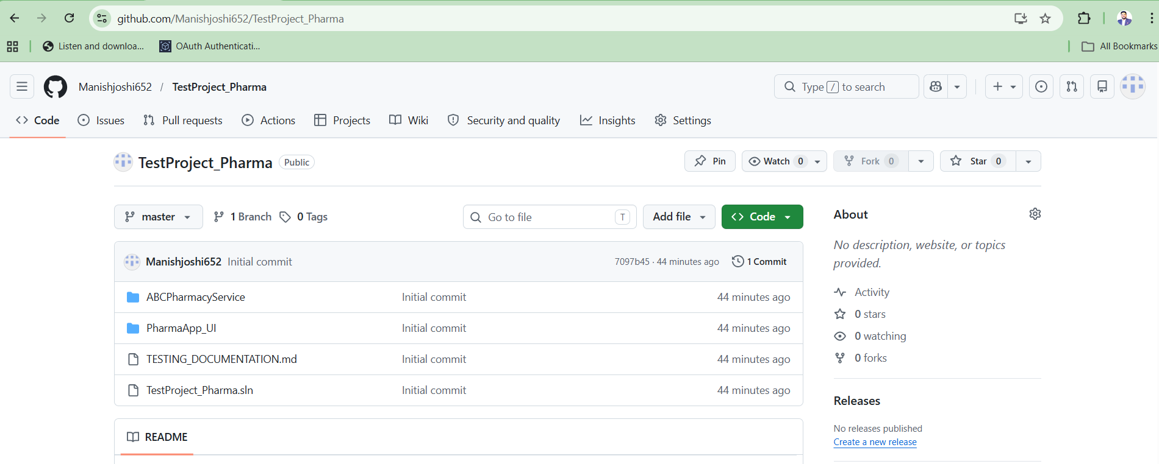

Back end application-
Important step:
Create a .Net Core New application for this Command
dotnet new webapi -n “AnyNewAppName”

- Using .net core 9.0
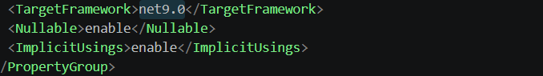
- Using swagger for test API
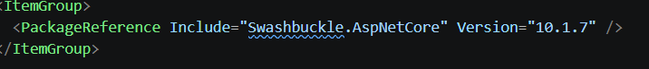
- Implementing CORS for restrictions of Origins calls
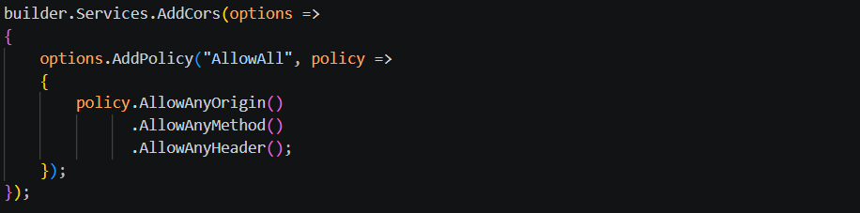
- For Data storage using JSON file-
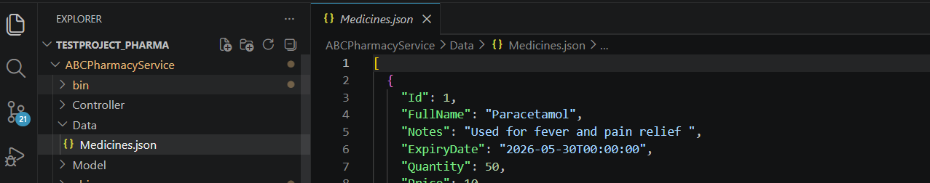
Running app steps:
- Run command on application path
---- cd ABCPharmacyService
Run Command for Build app
----- dotnet build

Run Command for run application
------- dotnet run

API Test Screens from Swagger:
- GETMedicine API()

Curl
curl -X 'GET' \
'http://localhost:5273/api/Medicines/GetMedicines' \
-H 'accept: */*'

Request URL
http://localhost:5273/api/Medicines/GetMedicines

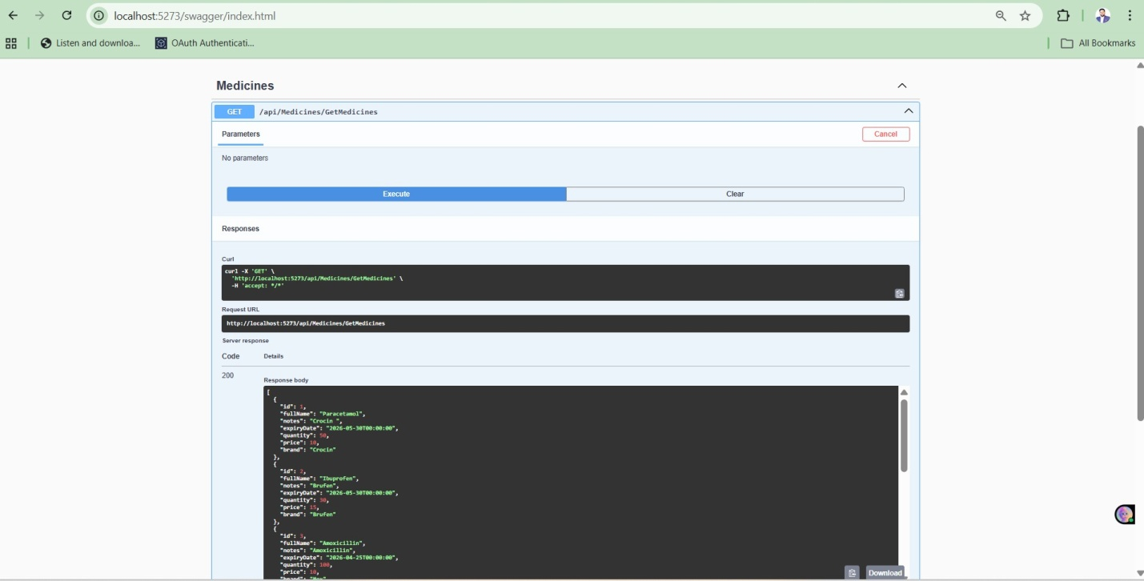
- AddMedicineAPI

Curl
curl -X 'POST' \
'http://localhost:5273/api/Medicines/AddMedicine' \
-H 'accept: */*' \
-H 'Content-Type: application/json' \
-d '{
"id": 0,
"fullName": "TestPharma1",
"notes": "TestPharma1",
"expiryDate": "2026-04-20T09:18:32.178Z",
"quantity": 10,
"price": 20,
"brand": "TestPharma1"
}'

Request URL
http://localhost:5273/api/Medicines/AddMedicine

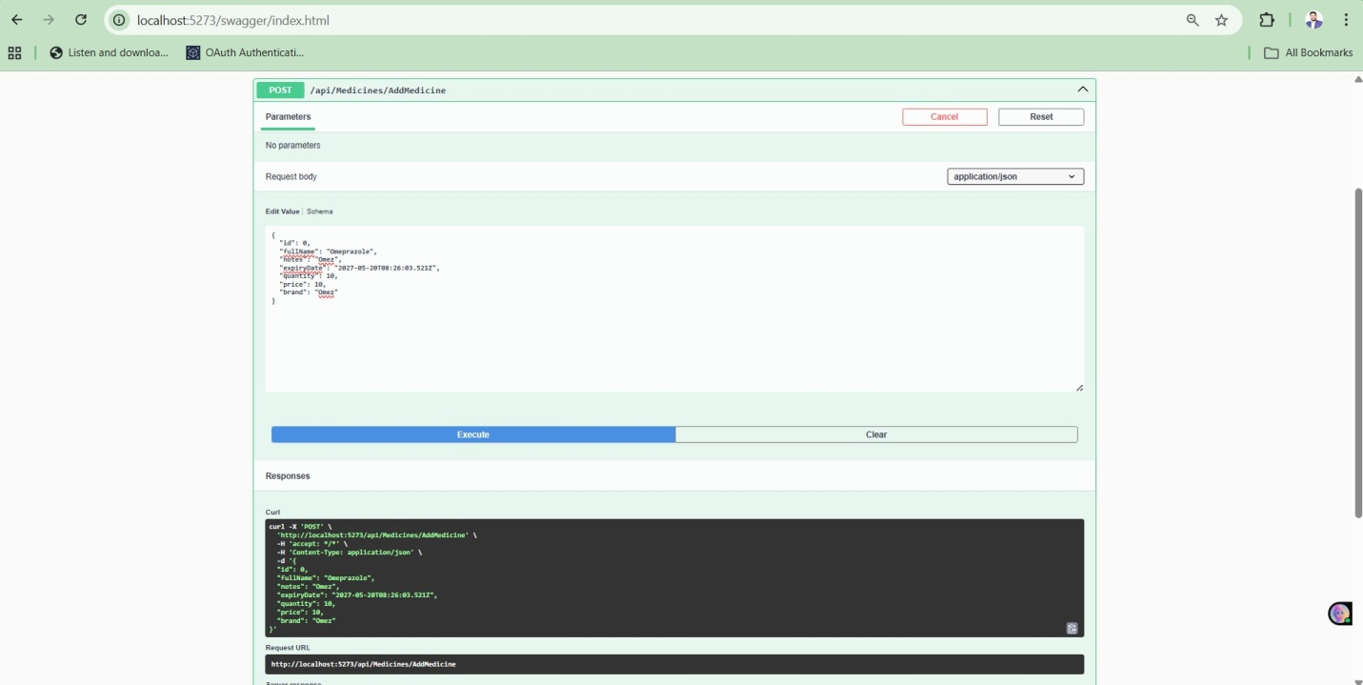
Front End application:
Using angular in front end app development
Important: S/w requirement or Steps for running angular app
- Install Visual Studio code editor
- Install node package
- Configure git repo
- Open application into the editor
- Run command on application path
---- cd PharmaApp_UI
Run Command for get Node folder in application
------ npm install -g @angular/cli
Run command for build application
--- ng build
Run command for Run application in Default port-4200
----- ng serve

`
Screens:
- Medicine Dashboard Screen:
Display the list of medicines available in System
- The results showing the medicine attributes (except Notes) should be displayed in a grid.
- There should be color indications which follow the guidelines mentioned below:
- Red background for medicines with expiry date less than 30 days
- Yellow background for medicines with quantity in stock less than 10
- Page should have search capability which can query on name of medicine attribute.

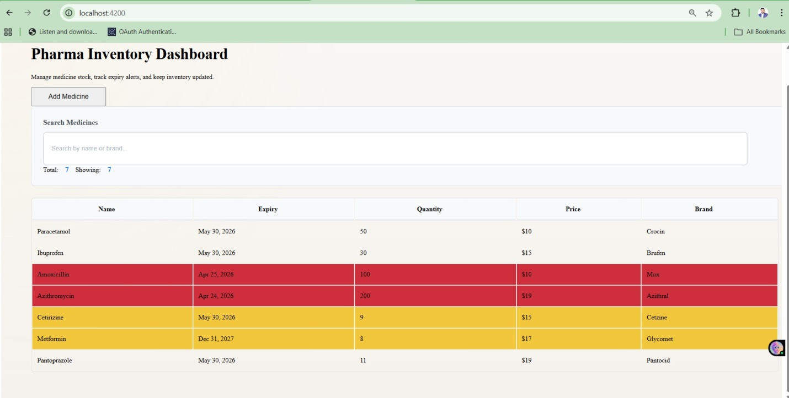

2. Add Medicine Screen:
Add medicine form attribute:
Medicine Attributes:
- Full Name of the medicine - text
- Notes - text
- Expiry Date – Date
- Quantity - number
- Price –number with 2places decimal
- Brand - text

