AI WEATHERWISE - Deliver
intelligent weather forecasts and insights.

Team ID: SWTID-2026-5185
Team Size: 4
Team Leader: MANISH KUMAR
Team Member: ASHFAQ.I
Team Member: SAI KUMAR.A
Team Member: NASEER AHAMAD
Deliver Intelligent Weather Forecasts and Insights
PROJECT DOCUMENTATION
RESTful Backend Platform • Node.js • Express.js • MongoDB • Mongoose • Gemini AI
1. Project Description
AI WeatherWise is a robust RESTful backend platform built with Node.js and Express.js, using MongoDB and Mongoose ODM for data persistence. It delivers real-time weather metrics integrated with Google Gemini AI to provide intelligent summaries and personalized recommendations based on live environmental conditions.
The platform provides secure JWT authentication, bcrypt password hashing, endpoints for managing favorite locations, and weather insights. It also includes fallback behavior when external API keys are unavailable, centralized error handling, and request sanitization.
2. Scenario-Based Case Study
Background
Alex is a travel enthusiast who frequently visits different cities and needs a streamlined way to track local weather conditions and receive AI-driven activity suggestions based on current forecasts.
Problem
- Difficulty tracking and managing multiple favorite weather locations efficiently.
- Lack of personalized recommendations for outdoor activities or clothing.
- Need for natural-language weather summaries rather than only raw data metrics.
- Absence of a secure system to store and synchronize preferences across devices.
Solution
AI WeatherWise provides a centralized service for weather-data retrieval and AI orchestration. It manages a secure User and Location database and supports customized insights and automated recommendation workflows through Google Gemini.
Usage
- User Usage: Manages favorite cities (CRUD), fetches real-time weather, and requests AI insights.
- Developer/Admin Usage: Monitors API health, manages global user registrations, and verifies weather/AI integrations.
- Weather Application User: Uses public weather endpoints to consume current metrics without requiring an account.
Outcome
By leveraging AI and centralized data management, users spend less time interpreting raw metrics. The system maintains data integrity through Mongoose schemas and provides context-aware weather advice through Gemini integrations.
3. Software and Hardware Requirements
Requirement Specification
Operating System Windows 10/11, macOS, or Linux
Node.js Version 16 or above
npm Version 8 or above
Gemini AI SDK Gemini integration
MongoDB Document-oriented NoSQL database
Postman API verification and testing
Code Editor Visual Studio Code or similar IDE
Processor Intel Core i5 (8th Gen+) / AMD Ryzen 5 or equivalent
RAM 8 GB minimum; 16 GB recommended
Storage At least 1 GB available disk workspace
4. Epic 1 — Project Architecture
The application follows the MVC pattern to decouple business logic from data management. The Controller layer orchestrates weather fetching and AI insight generation, while the Model layer manages User and Location entities.
Figure 1. MVC architecture pattern used by the backend.
Components Definition
- Interface: Postman or similar API tools query route paths and extract JSON entities.
- Express Server Gateway: Handles ports, GET/POST/PUT/DELETE methods, JSON payloads, and CORS.
- Authentication & Role Middleware: Validates tokens and protected resources.
- Database Interface Layer: Mongoose translates application operations into MongoDB queries.
- AI Service Integration: Gemini generates weather summaries and personalized recommendations.
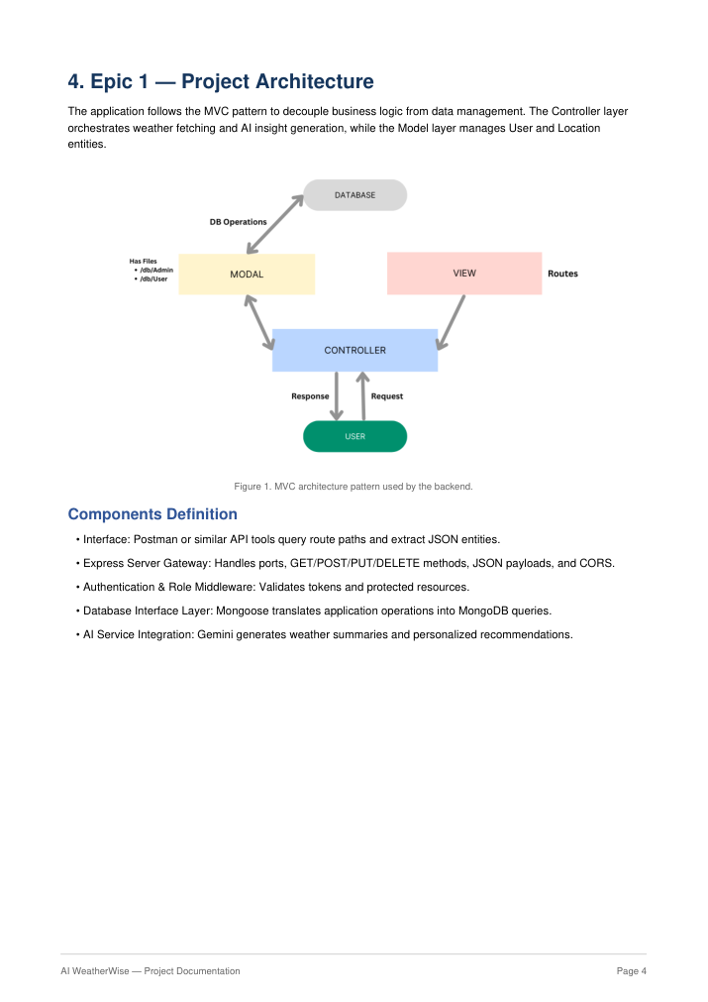
Visual reference from the original PDF
Figure 2. Overall backend architecture and component flow.
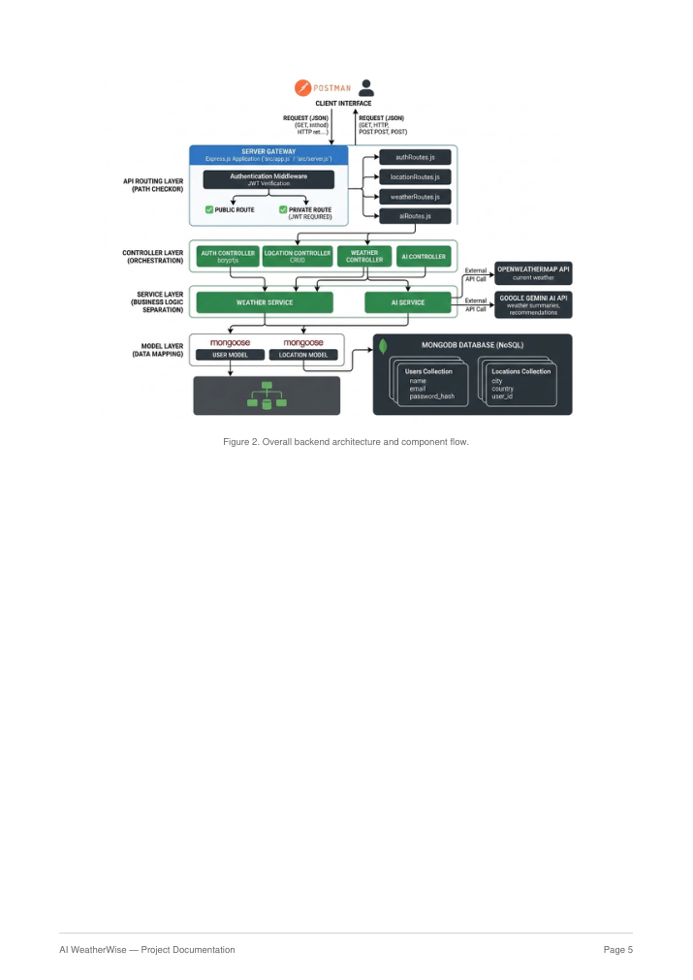
Visual reference from the original PDF
5. Entity-Relationship and Database Design
The data architecture manages User profiles and their associated favorite Locations through logical references.
Figure 3. WeatherWise MERN backend database/entity relationship diagram.
User Entity
- _id — Primary Key (ObjectId)
- name — String, Required
- email — String, Required, Unique
- password — String, Hashed, Required
- role — String, Default: "reader"
Location Entity
- _id — Primary Key (ObjectId)
- user — Foreign Key referencing User Collection
- city — String, Required
- country — String, Required
- createdAt — Date, Default: Now
Key Structural Mapping
User to Location (One-to-Many): A registered user can save multiple favorite locations.
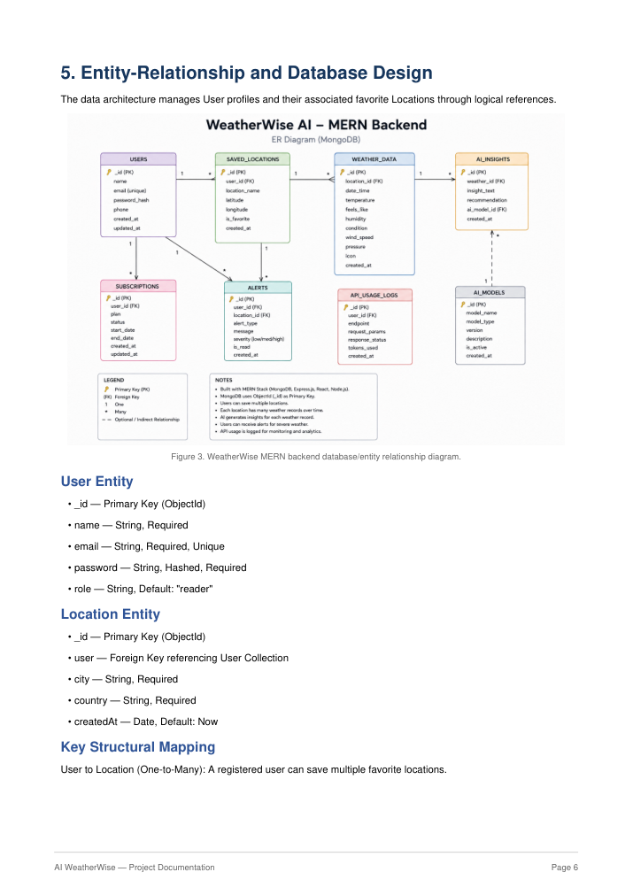
Visual reference from the original PDF
6. Key Features and User Flow
- Role-Based Route Guarding
- CRUD Favorite Location Management
- Real-Time Weather Retrieval
- AI-Powered Weather Insights
- JWT Authentication
- bcrypt Password Hashing
- Request Sanitization
- Centralized Error Handling
- Fallback Mode for External API Availability
Figure 4. AI WeatherWise API user workflow.
User Flow
1. User registers or logs in.
2. User saves a favorite city through the API.
3. User fetches current weather metrics.
4. User requests AI-driven insights or recommendations.
5. System validates JWT and returns the requested information.
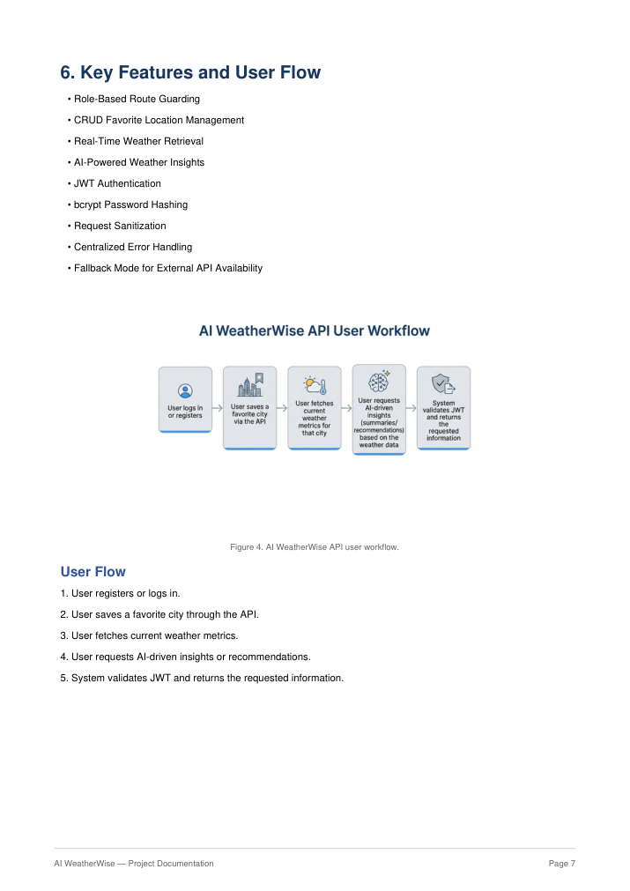
Visual reference from the original PDF
7. Epic 2 — Project Setup and Configuration
- Create a new folder named AI WeatherWise.
- Open the project folder in Visual Studio Code.
- Initialize the Node.js project and install required dependencies.
Figure 5. Project folder and backend structure in Visual Studio Code.
Project Initialization
npm init -y
Install Dependencies
npm install express mongoose bcryptjs jsonwebtoken cors dotenv multer @google/genai
Environment Configuration
PORT=5000 MONGO_URI=your_mongodb_connection_string JWT_SECRET=your_jwt_secret GEMINI_API_KEY=your_gemini_api_key
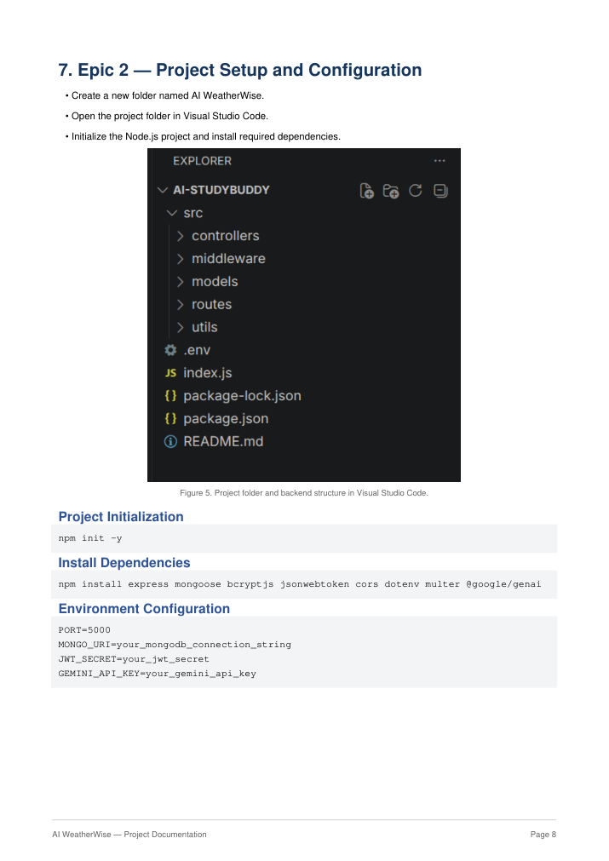
Visual reference from the original PDF
8. Epic 3 — Backend Development
The backend is organized into routing, controllers, middleware, models, and utility modules to improve maintainability and scalability.
Figure 6. Backend project folder structure.
Figure 7. Application entry-point implementation.
Core Responsibilities
- Authentication and authorization.
- Favorite-location management.
- Weather-data retrieval.
- AI-powered content generation.
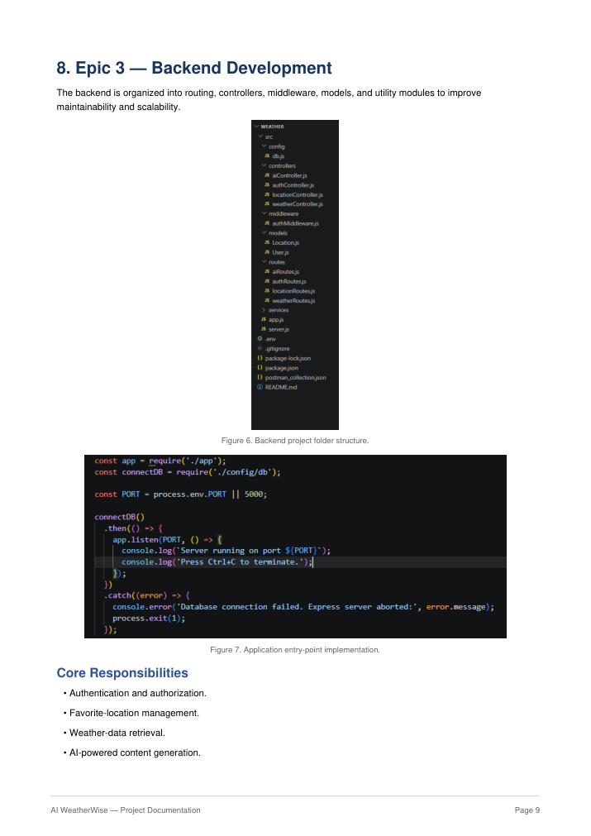
Visual reference from the original PDF
- Administrative and health operations.
- Centralized error handling.
9. Epic 4 — Database Configuration
Mongoose provides the connection and schema layer between the Node.js backend and MongoDB. The database should be connected before backend operations are processed.
Figure 8. Location schema definition.
Figure 9. User schema definition.
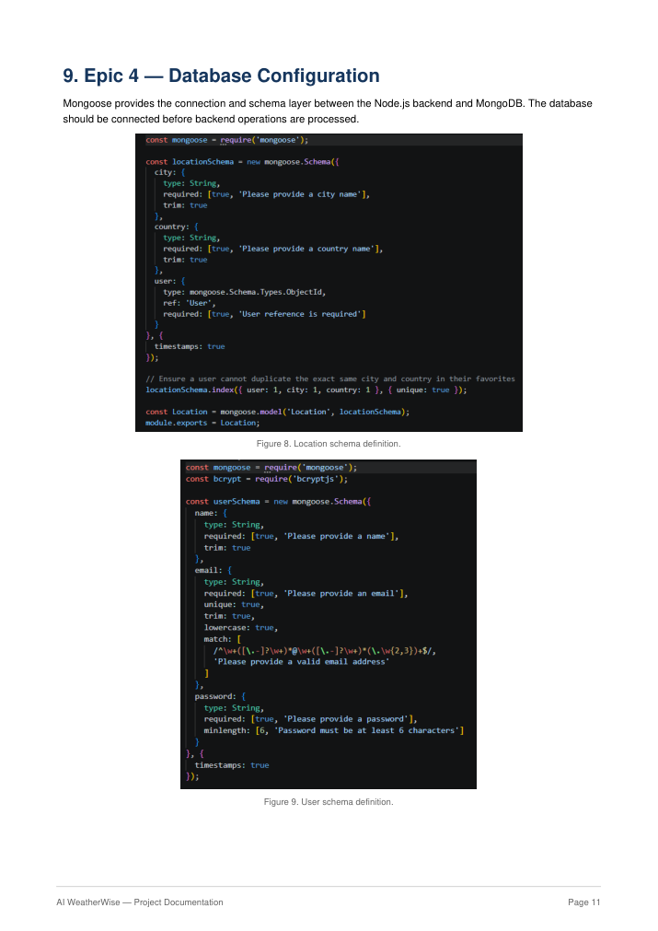
Visual reference from the original PDF
Figure 10. MongoDB connection configuration.

Visual reference from the original PDF
10. Epic 5 — Project Execution and API Testing
The backend can be executed locally using Node.js. MongoDB must be running and the required environment variables must be configured.
Running the Backend
npm install
npm start
API Testing Screenshots
Figure 11. API testing request/response screen.
Figure 12. API testing screen.
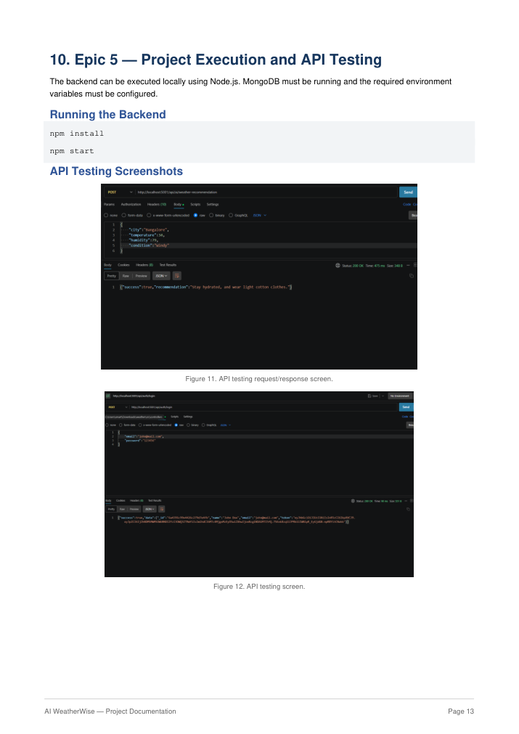
Visual reference from the original PDF
Figure 13. API testing screen.
Figure 14. API testing response screen.
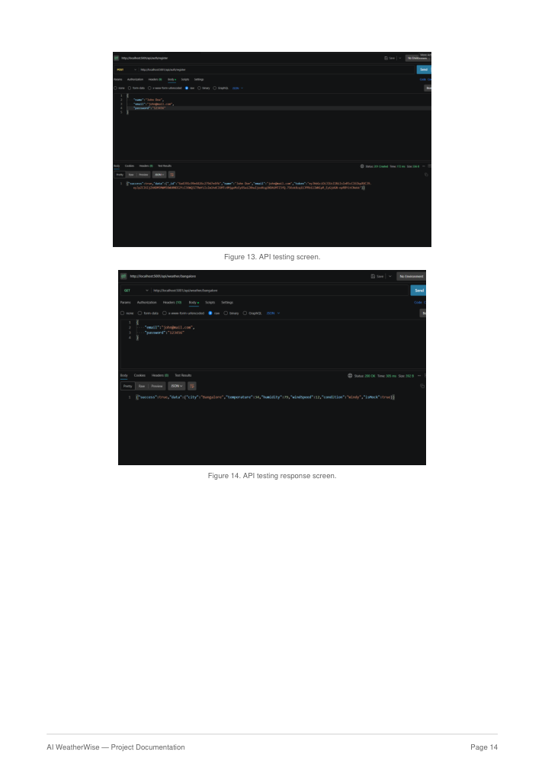
Visual reference from the original PDF
11. API Testing — Main Endpoints
- Register API
- Login API
- Weather API
- Recommendation API
Figure 15. Register/login or API request testing example.
Figure 16. Weather/recommendation API testing example.
The supplied reference also identifies API testing and backend demo video files as supporting project media.
12. Security and Reliability
- JWT authentication protects authenticated routes.
- bcrypt is used for password hashing.
- Environment variables keep secrets and configuration outside source code.
- Request sanitization helps reduce malicious input risks.
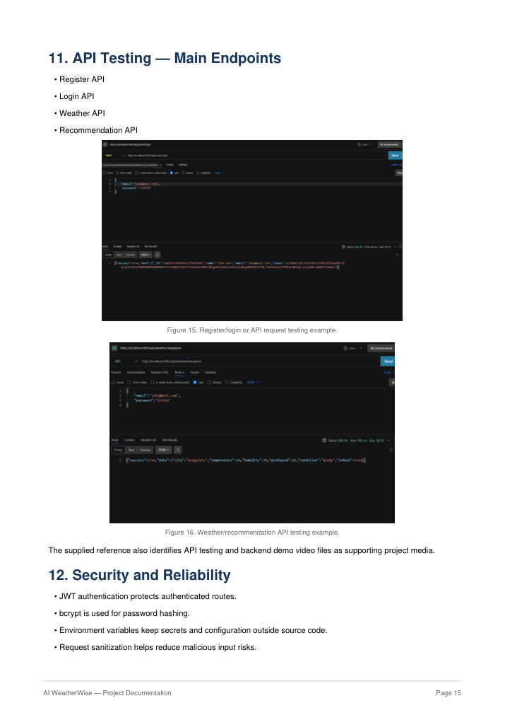
Visual reference from the original PDF
- Centralized error handling provides consistent backend behavior.
- Fallback behavior supports API operation when external keys are unavailable.
13. Project Outcome
AI WeatherWise combines real-time weather information, secure user management, persistent favorite locations, and AI-generated insights in a centralized backend platform. The architecture separates routing, business logic, database access, and external weather/AI services to support maintainability and scalability.
Reference Media
- API testing video: API testing.mp4
- Demo video: Backend demo.mp4
- CodeDrive: Code

API Testing video link:https://drive.google.com/file/d/1Fv_m9uSmnpNRecn69TuzYU3_Ha4D_035/view?usp=drivesdk

Demo video link: https://drive.google.com/file/d/1VuTFRLH5VzZiFWKMVkaSbBw6J0LiNOO2/view?usp=drivesdk

Code:

