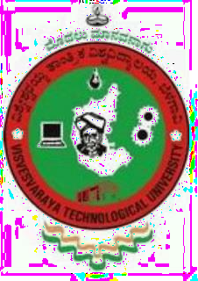

An Internship Report on

# REALM-WEB & MongoDB APP SERVICES

### Submitted in partial fulfillment of the requirement for the award of the degree of

#### MASTER OF COMPUTER APPLICATIONS

Under

#### VISVESVARAYA TECHNOLOGICAL UNIVERSITY

By

# MANISH N DEVADIGA

4SO22MC054

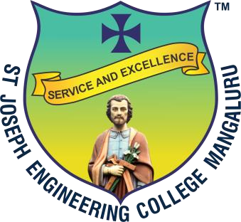

**Department of Computer Applications**

**St Joseph Engineering College, Mangaluru-575028**

## (An Autonomous Institution)



An Internship Report on

# REALM-WEB & MongoDB APP SERVICES

Submitted in partial fulfillment of the requirement for the award of the degree of

**MASTER OF COMPUTER APPLICATIONS**

Under

**VISVESVARAYA TECHNOLOGICAL UNIVERSITY**

By

# AJITH M M

### 4SO22MC004

Under the Guidance of

|  |  |
| --- | --- |
| **Internal Guide:**  Mr. Sunith Kumar T Assistant Professor  Department of Computer Applications St Joseph Engineering College Mangaluru-575 028. | **External Guide:**  Ms. Ranjini Aithal  Chief Marketing Officer (CMO)  Exelon Circuits Pvt Ltd Melric Building, Surathkal Mangaluru-575 014 |



**Department of Computer Applications**

**St Joseph Engineering College, Mangaluru-575028**

## (An Autonomous Institution)