**Name: Manish Rawat**

**Roll No: 975**

**INDUSTRY PAGE**

**Date: 4 Dec 2024**

Created a Card Component with static attributes.



**Date: 7 Dec 2024**

Created a JSON for storing objects with keys: Icon, Title and Description for each card.

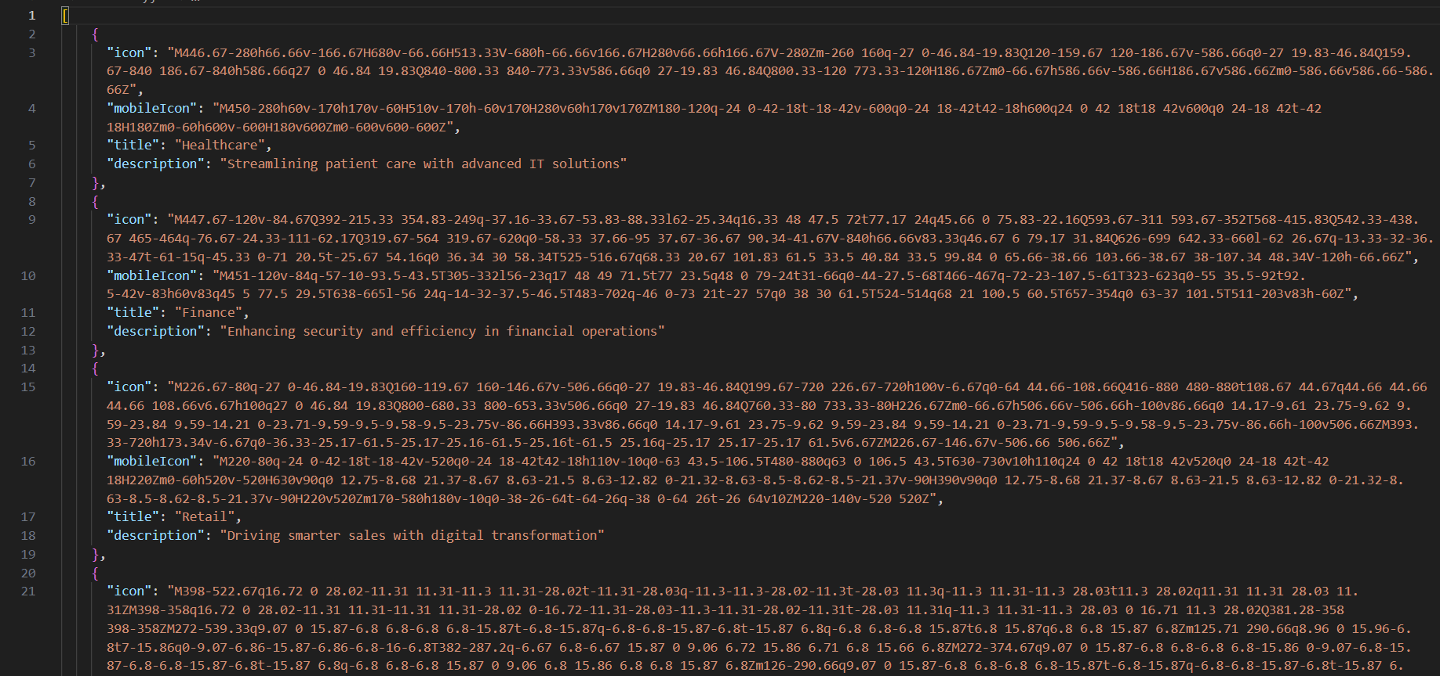

**Date: 8 Dec 2024**

Mapping the created JSON and providing icon

SVG path, title and description to the card

component using props through industry page.

Industry page is a grid of 3 rows and 4 columns.

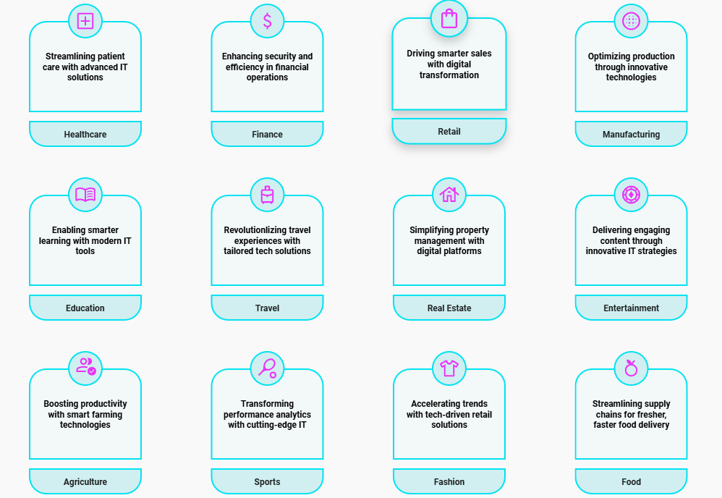

**Date: 12 Dec 2024**

Updated card component for mobile and tab view and changed the grid layout in industry page to 4 rows and 3 columns.

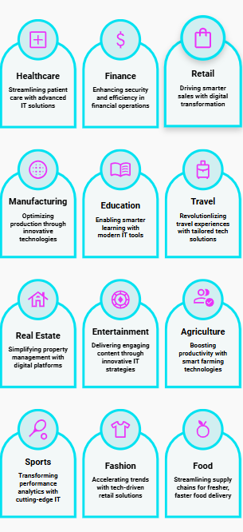

**Date: 13 Dec 2024**

Added animation on card component using AOS to fade-up cards on every visit to the industry page.