ARCHITECTURE DESIGN DOCUMENT

**(Crop Production Analysis India – BI PROJECT)**

Manish Rana VERSION: 1.0 DATED: 22/11/2022

**Document Version Control:**

|  |  |  |  |
| --- | --- | --- | --- |
| Version | Date | Author | Change |
| 1.0 | 22/11/2022 | Manish Rana | First Version of Complete Architecture  Document |
|  |  |  |  |
|  |  |  |  |

**Abstract**

The agriculture business domain, as a vital part of the overall supply chain, is expected to highly evolve in the upcoming years via the developments, which are taking place on the side of the Future Internet. This paper presents a novel business-to-business collaboration platform from the agri-food sector perspective, which aims to facilitate the collaboration of numerous stakeholders belonging to associated business domains, in an effective and flexible manner.

This dataset provides a huge amount of information on crop production in India ranging from several years. Based on the Information the ultimate goal would be to predict crop production and find important insights highlighting key indicators and metrics that influence the crop production.

**Contents**

1. Introduction. 05
   1. What is Architecture Design Document? 05
   2. Scope 05
2. Architecture 06
   1. Power-Bi Architecture 06
   2. Components of Power-Bi 07 – 08
3. Deployment Description 08
   1. Deployment Options in Power -Bi 08
   2. On-Premise Deployment 09
   3. Hybrid Deployment 10

# Introduction

* + - 1. **What is Architecture design document?**

Any software needs the architectural design to represents the design of software. IEEE defines architectural design as “the process of defining a collection of hardware and software components and their interfaces to establish the framework for the development of a computer system.” The software that is built for computer-based systems can exhibit one of these many architectures.

Each style will describe a system category that consists of:

* + - * + A set of components (e.g.: a database, computational modules) that will perform a function required by the system.
        + The set of connectors will help in coordination, communication, and cooperation between the components.
        + Conditions that how components can be integrated to form the system.
        + Semantic models that help the designer to understand the overall properties of the system.
      1. **Scope**

Architecture Design Document (ADD) is an architecture design process that follows a step-by-step refinement process. The process can be used for designing data structures, required software architecture, source code and ultimately, performance algorithms. Overall, the design principles may be defined during requirement analysis and then refined during architectural design work.

# Architecture

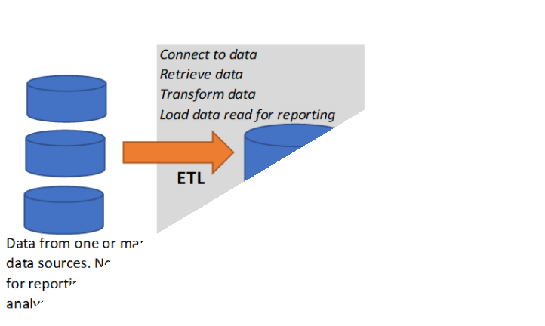

* 1. **Power Bi Architecture –**

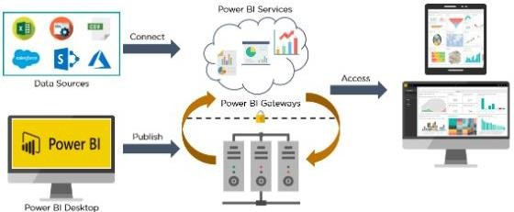

Power BI architecture is a service built on top of Azure. There are multiple data sources that Power BI can connect to. Power BI Desktop allows you to create reports and data visualizations on the dataset. Power BI gateway is connected to on-premise data sources to get continuous data for reporting and analytics.

# Components of Power BI

* + 1. Power Query

Power Query is the data transformation and mash up the engine. It enables you to discover, connect, combine, and refine data sources to meet your analysis need. It can be downloaded as an add-in for Excel or can be used as part of the Power BI Desktop.

* + 1. Power Pivot

Power Pivot is a data modelling technique that lets you create data models, establish relationships, and create calculations. It uses Data Analysis Expression (DAX) language to model simple and complex data.

* + 1. Power View

Power View is a technology that is available in Excel, SharePoint, SQL Server, and Power BI. It lets you create interactive charts, graphs, maps, and other visuals that bring your data to life. It can connect to data sources and filter data for each data visualization element or the entire report.

* + 1. Power Map

Microsoft's Power Map for Excel and Power BI is a 3-D data visualization tool that lets you map your data and plot more than a million rows of data visually on Bing maps in 3-D format from an Excel table or Data Model in Excel. Power Map works with Bing maps to get the best visualization based on latitude, longitude, or country, state, city, and street address information.

* + 1. Power BI Desktop

Power BI Desktop is a development tool for Power Query, Power Pivot, and Power View. With Power BI Desktop, you have everything under the same solution, and it is easier to develop BI and data analysis experience.

* + 1. Power Q&A

The Q&A feature in Power BI lets you explore your data in your own words. It is the fastest way to get an answer from your data using natural language. An example could be what was the total sales last year? Once you've built your data model and deployed that into the Power BI website, then you can ask questions and get answers quickly

# Deployment Description –

* 1. **Deployment Options in Power-Bi -**
     + **On-Premises**: Refers to data, applications and infrastructure entirely owned by client at client data centre and client has complete control over it.
     + **Cloud**: Refers to data, infrastructure and/or services residing in a public cloud environment and completely managed /controlled by third party. Microsoft Azure and web-based Power BI service are examples of the cloud offerings.
     + **Hybrid**: This denotes to the implementation which spans both on premises and cloud sources which can be services, infrastructure and data sources
  2. **On-Premises Deployment:**
     + **Option 1: File Share**

The first on-premises option involves usage of a file share:

* + - * Data preparation and report creation is done in client tools: Power BI Desktop and/or Excel.
      * The completed Power BI Desktop and/or Excel file is published to a file share or a document collaboration area / repository.
      * To view the reports, Excel or Power BI desktop has to be installed on the viewer’s machine
    - **Option 2: SharePoint**

The second on-premises option involves a specialized document library in SharePoint called the Power Pivot Gallery. Due to my limited knowledge, I am not going in details of this option

* + - * Data preparation and report creation occurs in Excel.
      * The completed Excel file is published to SharePoint within a Power Pivot Gallery
    - **Option 3: Third Party Integration**

The third on-premises option involves a third party which integrates with Power BI.

* + - * Data preparation and report creation occurs in Power BI Desktop.
      * The completed Power BI Desktop file is published to the third- party server

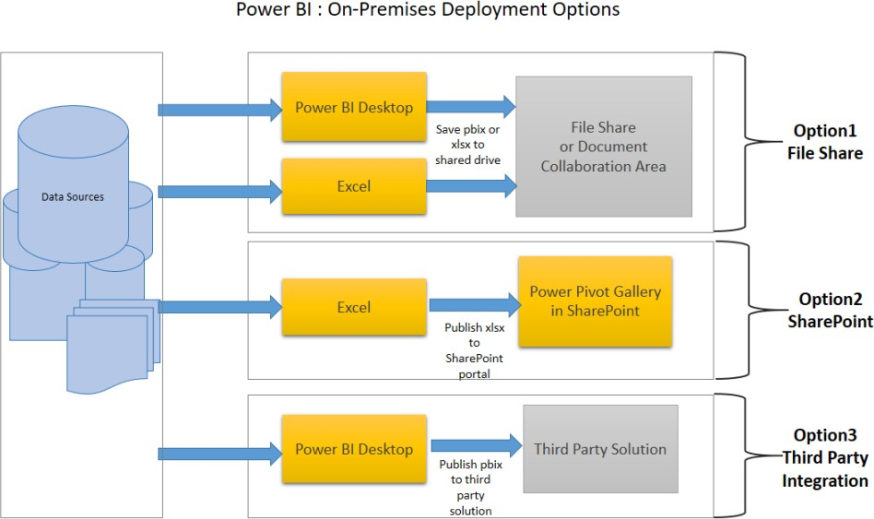

* 1. **Hybrid Deployment – Option 1: Power BI Service**
* Data is either from the on premises corporate applications or it might be born in cloud. It can even mix of these two
* Data preparation and report creation occurs in Power BI Desktop or excel
* Completed Power BI reports are then published to Power BI service
* Report consumption, sharing, security, collaboration, data refresh happens in Power BI service
* Dashboards are created in Power BI service and reports can also be edited or created in Power BI service
  1. **Option 2: Custom Application Integration –**
     + Data is either from the on premises corporate applications or it might be born in cloud. It can even mix of these two
     + Data preparation and report creation occurs in Power BI Desktop or excel
     + Completed Power BI reports are then published to Power BI service
     + With Power BI API, these reports can be published in custom web application or mobile app within iFrame.
     + If user interacts with this report, he/she will be redirected to Power BI service
     + Application can be on premise or cloud application.
  2. **Option 3: Public Website –**
     + Data is either from the on premises corporate applications or it might be born in cloud. It can even mix of these two
     + Data preparation and report creation occurs in Power BI Desktop
     + Completed Power BI reports are then published to Power BI service
     + An embed code is generated by Power BI service for selected report and this code can be embedded in web page of the website within iFrame
     + Here no security is maintained as its public website, hence suitable for the data which can be made publicly available.

