JDBC Driver

|  |
| --- |
| JDBC Driver is a software component that enables java application to interact with the database.There are 4 types of JDBC drivers:   1. JDBC-ODBC bridge driver 2. Native-API driver (partially java driver) 3. Network Protocol driver (fully java driver) 4. Thin driver (fully java driver) |

1) JDBC-ODBC bridge driver

|  |
| --- |
| The JDBC-ODBC bridge driver uses ODBC driver to connect to the database. The JDBC-ODBC bridge driver converts JDBC method calls into the ODBC function calls. This is now discouraged because of thin driver. |

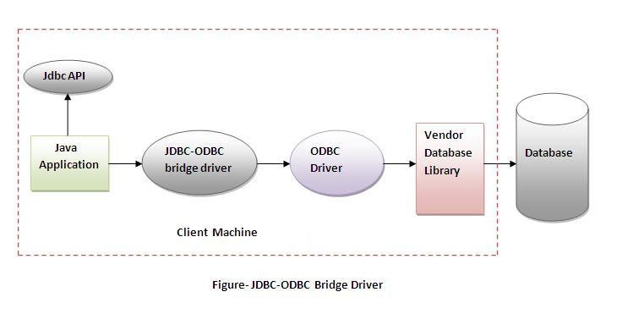

**Advantages:**

* easy to use.
* can be easily connected to any database.

**Disadvantages:**

* Performance degraded because JDBC method call is converted into the ODBC function calls.
* The ODBC driver needs to be installed on the client machine.

2) Native-API driver

|  |
| --- |
| The Native API driver uses the client-side libraries of the database. The driver converts JDBC method calls into native calls of the database API. It is not written entirely in java. |

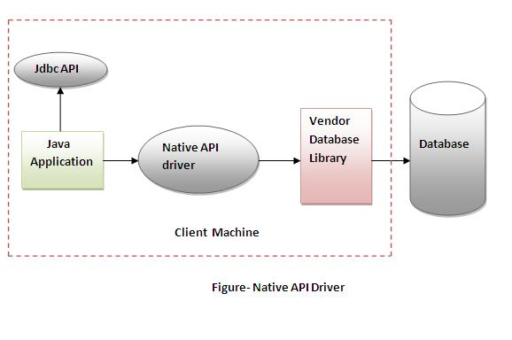

**Advantage:**

* performance upgraded than JDBC-ODBC bridge driver.

**Disadvantage:**

* The Native driver needs to be installed on the each client machine.
* The Vendor client library needs to be installed on client machine.

3) Network Protocol driver

The Network Protocol driver uses middleware (application server) that converts JDBC calls directly or indirectly into the vendor-specific database protocol. It is fully written in java.

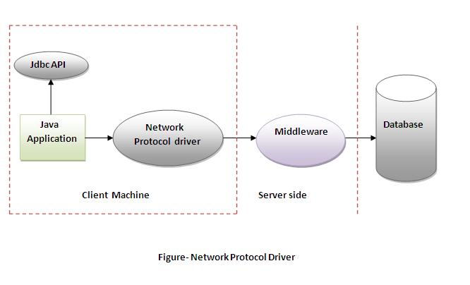

**Advantage:**

* No client side library is required because of application server that can perform many tasks like auditing, load balancing, logging etc.

**Disadvantages:**

* Network support is required on client machine.
* Requires database-specific coding to be done in the middle tier.
* Maintenance of Network Protocol driver becomes costly because it requires database-specific coding to be done in the middle tier.

4) Thin driver

|  |
| --- |
| The thin driver converts JDBC calls directly into the vendor-specific database protocol. That is why it is known as thin driver. It is fully written in Java language. |

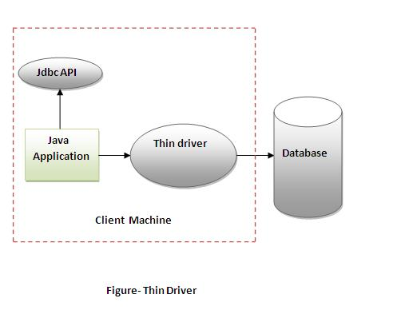

**Advantage:**

* Better performance than all other drivers.
* No software is required at client side or server side.

**Disadvantage:**

* Drivers depends on the Database.

5 Steps to connect to the database in java

1. [5 Steps to connect to the database in java](http://www.javatpoint.com/steps-to-connect-to-the-database-in-java)
   1. [Register the driver class](http://www.javatpoint.com/steps-to-connect-to-the-database-in-java#step1)
   2. [Create the connection object](http://www.javatpoint.com/steps-to-connect-to-the-database-in-java#step2)
   3. [Create the Statement object](http://www.javatpoint.com/steps-to-connect-to-the-database-in-java#step3)
   4. [Execute the query](http://www.javatpoint.com/steps-to-connect-to-the-database-in-java#step4)
   5. [Close the connection object](http://www.javatpoint.com/steps-to-connect-to-the-database-in-java#step5)

|  |
| --- |
| There are 5 steps to connect any java application with the database in java using JDBC. They are as follows:   * Register the driver class * Creating connection * Creating statement * Executing queries * Closing connection |

1) Register the driver class

|  |
| --- |
| The forName() method of Class class is used to register the driver class. This method is used to dynamically load the driver class. |

**Syntax of forName() method**

1. **public** **static** **void** forName(String className)**throws** ClassNotFoundException

Example to register the OracleDriver class

1. Class.forName("oracle.jdbc.driver.OracleDriver");

2) Create the connection object

|  |
| --- |
| The getConnection() method of DriverManager class is used to establish connection with the database. |

**Syntax of getConnection() method**

1. 1) **public** **static** Connection getConnection(String url)**throws** SQLException
2. 2) **public** **static** Connection getConnection(String url,String name,String password)
3. **throws** SQLException

Example to establish connection with the Oracle database

1. Connection con=DriverManager.getConnection(
2. "jdbc:oracle:thin:@localhost:1521:xe","system","password");

3) Create the Statement object

|  |
| --- |
| The createStatement() method of Connection interface is used to create statement. The object of statement is responsible to execute queries with the database. |

**Syntax of createStatement() method**

1. **public** Statement createStatement()**throws** SQLException

Example to create the statement object

1. Statement stmt=con.createStatement();

4) Execute the query

|  |
| --- |
| The executeQuery() method of Statement interface is used to execute queries to the database. This method returns the object of ResultSet that can be used to get all the records of a table. |

**Syntax of executeQuery() method**

1. **public** ResultSet executeQuery(String sql)**throws** SQLException

Example to execute query

1. ResultSet rs=stmt.executeQuery("select * from emp");
3. **while**(rs.next()){
4. System.out.println(rs.getInt(1)+" "+rs.getString(2));
5. }

5) Close the connection object

|  |
| --- |
| By closing connection object statement and ResultSet will be closed automatically. The close() method of Connection interface is used to close the connection. |

**Syntax of close() method**

1. **public** **void** close()**throws** SQLException

Example to close connection

1. con.close();