**EX.No**:11

**Date**:20.09.2020

**Reg NO**:1518102069

**Aim:**

Write a Python program to find the greatest common divisor (gcd) of two integers using recursion.

**Program:**

def gcd(a,b):

if(b==0):

return a

else:

return gcd(b,a%b)

a=int(input("Enter first number:"))

b=int(input("Enter second number:"))

GCD=gcd(a,b)

print("GCD is:")

print(GCD)

**Link:**

[**http://103.53.53.18/mod/vpl/forms/edit.php?id=326&userid=1786**](http://103.53.53.18/mod/vpl/forms/edit.php?id=326&userid=1786)

**Ouput:**

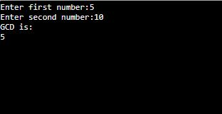

**Result:**

 Python program is Written to find the greatest common divisor (gcd) of two integers using recursion.