**EX NO**:14

**DATE**:20.11.2020

**REGNO**:1518102069

**Aim:**

Write a Python class to find validity of a string of parentheses, '(', ')', '{', '}', '[' and ']. These brackets must be close in the correct order.

**Program:**

class validity:

def f(str):

a=['()','{}','[]']

while any(i in str for i in a):

for j in a:

str=str.replace(j,'')

return not str

s=input()

if(validity.f(s)):

print("Valid")

else:

print("invalid")

**LINK:**

[**http://103.53.53.18/mod/vpl/forms/edit.php?id=327&userid=1786**](http://103.53.53.18/mod/vpl/forms/edit.php?id=327&userid=1786)

**Output:**

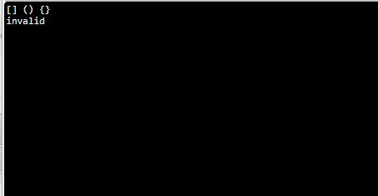

**Result:**

A python class is written to find validity of a string of parentheses, '(', ')', '{', '}', '[' and ']. These brackets must be close in the correct order.