MIN-HASHING AND LSH
Name: Manisha Bhalla
Roll No: M25DE1050
Github: https://github.com/Manisshabhlla/Min-hashing-and-LSH

Question 1: Create k-Grams: Compute the Jaccard similarity between all pairs of documents for each type of k-gram
Length of all files:
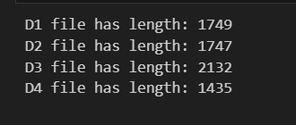
Analysis:
- Character 2-Gram:
  - D1 and D2 show extremely high similarity (0.98), indicating almost identical content.
  - D1–D3 and D2–D3 also show strong similarity (~0.8).
  - D4 has comparatively lower similarity with other documents.
- Character 3-Gram:
  - D1 and D2 remain highly similar (0.977).
  - The similarity between D3/D4 and the other documents (D1 and D2) decreases significantly, indicating that longer n-grams impose stricter matching.
- Word 2-Gram:
  - D1 and D2 still remain highly similar (0.94).
  - Similarity among other document pairs reduces drastically, showing that word-level matching is more restrictive.
  - 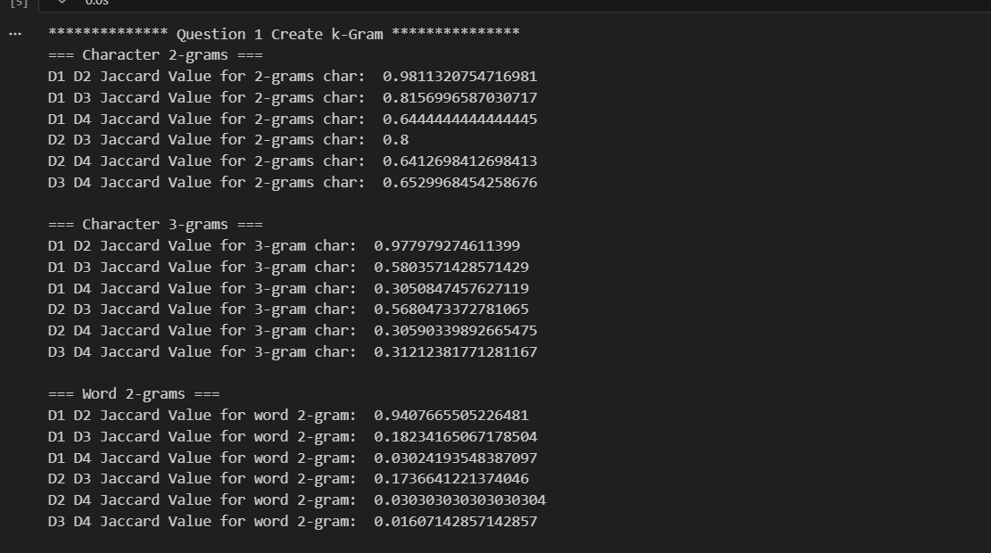

Question 2: Min-Hashing:
Analysis:
- For small t values (20–300), the estimate slightly overestimates the similarity. (e.g., 1.0, 0.9833, 0.9933).
- At t = 600, the estimate stabilizes closer to the exact Jaccard similarity i.e. 0.9733 (nearest to Exact Similarity = 0.9780)
- Increasing t reduces the variance of the Min-Hash estimate
- Larger t values provide more stable and reliable approximations, although they increase computational cost
t = 600 is the best choice for accuracy because it gives an estimate closest to the exact Jaccard similarity.
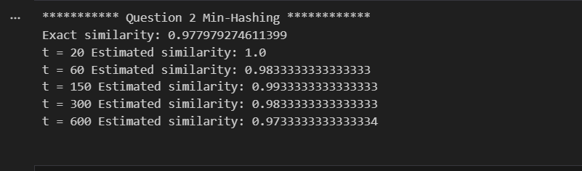

Question 3: LSH Probabilities
Analysis:
- Using r = 8 b = 20:
  - D1 & D2 Probability: 0.9999999999999998 ≈ 1.0
  - D1 & D3 Probability: 0.22822420166613133
  - D1 & D4 Probability: 0.001499976039931461
  - D2 & D3 Probability: 0.1958804369207785
  - D2 & D4 Probability: 0.0015324562526581875
  - D3 & D4 Probability: 0.0018000048667899948
- The probability for D1 & D2 is ~ 1.0, meaning they will almost always be placed in the same bucket.
- All other document pairs have significantly lower probabilities (close to zero in most cases), showing that LSH effectively separates highly similar and dissimilar document pairs.

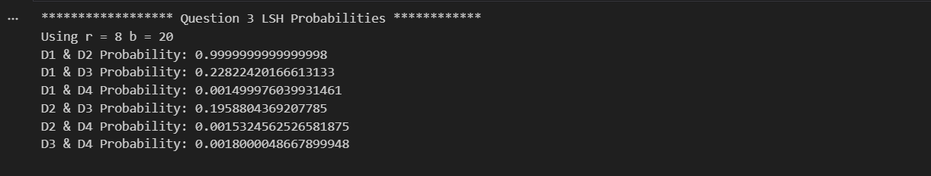

Question 4: Min-Hashing on MovieLens Dataset
Analysis:
- Average errors:
  - t=50
    - AVERAGE FALSE POSITVES for t = 50: 156.8
    - AVERAGE FALSE NEGATIVES for t = 50: 1.6
  - t=100
    - AVERAGE FALSE POSITVES for t = 100: 24.6
    - AVERAGE FALSE NEGATIVES for t = 100: 2.8
  - t=200
    - AVERAGE FALSE POSITVES for t = 200: 9.8
    - AVERAGE FALSE NEGATIVES for t = 200: 2.4

- At t=50, the number of false positives is high, meaning the algorithm detects many extra pairs.
- As the number of hash functions increases (t=100 and t=200), false positives decrease significantly, indicating better filtering.
- False negatives fluctuate slightly but remain relatively small. Overall, increasing the signature size reduces variance and improves reliability.
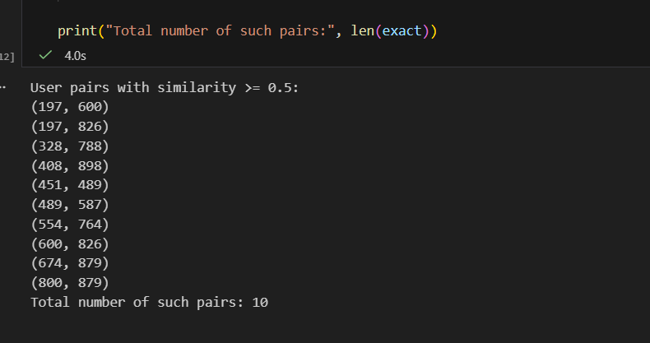
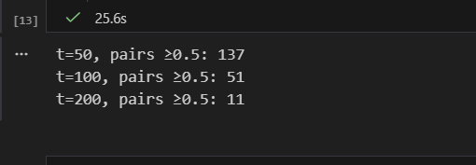
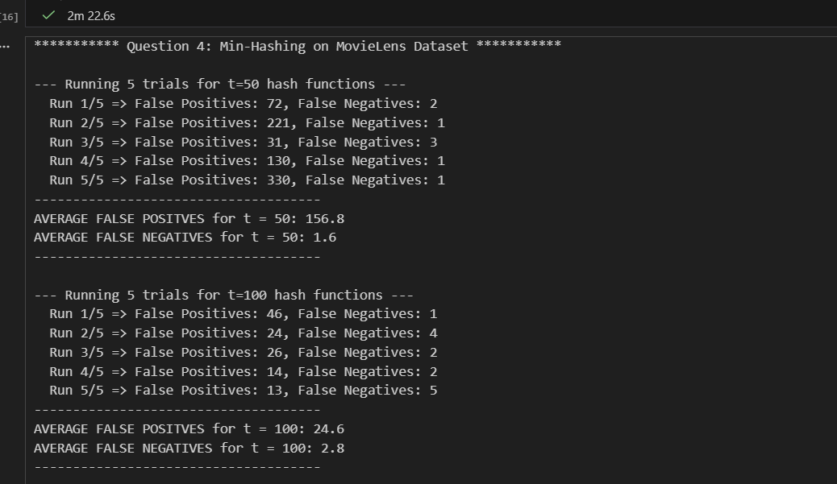

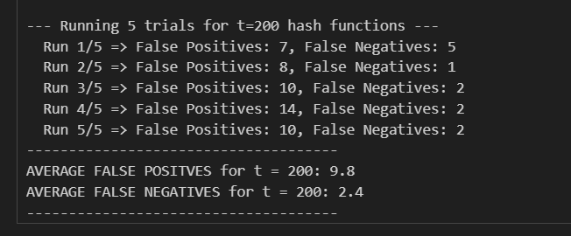

Question 5: LSH on MovieLens dataset
Analysis:
Effect of Increasing the Similarity Threshold from 0.6 to 0.8
- Threshold = 0.6
  - False Positives is high
  - False Negatives is ~ 0
- Threshold =0.8
  - False Positives is high
  - False Negatives ~ 0
- When the threshold is increased from 0.6 to 0.8, the similarity condition becomes stricter. Ideally, this should reduce false positives because fewer pairs qualify as similar.
- However, in our results (with r = 5), false positives remain high even at threshold 0.8. This indicates that band configuration has a stronger impact on error rates than the threshold alone.
- When r is increased to 10 (with 200 hashes), false positives drop dramatically to 2, showing that band size plays a crucial role in controlling incorrect matches.

