

Manivasakam R 17LMCA25

Brightpearl-AI | ERP System

 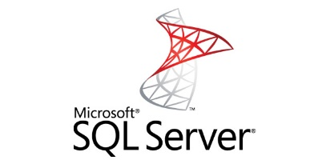



**Brightpearl-AI ERP System**

A business has several critical areas that need to be managed well. This system applies integrated solutions to streamline, automate and link the different departments and divisions of the organization such as HR, IT, finance, sales, and customer service for Groovy Exporters. The system serves as the hub whose network of solutions pump vital nutrients to all areas and functions of the organization to keep them in tune and in good working condition.

This system is generally classified as an enterprise application designed to meet the more complex and heavy duty functions of big businesses. Often, large corporations have their own IT departments or dedicated teams that utilize the system to analyze big data and address the needs of multiple departments. However, small business ERP applications have come about to cater to the lightweight business management requirements of startups and growing companies. This type of ERP solution is usually customized to fit smaller business operations, and match specific business industry. In a survey by Panorama Consulting, 46% of respondents cite “best functional fit” as top reason for selecting particular ERP software.

**Features**

**Improved data quality and accessibility.** A unified database is the predominant ERP feature that connects the various levels and departments of an organization. With a single source for data that is automatically collected, consolidated, organized and analyzed (largely without human input), you get accurate and reliable information to guide decisions.

**Reporting and planning.** These are a direct result of having a single source of information. You can quickly generate any kind of reports.

**Supply chain management**. An ERP platform can boost your supply chain, making it more responsive through better demand forecasting, enhanced inventory management, efficient procurement, among others.

**Reduce time and effort.** This Brightpearl-AI ERP software automates tasks and processes thereby greatly reducing time, effort and resources spent on daily, repetitive manual activities. This frees up employee time to focus on other revenue enhancing tasks.