

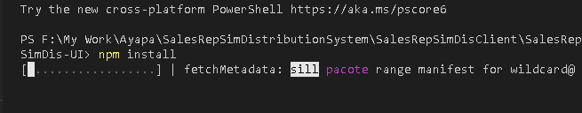

Install bootstrap

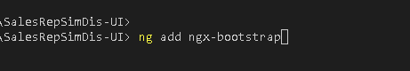

Font



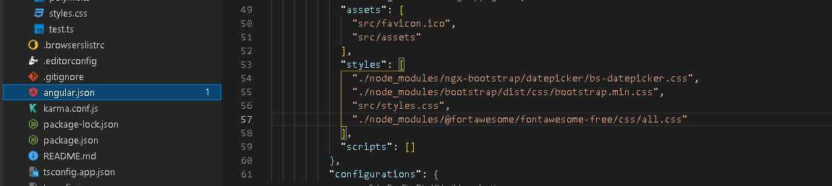

Add extention

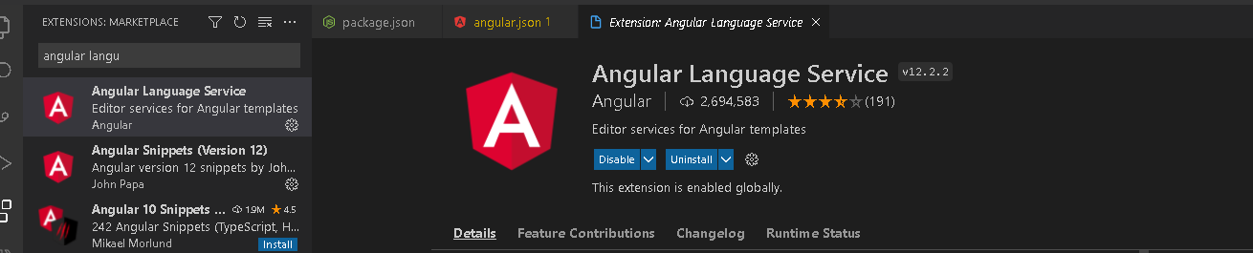

To run

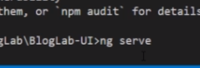

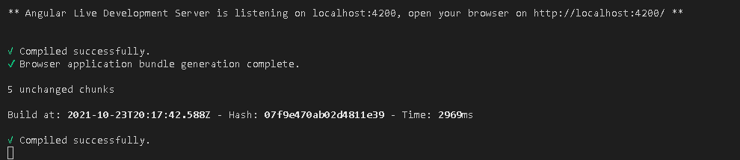

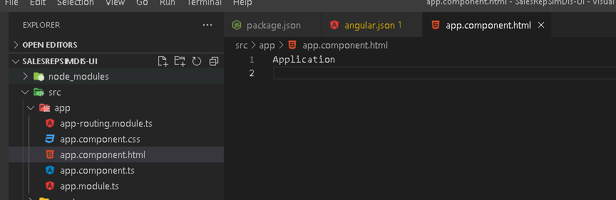

To check git install or not

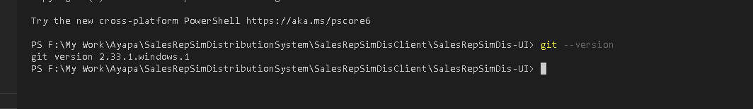

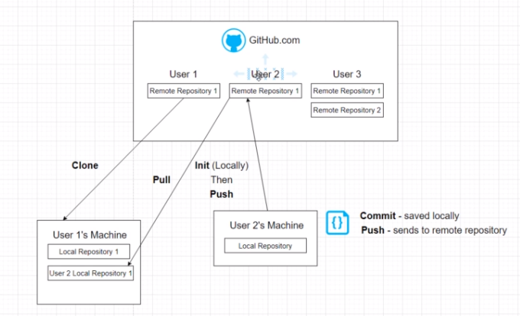

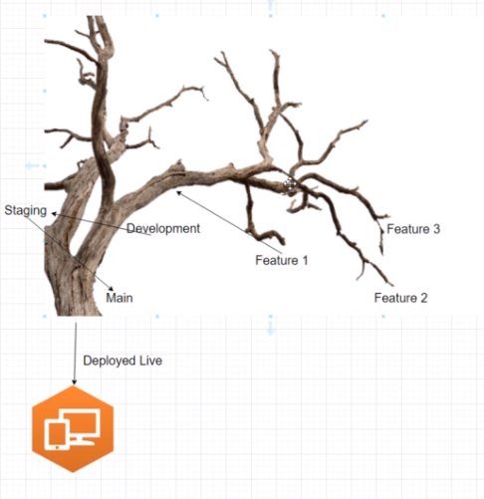

Git init

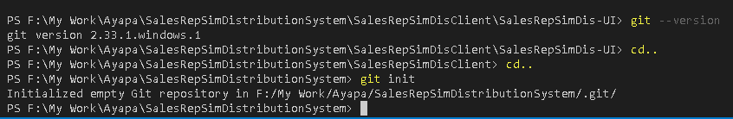

Git status

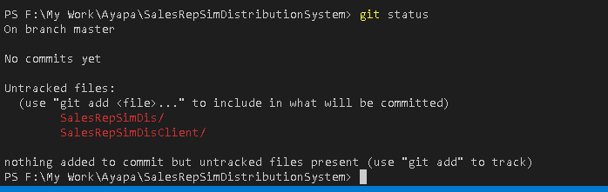

Create new repository

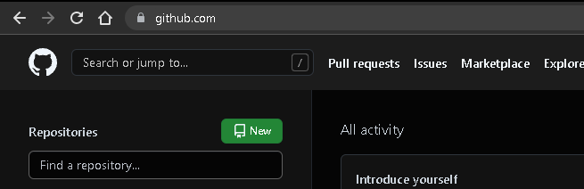

Stageing

This file is ready to comit(. Means all files)

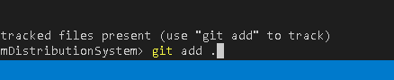

Put .gitignore in the main folder then only it will apply all sub folder