**Name :** Maniya Dhruvi Vinodbhai

**Course :** React.Js

• Define the terms: Website, Webpage, Web browser, Web server, HTML,

**website:** A website is a collection of publicly accessible, interlinked Web pages that share a single domain name. Websites can be created and maintained by an individual, group, business or organization to serve a variety of purposes.

**webpage :** A web page (or webpage) is a hypertext document on the World Wide Web. Web pages are delivered by a web server to the user and displayed in a web browser.

**web browser:** A web browser takes you anywhere on the internet. It retrieves information from other parts of the web and displays it on your desktop or mobile device. The information is transferred using the Hypertext Transfer Protocol, which defines how text, images and video are transmitted on the web.

**web server:** A web server is software and hardware that uses HTTP (Hypertext Transfer Protocol) and other protocols to respond to client requests made over the World Wide Web.

**HTML :** HTML is a markup language for describing web documents (web pages). HTML stands for Hyper Text Markup Language. A markup language is a set of markup tags.

**CSS:** CSS (Cascading Style Sheets) is a declarative language that controls how webpages look in the browser. The browser applies CSS style declarations to selected elements to display them properly. A style declaration contains the properties and their values, which determine how a webpage looks.

• CSS Create a webpage to show “This is my first HTML page”

<!DOCTYPE html>

<html lang="en">

<head>

<meta charset="UTF-8">

<meta http-equiv="X-UA-Compatible" content="IE=edge">

<meta name="viewport" content="width=device-width, initial-scale=1.0">

<title>Document</title>

</head>

<style>

body{

background-color: rgb(60, 141, 65); }

h1{

color: black;

font-weight: bold;

font-size: 50px; S}

</style>

<body>

<center>

<h1><b>"This is my first HTML page"</b></h1>

</center>

</body>

</html>



• Display top 10 IT companies list in html webpage

<!DOCTYPE html>

<html lang="en">

<head>

<meta charset="UTF-8">

<meta http-equiv="X-UA-Compatible" content="IE=edge">

<meta name="viewport" content="width=device-width, initial-scale=1.0">

<title>Document</title>

</head>

<body>

<center>

<h1><b>Top 10 IT companies list</b></h1>

1. IBM. International Business Machine<br><br>

2. TCS - Tata Consultancy Services<br><br>

3. HCL Technologies<br><br>

4. Infosys: This is a popular IT company<br><br>

5. Larsen & Toubro Infotech Limited:<br><br>

6. MindTree Ltd:<br><br>

7. Mphasis Limited:<br><br>

8. Larsen & Toubro Infotech Limited:<br><br>

9. Quess Corp Limited:<br><br>

10.Tech Mahindra Ltd

</center>

</body>

</html>



• Create a dropdown list

<!DOCTYPE html>

<html lang="en">

<head>

<meta charset="UTF-8">

<meta http-equiv="X-UA-Compatible" content="IE=edge">

<meta name="viewport" content="width=device-width, initial-scale=1.0">

<title>Document</title>

</head>

<style>

.dropbtn {

background-color: #04AA6D;

color: white;

padding: 16px;

font-size: 16px;

border: none;

}

.dropdown {

position: relative;

display: inline-block;

}

.dropdown-content {

display: none;

position: absolute;

background-color: #f1f1f1;

min-width: 160px;

box-shadow: 0px 8px 16px 0px rgba(0, 0, 0, 0.2); }

.dropdown-content a {

color: black;

padding: 12px 16px;

text-decoration: none;

display: block;

}

.dropdown-content a:hover {

background-color: #ddd;

}

.dropdown:hover .dropdown-content {

display: block;}

.dropdown:hover .dropbtn {

background-color: #3e8e41;

}

</style>

</style>

<body>

<h2>Hoverable Dropdown</h2>

<div class="dropdown">

<button class="dropbtn">Dropdown</button>

<div class="dropdown-content">

<a href="#">Link 1</a>

<a href="#">Link 2</a>

<a href="#">Link 3</a>

</div>

</div>

</body>

</html>



• Create a Table Of college Management system using row span & col span.

<!DOCTYPE html>

<html lang="en">

<head>

<meta charset="UTF-8">

<meta http-equiv="X-UA-Compatible" content="IE=edge">

<meta name="viewport" content="width=device-width, initial-scale=1.0">

<title>Document</title>

</head>

<style>

table, th, td {

border: 1px solid black;

border-collapse: collapse;

width: 50%;

height: 50px;

}

h2{

font-size: 25px;

}

p{

font-size: 20px;}

</style>

<body>

<center>

<h2>College management system</h2>

<p><b>Row span & Col span</b></p>

<table>

<tr>

<th colspan="2">Subject code and subject name</th>

<th colspan="4">Internal Assessment</th>

<th colspan="4">External Assessment</th>

<th colspan="4">Grand total</th>

<th rowspan="2">Remark</th>

</tr>

<tr>

<th colspan="2"></th>

<th colspan="2">MM</th>

<th colspan="2">MO</th>

<th colspan="2">MM</th>

<th colspan="2">MO</th>

<th colspan="2">MM</th>

<th colspan="2">MO</th>

</tr>

<tr>

<th colspan="2">Economics theory</th>

<th colspan="2">40</th>

<th colspan="2">32</th>

<th colspan="2">60</th>

<th colspan="2">43</th>

<th colspan="2">100</th>

<th colspan="2">75</th>

<th colspan="2">P</th>

</tr>

<tr>

<th colspan="2">Elements of statistics</th>

<th colspan="2">40</th>

<th colspan="2">87</th>

<th colspan="2">34</th>

<th colspan="2">65</th>

<th colspan="2">100</th>

<th colspan="2">89</th>

<th colspan="2">P</th>

</tr>

<tr>

<th colspan="2">Company Law</th>

<th colspan="2">32</th>

<th colspan="2">54</th>

<th colspan="2">77</th>

<th colspan="2">56</th>

<th colspan="2">100</th>

<th colspan="2">75</th>

<th colspan="2">P</th>

</tr>

<tr>

<th colspan="2">Banking,Financial Management</th>

<th colspan="2">32</th>

<th colspan="2">87</th>

<th colspan="2">54</th>

<th colspan="2">28</th>

<th colspan="2">100</th>

<th colspan="2">46</th>

<th colspan="2">P</th>

</tr>

<tr>

<th colspan="2">Elements of coding</th>

<th colspan="2">44</th>

<th colspan="2">66</th>

<th colspan="2">29</th>

<th colspan="2">84</th>

<th colspan="2">100</th>

<th colspan="2">92</th>

<th colspan="2">P</th>

</tr>

</table>

</center>

</body>

</html>

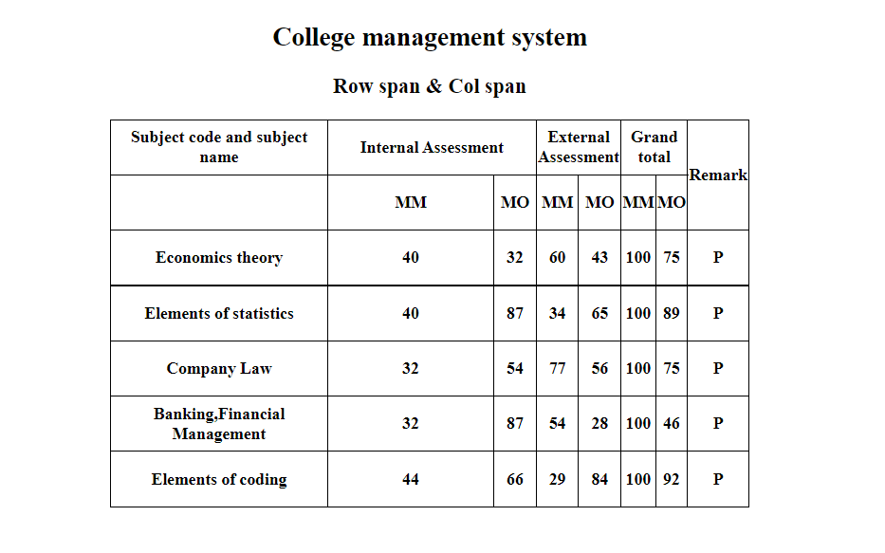

• Create below table using HTML table tags

<!DOCTYPE html>

<html lang="en">

<head>

<meta charset="UTF-8">

<meta http-equiv="X-UA-Compatible" content="IE=edge">

<meta name="viewport" content="width=device-width, initial-scale=1.0">

<title>Document</title>

</head>

<style>

form{

background-color: green;

padding-bottom: 5ch;

padding-top: 1ch;

margin-left: 20ch;

margin-right: 20ch;

}

table{

background-color:green;

color: antiquewhite;

border: white;}

</style>

<body>

<center>

<form>

<table border="2" cellpadding="5px" cellspacing="0px">

<h1>European Roulette</h1>

<tr>

<th rowspan="5">0</th>

<th bgcolor="red">3</th>

<th bgcolor="black">6</th>

<th bgcolor="red">9</th>

<th bgcolor="red">12</th>

<th bgcolor="black">15</th>

<th bgcolor="red">18</th>

<th bgcolor="red">21</th>

<th bgcolor="black">24</th>

<th bgcolor="red">27</th>

<th bgcolor="red">30</th>

<th bgcolor="black">33</th>

<th bgcolor="red">36</th>

<th colspan="2">2to1</th>

</tr>

<tr>

<th bgcolor="black">2</th>

<th bgcolor="red">5</th>

<th bgcolor="black">8</th>

<th bgcolor="black">11</th>

<th bgcolor="red">14</th>

<th bgcolor="black">17</th>

<th bgcolor="black">20</th>

<th bgcolor="red">23</th>

<th bgcolor="black">26</th>

<th bgcolor="black">29</th>

<th bgcolor="red">32</th>

<th bgcolor="black">35</th>

<th colspan="2">2to1</th>

</tr>

<tr>

<th bgcolor="red">1</th>

<th bgcolor="black">4</th>

<th bgcolor="red">7</th>

<th bgcolor="black">10</th>

<th bgcolor="black">13</th>

<th bgcolor="red" >16</th>

<th bgcolor="red">19</th>

<th bgcolor="black">22</th>

<th bgcolor="red">25</th>

<th bgcolor="black">28</th>

<th bgcolor="black">31</th>

<th bgcolor="red">34</th>

<th colspan="2">2to1</th>

</tr>

<tr>

<th colspan="4">1st12</th>

<th colspan="4">2nd12</th>

<th colspan="4">3rd12</th>

<th rowspan="2"></th>

</tr>

<tr>

<th colspan="2">1to18</th>

<th colspan="2">EVEN</th>

<th bgcolor="red" colspan="2"></th>

<th bgcolor="black"colspan="2"></th>

<th colspan="2">ODD</th>

<th colspan="2">19to36</th>

</tr>

</table>

</form>

</center>

</body>

</html>

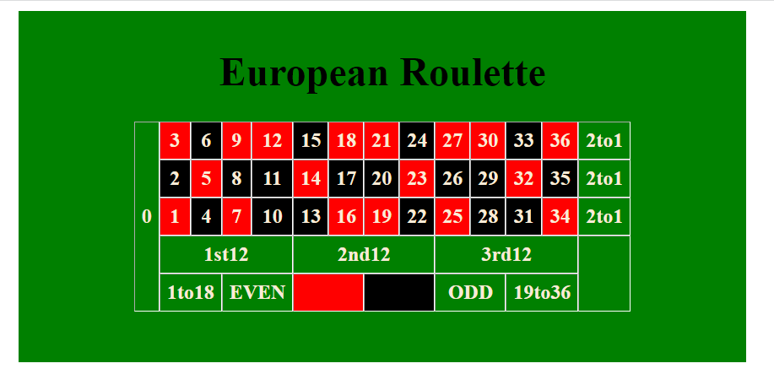

• Create Registration form using HTML, CSS

<!DOCTYPE html>

<html lang="en">

<head>

<meta charset="UTF-8">

<meta http-equiv="X-UA-Compatible" content="IE=edge">

<meta name="viewport" content="width=<device-width>, initial-scale=1.0">

<title>Document</title>

</head>

<style>

body {

background-color: rgb(89, 61, 115);}

.wrapper {

position: absolute;

top: 50%;

left: 50%;

transform: translate(-50%, -50%);

padding: 20px;

}

form {

background-color: rgb(197, 177, 213);

width: 300px;}

#btn{

background-color: green;

color: white;}

h2 {

font-size: 15px;

color: rgb(1, 1, 1); }

h1 {

color: white; }

</style>

<body>

<div class="wrapper">

<center>

<h1>Registration Form</h1>

</center>

<form border="2px">

<table>

<center>

<h2>

<b>Full Name :</b>

</h2>

<label type="text">First Name : </label>

<input type="text" name="name">

<br><br>

<label type="text">Last Name :</label>

<input type="text" name="name">

<br><br>

<button type="submit" id="btn">Next</button>

<br><br>

</center>

</table>

</form>

<form border="2px">

<table>

<center>

<h2>

<b>Address :</b>

</h2>

<label type="text">Street Address : </label>

<input type="text" name="name">

<br><br>

<label type="text">Address Line2 :</label>

<input type="text" name="name">

<br><br>

<input type="text" name="name" placeholder="City">

<br><br>

<input type="text" name="name" placeholder="Postal/Zip Code">

<br><br>

<label type="text">Country :</label>

<select id="country" value="country">

<option value="">Please Select</option>

<option value="valsad">valsad</option>

<option value="navsari">navsari</option>

<option value="surat">Surat</option>

<option value="bardoli">bardoli</option>

</select>

<br><br>

<button type="submit" id="btn">Next</button>

<br><br>

</center>

</table>

</form>

<form border="2px"

<table>

<center>

<h2>

<b>Phone Number :</b>

</h2>

<input type="number" name="code" placeholder="Area Code">

<br><br>

<input type="text" name="name" placeholder="Phone Number">

<br><br>

<button type="submit" id="btn">Submit</button>

<br><br>

</center>

</table>

</form>

</div>

</body>

</html>

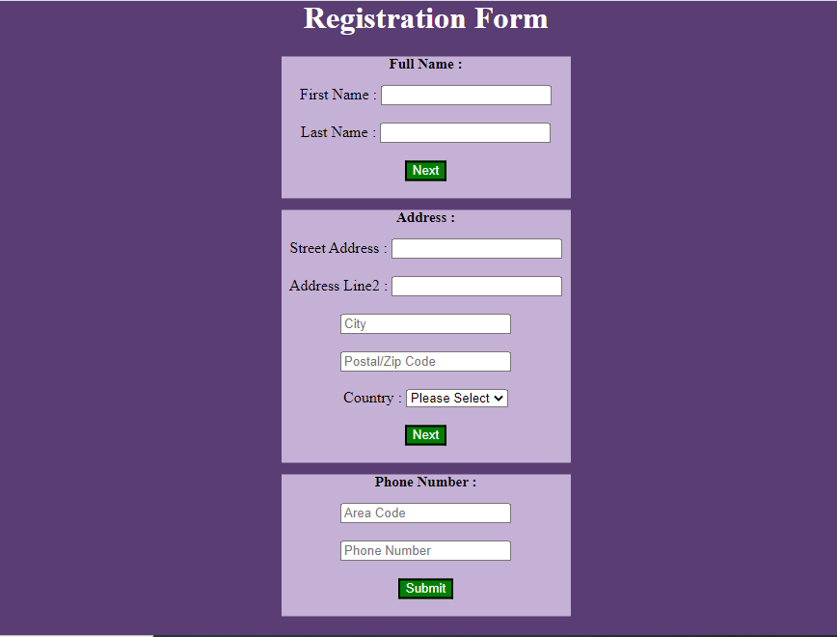

• In how many ways can a CSS be integrated as a web page?

**Types of CSS**

* Inline CSS.
* Internal/ Embedded CSS.
* External CSS.

• Create simple three pages using External CSS, Internal CSS, and Inline CSS.

**External css**

<!DOCTYPE html>

<html>

<head>

<link rel="stylesheet" href="mystyle.css">

</head>

<body>

<h1>This is a heading</h1>

<p>This is a paragraph.</p>

</body>

</html>

**mystyle.css**

body {

background-color: lightblue;}

h1 {

color: navy;

margin-left: 20px;

}



**Internal CSS**

<!DOCTYPE html>

<html>

<head>

<style>

body {

background-color: rgb(181, 149, 116);

}h1 {

color: maroon;

margin-left: 40px;

}

</style>

</head>

<body>

<h1>This is a heading</h1>

<p>This is a paragraph.</p>

</body>

</html>



**Inline CSS**

<!DOCTYPE html>

<html>

<body>

<h1 style="color:blue;text-align:center;">This is a heading</h1>

<p style="color:red;">This is a paragraph.</p>

</body>

</html>



• Create below page using HTML CSS

<!DOCTYPE html>

<html lang="en">

<head>

<meta charset="UTF-8">

<meta http-equiv="X-UA-Compatible" content="IE=edge">

<meta name="viewport" content="width=device-width, initial-scale=1.0">

<title>Document</title>

</head>

<style>

h1 {

font-size: 20px;

background-color: rgb(33, 93, 93);

color: rgb(255, 255, 255);}

form {

background-color: rgb(104, 206, 206);

}

h2 {

font-size: 15px;

color: rgb(234, 15, 15)

}

h3 {

color: rgb(11, 25, 46);

font-size: 13px;}

#btn{

color: lightblue;

background-color: darkblue;}

</style>

<body>

<center>

<h1>Individual Registration</h1>

</center>

<form>

<h2>User Particulars</h2>

<h3>

<br>&nbsp;&nbsp;&nbsp;&nbsp;&nbsp;&nbsp;&nbsp;&nbsp;&nbsp;&nbsp;&nbsp;&nbsp

<label type="text">*Login ID</label>

<input type="text" size="20" name="id">

<br><br>&nbsp;&nbsp;&nbsp;&nbsp;&nbsp;&nbsp;&nbsp;&nbsp;&nbsp;&nbsp;&nbsp;&nbsp;

<label type="password">*Password</label>

<input type="password" size="20" name="pwd">

<br><br>&nbsp;&nbsp;&nbsp;&nbsp;&nbsp;&nbsp;&nbsp;&nbsp;&nbsp;&nbsp;&nbsp;&nbsp;

<label type="password">*Confirm Password</label>

<input type="password" size="20" name="pwd">

</h3>

<h2>Personal Particulars</h2>

<h3>

<br>&nbsp;&nbsp;&nbsp;&nbsp;&nbsp;&nbsp;&nbsp;&nbsp;&nbsp;&nbsp;&nbsp;&nbsp;

<label type="text">*Salutation </label>

<select id="text">

<option value="select">Select</option>

<option value="Service Manager">Service Manager</option>

<option value="Service Team">Service Team</option>

<option value="Human Resources Manager.">Human Resources Manager</option>

</select>

&nbsp;&nbsp;&nbsp;&nbsp;&nbsp;&nbsp;

<label type="text">*First Name </label>

<input type="text" size="20" name="id">

<br><br>

&nbsp;&nbsp;&nbsp;&nbsp;&nbsp;&nbsp;&nbsp;&nbsp;&nbsp;

&nbsp;&nbsp;&nbsp;&nbsp;&nbsp;&nbsp;&nbsp;&nbsp;&nbsp;

<label type="text">*Middle Name </label>

<input type="text" size="20" name="id">

&nbsp;&nbsp;&nbsp;&nbsp;&nbsp;&nbsp;

<label type="text">*Last Name </label>

<input type="text" size="20" name="id">

<br><br>

&nbsp;&nbsp;&nbsp;&nbsp;&nbsp;&nbsp;&nbsp;&nbsp;&nbsp;

&nbsp;&nbsp;&nbsp;&nbsp;&nbsp;&nbsp;&nbsp;&nbsp;&nbsp;

<label type="text">*Resident Status </label>

<select id="text">

<option value="select">Select</option>

<option value="Ordinarily Resident">Ordinarily Resident</option>

<option value="Not Ordinarily Resident">Not Ordinarily Residents</option>

<option value="resident">resident</option>

</select>

&nbsp;&nbsp;&nbsp;&nbsp;&nbsp;&nbsp;&nbsp;&nbsp;&nbsp;&nbsp;&nbsp;&nbsp;

<label type="text">*Country </label>

<select id="text">

<option value="select">Select</option>

<option value="India">India</option>

<option value="canada">canada</option>

<option value="Jermoney">Jermoney</option>

</select>

<br><br>

&nbsp;&nbsp;&nbsp;&nbsp;&nbsp;&nbsp;&nbsp;&nbsp;&nbsp;

&nbsp;&nbsp;&nbsp;&nbsp;&nbsp;&nbsp;&nbsp;&nbsp;&nbsp;

<label type="text">*Email-id </label>

<input type="text" size="20" name="id">

&nbsp;&nbsp;&nbsp;

&nbsp;

<label type="text">*Mobile Number </label>

<input type="text" size="20" name="id">

<br><br>&nbsp;&nbsp;&nbsp;&nbsp;&nbsp;&nbsp;&nbsp;&nbsp;&nbsp;&nbsp;&nbsp;&nbsp;

</h3>

s<h2>Account Particulars</h2>

<h3>

<br>&nbsp;&nbsp;&nbsp;&nbsp;&nbsp;&nbsp;&nbsp;&nbsp;&nbsp;&nbsp;&nbsp;&nbsp;

&nbsp;&nbsp;&nbsp;&nbsp;&nbsp;&nbsp;&nbsp;&nbsp;&nbsp;&nbsp;&nbsp;&nbsp;&nbsp;&nbsp;s

<label type="number">*15 Digit Account No</label>

<input type="" size="20" name="id">

&nbsp;&nbsp;&nbsp;&nbsp;&nbsp;&nbsp;&nbsp;&nbsp;&nbsp;&nbsp;&nbsp;&nbsp;

<label type="number">Nick Name </label>

<input type="" size="20" name="id">

<br><br>

&nbsp;&nbsp;&nbsp;&nbsp;&nbsp;&nbsp;&nbsp;&nbsp;&nbsp;&nbsp;&nbsp;&nbsp;

&nbsp;&nbsp;&nbsp;&nbsp;&nbsp;&nbsp;&nbsp;&nbsp;&nbsp;&nbsp;&nbsp;&nbsp;

<label type="number">Fund Transfer </label>

<select id="text">

<option value="select">Select</option>

<option value="NEFT">NEFT</option>

<option value="RTGS">RTGS</option>

<option value="UPI">UPI</option>

<option value="Cheque">Cheque</option>

</select>

</h3

<h2>DECLARATION</h2>

<h3>

<br>

I have read,understood and hereby agree to the terms and condition in respect of all productsa and cgannels.

<br>

I understand that any change in the terms and conditions application to this relationship would

be made available to me on request at any IOB branches.I confirm that all accounts unser relationship would be made this login

name are operated singly and in case of joint account operated by either or survivor/anyone or under his/her joint name respectively.

<br>

&nbsp;&nbsp;&nbsp;&nbsp;&nbsp;&nbsp;

</h3><h3>

<br>&nbsp;&nbsp;&nbsp;&nbsp;&nbsp;&nbsp;&nbsp;&nbsp;&nbsp;&nbsp;&nbsp;&nbsp;

&nbsp;&nbsp;&nbsp;&nbsp;&nbsp;&nbsp;&nbsp;&nbsp;&nbsp;&nbsp;&nbsp;&nbsp;&nbsp;&nbsp;

<button type="submit" id="btn">Submit</button>

&nbsp;&nbsp;&nbsp;&nbsp;&nbsp;&nbsp;&nbsp;&nbsp;

<button type="reset" id="btn">Reset</button>

<br><br>

</h3>

</form>

</body>

</html>

