**Name :** Maniya Dhruvi Vinodbhai

**Project :** Online Italian food ordering system

**PROJECT INTRODUCTION**

 Online ordering system that I am processing here, greatly simplifies the ordering process for both the customer and the restaurant. System presents an interactive and up-to-date menu with all available options in an easy to use manner. Customers can choose one or more items to place an order which land in the cart.Customers will can view all the order details in the cart before checking out. At the end, the customer gets order confirmation details. Once the order is placed, it is entered in the database and retrieved in pretty much real time. In a modern generation Online food ordering is a mobility of food delivery or takeout from a local restaurant or food cooperative.

Nowadays the rapid growth in the use of the internet and the technologies associated with it, the several opportunities are coming up on the web or mobile application. This  is  made  possible  through  the use  of  electronic  payment  systems.

                    The online food ordering system sets up a food menu online and customers can easily place the order as per they like. Also with a food menu, online customers can easily track the orders. The payment can be done through the customer’s credit card, debit card.

The management maintains customers’ databases, and improves food delivery service. The Restaurant management system motivates us to develop the system. There are various facilities provided so that the users of the system will get service effectively. Online food ordering system is a process in which one can order various foods and beverages from some local restaurant and hotels through the use of the internet. Just by sitting at home or any place. And the order is delivered to the told location.

**SCOPE**

* Our system is used globally.
* Customers can order food from different restaurants.
* Website is able to manage the members and also their cart details of a food online.
* Websites are able to provide the best security level to the members of the site for authenticating members online.
* Website is also good at the security level, which means that the web-user or other unauthorized web user will not be able to get all the details of the members.
* Website gives the best way for the registration of new members and joins the portal.

**FUNCTIONALITIES**

**Admin:**

Login

Manage Category

Manage Menu

Manage Order

Manage Admin

View Feedback

View Contact

Logout

**User:**

Login

Search

View Category

Give Feedback

View Booking Order

Manage cart

Contact us

Logout

**USE CASE DIAGRAM**

1. Admin

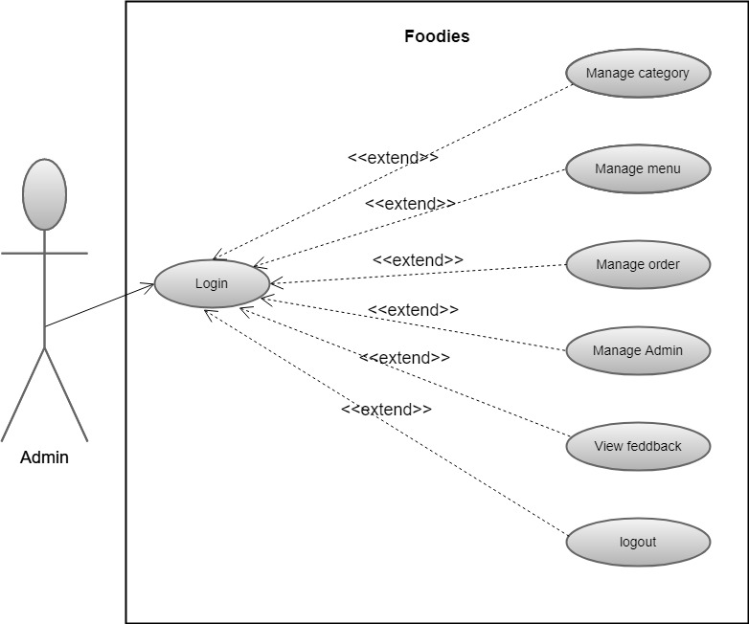

1. User:

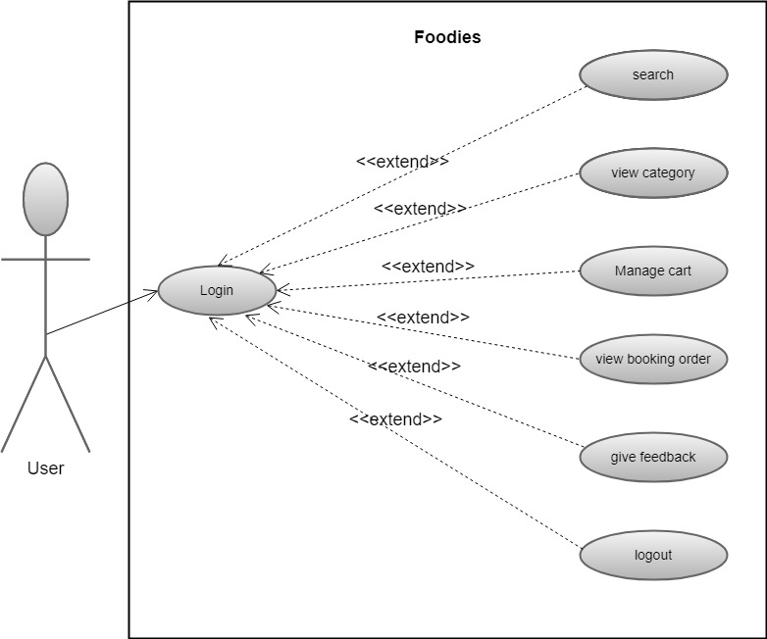

**DATA FLOW DIAGRAM**

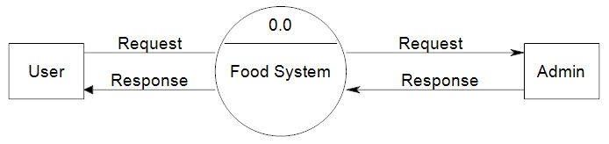

**Level 0 DFD**

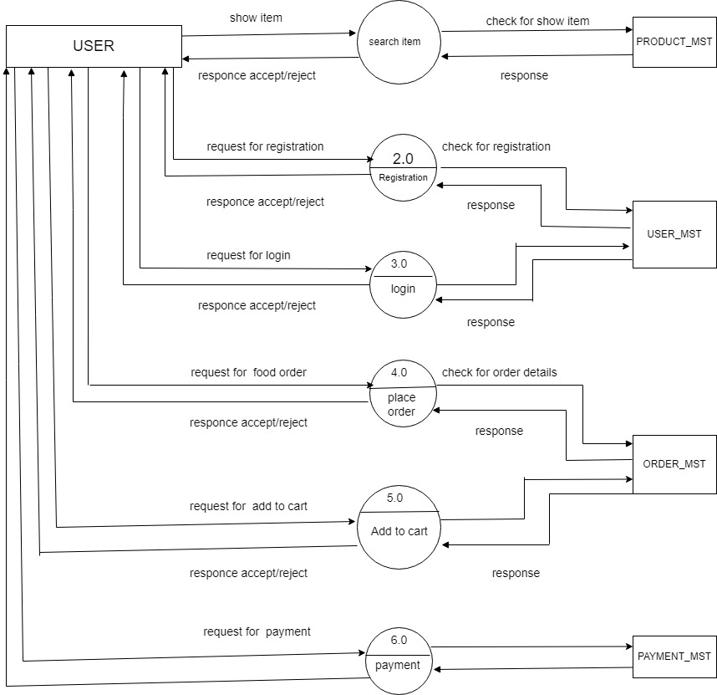

**Level 2 User DFD**

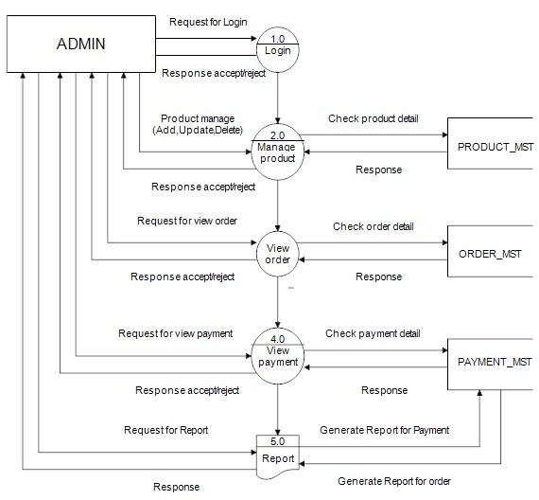

**Level 2 Admin DFD**

**E-R DIAGRAM**

