**ASSIGNMENT-2**

**Introduction to Cloud Computing**

**Submitted by,**

**Manjari Jayan**

**Roll No:35**

**COURSE SUMMARY**

**Introduction**

This course provides information on the definition, key features, background, current trends, and business case for cloud computing. Additionally, it explains the different cloud service models (IaaS, PaaS, SaaS) and deployment models (Public Cloud, Private Cloud, Hybrid Cloud), as well as the fundamental elements of a cloud architecture (Virtualization, VMs, Storage, Networking, Containers) and emerging cloud trends (Hybrid Multicloud, Serverless, Microservices, Cloud Native, Application Modernization). This course is divided into six modules.

**Summary**

The **first module** discusses definitions and fundamental traits.

The usage of computing resources like servers, storage, databases, networking, software, and more over the internet is made possible by a technology called cloud computing.

Ondemand selfservice, widespread network access, resource pooling, quick elasticity, and measured service are important features.A quick overview of the history and development of cloud computing Starting with mainframes and clientserver models, cloud computing has advanced over time.With the introduction of virtualization and the subsequent rise of major cloud service providers like Amazon Web Services (AWS), Microsoft Azure, and Google Cloud, the idea gained popularity.

Important cloud service providers and their offerings Infrastructure as a Service (IaaS), Platform as a Service (PaaS), and Software as a Service (SaaS) are just a few of the services offered by the best cloud providers. The industry is dominated by AWS, Azure, and Google Cloud, which provide services such as virtual machines, databases, machine learning, and more.

The **second module** covers Cloud Adoption and Emerging Technologies.

The Case for Cloud Computing : Cloud computing is used by businesses to reduce expenses, boost scalability, increase flexibility, and improve accessibility. Cloud computing allows for quick innovation and digital change.

Cloud-enabled emerging technologies : Artificial intelligence (AI), the Internet of Things (IoT), blockchain, and analytics are all supported by cloud computing. For processing and data storage, these technologies make use of cloud infrastructure.

**Third module** covers cloud computing service and deployment models.

***Service Models: IaaS, PaaS, SaaS***

The course dives into the core components of cloud computing, including the various service and deployment methods. These models specify how cloud resources are supplied and where they are housed, allowing businesses to adjust their cloud strategy to unique requirements.

IaaS (Infrastructure as a Service): IaaS is a service that provides virtualized computing resources via the internet. Virtual machines, storage, and networking components are available to users. It provides customers with flexibility and scalability by allowing them to deploy resources on-demand. Users are in charge of maintaining the operating system and apps.

PaaS (Platform as a Service): PaaS abstracts even more of the underlying infrastructure, enabling application development and deployment. Because the platform maintains the underlying infrastructure, including servers, storage, and databases, developers can concentrate on coding and application logic.

SaaS (Software as a Service): On a subscription basis, SaaS provides fully working software applications through the internet. Users can access software without having to install or maintain it. Email services, CRM systems, and office productivity suites are popular SaaS examples.

*Deployment Models: Public, Private, Hybrid*

The Public Cloud: Third-party cloud service providers, such as AWS, Azure, and Google Cloud, own and operate public clouds. Multiple organizations pool their resources. Scalability, cost-effectiveness, and a low initial commitment are all advantages of public clouds.

The Private Cloud: Private clouds are hosted on-premises or by a third-party provider and are devoted to a particular enterprise.They provide better control, security, and customization, but may necessitate a larger initial investment and ongoing upkeep.

Cloud Hybrid: Hybrid clouds integrate public and private cloud elements, allowing data and applications to be transferred between them. Organizations can benefit from the public cloud's scale while maintaining sensitive data and key apps on a private cloud for security and compliance reasons.

The **fourth module** goes through the underlying infrastructure that supports cloud computing, such as data centers and server farms, virtualization technologies, virtual machines (VMs), and bare-metal instances and importance of containerization technologies such as Docker and Kubernetes in cloud deployments.

The **second last module** covers the direct-attached storage and its application in cloud environments, cloud-based file sharing and collaboration alternatives for file storage, block storage choices if we need high-performance storage, object storage and its benefits for scalable data storage and how CDNs improve content delivery and user experience.

The **last module** was about the benefits and challenges of managing applications across multiple clouds and on-premises environments are discussed in detail, followed by a look at serverless computing, which allows us to run code without having to manage servers, the microservices architecture and its role in cloud-native applications, the principles of cloud-native development and deployment, and strategies for modernizing legacy applications in the cloud.

This course provides an in-depth understanding of cloud computing, from its fundamental concepts to cutting-edge applications.

**Certificate**

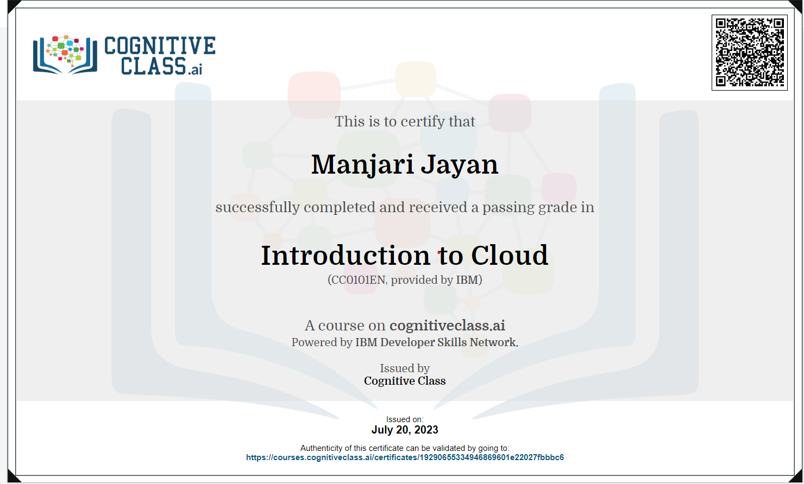

**Link:**

[https://courses.cognitiveclass.ai/certificates/19290655334946869601e22027fbbbc6](https://cognitiveclass.ai/courses/introduction-to-cloud)