**Power BI Installation Assignment -1**

1. Screenshot of the final Report View after the installation

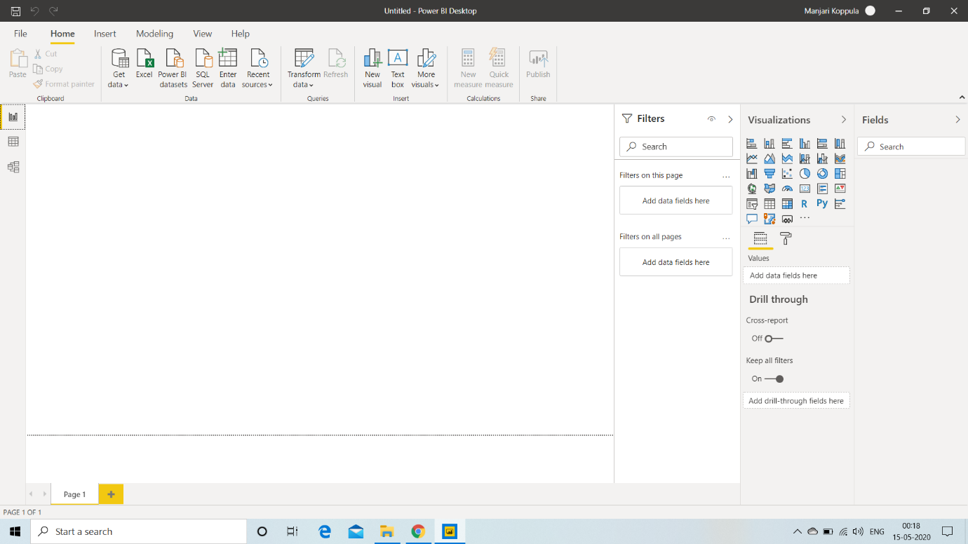

1. Report View

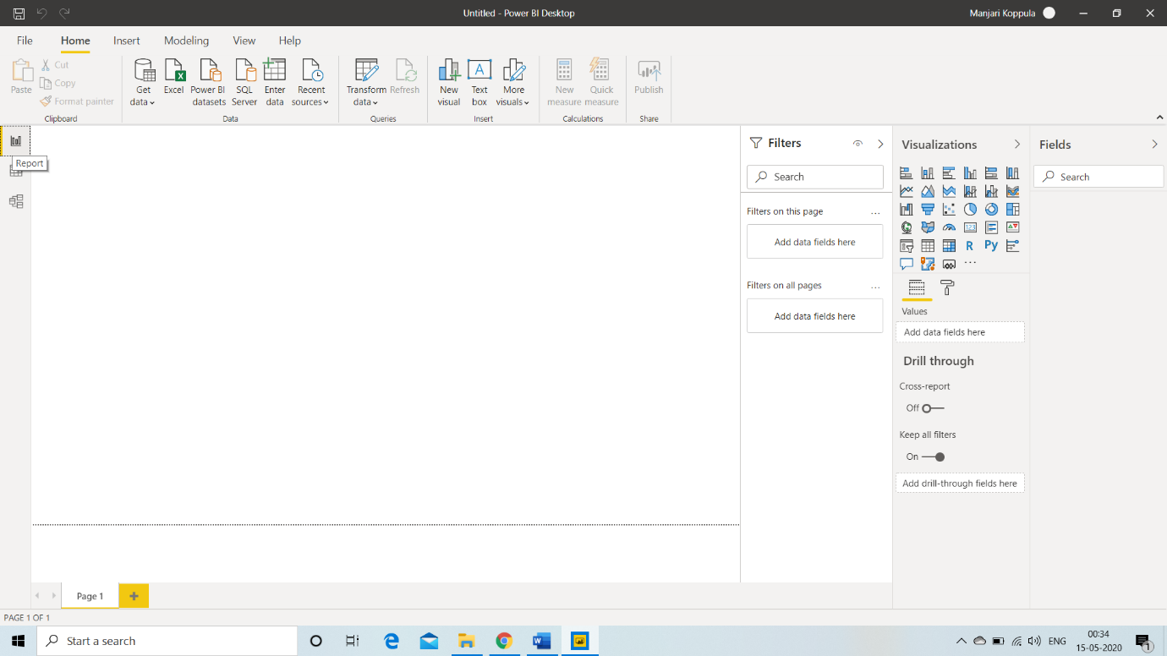

1. Data View

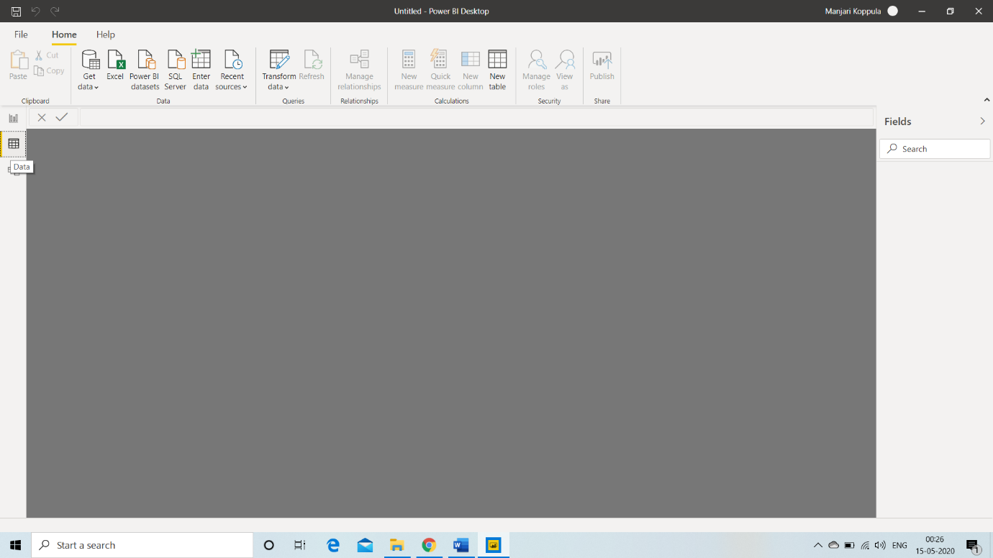

1. Model View

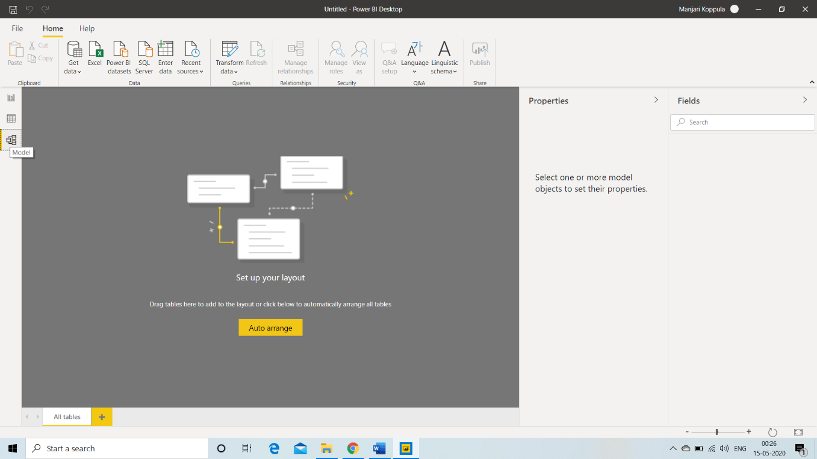

1. Power Query Editor

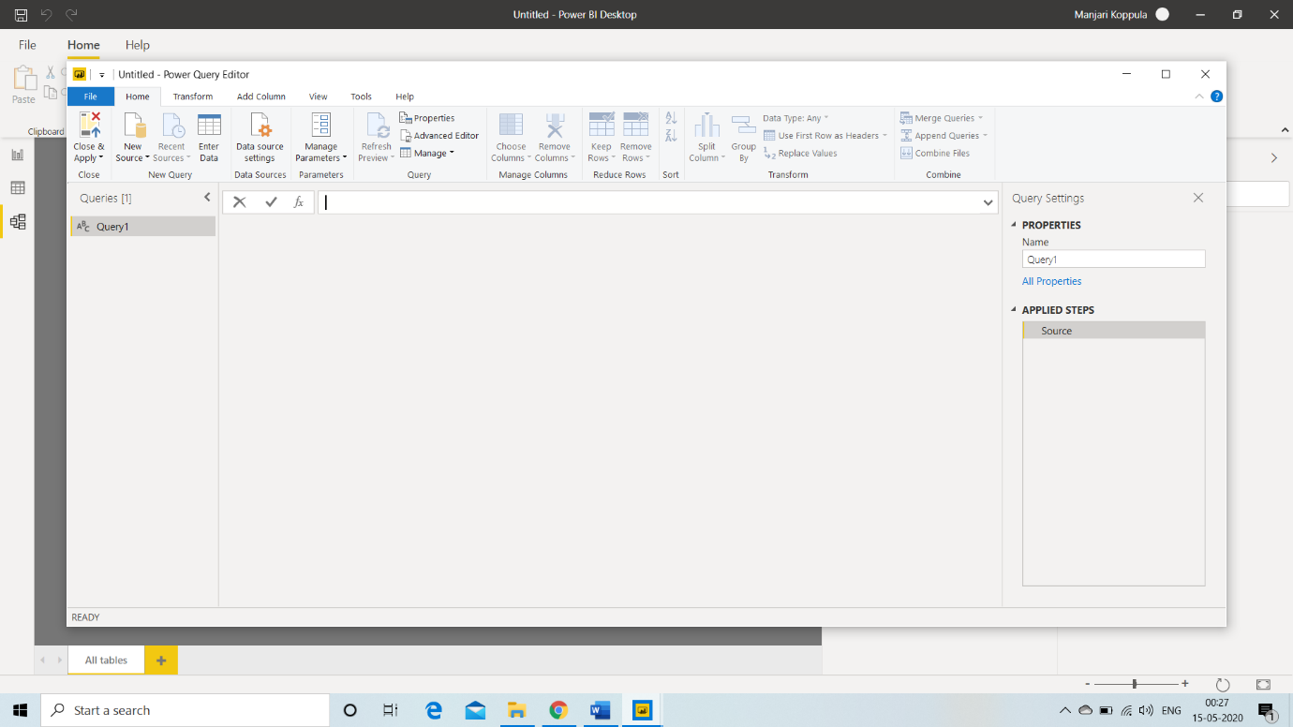

1. Advance Editor

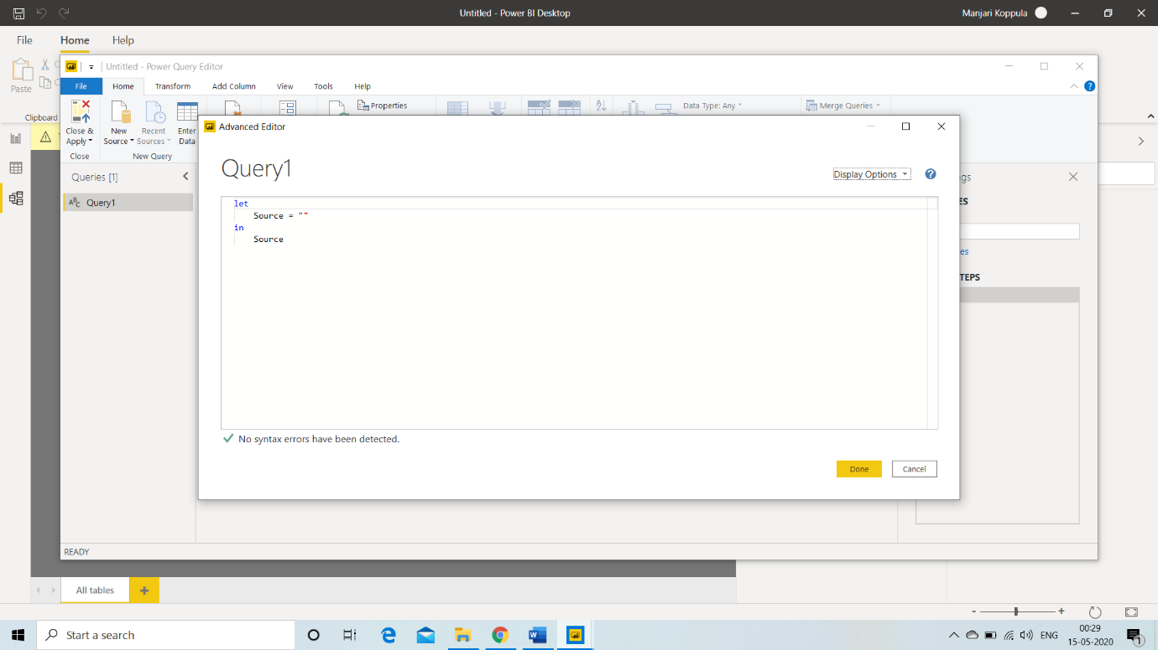

1. Power BI Desktop

Power BI Desktop is a free application you install on your local computer that lets you connect to, transform, and visualize your data. With Power BI Desktop, you can connect to multiple different sources of data, and combine them (often called modelling) into a data model.

The most common uses for Power BI Desktop are as follows:

* Connect to data
* Transform and clean that data, to create a data model
* Create visuals, such as charts or graphs, that provide visual representations of the data
* Create reports that are collections of visuals, on one or more report pages
* Share reports with others by using the Power BI service

There are three views available in Power BI Desktop, which you select on the left side of the canvas. The views, shown in the order they appear, are as follows:

* **Report**: In this view, you create reports and visuals, where most of your creation time is spent.
* **Data**: In this view, you see the tables, measures, and other data used in the data model associated with your report, and transform the data for best use in the report's model.
* **Model**: In this view, you see and manage the relationships among tables in your data model.

**PRICE:** Free for Individual Users

1. Power BI Pro

Create a data-driven culture throughout your organization. Easily share and collaborate on interactive data visualizations using Power BI Pro for self-service analytics.

Discover insights quickly

* Explore data easily by using conversational language and get meaningful answers to data questions asked in your own words.
* Get insights instantly from your favourite applications using pre-built data visualization and report templates.
* Keep your priority analytics handy by pinning your most relevant content, and ensure others see valuable insights by promoting them using administrative tools.

**PRICE:** $9.99 per user per month

1. Power Bi Premium

Power BI Premium consists of capacity in the Power BI service exclusively allocated to each organization. The capacity is supported by dedicated hardware fully managed by Microsoft. Organizations can choose to apply their dedicated capacity broadly, or allocate it to assigned workspaces based on the number of users, workload needs, or other factors—and scale up or down as requirements change.

Power BI Premium is a capacity-based offering that includes:

* Flexibility to publish reports broadly across an enterprise, without requiring recipients to be licensed individually per user.
* Greater scale and performance than shared capacity in the Power BI service.
* The ability to maintain BI assets on-premises with Power BI Report Server.
* One API surface, a consistent set of capabilities, and access to the latest features for embedded analytics.

**PRICE:** $4,995 a month per dedicated cloud compute and storage resource

Difference Between Power BI Desktop and Power BI PRO

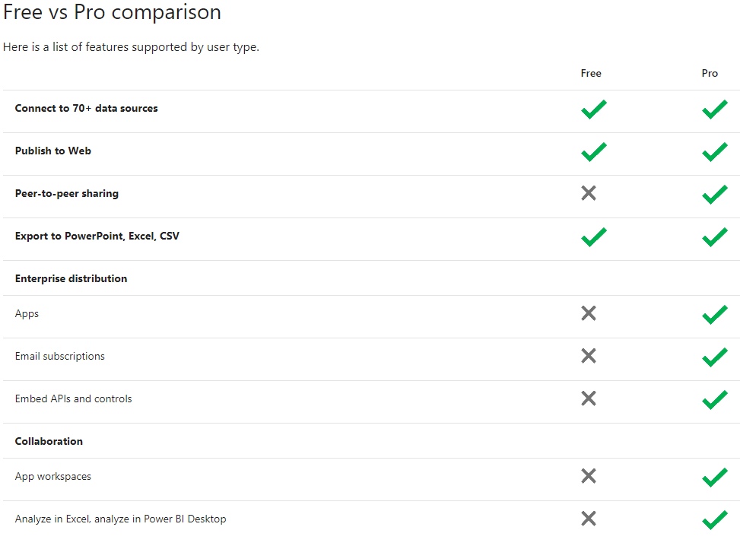

Difference Between Power BI Pro and Power BI Premium

With Power BI Premium, you are licensing capacity for your content rather than licensing all users of that content. Content (datasets, dashboards, and reports) is stored in Premium and can then be viewed by as many users as you want, without additional per-user costs. These users can only view content, not create it. Viewing includes looking at dashboards and reports on the web, in our mobile apps, or embedded in your organization’s portals or apps. The creators of content in Premium still need their own Pro licenses.