PROJECT REPORT
Hotel Reservation Cancellation Prediction Using Machine Learning
A Predictive Analytics Course Project
Submitted by
Manjari N.K.
B.Tech Computer Science Engineering (2nd Year)
Roll / Registration No.: ____________________
Institution: ____________________________________
Course Instructor: ______________________________
October 2026

1. Abstract
Hotel booking cancellations reduce revenue and make room planning difficult. This project builds a machine-learning system that predicts whether a hotel reservation will be cancelled, using booking information. The dataset contains 36,275 reservations with 19 columns, of which 11,885 (32.76%) were cancelled. After exploratory analysis and preprocessing, 14 features were used. To avoid using information that may only appear after the booking is made, the number of special requests was left out of the main models. The data were split 80:20 with stratification (29,020 training and 7,255 test records), and six classifiers were trained and compared: Logistic Regression, K-Nearest Neighbors, Gaussian Naïve Bayes, Support Vector Machine, Decision Tree and Random Forest. Models were judged on accuracy and on precision, recall and F1-score for the cancelled class. Random Forest performed best overall, with accuracy 0.8469, precision 0.8121, recall 0.6929 and F1-score 0.7478 for cancellations. Lead time was the strongest predictor, followed by average room price and arrival month. A separate check that added the number of special requests raised the Random Forest F1-score to 0.8431, so that feature is very informative, and the hotel must confirm when it becomes known before using it.

2. Introduction
Cancellations are a major operational problem for hotels. A room that is cancelled late may stay empty, while a hotel that overbooks to protect itself risks turning away guests who do arrive. If a hotel can estimate which reservations are likely to be cancelled, it can plan overbooking, reconfirmation messages and deposit policies more carefully.
Machine learning supports this by learning patterns from past reservations. This project applies supervised classification to a public hotel reservations dataset. It follows the workflow taught in the Predictive Analytics practicals: load and inspect the data, explore it visually, preprocess it, split it into training and test sets, scale the features where needed, train classifiers, and evaluate them using the confusion matrix, accuracy and the classification report.

3. Problem Statement
Can we predict whether a hotel reservation will be cancelled or not cancelled using booking information available at the time the reservation is made?
The intended prediction time is taken to be immediately after the booking is confirmed. This is a binary classification problem in which the positive class is "Canceled".

4. Project Objectives
- To quantify hotel reservation cancellation patterns across market segments, repeat-guest status, booking lead times and other relevant reservation characteristics.
- To examine the associations between reservation characteristics and cancellation outcomes.
- To develop a binary classification model that predicts whether a hotel reservation will be cancelled or not cancelled.
- To compare the performance of six classification algorithms using appropriate evaluation metrics and identify the most suitable model.
- To interpret the selected model's predictions and develop evidence-based recommendations for hotel reservation management.
Note on Objective 1: the dataset has no column called "customer type". Market segment type and repeated-guest status are used to describe customer groups instead.

5. Dataset Description and Source
The dataset is the Hotel Reservations Classification Dataset from Kaggle (https://www.kaggle.com/datasets/ahsan81/hotel-reservations-classification-dataset). The file "Hotel Reservations.csv" has 36,275 records and 19 columns, and every record has a unique Booking_ID. The target column is booking_status, with values Canceled and Not_Canceled.
Column | Type | Description / role in the project
Booking_ID | Text | Identifier. Excluded.
no_of_adults, no_of_children | Integer | Number of adults and children. Used.
no_of_weekend_nights, no_of_week_nights | Integer | Nights booked on weekends and weekdays. Used.
type_of_meal_plan | Text | Meal plan chosen (Meal Plan 1/2/3 or Not Selected). Used after encoding.
required_car_parking_space | Integer (0/1) | Parking requested. Used.
room_type_reserved | Text | Room type 1 to 7. Used after encoding.
lead_time | Integer | Days between booking and arrival. Used.
arrival_year, arrival_month, arrival_date | Integer | Arrival date parts. Only arrival_month used.
market_segment_type | Text | Online, Offline, Corporate, Complementary, Aviation. Used after encoding.
repeated_guest | Integer (0/1) | Whether the guest has stayed before. Used.
no_of_previous_cancellations | Integer | Earlier cancellations by the guest. Used.
no_of_previous_bookings_not_canceled | Integer | Earlier completed bookings by the guest. Used.
avg_price_per_room | Float | Average price per room per day. Used.
no_of_special_requests | Integer | Special requests made. Analysed in EDA; left out of the main models and tested separately (Section 11.3).
booking_status | Text | Target: Canceled / Not_Canceled.

5.1 Data quality checks (output of the notebook)
- No missing values and no duplicate rows were found, and all 36,275 Booking_IDs are unique.
- 37 records have an invalid arrival date. All of them are 29 February 2018, which does not exist because 2018 was not a leap year.
- 545 records have an average room price of zero. Of these, 354 belong to the Complementary segment and 191 to the Online segment, and 539 of the 545 were not cancelled.
- 139 records have zero adults. In every one of them at least one child is booked (1 to 3 children).
- 78 records have zero total nights (no weekend nights and no week nights).
- Cancellation distribution: 24,390 Not_Canceled (67.24%) and 11,885 Canceled (32.76%).

6. Methodology
The project followed the sequence taught in the classroom practicals, and every step was executed in a Jupyter notebook (pandas, numpy, matplotlib, seaborn and scikit-learn):
- Import the libraries and load the CSV file with pandas.
- Inspect the data using head(), tail(), shape, info(), describe() and missing-value counts.
- Investigate unusual values (invalid dates, zero prices, zero adults) instead of deleting them automatically.
- Carry out exploratory data analysis (EDA) with count plots, bar plots, histograms, box plots and a correlation heatmap.
- Preprocess the data: drop unsuitable columns and encode text columns with LabelEncoder.
- Select the feature matrix X and the target y, then split with train_test_split (80% training, 20% testing, random_state = 42, stratified on the target).
- Scale the features with StandardScaler, fitted on the training set only, for the models that depend on feature scale.
- Train the six classifiers and predict on the test set with predict().
- Evaluate with the confusion matrix, accuracy and the classification report, and compare the models in one table.
- Interpret the results using the decision-tree plot and Random Forest feature importance, and run a sensitivity check that adds the special-requests feature.

7. Data Preprocessing

7.1 Handling unusual values
Unusual records were investigated before any decision was made. The zero-price records are mostly complimentary stays, which are genuine bookings with no charge, so they were kept. The zero-adult records all include children, so they are unusual but not clearly wrong, and were kept. The 37 invalid-date records are all the same non-existent date (29 February 2018). Since the day of the month is not used as a feature, these records do not affect the model, and they were kept because their other fields are valid.

7.2 Feature selection and leakage check
Feature | Decision | Reason
Booking_ID | Dropped | Identifier with no predictive meaning.
booking_status | Dropped from X | This is the target. A numeric copy ("cancelled", 1 = Canceled) is used as y.
arrival_year | Dropped | Only two values (2017, 2018). The model would learn the year instead of a general pattern.
arrival_date | Dropped | Day of month is a weak predictor and contains the invalid dates.
no_of_special_requests | Left out of main models | Guests may add requests after booking, so it may not be known at prediction time. Tested separately in Section 11.3.
All other 14 features | Kept | Known when the booking is made.

7.3 Encoding
Three text columns were converted to numbers with LabelEncoder: type_of_meal_plan (Meal Plan 1 = 0, Meal Plan 2 = 1, Meal Plan 3 = 2, Not Selected = 3), room_type_reserved (Room_Type 1 to 7 = 0 to 6) and market_segment_type (Aviation = 0, Complementary = 1, Corporate = 2, Offline = 3, Online = 4). The target was coded Not_Canceled = 0 and Canceled = 1 so that "Canceled" is the positive class and precision and recall describe how well cancellations are detected.

7.4 Train-test split and scaling
The data were split 80:20 with random_state = 42. The split was stratified so that both parts keep the same cancelled share: 32.76% in the training set (29,020 records) and 32.76% in the test set (7,255 records), each with 14 features. StandardScaler was fitted on the training data only and then applied to the test data, which avoids leaking test information into training. Scaled data were used for Logistic Regression, KNN and SVM, which are sensitive to feature scale. Gaussian Naïve Bayes, Decision Tree and Random Forest used the original values, so the tree plot shows real values such as lead_time ≤ 151.5.

8. Exploratory Data Analysis

8.1 Cancellation distribution
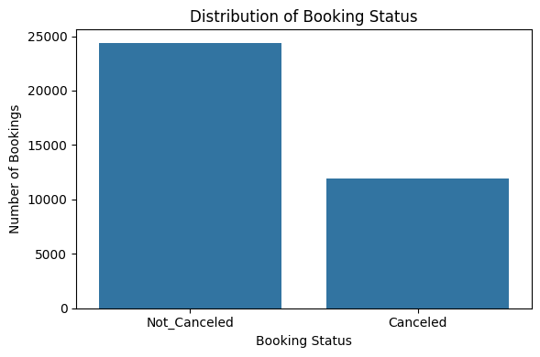
Figure 1: Distribution of booking status
About one booking in three (11,885 of 36,275, or 32.76%) was cancelled. The classes are moderately imbalanced, so a model that always predicted "Not Canceled" would already score about 67% accuracy. For this reason accuracy alone cannot be used to choose a model, and precision, recall and F1-score for the cancelled class are reported.

8.2 Market segment and repeat guests
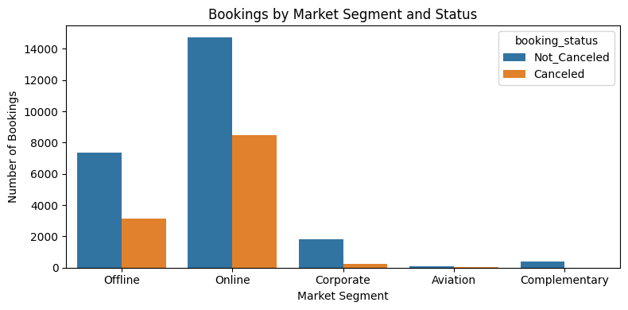
Figure 2: Bookings by market segment and status
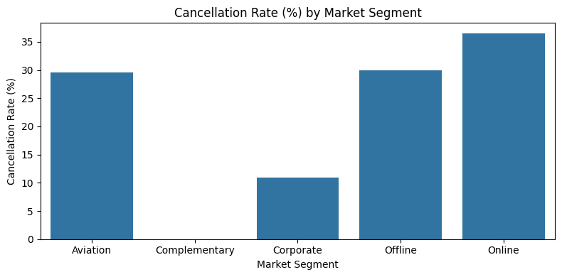
Figure 3: Cancellation rate by market segment
Online bookings are the largest group (23,214) and have the highest cancellation rate at 36.51%. Offline (29.95%) and Aviation (29.60%) are lower, Corporate bookings are much lower at 10.91%, and none of the 391 Complementary bookings was cancelled. Segment is therefore strongly associated with cancellation.
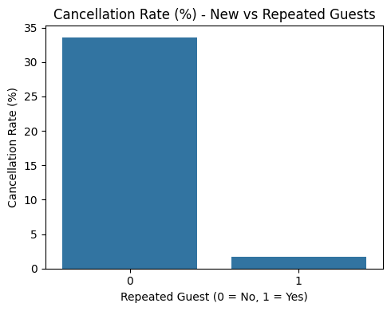
Figure 4: Cancellation rate for new and repeated guests
New guests cancel 33.58% of the time, whereas repeated guests cancel only 1.72% of the time. Returning guests are very reliable, although they are a small share of all bookings.

8.3 Lead time
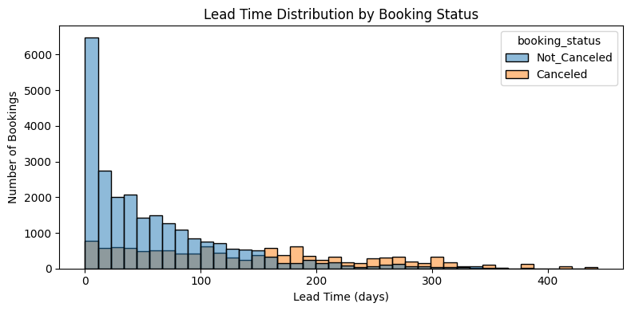
Figure 5: Lead time distribution by booking status
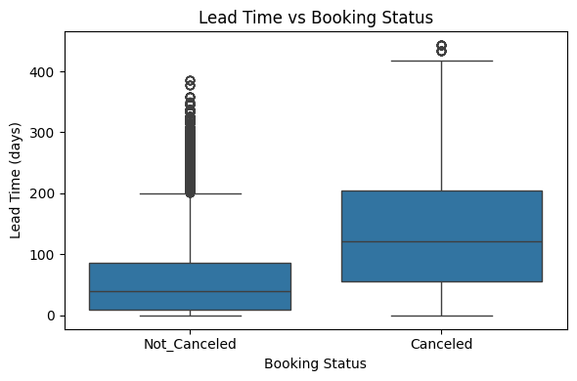
Figure 6: Lead time versus booking status
Cancelled bookings were made much earlier than completed ones. The mean lead time is 139.2 days for cancelled bookings against 58.9 days for completed ones, and the medians are 122 and 39 days. Lead time has the strongest correlation with cancellation (+0.44) of any numerical feature. The longer a guest waits between booking and arrival, the more likely the plans change.

8.4 Room type and meal plan
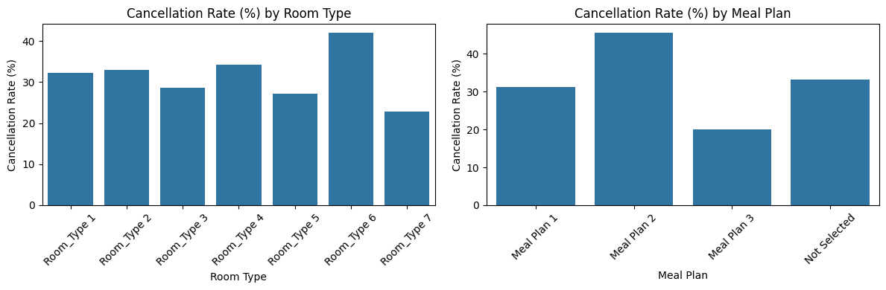
Figure 7: Cancellation rate by room type and meal plan
Room Type 6 has the highest cancellation rate (42.03%) and Room Type 7 the lowest (22.78%, from only 158 bookings). Meal Plan 2 stands out at 45.57%, compared with 31.18% for Meal Plan 1 and 33.12% for "Not Selected". Room Type 3 (7 bookings) and Meal Plan 3 (5 bookings) have too few bookings for their rates (28.57% and 20.00%) to be reliable.

8.5 Price
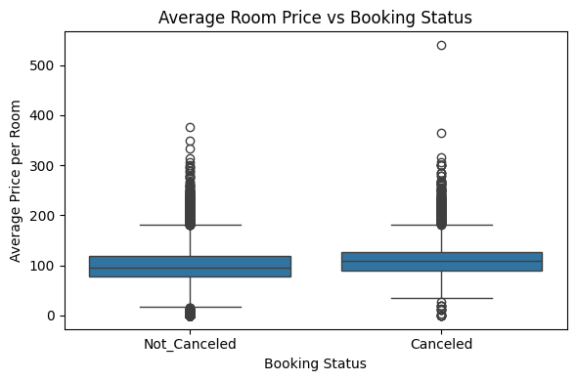
Figure 8: Average room price versus booking status
Cancelled bookings have a higher mean price per room (110.59) than completed bookings (99.93), and price has a weak positive correlation with cancellation (+0.14). Price is also related to segment, room type and season, so it should not be read as a direct cause.

8.6 Special requests
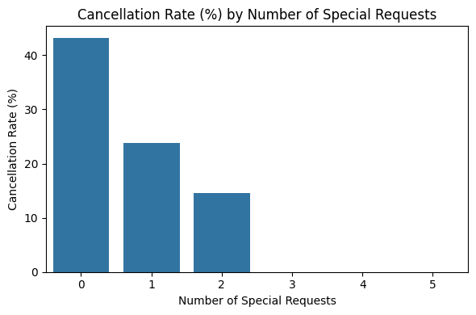
Figure 9: Cancellation rate by number of special requests
Guests with no special request cancel 43.21% of the time, those with one request 23.77%, and those with two requests 14.60%. No booking with three or more requests was cancelled. The correlation is −0.25. Guests who make requests seem more committed to their stay. Because requests can be added after booking, this feature is left out of the main models (Section 11.3).

8.7 Arrival month and year
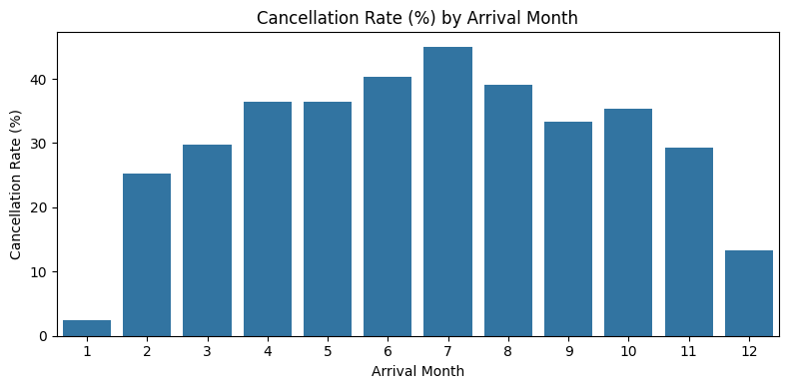
Figure 10: Cancellation rate by arrival month
Cancellation rates are lowest in January (2.37%) and December (13.31%) and highest in July (45.00%). This chart must be read with care. The data cover July 2017 to December 2018: January to June occur only in 2018, and the 2017 cancellation rate (14.75%) is much lower than the 2018 rate (36.71%). The monthly pattern therefore mixes a seasonal effect with a change over time, and the two cannot be separated with this dataset.

8.8 Correlation analysis
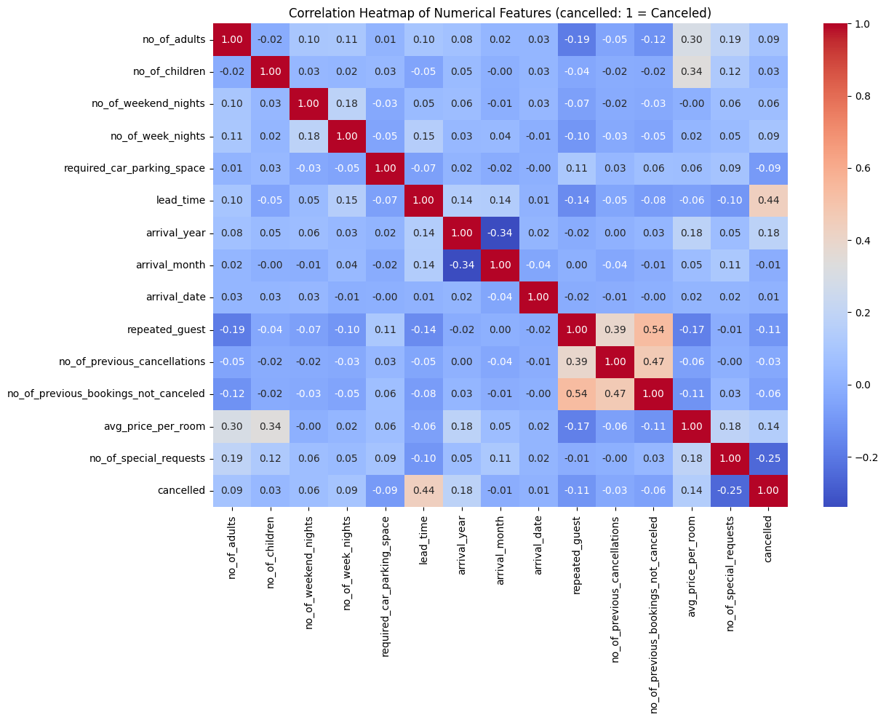
Figure 11: Correlation heatmap of numerical features
Correlation with cancellation (cancelled = 1): lead_time +0.44, arrival_year +0.18, avg_price_per_room +0.14, no_of_week_nights +0.09, no_of_adults +0.09, no_of_special_requests −0.25, repeated_guest −0.11 and required_car_parking_space −0.09. Apart from lead time, the linear correlations are weak, which suggests that combinations of features matter, a pattern that tree-based models can capture. Correlation measures linear association only and does not prove cause. Repeated_guest and the two previous-booking columns are correlated with each other (0.39 to 0.54), because they describe the same guest history.

9. Model Implementation
All six classifiers were trained on the same training set (14 features) and tested on the same test set. Settings follow the classroom practicals:
Model | Data used | Settings and note
Logistic Regression | Scaled | max_iter = 1000. A linear model; the probability of cancellation is a weighted sum of the features.
K-Nearest Neighbors | Scaled | n_neighbors = 5, metric = euclidean. Classifies a booking by its 5 nearest training bookings.
Gaussian Naïve Bayes | Original | Default settings. Assumes each feature is normally distributed within each class.
Support Vector Machine | Scaled | SVC with kernel = rbf, random_state = 42. Finds the best separating boundary.
Decision Tree | Original | criterion = entropy, random_state = 42, no depth limit. The tree grew to depth 56 with 5,010 leaves.
Random Forest | Original | n_estimators = 100, random_state = 42. Averages 100 trees.

Hyperparameters were not tuned, so every model is compared at its classroom-standard settings.

10. Model Evaluation and Comparison

10.1 Metrics used
The confusion matrix counts four outcomes. TP (true positives) are cancellations correctly predicted, TN are completed bookings correctly predicted, FP are completed bookings wrongly flagged as cancellations, and FN are cancellations that were missed. From these:
- Accuracy = (TP + TN) / all bookings. The share of all predictions that are correct.
- Precision (Canceled) = TP / (TP + FP). Of the bookings flagged as cancellations, how many really were cancelled.
- Recall (Canceled) = TP / (TP + FN). Of all real cancellations, how many were caught.
- F1-score = the harmonic mean of precision and recall. It is high only when both are high.

10.2 Results on the test set (7,255 bookings, 2,377 of them cancelled)
Model | Accuracy | Precision (Canc.) | Recall (Canc.) | F1 (Canc.) | TN | FP | FN | TP
Logistic Regression | 0.7615 | 0.6931 | 0.4884 | 0.5731 | 4364 | 514 | 1216 | 1161
KNN | 0.8066 | 0.7308 | 0.6487 | 0.6873 | 4310 | 568 | 835 | 1542
Gaussian Naïve Bayes | 0.3775 | 0.3436 | 0.9882 | 0.5099 | 390 | 4488 | 28 | 2349
SVM | 0.7943 | 0.8177 | 0.4792 | 0.6042 | 4624 | 254 | 1238 | 1139
Decision Tree | 0.8190 | 0.7274 | 0.7160 | 0.7216 | 4240 | 638 | 675 | 1702
Random Forest | 0.8469 | 0.8121 | 0.6929 | 0.7478 | 4497 | 381 | 730 | 1647

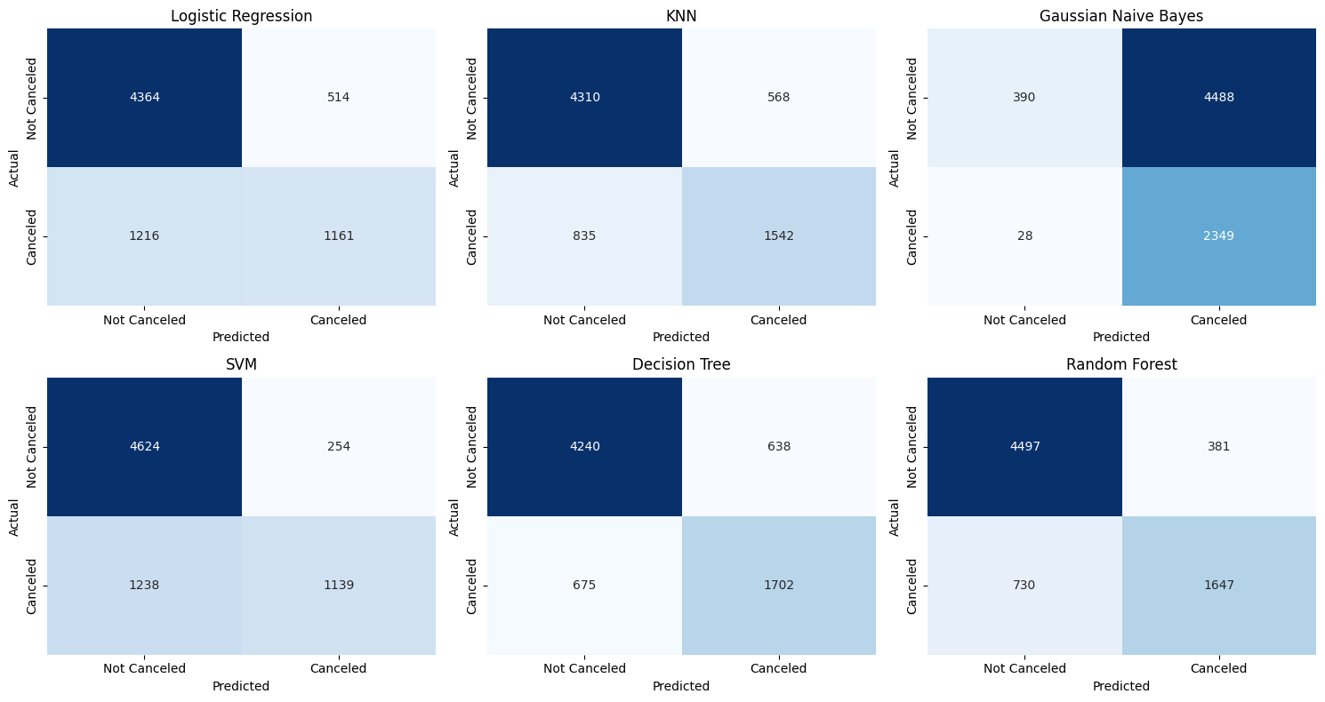
Figure 12: Confusion matrices of all six models
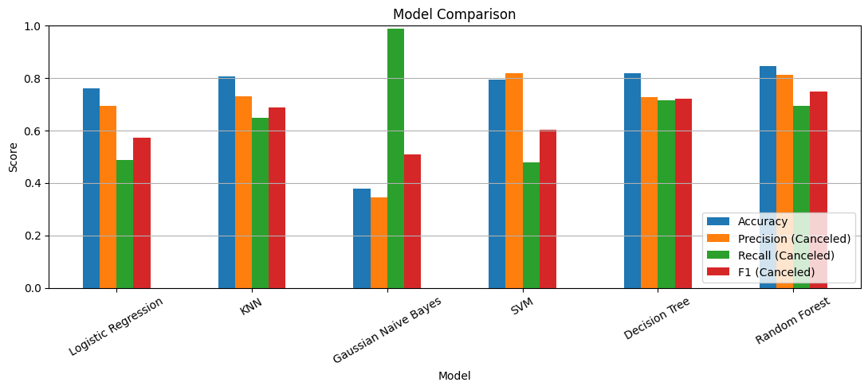
Figure 13: Comparison of accuracy, precision, recall and F1-score

11. Results and Discussion

11.1 Which model is the most suitable?
Random Forest is the most suitable model. It has the highest accuracy (0.8469) and the highest F1-score for cancellations (0.7478), and it keeps a good balance between precision (0.8121) and recall (0.6929). Its accuracy is about 17 points above the 67.24% that a model predicting "Not Canceled" every time would reach. The choice does not rest on accuracy alone, and the other models each have a weakness:
- Decision Tree: it catches more cancellations than Random Forest (recall 0.7160 against 0.6929, with 675 missed against 730) but raises 638 false alarms against 381, so its precision (0.7274) and F1 (0.7216) are lower.
- SVM: it has the highest precision (0.8177, only 254 false alarms) but the lowest recall among useful models (0.4792), so it misses 1,238 of the 2,377 real cancellations.
- Logistic Regression: recall 0.4884, so it also misses more than half of the cancellations.
- KNN: it sits in the middle (F1 0.6873).
- Gaussian Naïve Bayes: it has the highest recall (0.9882) but the lowest precision (0.3436) and accuracy (0.3775). It labels 6,837 of the 7,255 test bookings (about 94%) as cancellations, so it is not useful.
Naïve Bayes shows why accuracy must not be used alone, and also why recall must not be used alone. A likely reason for its failure is that several features are strongly skewed and are not normally distributed, for example no_of_previous_cancellations, so the normal-distribution assumption of this model does not hold.
For Random Forest, 730 cancellations were missed (false negatives) and 381 genuine bookings were flagged (false positives). Which error costs more depends on the hotel, so in practice the decision threshold should be set with the hotel's own costs in mind.

11.2 What drives the predictions?
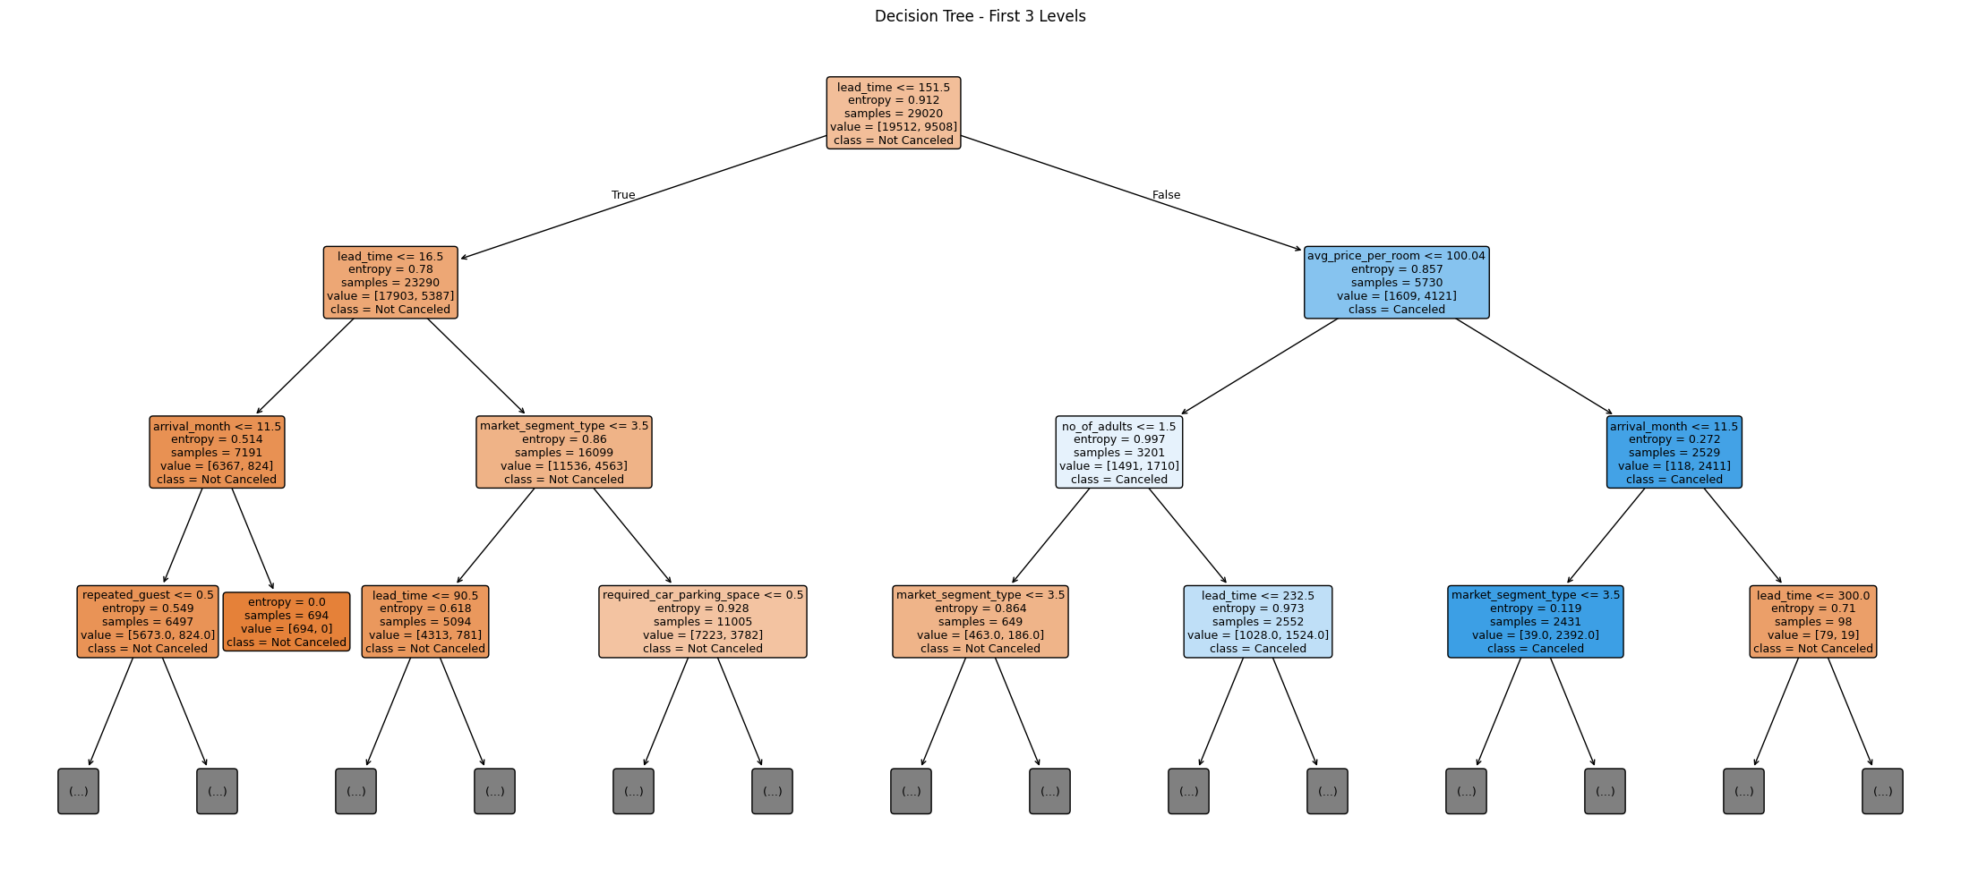
Figure 14: First three levels of the Decision Tree
The Decision Tree's first split is lead_time ≤ 151.5 days. Of the 5,730 training bookings made more than about 5 months ahead, 4,121 were cancelled. Among bookings with a shorter lead time, the next split is lead_time ≤ 16.5 days, and the training bookings in that group with an arrival month of December (694 records) were all completed. This is a pattern in these data only and should not be treated as a rule, because month and year effects are mixed (Section 8.7). The full tree has depth 56 and 5,010 leaves, so only the top levels are meaningful.
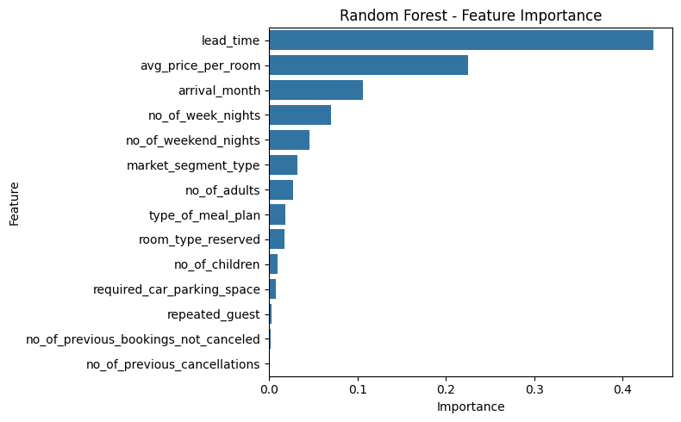
Figure 15: Random Forest feature importance
Random Forest importance ranks lead_time first (0.4346), followed by avg_price_per_room (0.2249), arrival_month (0.1059), no_of_week_nights (0.0703), no_of_weekend_nights (0.0460) and market_segment_type (0.0325). The three guest-history features have very low importance (0.0032 or less), probably because very few bookings come from repeated guests, even though those guests rarely cancel. Importance shows how much a feature is used by the model, not whether it raises or lowers the chance of cancellation.

11.3 Sensitivity check: adding special requests
Because guests can add special requests after booking, the main models leave this feature out. To see how much it would help, Random Forest and Logistic Regression were re-run with it added.
Model | Feature set | Accuracy | Precision | Recall | F1
Random Forest | Without special requests (main) | 0.8469 | 0.8121 | 0.6929 | 0.7478
Random Forest | With special requests | 0.9016 | 0.8823 | 0.8073 | 0.8431
Logistic Regression | Without special requests (main) | 0.7615 | 0.6931 | 0.4884 | 0.5731
Logistic Regression | With special requests | 0.8094 | 0.7528 | 0.6226 | 0.6816

Adding the feature raises the Random Forest F1-score from 0.7478 to 0.8431 and the Logistic Regression F1-score from 0.5731 to 0.6816. Random Forest is the better model in both settings. If a hotel records the number of special requests at the time of booking, it can use the higher-scoring version. If requests arrive later, the more cautious main results (F1 = 0.7478) are the realistic ones.

11.4 Recommendations for reservation management
These suggestions follow from the associations found in this dataset. They show where the risk lies and should be tested by the hotel before they are adopted as policy.
- Watch long lead times. Bookings made far ahead are the strongest cancellation signal. Reconfirmation messages or deposits closer to arrival could be tested for these bookings.
- Treat online bookings differently. Online bookings cancel at 36.51% against 10.91% for Corporate. Flexible online rates may need a different policy from corporate rates.
- Use predicted risk in overbooking. A controlled amount of overbooking for dates with many high-risk reservations could reduce empty rooms, with the model's false-alarm count (381 in the test set) in mind.
- Record special requests early. Guests who make requests cancel much less often, and adding the feature raised the F1-score by about 0.10. If the hotel can capture requests at booking, the model becomes more accurate. This dataset cannot show that requests cause fewer cancellations.
- Reward repeat guests. Repeat guests cancel only 1.72% of the time, so loyalty benefits protect a very reliable group.

12. Conclusion
This project showed that hotel cancellations can be predicted from booking information with useful accuracy. Among six classifiers, Random Forest was the most suitable, reaching 0.8469 accuracy and an F1-score of 0.7478 for the cancelled class, with 0.8121 precision and 0.6929 recall, using only features that are likely to be known when the booking is made. Lead time, price and arrival month were the most useful signals. The comparison also showed that accuracy alone can mislead: Gaussian Naïve Bayes catches nearly every cancellation yet flags about 94% of all bookings. Adding the number of special requests lifted the Random Forest F1-score to 0.8431, so the hotel should confirm when that information becomes available.

13. Limitations
- The data come from one source, and the hotel(s) and booking channels behind it are not described in the dataset, so the results may not apply to other hotels.
- The data run from July 2017 to December 2018. Seasonal and yearly effects are mixed, and a random split lets the model learn from bookings made after those it is tested on. Real use would predict future bookings from past ones.
- LabelEncoder gives text categories an artificial order (for example Online = 4 and Offline = 3). This can mislead Logistic Regression, KNN and SVM, which treat numbers as ordered.
- Hyperparameters were not tuned, and a single train-test split was used, so the scores come from one split and carry some uncertainty. Differences of a few hundredths between models may not be reliable.
- The unrestricted Decision Tree is very deep (depth 56, 5,010 leaves) and may over-fit. Its training accuracy was not measured, so over-fitting is suspected, not shown.
- Gaussian Naïve Bayes assumes normally distributed features, which does not fit this data, so its result reflects that mismatch.
- Whether the number of special requests is known at booking time cannot be settled from the data (Section 11.3).
- The relationships found are associations, not proof of cause.

14. Future Scope
- Use cross-validation and tune hyperparameters (for example the number of trees, tree depth and the value of k) for a more reliable comparison.
- Use one-hot encoding for nominal columns so that categories have no artificial order.
- Split the data by time, training on earlier bookings and testing on later ones, to mimic real use.
- Choose the decision threshold according to the hotel's cost of a missed cancellation compared with a false alarm.
- Add features such as payment type, deposit policy, booking channel details and local events.
- Explore other tree-based or boosting methods and deploy the chosen model as a simple tool for reservation staff.

15. References
- Kaggle. Hotel Reservations Classification Dataset (ahsan81). https://www.kaggle.com/datasets/ahsan81/hotel-reservations-classification-dataset
- Pedregosa, F. et al. (2011). Scikit-learn: Machine Learning in Python. Journal of Machine Learning Research, 12, 2825–2830.
- McKinney, W. (2010). Data Structures for Statistical Computing in Python. Proceedings of the 9th Python in Science Conference.
- Hunter, J. D. (2007). Matplotlib: A 2D Graphics Environment. Computing in Science & Engineering, 9(3), 90–95.
- Waskom, M. L. (2021). seaborn: statistical data visualization. Journal of Open Source Software, 6(60), 3021.
- Predictive Analytics course practical files (classroom material on regression, Logistic Regression, KNN, Naïve Bayes, SVM, Decision Tree and Random Forest).

16. Screenshots of Implementation and Results
Insert your own screenshots here, taken while running your Jupyter notebook. Screenshots must be genuine captures of your own run.
Screenshot 1: the import and data-loading cells with the output of df.info().
Screenshot 2: the output of the data-quality checks (invalid dates, zero price, zero adults).
Screenshot 3: the preprocessing and train-test split cells with their output.
Screenshot 4: the cell that trains the six models.
Screenshot 5: the MODEL COMPARISON TABLE output.
Screenshot 6: the confusion-matrix figure, the feature-importance figure and the special-requests sensitivity table.
For reference, the model comparison table printed by the notebook is:
Model Accuracy Precision (Canceled) Recall (Canceled) F1 (Canceled)
Logistic Regression 0.7615 0.6931 0.4884 0.5731
KNN 0.8066 0.7308 0.6487 0.6873
Gaussian Naive Bayes 0.3775 0.3436 0.9882 0.5099
SVM 0.7943 0.8177 0.4792 0.6042
Decision Tree 0.8190 0.7274 0.7160 0.7216
Random Forest 0.8469 0.8121 0.6929 0.7478

