**HEALTHCARE DASHBOARD**

**Problem Statement -**

People with intellectual disabilities (ID) are at increased risk for poor health outcomes and health disparities. The lack of health care provider training on disability has been highlighted in recent literature as a key, modifiable determinant of the health disparities experienced by people with ID.

Despite national calls for didactic and clinical interventions aimed at improving health care provider competency in treating people with ID, most health care providers receive little training during medical school in the health care of patients with ID. Additionally, mainstream clinical guidelines do not address the unique concerns of patients with ID. As a result, patients with ID are not included in mainstream health care delivery organizations and practices.

**About The Use Case -**

A healthcare dashboard is a modern analytics tool to monitor healthcare KPIs in a dynamic and interactive way. A common example is a hospital KPI dashboard, that enables healthcare professionals to access important patient statistics in real-time to increase the overall hospital performance and patient satisfaction.

**About Dataset -**

Healthcare data sets include a vast amount of medical data, various measurements, financial data, statistical data, demographics of specific populations, and insurance data, to name just a few, gathered from various healthcare data sources.

Health care data sets are an important source of information for understanding health disparities and addressing health inequities in patient populations.

**Data Cleaning –**

In Data Cleaning the first columns are promoted as headers and data types of the columns are changed /

**Dashboard Main Components -**

1. **Home**

🡪Insight on the Patients stay and amount spend.

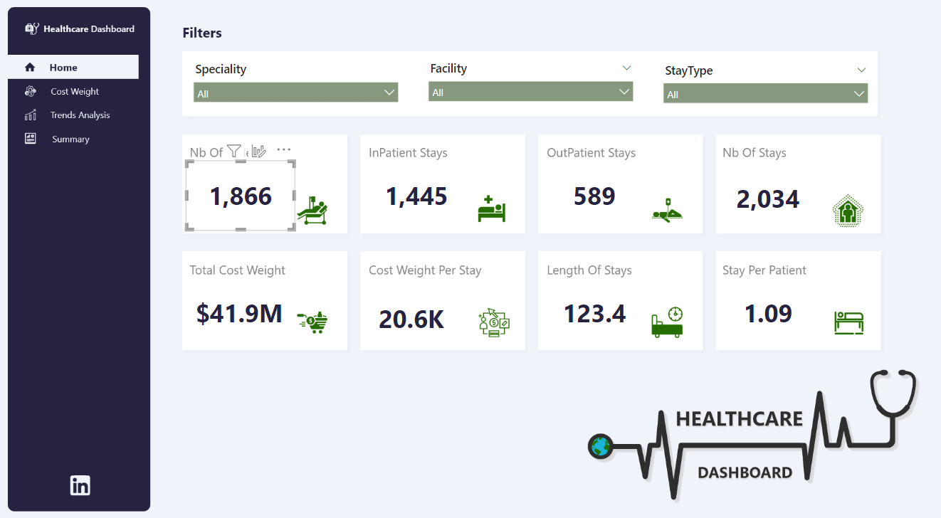

**2. Cost Weight Analysis**

🡪Analysis of the cost weight per stay

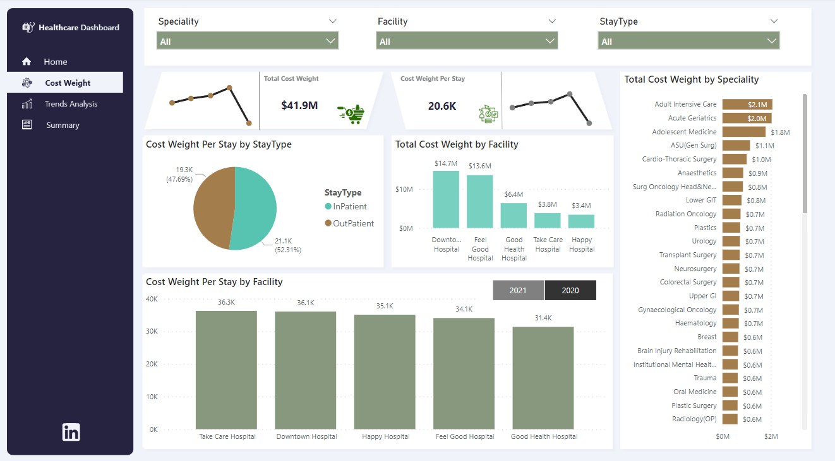**3.Trends Analysis**

**🡪**Analysis of the trend in cost weight per stay by month and year.

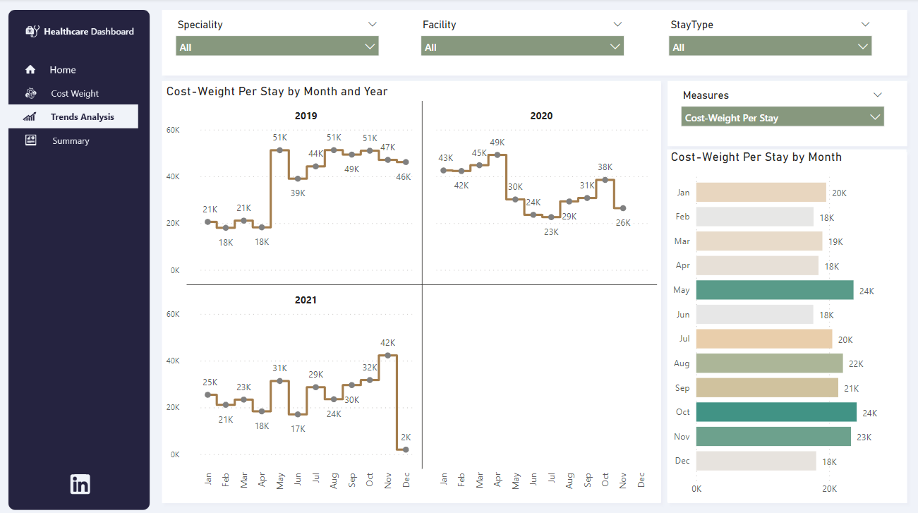

**4. Summary Dashboard**

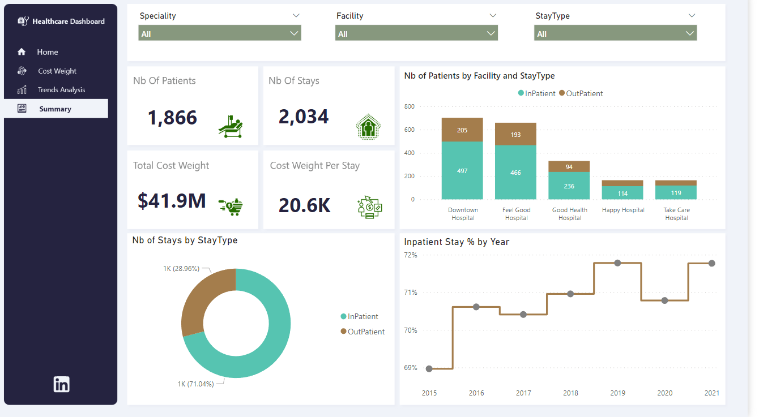

**KPI’s -**   
  
In this report, I have created the following KPIs.

**1. Nb of Stays.**

Nb of Stays =

COUNT ( FactPatientStay[StayNbr] ) + 0

**2. Nb of Patients**

Nb of Patients =

DISTINCTCOUNT ( FactPatientStay[PatientKey] ) + 0

**3.Patient Per Stay**

Stay Per Patient =

DIVIDE ( [Nb of Stays], [Nb of Patients], 0 )

**4.Total Cost Weight**

Total Cost Weight = SUM(FactPatientStay[Cost-Weight])

**5.Cost Weight Per Stay**

Cost Weight Per Stay = DIVIDE([Total Cost Weight] , [Nb of Stays] )

**6.LOS (Length Of Stays)**

Length Of Stays =

AVERAGE ( FactPatientStay[Days Different] ) + 0

**7.Nb of Out Patients Stays**

Outpatient Stays =

CALCULATE ( [Nb of Stays], StayType[StayType] = "OutPatient" ) + 0

**8.Nb of In Patients Stays**

Nb of Patients =

DISTINCTCOUNT ( FactPatientStay[PatientKey] ) + 0

**Conclusion -**

The average length of stay in hospitals (ALOS) is often used as an indicator of efficiency. All other things being equal, a shorter stay will reduce the cost per discharge and shift care from inpatient to less expensive post-acute settings. The ALOS refers to the average number of days that patients spend in hospital. It is generally measured by dividing the total number of days stayed by all inpatients during a year by the number of admissions or discharges. Day cases are excluded. The indicator is presented both for all acute care cases and for childbirth without complications.