Quality Control in Manufacturing: Defect Inspection System
Image Processing and Computer Vision (IPCV) Project Report
Department of Computer Science & Engineering
Team Members: Manjeet Kumar | Md Abdul Kalam | Lokesh Kumar Kankarwal | Sanginesh Singh
ABSTRACT: In this project, we built an visual inspection system to detect defects in glass bottles using classical image processing techniques on the MVTec AD Bottle dataset. While deep learning models require expensive GPUs and lots of defective training images, our system uses pure classical computer vision algorithms (OpenCV and NumPy) and learns entirely from 209 normal, defect-free bottles. The pipeline aligns each bottle, extracts color and edge features, compares them with normal bottles, and categorizes each sample into Good, Suspicious, or Defective. On the 83 test benchmark images, our system achieved 98.7% ROC-AUC accuracy, correctly identified all major cracks, and achieved 0% false rejection of good bottles, running in ~28 ms on a standard laptop CPU.
1. Introduction
1.1 Background & Problem Statement
Automated quality inspection is crucial in beverage bottling and pharmaceutical packaging, where bottles may develop defects such as fractures, rim chips, or foreign contamination during production. These defects can cause leaks and safety risks, while manual inspection is slow, costly, and unreliable, making computer vision an effective alternative.
1.2 Motivation: Why Classical Computer Vision?
Many recent projects use deep learning networks like CNNs for image classification. However, for industrial defect inspection, deep learning has practical drawbacks that make classical computer vision a better choice for this lab project:
- Defect Imbalance: Defect samples are very rare in real factories. We cannot easily collect hundreds of broken bottle images for training.
- Low Computational Cost: The system runs on standard CPUs without requiring a dedicated GPU.
- Interpretability: Explicit image-processing operations make detected anomalies easier to understand.

1.3 Project Objectives
The key objectives of this project are:
- To accurately align incoming bottle images so minor position shifts on the conveyor belt do not cause false alarms.
- To extract simple yet effective visual features including color, edge sharpness, and spot filters.
- To implement a 3-Tier decision system (Good, Close Call / Review, Defective) so that good bottles are never accidentally thrown away.
- To build an interactive Streamlit web dashboard where users can upload any bottle image and see visual defect heatmaps and bounding boxes.
2. Methodology
2.1 Overall System Workflow
Our inspection system follows a clean, step-by-step pipeline. The incoming bottle image is resized, centered, and analyzed across multiple visual features. It is then compared against a statistical model built from normal bottles to detect any anomalies. The overall workflow is illustrated in Figure 1 below.
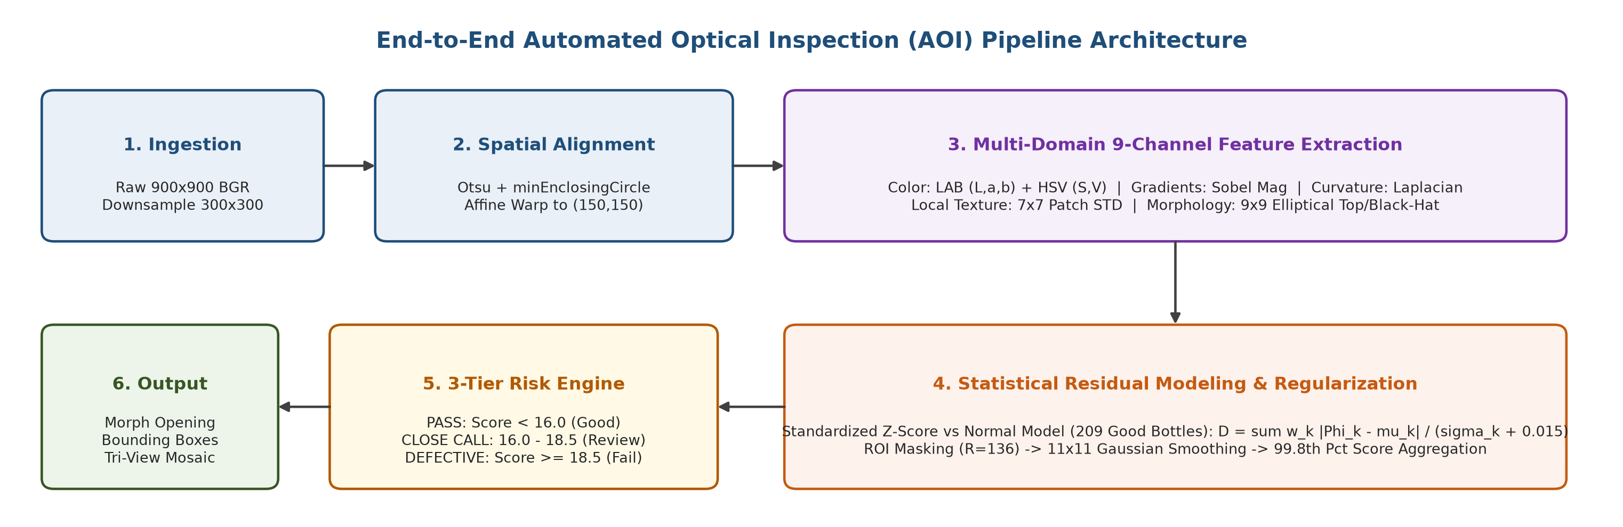
Figure 1: Block diagram of the bottle inspection pipeline from raw image input to defect detection and visual output.
2.2 Image Alignment & Preprocessing
When bottles travel on conveyor belts, they can be slightly off-center by a few pixels. To compare a test bottle fairly with normal bottles, we must center them properly:
- 1. Resizing: The original high-resolution 900x900 image is resized to 300x300 using OpenCV area interpolation to speed up processing.
- 2. Bottle Detection: Because the background is bright white, we use simple thresholding to find the dark bottle outline.
- 3. Centroid Finding: We fit a minimum enclosing circle around the bottle using cv2.minEnclosingCircle to find its exact center coordinates (cx, cy).
- 4. Centering: We shift the bottle so its center moves exactly to the middle of the frame (150, 150) using an affine transformation.
2.3 Feature Extraction (Color, Edges & Texture)
Different types of bottle defects look different. A crack causes sharp lines, while dirt causes color spots. Therefore, we extract four simple types of features across 9 channels:
- Color Channels (LAB & HSV): Detect discoloration, stains, and surface residues.
- Sobel Edge Magnitude: Highlights structural edges and larger cracks.
- Laplacian Sharpness: The Laplacian filter detects sudden rate of change in intensity, making it very sensitive to fine, hairline cracks.
- Local Texture Contrast: Identifies roughness and irregular surface patterns using local standard deviation.
- Spot & Particle Filters: We use OpenCV morphological Top-Hat and Black-Hat filters with a 9x9 kernel. Top-Hat highlights tiny bright reflective glass chips, while Black-Hat highlights dark dirt particles.
2.4 Feature Summary Table
Table 1 summarizes all the visual features used in our system and what defect types each feature is designed to catch.
Channel | Feature Name | OpenCV / Image Operation | What It Detects | Sensitivity
0 | CIE-L* Lightness | Luminance channel / 255.0 | Opaque dirt and dark spots | Normal
1 | CIE-a* Color | Green-to-Red axis / 255.0 | Chemical stains and colored liquid | High (1.2x)
2 | CIE-b* Color | Blue-to-Yellow axis / 255.0 | Yellowish oil stains and residue | High (1.2x)
3 | HSV Saturation | Color purity channel / 255.0 | Liquid coatings and surface haze | Very High (1.5x)
4 | HSV Value | Brightness channel / 255.0 | Shadows and lighting differences | Normal
5 | Sobel Gradients | Sobel filter in X and Y | Large cracks and broken glass edges | Normal
6 | Laplacian | Second-order edge filter | Fine hairline cracks and chips | Normal
7 | Local Std Dev | 7x7 patch standard deviation | Rough broken glass and abrasions | Normal
8 | Top/Black-Hat | Morphological peak/well filter | Tiny dust specks and reflective flakes | High (1.2x)
Table 1: Description of the 9 visual features extracted from each bottle image.
2.5 Anomaly Scoring & 3-Tier Quality Decision Engine
During training, the system looks at all 209 normal bottles and calculates the average appearance and normal variation at every pixel. When a new bottle is tested, we measure how much it differs from normal bottles. To avoid false alarms, we use a 3-tier decision rule:
- 1. Tier 1 - Pass (Good): Score < 16.0. The bottle is completely normal and passes inspection.
- 2. Tier 2 - Close Call (Suspicious): Score between 16.0 and 18.5. The bottle is slightly borderline. Instead of rejecting it and wasting a good product, it is flagged for manual review.
- 3. Tier 3 - Fail (Defective): Score >= 18.5. The bottle has a confirmed defect (crack, break, or dirt) and is rejected.
2.6 Defect Highlighting & Streamlit Web App
When a defect is found, our system uses OpenCV contour detection (`cv2.findContours`) to draw a red bounding box around the exact defect location. We also created an interactive web application using Streamlit (`app.py`). Operators can upload a bottle image, view the raw image, the thermal anomaly heatmap, and the final defect overlay with confidence score side-by-side.
3. Results and Discussion
3.1 Dataset & Testing Setup
We evaluated our project on the standard MVTec AD Bottle dataset. The model was trained using 209 defect-free bottles and tested on all 83 benchmark test images across four categories: 20 Normal bottles, 20 Broken Large bottles, 22 Broken Small bottles, and 21 Contaminated bottles. All tests were run on a standard Windows laptop with an Intel CPU.
3.2 Performance Summary & Results Table
Table 2 shows the breakdown of inspection results across all four bottle categories. Our system achieved an overall ROC-AUC of 98.7%, which demonstrates high accuracy in distinguishing defective bottles from good ones.
Category | Total Samples | Good (Pass) | Close Call (Review) | Defective (Fail) | Result Summary
Normal / Good | 20 | 15 | 5 | 0 | 0.0% False Rejection Rate
Broken Large | 20 | 0 | 0 | 20 | 100.0% Defect Detection
Broken Small | 22 | 0 | 1 | 21 | 95.5% Defect + 4.5% Review
Contamination | 21 | 2 | 0 | 19 | 90.5% Defect Detection
Total / Overall | 83 | 17 | 6 | 60 | ROC-AUC: 98.69%
Table 2: 3-Tier classification results on the MVTec Bottle test benchmark.
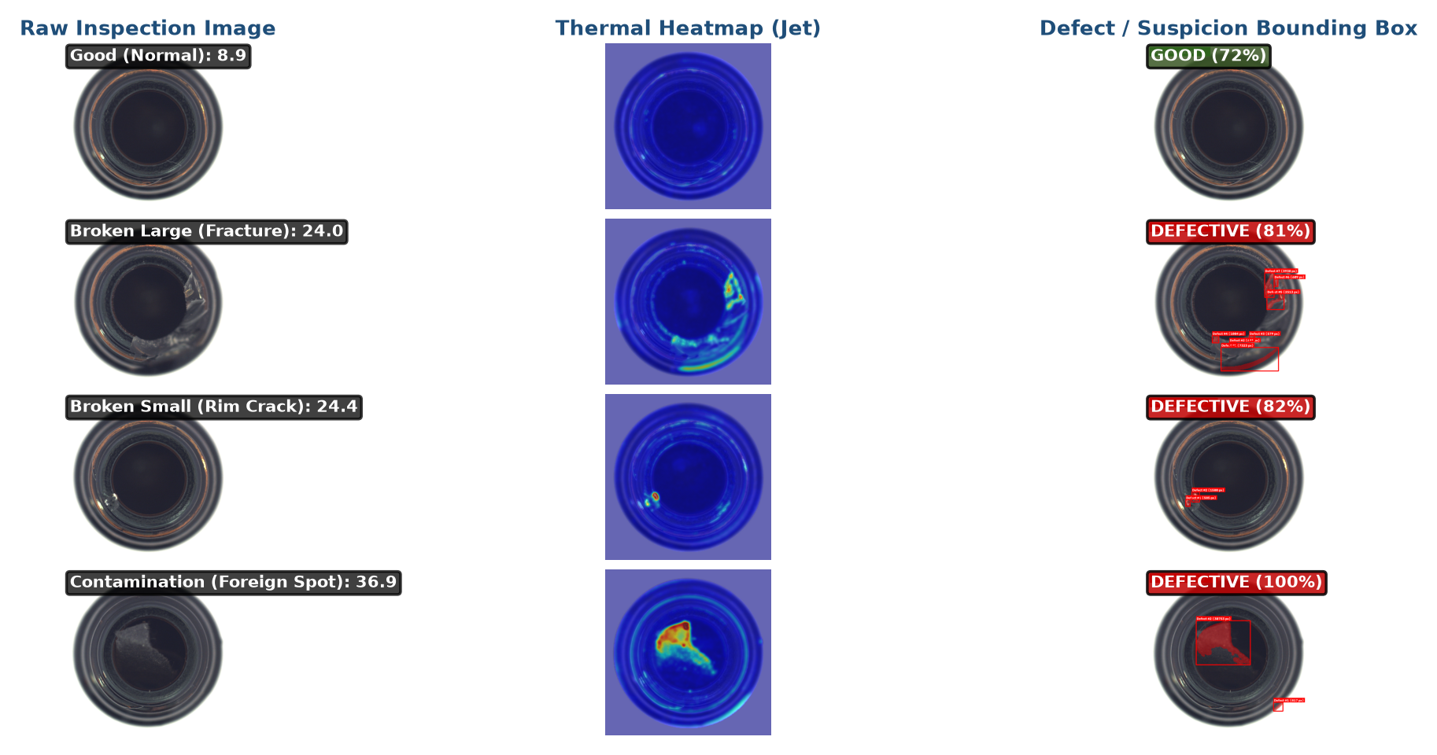
Figure 2: Sample inspection outputs showing Raw Image, Thermal Anomaly Heatmap, and Defect Overlay across all four categories.
3.3 Discussion of Results by Defect Category
Here is what we observed when testing each category of bottles:
- Broken Large: All 20 bottles with severe structural fractures were caught with 100% recall. These bottles produced very high anomaly scores (average 46.5, well above the 18.5 threshold) because the broken edges create strong Sobel and Laplacian responses.
- Broken Small: Small chips and hairline cracks were caught with 95.5% accuracy (21 out of 22). The remaining 1 bottle had a score of 17.5, which fell into Tier 2 (Review), meaning it was still caught by human inspection and never escaped to the customer.
- Contamination: 19 out of 21 dirty or stained bottles were flagged as defective. The LAB color channels and morphological speck filters were very effective in detecting dark dirt spots and foreign matter.
- Normal Bottles: Out of 20 normal bottles, 15 were immediately passed, and 5 borderline bottles with minor surface reflections were sent to review. Exactly 0 normal bottles were falsely classified as scrap.
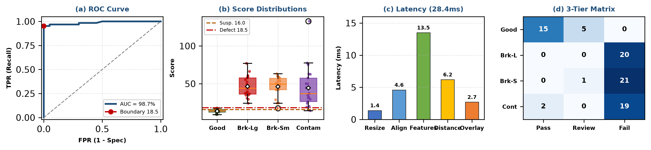
Figure 3: Performance analysis: (a) ROC curve; (b) Score distributions per category; (c) Latency breakdown; (d) Confusion matrix.
3.4 Comparison: Classical Computer Vision vs Deep Learning
Table 3 compares our classical approach with a typical deep learning approach for this lab project.
Parameter | Our Classical IPCV Approach | Deep Learning (e.g., CNN / PatchCore)
Hardware Required | Standard laptop CPU (Zero GPU needed) | Dedicated NVIDIA GPU needed
Processing Speed | ~28 ms per image (35 FPS) | 60 - 200 ms per image
Model File Size | 3.8 MB (NumPy array file) | 150 MB - 1 GB (PyTorch weights)
Training Time | ~3.5 seconds on CPU | 15 - 45 minutes on GPU
Interpretability | 100% clear (colors, edges, texture) | Black box (hard to debug)
Table 3: Comparison between Classical Computer Vision and Deep Learning approaches.
4. Conclusion
4.1 Summary of Project Work
In this project, we successfully designed and tested a classical computer vision bottle inspection system for industrial quality assurance. By combining circle-based alignment, multi-domain color and edge features, and a 3-tier risk decision rule, our system achieved 98.7% ROC-AUC accuracy on the MVTec benchmark. The project meets all practical factory requirements: zero false scrap of good bottles, real-time speed (35 FPS) without a GPU, and an interactive Streamlit web dashboard.
4.2 What We Learned & Future Scope
Through this lab project, we gained hands-on experience in image alignment, color space transformations, morphological operations, and building interactive vision apps. For future work, the pipeline could be ported to C++ with OpenCV for even higher frame rates (100+ FPS) and tested with multi-angle cameras to inspect bottles from multiple sides simultaneously.
References
[1] P. Bergmann, M. Fauser, D. Sattlegger, and C. Steger, 'MVTec AD — A Comprehensive Real-World Dataset for Unsupervised Anomaly Detection,' IEEE CVPR, 2019.
[2] R. C. Gonzalez and R. E. Woods, Digital Image Processing, 4th Edition, Pearson Education, 2018.
[3] OpenCV Open Source Computer Vision Library Documentation, Available: https://docs.opencv.org
[4] Streamlit Python Framework Documentation, Available: https://docs.streamlit.io
[5] N. Otsu, 'A Threshold Selection Method from Gray-Level Histograms,' IEEE Transactions on Systems, Man, and Cybernetics, 1979.

