Superstore Dashboard

Develop a Tableau dashboard utilizing the Sample Superstore dataset, as shown in below figures. The formatting / labelling / spacing / alignment should be the same as used in the charts. The Dashboard should have the following features:

*Features:*

1. Divide the dashboard into two planes. The left plane will feature the company logo, interaction controls, and filters for year and region. The right plane will contain 6 dynamic visualizations and 3 Key Performance Indicator (KPI) cards based on selected metrics.
   * Profit Margin = total profit/ total sales
   * Return Rate = quantity returned/ quantity ordered
2. Create a parameter “Metric” that will allow users to select a metric for analysis from options including sales, profit, and no. of orders (# Orders). Visualizations will dynamically adjust based on the selected metric, with titles and tooltips changing accordingly. For instance, if "sales" is chosen, the visualization will display "Sales by Category."

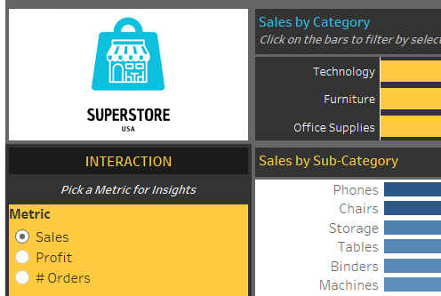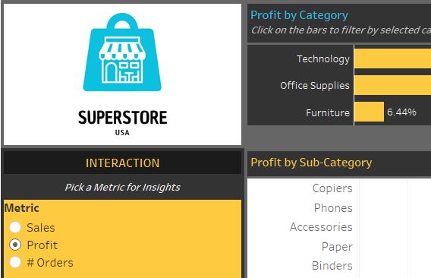

1. Implement filtering options for year and region, allowing users to further refine their analysis. Include a button to hide/display both filters for improved viewing experience.

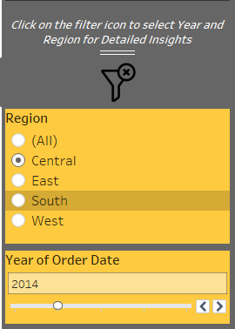

1. Ensure that the dashboard consistently displays the top 5 products based on the selected metric, regardless of any filter actions or dropdown selections made by the user.
2. Implement a filter action on the category chart to dynamically filter data in the other five charts and KPI cards upon interaction.
3. Clicking on the logo should redirect users to the dashboard published on Tableau Public.
4. Display Average and Trend Lines where required.
5. Find the dashboard logo and filters logo attached below.
   * Dashboard logo:



|  |  |
| --- | --- |
| * Show Filters Icon: | * Hide Filters Icon: |

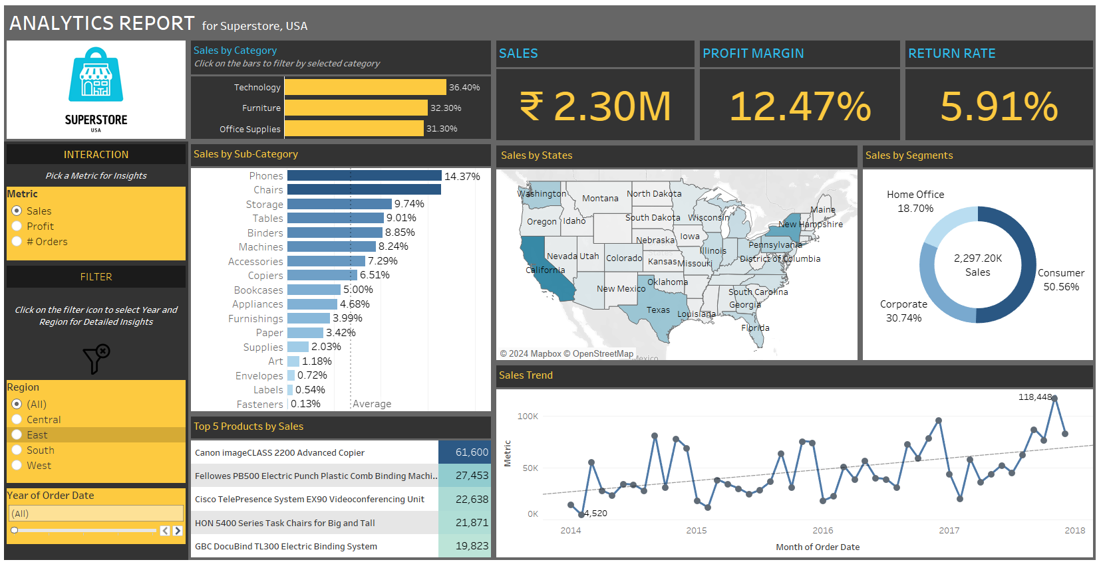**Dashboard (Superstore Data Analytics):**