VISVESVARAYA TECHNOLOGICAL UNIVERSITY

**“JnanaSangama”, Belgaum -590014, Karnataka.**



**LAB REPORT**

**On**

**ARTIFICIAL INTELLIGENCE**

**Submitted by**

**MANJIL RAJ PANTA(1BM21CS103)**

**in partial fulfillment for the award of the degree of BACHELOR OF ENGINEERING**

**in**

**COMPUTER SCIENCE AND ENGINEERING**



**B.M.S. COLLEGE OF ENGINEERING (Autonomous Institution under VTU)**

**BENGALURU-560019 Oct 2023-Feb 2024**

**B. M. S. College of Engineering,**

**Bull Temple Road, Bangalore 560019**

**(Affiliated To Visvesvaraya Technological University, Belgaum) Department of Computer Science and Engineering**

CERTIFICATE

This is to certify that the Lab work entitled **“ARTIFICIAL INTELLIGENCE”** carried out

by **MANJIL RAJ PANTA(1BM21CS103)**, who is bonafide student of **B. M. S. College of**

**Engineering**. It is in partial fulfillment for the award of **Bachelor of Engineering in**

**Computer Science and Engineering** of the Visvesvaraya Technological University, Belgaum during the year 2023-24. The Lab report has been approved as it satisfies the academic requirements in respect of Artificial Intelligence Lab - **(22CS5PCAIN )**work prescribed for the said degree.

**Sneha S Bagalkot Dr. Jyothi S Nayak**

Assistant Professor Professor and Head

Department of CSE Department of CSE

BMSCE, Bengaluru BMSCE, Bengaluru

**Table of Contents**

|  |  |  |
| --- | --- | --- |
| **Sl.**  **No.** | **Experiment Title** | **Page No.** |
| 1 | Tic Tac Toe | 1 |
| 2 | 8 Puzzle Breadth First Search Algorithm | 6 |
| 3 | 8 Puzzle Iterative Deepening Search Algorithm | 8 |
| 4 | 8 Puzzle A* Search Algorithm | 10 |
| 5 | Vacuum Cleaner | 14 |
| 6 | Knowledge Base Entailment | 17 |
| 7 | Knowledge Base Resolution | 18 |
| 8 | Unification | 21 |
| 9 | FOL to CNF | 25 |
| 10 | Forward Reasoning | 28 |

1. Implement Tic –Tac –Toe Game tic=[]

import random def board(tic):

for i in range(0,9,3): print("+"+"-"*29+"+")

print("|"+" "*9+"|"+" "*9+"|"+" "*9+"|")

print("|"+" "*3,tic[0+i]," "*3+"|"+" "*3,tic[1+i]," "*3+"|"+" "*3,tic[2+i]," "*3+"|")

print("|"+" "*9+"|"+" "*9+"|"+" "*9+"|") print("+"+"-"*29+"+")

def update_comp(): global tic,num for i in range(9):

if tic[i]==i+1: num=i+1 tic[num-1]='X'

if winner(num-1)==False: #reverse the change tic[num-1]=num

else:

return for i in range(9):

if tic[i]==i+1: num=i+1 tic[num-1]='O'

if winner(num-1)==True: tic[num-1]='X'

return else:

tic[num-1]=num num=random.randint(1,9) while num not in tic:

num=random.randint(1,9) else:

tic[num-1]='X'

def update_user(): global tic,num

num=int(input("enter a number on the board :")) while num not in tic:

num=int(input("enter a number on the board :")) else:

tic[num-1]='O'

def winner(num):

if tic[0]==tic[4] and tic[4]==tic[8] or tic[2]==tic[4] and tic[4]==tic[6]: return True

if tic[num]==tic[num-3] and tic[num-3]==tic[num-6]: return True

if tic[num//3*3]==tic[num//3*3+1] and tic[num//3*3+1]==tic[num//3*3+2]: return True

return False

try:

for i in range(1,10): tic.append(i)

count=0 #print(tic) board(tic) while count!=9:

if count%2==0: print("computer's turn :") update_comp() board(tic)

count+=1 else:

print("Your turn :") update_user() board(tic) count+=1

if count>=5:

if winner(num-1):

print("winner is ",tic[num-1]) break

else:

continue

except:

print("\nerror\n") Output:

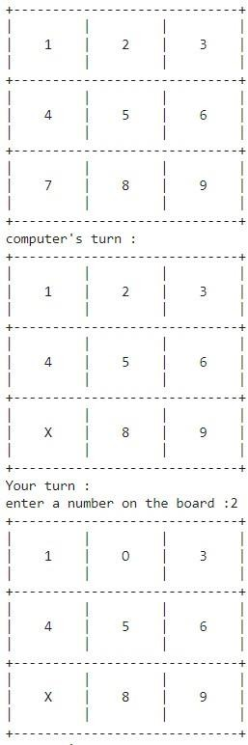

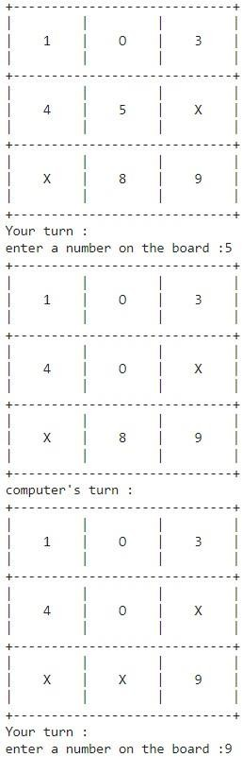

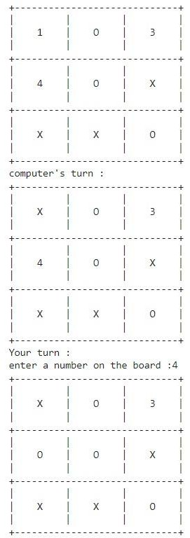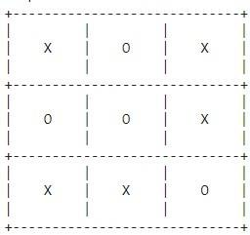

1. 8 Puzzle Breadth First Search Algorithm def bfs(src,target):

queue=[] queue.append(src) exp=[]

while len(queue)>0: source=queue.pop(0) #print("queue",queue) exp.append(source)

print(source[0],'|',source[1],'|',source[2])

print(source[3],'|',source[4],'|',source[5])

print(source[6],'|',source[7],'|',source[8]) print(" ")

if source==target: print("Success") return

poss_moves_to_do=[] poss_moves_to_do=possible_moves(source,exp) #print("possible moves",poss_moves_to_do)

for move in poss_moves_to_do:

if move not in exp and move not in queue: #print("move",move) queue.append(move)

def possible_moves(state,visited_states): b=state.index(0)

#direction array d=[]

if b not in [0,1,2]:

d.append('u')

if b not in [6,7,8]:

d.append('d')

if b not in [0,3,6]:

d.append('l')

if b not in [2,5,8]:

d.append('r') pos_moves_it_can=[]

for i in d: pos_moves_it_can.append(gen(state,i,b))

return [move_it_can for move_it_can in pos_moves_it_can if move_it_can not in visited_states]

def gen(state,m,b): temp=state.copy() if m=='d':

temp[b+3],temp[b]=temp[b],temp[b+3] if m=='u':

temp[b-3],temp[b]=temp[b],temp[b-3] if m=='l':

temp[b-1],temp[b]=temp[b],temp[b-1] if m=='r':

temp[b+1],temp[b]=temp[b],temp[b+1] return temp

src=[1,2,3,4,5,6,0,7,8]

target=[1,2,3,4,5,6,7,8,0]

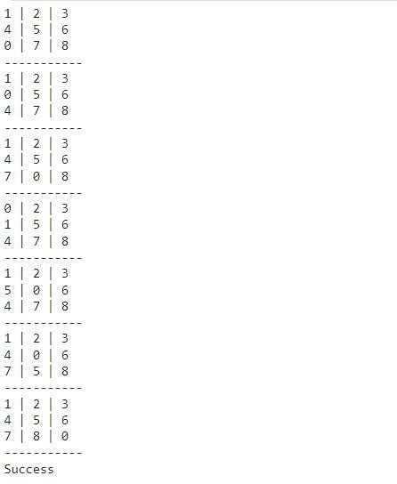bfs(src,target) Output:

1. 8 Puzzle Iterative Deepening Search Algorithm def id_dfs(puzzle, goal, get_moves):

import itertools

#get_moves -> possible_moves def dfs(route, depth):

if depth == 0: return

if route[-1] == goal: return route

for move in get_moves(route[-1]): if move not in route:

next_route = dfs(route + [move], depth - 1) if next_route:

return next_route

for depth in itertools.count(): route = dfs([puzzle], depth) if route:

return route

def possible_moves(state):

b = state.index(0) # ) indicates White space -> so b has index of it. d = [] # direction

if b not in [0, 1, 2]:

d.append('u')

if b not in [6, 7, 8]:

d.append('d')

if b not in [0, 3, 6]:

d.append('l')

if b not in [2, 5, 8]:

d.append('r')

pos_moves = [] for i in d:

pos_moves.append(generate(state, i, b)) return pos_moves

def generate(state, m, b): temp = state.copy()

if m == 'd':

temp[b + 3], temp[b] = temp[b], temp[b + 3] if m == 'u':

temp[b - 3], temp[b] = temp[b], temp[b - 3] if m == 'l':

temp[b - 1], temp[b] = temp[b], temp[b - 1] if m == 'r':

temp[b + 1], temp[b] = temp[b], temp[b + 1] return temp

# calling ID-DFS

initial = [1, 2, 3, 0, 4, 6, 7, 5, 8]

goal = [1, 2, 3, 4, 5, 6, 7, 8, 0]

route = id_dfs(initial, goal, possible_moves) if route:

print("Success!! It is possible to solve 8 Puzzle problem") print("Path:", route)

else:

print("Failed to find a solution") Output:



1. 8 Puzzle A* search algorithm class Node:

def init (self,data,level,fval):

""" Initialize the node with the data, level of the node and the calculated fvalue

"""

self.data = data self.level = level self.fval = fval

def generate_child(self):

""" Generate child nodes from the given node by moving the blank space either in the four directions {up,down,left,right} """

x,y = self.find(self.data,'_')

""" val_list contains position values for moving the blank space in either of the 4 directions [up,down,left,right] respectively. """

val_list = [[x,y-1],[x,y+1],[x-1,y],[x+1,y]] children = []

for i in val_list:

child = self.shuffle(self.data,x,y,i[0],i[1]) if child is not None:

child_node = Node(child,self.level+1,0) children.append(child_node)

return children

def shuffle(self,puz,x1,y1,x2,y2):

""" Move the blank space in the given direction and if the position value are out of limits the return None """

if x2 >= 0 and x2 < len(self.data) and y2 >= 0 and y2 < len(self.data): temp_puz = []

temp_puz = self.copy(puz) temp = temp_puz[x2][y2]

temp_puz[x2][y2] = temp_puz[x1][y1] temp_puz[x1][y1] = temp

return temp_puz else:

return None

def copy(self,root):

""" Copy function to create a similar matrix of the given node""" temp = []

for i in root: t = []

for j in i:

t.append(j) temp.append(t)

return temp

def find(self,puz,x):

""" Specifically used to find the position of the blank space """ for i in range(0,len(self.data)):

for j in range(0,len(self.data)): if puz[i][j] == x:

return i,j

class Puzzle:

def init (self,size):

""" Initialize the puzzle size by the specified size,open and closed lists to empty

"""

self.n = size self.open = [] self.closed = []

def accept(self):

""" Accepts the puzzle from the user """ puz = []

for i in range(0,self.n): temp = input().split(" ") puz.append(temp)

return puz

def f(self,start,goal):

""" Heuristic Function to calculate hueristic value f(x) = h(x) + g(x) """ return self.h(start.data,goal)+start.level

def h(self,start,goal):

""" Calculates the different between the given puzzles """ temp = 0

for i in range(0,self.n): for j in range(0,self.n):

if start[i][j] != goal[i][j] and start[i][j] != '_': temp += 1

return temp

def process(self):

""" Accept Start and Goal Puzzle state"""

print("Enter the start state matrix \n") start = self.accept()

print("Enter the goal state matrix \n") goal = self.accept()

start = Node(start,0,0) start.fval = self.f(start,goal)

""" Put the start node in the open list""" self.open.append(start)

print("\n\n") while True:

cur = self.open[0] print("")

print(" | ")

print(" | ")

print(" \\'/ \n") for i in cur.data:

for j in i: print(j,end=" ")

print("")

""" If the difference between current and goal node is 0 we have reached the goal node"""

if(self.h(cur.data,goal) == 0): break

for i in cur.generate_child(): i.fval = self.f(i,goal) self.open.append(i)

self.closed.append(cur) del self.open[0]

""" sort the opne list based on f value """ self.open.sort(key = lambda x:x.fval,reverse=False)

puz = Puzzle(3) puz.process()

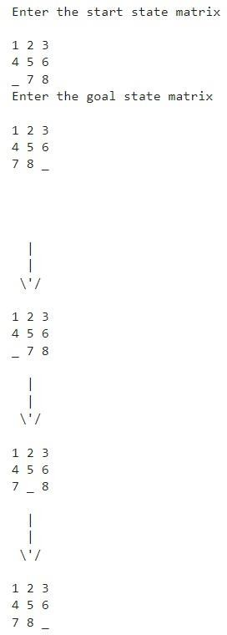Output:

1. Vacuum Cleaner

def vacuum_world():

# 0 indicates Clean and 1 indicates Dirty goal_state = {'A': '0', 'B': '0'}

cost = 0

location_input = input("Enter Location of Vacuum") status_input = input("Enter status of " + location_input) status_input_complement = input("Enter status of other room")

if location_input == 'A': # Location A is Dirty.

print("Vacuum is placed in Location A") if status_input == '1':

print("Location A is Dirty.")

# suck the dirt and mark it as clean cost += 1 #cost for suck

print("Cost for CLEANING A " + str(cost)) print("Location A has been Cleaned.")

if status_input_complement == '1': # if B is Dirty

print("Location B is Dirty.") print("Moving right to the Location B. ")

cost += 1 #cost for moving right print("COST for moving RIGHT" + str(cost)) # suck the dirt and mark it as clean

cost += 1 #cost for suck print("COST for SUCK " + str(cost)) print("Location B has been Cleaned. ")

else:

print("No action" + str(cost)) # suck and mark clean

print("Location B is already clean.")

if status_input == '0':

print("Location A is already clean ")

if status_input_complement == '1':# if B is Dirty print("Location B is Dirty.")

print("Moving RIGHT to the Location B. ") cost += 1 #cost for moving right print("COST for moving RIGHT " + str(cost)) # suck the dirt and mark it as clean

cost += 1 #cost for suck print("Cost for SUCK" + str(cost)) print("Location B has been Cleaned. ")

else:

print("No action " + str(cost)) print(cost)

# suck and mark clean print("Location B is already clean.")

else:

print("Vacuum is placed in location B") # Location B is Dirty.

if status_input == '1': print("Location B is Dirty.")

# suck the dirt and mark it as clean cost += 1 # cost for suck

print("COST for CLEANING " + str(cost)) print("Location B has been Cleaned.")

if status_input_complement == '1': # if A is Dirty

print("Location A is Dirty.") print("Moving LEFT to the Location A. ") cost += 1 # cost for moving right

print("COST for moving LEFT" + str(cost)) # suck the dirt and mark it as clean

cost += 1 # cost for suck print("COST for SUCK " + str(cost)) print("Location A has been Cleaned.")

else:

print(cost)

# suck and mark clean print("Location B is already clean.")

if status_input_complement == '1': # if A is Dirty print("Location A is Dirty.")

print("Moving LEFT to the Location A. ") cost += 1 # cost for moving right print("COST for moving LEFT " + str(cost)) # suck the dirt and mark it as clean

cost += 1 # cost for suck print("Cost for SUCK " + str(cost))

print("Location A has been Cleaned. ")

else:

print("No action " + str(cost)) # suck and mark clean

print("Location A is already clean.")

# done cleaning print("GOAL STATE: ")

print(goal_state)

print("Performance Measurement: " + str(cost))

print("0 indicates clean and 1 indicates dirty") vacuum_world()

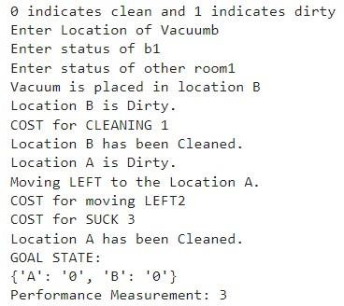Output:

1. Create a knowledge base using prepositional logic and show that the given query entails the knowledge base or not .

from sympy import symbols, And, Not, Implies, satisfiable def create_knowledge_base():

# Define propositional symbols p = symbols('p')

q = symbols('q') r = symbols('r')

# Define knowledge base using logical statements knowledge_base = And(

Implies(p, q), # If p then q Implies(q, r), # If q then r Not(r) # Not r

)

return knowledge_base

def query_entails(knowledge_base, query):

# Check if the knowledge base entails the query

entailment = satisfiable(And(knowledge_base, Not(query)))

# If there is no satisfying assignment, then the query is entailed return not entailment

if name == " main ": # Create the knowledge base

kb = create_knowledge_base()

# Define a query query = symbols('p')

# Check if the query entails the knowledge base result = query_entails(kb, query)

# Display the results print("Knowledge Base:", kb) print("Query:", query)

print("Query entails Knowledge Base:", result) Output:

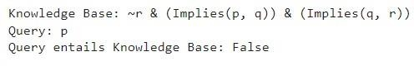

1. Create a knowledge base using prepositional logic and prove the given query using resolution

import re

def main(rules, goal): rules = rules.split(' ')

steps = resolve(rules, goal) print('\nStep\t|Clause\t|Derivation\t') print('-' * 30)

i = 1

for step in steps:

print(f' {i}.\t| {step}\t| {steps[step]}\t') i += 1

def negate(term):

return f'~{term}' if term[0] != '~' else term[1]

def reverse(clause): if len(clause) > 2:

t = split_terms(clause) return f'{t[1]}v{t[0]}'

return “”

def split_terms(rule):

exp = '(~*[PQRS])'

terms = re.findall(exp, rule) return terms

split_terms('~PvR')

def contradiction(goal, clause):

contradictions = [ f'{goal}v{negate(goal)}', f'{negate(goal)}v{goal}'] return clause in contradictions or reverse(clause) in contradictions

def resolve(rules, goal): temp = rules.copy() temp += [negate(goal)] steps = dict()

for rule in temp: steps[rule] = 'Given.'

steps[negate(goal)] = 'Negated conclusion.' i = 0

while i < len(temp): n = len(temp)

j = (i + 1) % n

clauses = [] while j != i:

terms1 = split_terms(temp[i]) terms2 = split_terms(temp[j]) for c in terms1:

if negate(c) in terms2:

t1 = [t for t in terms1 if t != c]

t2 = [t for t in terms2 if t != negate(c)] gen = t1 + t2

if len(gen) == 2:

if gen[0] != negate(gen[1]):

clauses += [f'{gen[0]}v{gen[1]}'] else:

if contradiction(goal,f'{gen[0]}v{gen[1]}'):

temp.append(f'{gen[0]}v{gen[1]}')

steps[''] = f"Resolved {temp[i]} and {temp[j]} to {temp[-1]}, which is in turn null. \

\nA contradiction is found when {negate(goal)} is assumed as true. Hence, {goal} is true."

return steps elif len(gen) == 1:

clauses += [f'{gen[0]}'] else:

if contradiction(goal,f'{terms1[0]}v{terms2[0]}'): temp.append(f'{terms1[0]}v{terms2[0]}')

steps[''] = f"Resolved {temp[i]} and {temp[j]} to {temp[-1]}, which

is in turn null. \

\nA contradiction is found when {negate(goal)} is assumed as true.

Hence, {goal} is true."

return steps for clause in clauses:

if clause not in temp and clause != reverse(clause) and reverse(clause) not in

temp:

temp.append(clause)

steps[clause] = f'Resolved from {temp[i]} and {temp[j]}.' j = (j + 1) % n

i += 1

return steps Output:

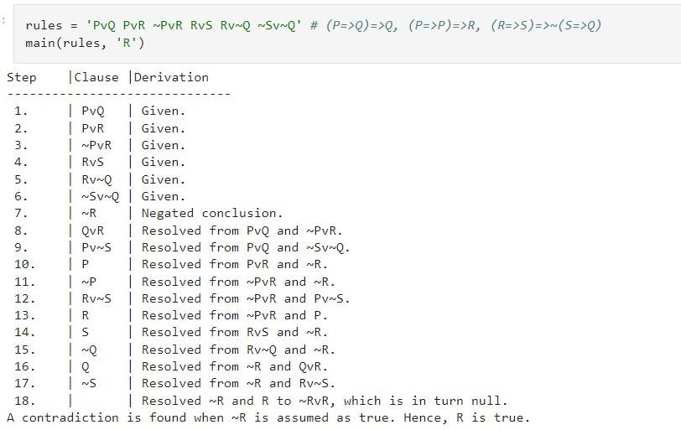

1. Implement unification in first order logic import re

def getAttributes(expression): expression = expression.split("(")[1:] expression = "(".join(expression) expression = expression[:-1]

expression = re.split("(?<!\(.),(?!.\))", expression) return expression

def getInitialPredicate(expression): return expression.split("(")[0]

def isConstant(char):

return char.isupper() and len(char) == 1

def isVariable(char):

return char.islower() and len(char) == 1

def replaceAttributes(exp, old, new): attributes = getAttributes(exp)

for index, val in enumerate(attributes): if val == old:

attributes[index] = new predicate = getInitialPredicate(exp)

return predicate + "(" + ",".join(attributes) + ")"

def apply(exp, substitutions):

for substitution in substitutions: new, old = substitution

exp = replaceAttributes(exp, old, new) return exp

def checkOccurs(var, exp): if exp.find(var) == -1:

return False return True

def getFirstPart(expression):

attributes = getAttributes(expression) return attributes[0]

def getRemainingPart(expression):

predicate = getInitialPredicate(expression)

attributes = getAttributes(expression)

newExpression = predicate + "(" + ",".join(attributes[1:]) + ")" return newExpression

def unify(exp1, exp2): if exp1 == exp2:

return []

if isConstant(exp1) and isConstant(exp2): if exp1 != exp2:

return False

if isConstant(exp1): return [(exp1, exp2)]

if isConstant(exp2): return [(exp2, exp1)]

if isVariable(exp1):

if checkOccurs(exp1, exp2): return False

else:

return [(exp2, exp1)]

if isVariable(exp2):

if checkOccurs(exp2, exp1): return False

else:

return [(exp1, exp2)]

if getInitialPredicate(exp1) != getInitialPredicate(exp2): print("Predicates do not match. Cannot be unified") return False

attributeCount1 = len(getAttributes(exp1)) attributeCount2 = len(getAttributes(exp2)) if attributeCount1 != attributeCount2:

return False

head1 = getFirstPart(exp1) head2 = getFirstPart(exp2)

initialSubstitution = unify(head1, head2) if not initialSubstitution:

return False

if attributeCount1 == 1:

return initialSubstitution

tail1 = getRemainingPart(exp1) tail2 = getRemainingPart(exp2)

if initialSubstitution != []:

tail1 = apply(tail1, initialSubstitution) tail2 = apply(tail2, initialSubstitution)

remainingSubstitution = unify(tail1, tail2) if not remainingSubstitution:

return False

initialSubstitution.extend(remainingSubstitution) return initialSubstitution

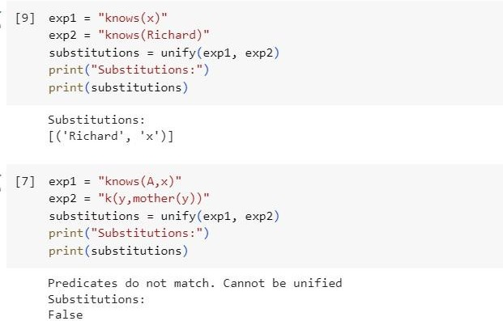Output:

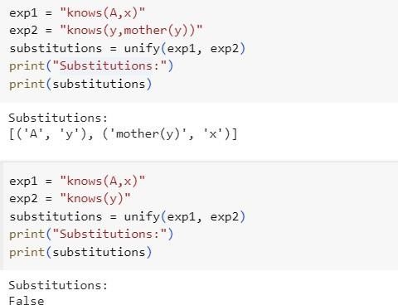

1. Convert a given first order logic statement into Conjunctive Normal Form (CNF).

def getAttributes(string): expr = '\([^)]+\)'

matches = re.findall(expr, string)

return [m for m in str(matches) if m.isalpha()]

def getPredicates(string):

expr = '[a-z~]+\([A-Za-z,]+\)' return re.findall(expr, string)

def DeMorgan(sentence):

string = ''.join(list(sentence).copy()) string = string.replace('~~','')

flag = '[' in string

string = string.replace('~[','') string = string.strip(']')

for predicate in getPredicates(string):

string = string.replace(predicate, f'~{predicate}') s = list(string)

for i, c in enumerate(string): if c == '|':

s[i] = '&' elif c == '&': s[i] = '|'

string = ''.join(s)

string = string.replace('~~','')

return f'[{string}]' if flag else string

def Skolemization(sentence):

SKOLEM_CONSTANTS = [f'{chr(c)}' for c in range(ord('A'), ord('Z')+1)] statement = ''.join(list(sentence).copy())

matches = re.findall('[∀∃].', statement) for match in matches[::-1]:

statement = statement.replace(match, '') statements = re.findall('\[\[[^]]+\]]', statement) for s in statements:

statement = statement.replace(s, s[1:-1]) for predicate in getPredicates(statement):

attributes = getAttributes(predicate) if ''.join(attributes).islower():

statement = statement.replace(match[1],SKOLEM_CONSTANTS.pop(0)) else:

aL = [a for a in attributes if a.islower()]

aU = [a for a in attributes if not a.islower()][0] statement = statement.replace(aU,

f'{SKOLEM_CONSTANTS.pop(0)}({aL[0] if len(aL) else match[1]})') return statement

import re

def fol_to_cnf(fol):

statement = fol.replace("<=>", "_") while '_' in statement:

i = statement.index('_')

new_statement = '[' + statement[:i] + '=>' + statement[i+1:] + ']&['+ statement[i+1:] + '=>' + statement[:i] + ']'

statement = new_statement

statement = statement.replace("=>", "-") expr = '\[([^]]+)\]'

statements = re.findall(expr, statement) for i, s in enumerate(statements):

if '[' in s and ']' not in s: statements[i] += ']'

for s in statements:

statement = statement.replace(s, fol_to_cnf(s)) while '-' in statement:

i = statement.index('-')

br = statement.index('[') if '[' in statement else 0 new_statement = '~' + statement[br:i] + '|' + statement[i+1:]

statement = statement[:br] + new_statement if br > 0 else new_statement while '~∀' in statement:

i = statement.index('~∀') statement = list(statement)

statement[i], statement[i+1], statement[i+2] = '∃', statement[i+2], '~' statement = ''.join(statement)

while '~∃' in statement:

i = statement.index('~∃') s = list(statement)

s[i], s[i+1], s[i+2] = '∀', s[i+2], '~' statement = ''.join(s)

statement = statement.replace('~[∀','[~∀') statement = statement.replace('~[∃','[~∃') expr = '(~[∀|∃].)'

statements = re.findall(expr, statement) for s in statements:

statement = statement.replace(s, fol_to_cnf(s))

expr = '~\[[^]]+\]'

statements = re.findall(expr, statement) for s in statements:

statement = statement.replace(s, DeMorgan(s)) return statement

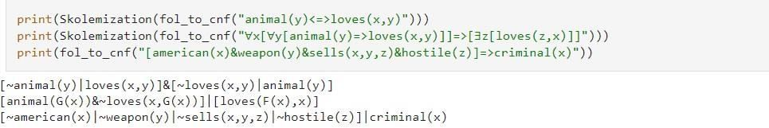Output:

1. Create a knowledge base consisting of first order logic statements and prove the given query using forward reasoning.

import re

def isVariable(x):

return len(x) == 1 and x.islower() and x.isalpha()

def getAttributes(string): expr = '\([^)]+\)'

matches = re.findall(expr, string) return matches

def getPredicates(string): expr = '([a-z~]+)\([^&|]+\)'

return re.findall(expr, string) class Fact:

def init (self, expression): self.expression = expression

predicate, params = self.splitExpression(expression) self.predicate = predicate

self.params = params

self.result = any(self.getConstants())

def splitExpression(self, expression): predicate = getPredicates(expression)[0]

params = getAttributes(expression)[0].strip('()').split(',') return [predicate, params]

def getResult(self): return self.result

def getConstants(self):

return [None if isVariable(c) else c for c in self.params]

def getVariables(self):

return [v if isVariable(v) else None for v in self.params]

def substitute(self, constants): c = constants.copy()

f = f"{self.predicate}({','.join([constants.pop(0) if isVariable(p) else p for p in self.params])})"

return Fact(f)

class Implication:

def init (self, expression): self.expression = expression l = expression.split('=>')

self.lhs = [Fact(f) for f in l[0].split('&')] self.rhs = Fact(l[1])

def evaluate(self, facts): constants = {} new_lhs = []

for fact in facts:

for val in self.lhs:

if val.predicate == fact.predicate:

for i, v in enumerate(val.getVariables()): if v:

constants[v] = fact.getConstants()[i] new_lhs.append(fact)

predicate, attributes = getPredicates(self.rhs.expression)[0], str(getAttributes(self.rhs.expression)[0])

for key in constants: if constants[key]:

attributes = attributes.replace(key, constants[key]) expr = f'{predicate}{attributes}'

return Fact(expr) if len(new_lhs) and all([f.getResult() for f in new_lhs]) else None

class KB:

def init (self): self.facts = set() self.implications = set()

def tell(self, e): if '=>' in e:

self.implications.add(Implication(e)) else:

self.facts.add(Fact(e)) for i in self.implications:

res = i.evaluate(self.facts) if res:

self.facts.add(res)

def query(self, e):

facts = set([f.expression for f in self.facts]) i = 1

print(f'Querying {e}:') for f in facts:

if Fact(f).predicate == Fact(e).predicate: print(f'\t{i}. {f}')

i += 1

def display(self): print("All facts: ")

for i, f in enumerate(set([f.expression for f in self.facts])): print(f'\t{i+1}. {f}')

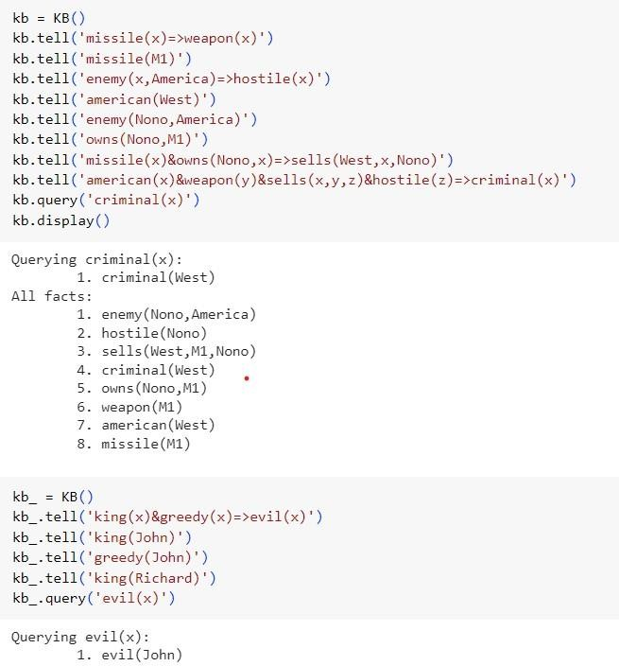Output: