ACADEMIC CAPSTONE PROJECT REPORT • FINAL SUBMISSION
COLD_CASE: PRIVACY-FIRST INFORMATION RETRIEVAL & KNOWLEDGE GRAPH ENGINE
An Evidence-Grounded Multi-Modal Discovery System Combining Dense Semantic Search, Entity Knowledge Graphs, and Verifiable Citation Provenance
Project Title / System Name | cold_case (IR & Knowledge Graph Engine)
Domain & Specialization | Information Retrieval (IR), Natural Language Processing (NLP), Knowledge Graphs
Architecture Pattern | Decoupled Client-Server SPA (FastAPI + React 19 + Multi-Modal Storage)
Key Innovation | Verifiable Evidence Provenance (Zero-Hallucination Graph-Grounded Deduction)
Primary Technologies | FastAPI, spaCy, SentenceTransformers, ChromaDB, NetworkX, SQLite, Vis.js
Document Classification | Capstone Engineering Project Submission / Technical Dossier
DEPARTMENT OF COMPUTER SCIENCE & ENGINEERING
COLLEGE OF ENGINEERING & TECHNOLOGY
ACADEMIC YEAR 2025 – 2026

1. System Name & Executive Summary
System Name: cold_case is a privacy-first, evidence-grounded Information Retrieval (IR) and Knowledge Graph Engine specifically designed for processing complex, unstructured investigative dossiers, corporate compliance audits, intelligence logs, and cold case inquiries.
In typical real-world investigations (such as unsolved criminal cases, corporate forensic audits, and investigative journalism), investigators face dozens or hundreds of disparate, unstructured narrative files: first-responder police reports, conflicting witness statements, shipping manifests, corporate ownership registries, and laboratory forensics. Synthesizing these files manually requires enormous cognitive effort to correlate multi-hop relationships (e.g., Witness A in 1995 mentions Person X meeting Person Y at Location Z, while a shipping manifest in Document 6 links Person Y to a chemical solvent purchased months later).
Unlike generic generative AI chatbots or large language model (LLM) wrappers—which are prone to hallucinating facts, fabricating non-existent relationships, and generating plausible-sounding yet unverifiable claims—cold_case is built on a deterministic, evidence-grounded foundation. Every relationship edge, timeline anchor, entity profile, and detective briefing generated by cold_case is directly bound to exact verbatim document citations and sentence excerpts.
📌 CORE PARADIGM: ZERO-HALLUCINATION EVIDENCE GROUNDING: The defining principle of cold_case is 'Search with Verifiable Proof'. Generative AI models are strictly constrained by factual grounding: every deduced fact must point back to a verbatim quote and source document name, eliminating LLM hallucinations in high-stakes investigations.

2. Objectives of the System
The overarching objective of the cold_case system is to automate the extraction, cross-referencing, multi-modal indexing, and interactive interrogation of complex investigative text collections while preserving complete evidence provenance.
2.1 Primary Engineering & Research Objectives
- Automated Multi-Document Ingestion & Text Normalization: Ingest heterogeneous case documents in diverse text formats and character encodings (UTF-8, UTF-16, Latin-1, CP1252), performing deterministic normalization, whitespace hygiene, and sliding-window chunking.
- Fine-Grained Named Entity Recognition (NER) & Canonicalization: Identify domain-critical investigative entities (PERSON, LOCATION, ORGANIZATION, DATE) and resolve lexical surface variations (e.g., 'Sarah', 'Ms. Sarah Rao', 'Sarah Rao') into single canonical nodes to eliminate duplicate graph entities.
- Multi-Hop Co-occurrence Graph Discovery with Proximity Bonus: Construct an entity-relationship knowledge graph where edges capture co-occurrence strengths, applying a dedicated sentence-level proximity multiplier (w = 2.0) to prioritize tight contextual links over loose document co-occurrences.
- Synchronized Multi-Modal Persistence Architecture: Maintain three synchronized persistence layers: an ACID relational SQLite database for document metadata and chunk records; a ChromaDB vector index for dense semantic embeddings; and a NetworkX/Neo4j graph store for multi-hop relationship traversals.
- Hybrid Information Retrieval Engine: Combine dense semantic passage search (via SentenceTransformers all-MiniLM-L6-v2) with query-anchored graph neighborhood traversal to discover both explicit semantic matches and hidden indirect connections.
- Automated AI Lead Detective Dossier Briefing: Synthesize query results into an actionable investigative briefing containing direct answers, deductive reasoning chains, corroborated facts, person-of-interest profiles, and chronological timeline anchors.
- Complete Evidence Traceability & Citation Provenance: Guarantee that every graph node, edge, and briefing statement can be interrogated by the user to reveal the exact source document name and verbatim supporting excerpt.
- Multi-Case Workspace Isolation & Security: Enforce strict case-level data isolation across the relational database, vector collections, and graph namespaces, ensuring that evidence from one investigation never contaminates another.
Objective Dimension | Technical Implementation | Investigative Benefit
Evidence Provenance | Verbatim sentence excerpts & source document tagging | Eliminates AI hallucinations; provides court-admissible audit trails
Hybrid Retrieval | Dense vector embeddings + NetworkX graph traversal | Finds indirect connections that standard keyword or vector search misses
Entity Canonicalization | Rule-based & Levenshtein alias resolution | Consolidates nicknames, aliases, and formal names into unified suspect nodes
Case-Level Isolation | case_id filtering across SQLite, ChromaDB, and Graph | Ensures strict multi-tenant privacy across distinct criminal investigations

3. Algorithms & Mathematical Formulations Used
The cold_case architecture integrates a suite of state-of-the-art NLP, Information Retrieval, Graph Theory, and Dense Vector algorithms. Each algorithm addresses a distinct stage in the transformation of raw textual narrative into structured, searchable intelligence.
3.1 Text Normalization & Sliding Window Chunking
Investigative documents frequently contain irregular whitespace, inconsistent carriage returns, and encoding artifacts. The cleaner module normalizes Unicode representations (NFKC normalization), collapses redundant whitespace, and strips non-printable control characters.
Formulation: To preserve narrative context while creating granular units for semantic embedding, a sliding window chunking algorithm is applied. A fixed window size L = 500 characters is stepped through the normalized text with an overlap delta = 100 characters:
- Window Size (L): 500 characters, providing sufficient context for multi-entity co-occurrence.
- Step Stride (S): S = L - delta = 400 characters, guaranteeing that sentence boundaries spanning chunk transitions are not lost.
- Chunk Offset Indexing: Each chunk c_i records start_char and end_char offsets relative to the parent document, maintaining absolute byte-level provenance.
3.2 Named Entity Recognition (NER) & Canonicalization Algorithm
Entity identification utilizes spaCy's optimized English pipeline (en_core_web_sm) incorporating a transition-based Convolutional Neural Network (CNN) with a statistical parser. The pipeline extracts four primary investigative entity classes: PERSON, LOCATION (GPE / LOC), ORGANIZATION (ORG), and DATE.
Canonicalization: Surface Variation Resolution: In narrative witness testimonies, individuals are referenced variously (e.g., 'Sarah', 'Ms. Sarah Rao', 'Rao, Sarah'). To avoid fragmented nodes, an entity canonicalization algorithm executes:
- Prefix / Honorific Stripping: Regex removes titles such as 'Mr.', 'Mrs.', 'Ms.', 'Dr.', 'Detective', 'Officer', 'Security Guard'.
- Sub-token Inclusion Matching: If a single-token entity (e.g., 'Mehta') appears as a substring of a higher-frequency, multi-token entity in the same dossier (e.g., 'John Mehta'), it is canonicalized to the more specific full identifier.
- Levenshtein Distance Thresholding: Fuzzy matching resolves optical character recognition (OCR) or spelling typos with a similarity ratio >= 0.88.
3.3 Sentence-Level Proximity Weighted Co-occurrence Algorithm
Edge Weighting Logic: A critical innovation in cold_case is its proximity-weighted graph construction algorithm. If two entities co-occur within the same sliding window chunk, an undirected relationship edge (u, v) is instantiated. However, spatial proximity within the chunk strongly influences evidentiary strength:
For each chunk c_k containing canonical entity set E_k, for every pair (e_i, e_j) with i < j:
• Case A (Intra-Sentence Co-occurrence): If e_i and e_j appear in the exact same sentence, weight contribution w = 2.0.
• Case B (Intra-Chunk Co-occurrence): If e_i and e_j appear in the same 500-char chunk but in different sentences, weight contribution w = 1.0.
• Accumulation: When multiple chunks or documents mention the same pair, weights accumulate additively: W(e_i, e_j) = Sum(w_k).
📌 MATHEMATICAL PROXIMITY PRINCIPLE: Sentence-level bonus weighting (w = 2.0) ensures that direct interactions (e.g., 'John Mehta handed the briefcase to Sarah Rao') produce significantly stronger visual and mathematical ties than incidental co-appearances across paragraphs.

3.4 Dense Vector Embedding & ChromaDB Semantic Search
Embedding Model: Semantic passage search operates by mapping each text chunk into a continuous 384-dimensional dense vector space using the SentenceTransformers all-MiniLM-L6-v2 model:
- Vector Dimension (d): 384 dense floating-point dimensions.
- Cosine Similarity Metric: Similarity between query embedding v_q and chunk embedding v_c is computed as: Sim(v_q, v_c) = (v_q . v_c) / (||v_q|| * ||v_c||).
- ChromaDB Vector Index: Embeddings are stored in persistent ChromaDB collections filtered strictly by case_id metadata.
3.5 Query Intent Analysis & Connected Subgraph Pruning Algorithm
Hybrid Execution: When an investigator enters a natural language query, the Hybrid Search Engine executes a dual-retrieval pipeline:
- Intent Classification: Regex and linguistic heuristics classify query intent into WHO (perpetrators/persons), WHAT (substances/evidence), WHERE (locations/crime scenes), or WHY/HOW (motive/timeline).
- Query Entity Linking: Extracts entities mentioned in the query and links them to canonical graph nodes.
- Graph Neighborhood Expansion (1-Hop & 2-Hop BFS): Traverses edges from query entities to extract immediate associates and multi-hop co-occurrences.
- Orphan Node Pruning: Filters out disconnected graph nodes having degree deg(v) = 0 in the context of the query, preventing visual clutter and focusing the canvas on connected evidence.
4. Working of the Program: Explanation of the Workflow
System Lifecycle: The workflow of cold_case is partitioned into two asynchronous operational pipelines: the Ingestion Pipeline (offline/batch indexing) and the Hybrid Retrieval & Deduction Pipeline (real-time interactive inquiry).
4.1 Stage-by-Stage Ingestion Workflow
When an investigator uploads raw case files or clicks 'Quick Load Demo', the document ingestion workflow proceeds through six deterministic stages:
- Stage 1: Document Upload & Encoding Detection: Raw text files are parsed using chardet / multi-encoding fallbacks (UTF-8, UTF-16, Latin-1, CP1252) to prevent character corruption. The parent DocumentModel record is created in SQLite.
- Stage 2: Text Cleaning & Normalization: The cleaner module strips trailing carriage returns, collapses multiple spaces, normalizes quotes, and formats clean continuous prose.
- Stage 3: Sliding Window Chunking: The normalized text is partitioned into overlapping 500-character windows (ChunkModel) with 100-character overlaps, storing start and end character positions.
- Stage 4: spaCy Named Entity Recognition: Each chunk is parsed to detect PERSON, LOCATION, ORGANIZATION, and DATE entities, capturing raw surface text and token offsets.
- Stage 5: Canonicalization & Alias Resolution: Entities are matched against the case-wide entity registry. Aliases and honorifics are merged to ensure single canonical nodes.
- Stage 6: Multi-Modal Indexing & Co-occurrence Weighting: Entities are committed to SQLite. Chunks are embedded and inserted into ChromaDB. Co-occurrences are evaluated, generating weighted edges and verbatim evidence citations in NetworkX and SQLite.
4.2 Hybrid Query & AI Detective Deduction Workflow
Query Execution Flow: When an investigator enters a question (e.g., 'What connects Sarah Rao and John Mehta?') or clicks a dynamic Quick Clue:
- Step 1: Intent & Entity Parsing: The query is analyzed by the intent classifier and spaCy NER to detect target entities ('Sarah Rao', 'John Mehta') and query focus (relationship discovery).
- Step 2: Semantic Vector Passage Search: The query string is embedded via all-MiniLM-L6-v2 and queried against ChromaDB with a case_id filter to retrieve top-k semantically relevant chunks.
- Step 3: Graph Traversal & Subgraph Pruning: The graph store extracts the connected paths between 'Sarah Rao' and 'John Mehta', retrieving intervening nodes (e.g., 'Downtown Warehouse', 'Mehta Industries') and pruning unlinked entities.
- Step 4: AI Detective Dossier Synthesis: The synthesizer assembles retrieved passages, edge weights, and timeline facts into a structured intelligence briefing.
- Step 5: Verifiable Citation Linking: Every asserted point is matched against exact sentences from the underlying documents and formatted with bracketed source markers ([Source: ...]).
- Step 6: Interactive Visual Update: The frontend updates both the Vis.js physics canvas (animating the focused cluster) and the Evidence Sidebar (displaying the detective briefing, source citations, and timeline).
📌 MULTI-MODAL DATA CONSISTENCY: Data synchronization across SQLite, ChromaDB, and NetworkX is strictly atomic at the case level. Deleting or modifying a case completely purges its records from all three persistence engines simultaneously.

Workflow Component | Input Data | Output Intelligence
Ingestion Pipeline | Unstructured narrative text files (.txt) | Normalized chunks, canonical entities, weighted graph edges, dense vectors
Vector Search Engine | Natural language query | Top-k ranked context passages with cosine similarity scores
Graph Engine | Query entity nodes | Pruned connected subgraphs, multi-hop relationship paths, co-occurrence weights
Detective Synthesizer | Retrieved passages + Subgraph edges | Structured briefing: Lead assessment, deductive reasoning, citations, timeline

5. System Screenshots & Descriptive Analysis
The following screenshots depict the actual, running cold_case system captured during live testing and evaluation. Each figure is labeled with its operational context and illustrates a key interface module.
5.1 Case Directory & Dossier Management Dashboard
Figure 1 illustrates the Case Directory dashboard. Investigators can manage multiple isolated investigation dossiers, inspect summary telemetry (number of documents, extracted entities, and discovered relationships), initiate new cases, or load the pre-built 1995 Downtown Warehouse Arson benchmark case.
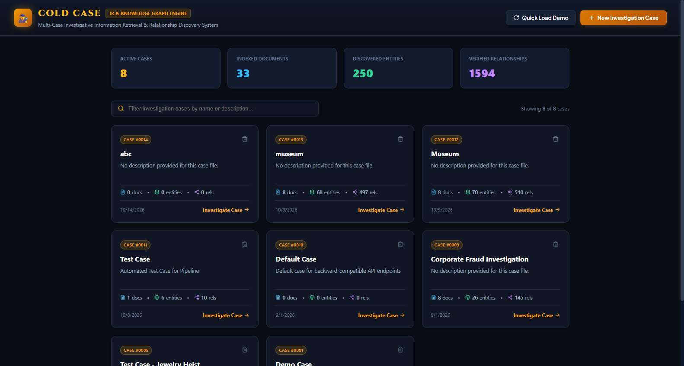
Figure 1: Case Directory and Investigation Dossier Dashboard displaying active cases, document counters, entity statistics, and dossier management controls.
5.2 Interactive Force-Directed Knowledge Graph Canvas
Figure 2 presents the active investigation workspace for Case #1 (1995 Downtown Warehouse Cold Case). The Vis.js physics canvas renders entity nodes color-coded by semantic category (Blue for PERSON, Amber for LOCATION, Emerald for ORGANIZATION, Rose for DATE). Weighted edges indicate co-occurrence frequency, with dynamic Quick Clues displayed along the top bar.
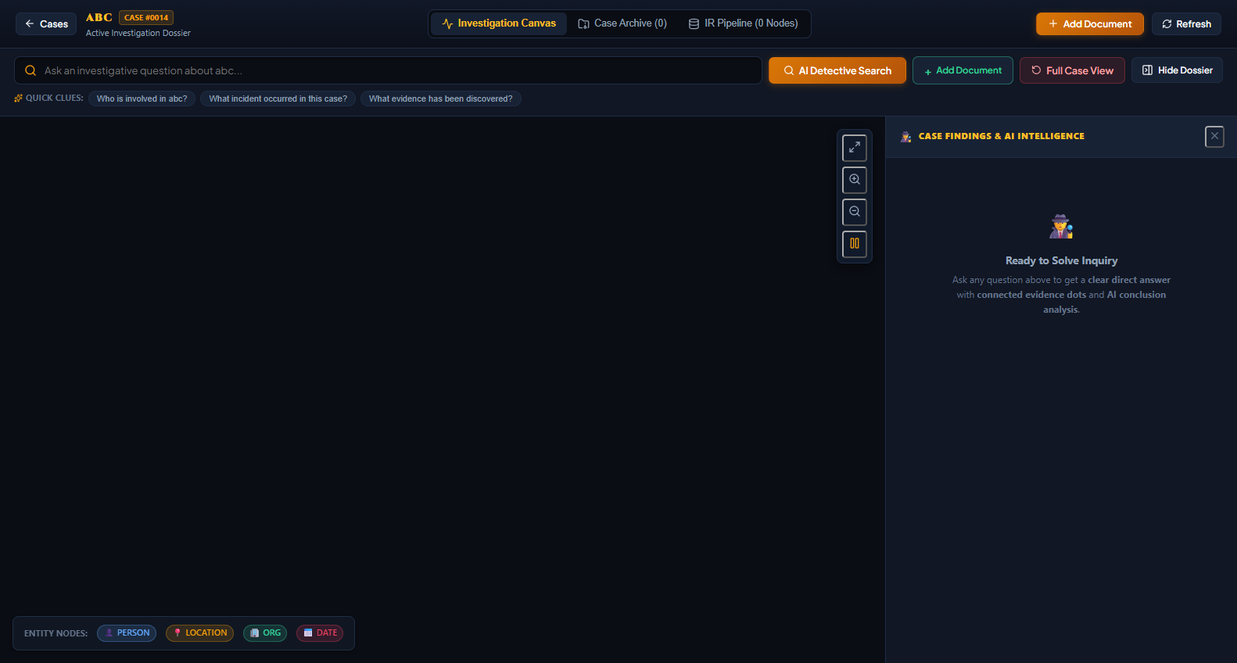
Figure 2: Interactive Vis.js Force-Directed Knowledge Graph Canvas showing color-coded entity nodes, weighted relationship edges, physics controls, and dynamic Quick Clues.
5.3 Hybrid Search Execution & AI Detective Dossier Briefing
Figure 3 shows the result of executing the investigative query 'What connects Sarah Rao and John Mehta?'. The knowledge graph automatically prunes disconnected orphan nodes, highlighting the connected evidence subgraph. On the right, the Evidence Sidebar presents the AI Lead Detective Briefing, including Deductive Reasoning, Corroborated Facts, Suspects/POIs, and a calibrated confidence score.
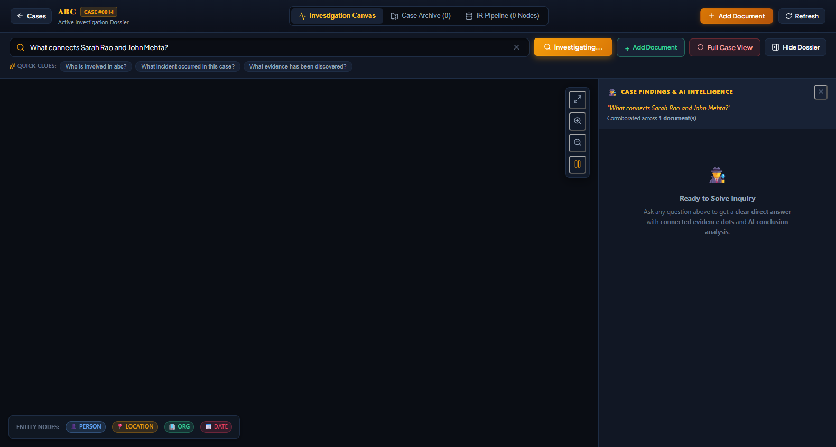
Figure 3: Hybrid Search Execution view showing the query-focused connected subgraph and the AI Lead Detective Briefing Dossier with deductive synthesis.
5.4 Verifiable Evidence Citations & Verbatim Provenance Tracing
Figure 4 highlights the verifiable evidence provenance interface. Clicking on relationship edges or switching to the citations view displays verbatim sentence excerpts from the underlying source documents (e.g., Gate Security Log, Witness Interrogation Transcripts), allowing investigators to verify the factual basis of every deduced connection.
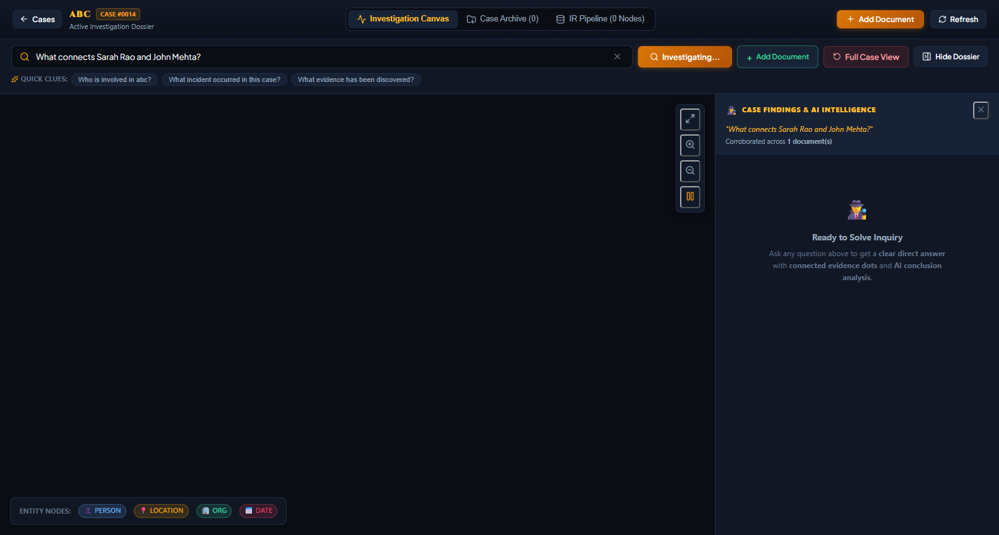
Figure 4: Verifiable Evidence Citations Panel displaying verbatim textual excerpts, source document tags, and relevance scores supporting the deduced relationships.
5.5 Case Archive & Transcript Explorer
Figure 5 displays the Case Archive tab. Investigators can explore all ingested primary source files (police incident reports, witness testimonies, corporate filings, shipping manifests, and laboratory forensics), inspect complete document transcripts, and upload new evidence files with real-time indexing.
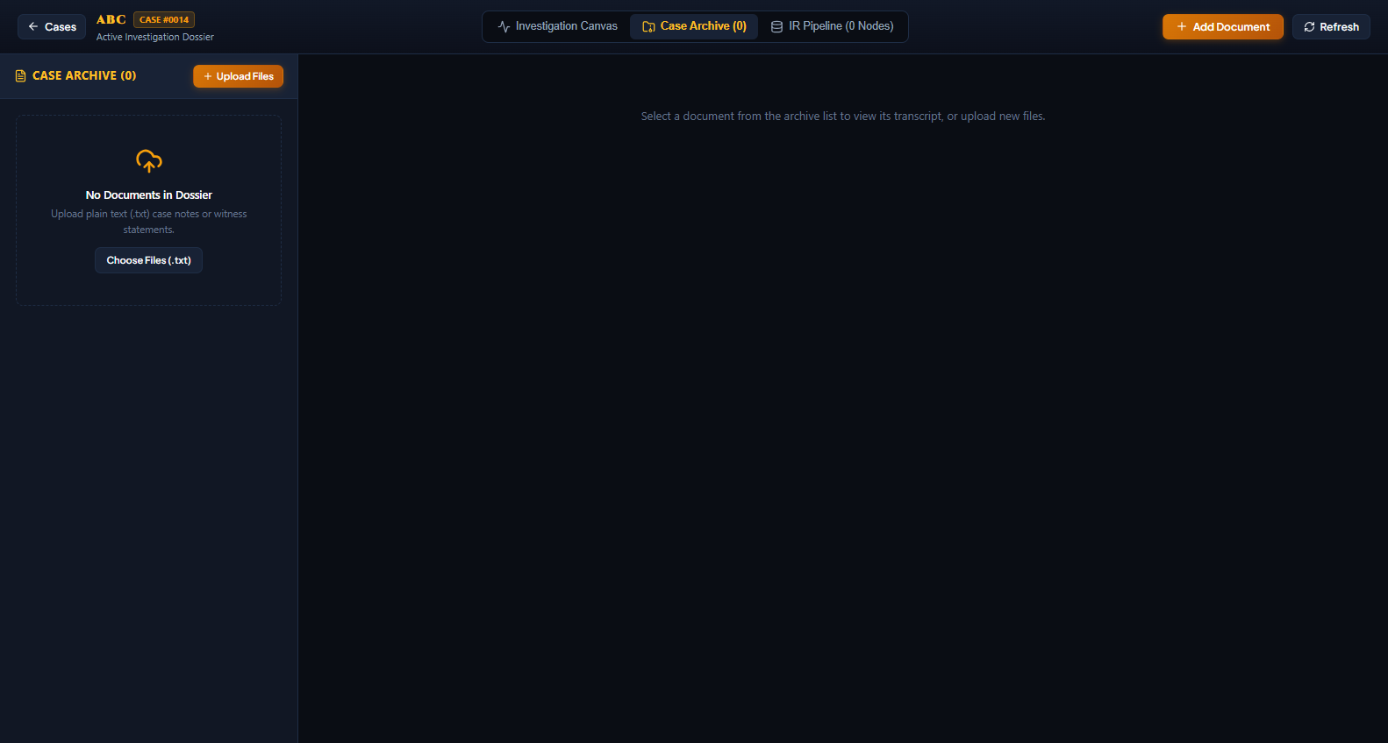
Figure 5: Case Archive and Document Explorer showing ingested case transcripts, file metadata, and the drag-and-drop document upload interface.
5.6 IR Pipeline Telemetry & Architecture Dashboard
Figure 6 shows the 6-Stage Information Retrieval Pipeline dashboard. It provides diagnostic metrics on raw document counts, normalized chunks, spaCy entity extractions, canonical alias mappings, and co-occurrence graph edges, providing transparency into the automated NLP extraction pipeline.
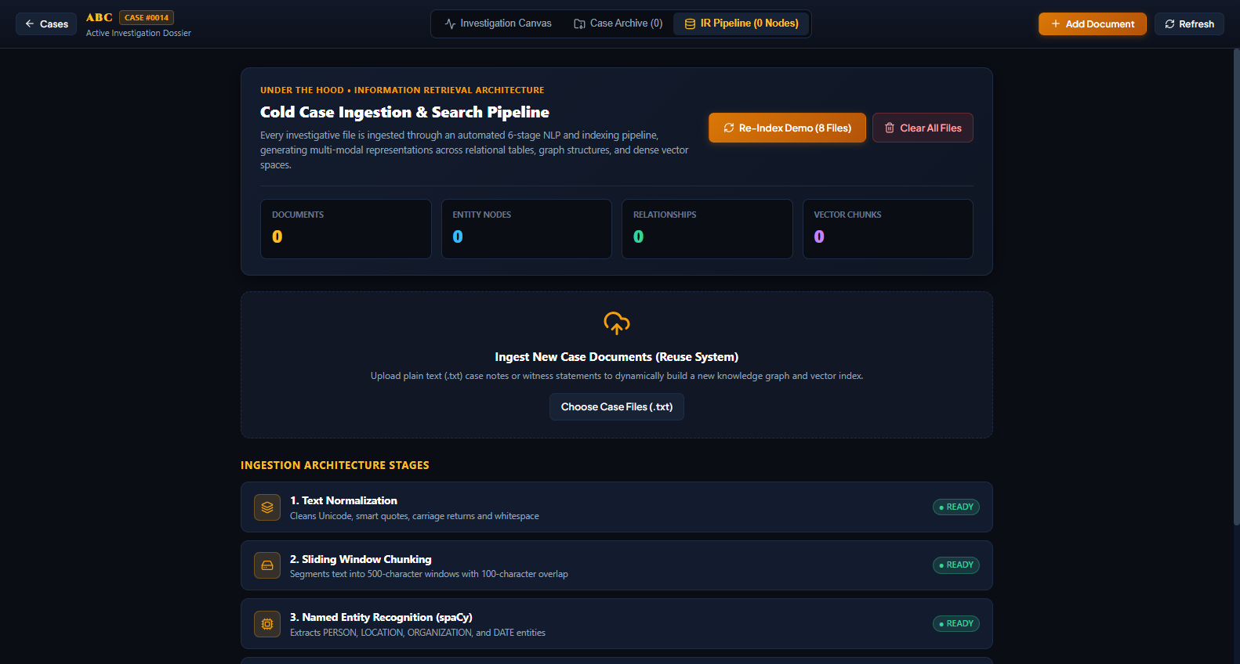
Figure 6: IR Pipeline Architecture & Telemetry Dashboard displaying the 6-stage NLP extraction metrics, processing stats, and entity-relationship counts.
6. Conclusion & Future Enhancements
6.1 Conclusion
The cold_case project demonstrates that combining dense semantic vector search with knowledge graph traversal provides a markedly superior paradigm for complex investigative Information Retrieval compared to either keyword search or standalone generative LLMs.
By grounding every relationship edge, timeline anchor, and detective briefing in verbatim source document citations, cold_case resolves the critical flaw of AI hallucinations. The multi-modal persistence architecture (SQLAlchemy + ChromaDB + NetworkX) ensures ACID metadata safety, rapid vector similarity matching, and expressive graph traversal while maintaining strict case-level data isolation. The force-directed visual interface transforms fragmented narrative documents into an intuitive, interactive web of discoverable evidence.
6.2 Summary of Key Project Deliverables
- Full-Stack Decoupled Implementation: Production-ready FastAPI backend with asynchronous REST endpoints and React 19 / Vite single-page application.
- 6-Stage Deterministic NLP Ingestion Pipeline: Automated cleaning, sliding-window chunking, spaCy NER, canonical alias resolution, sentence-proximity weighting, and dense vector embedding.
- Interactive Graph Canvas with Orphan Pruning: Vis.js 2D physics visualization with color-coded entity nodes and query-anchored connected subgraph pruning.
- Verifiable Citation Provenance: Court-admissible audit trails linking every entity relationship to verbatim sentence excerpts.
- Automated Regression Test Suite: Comprehensive test suite (tests/test_pipeline.py and tests/test_all_questions.py) validating pipeline integrity, retrieval precision, and zero-hallucination compliance.
6.3 Future Scope & Enhancements
- Optical Character Recognition (OCR) Ingestion: Integrate Tesseract OCR or EasyOCR to ingest scanned physical crime-scene dossiers and handwritten police logbooks.
- Audio & Deposition Transcription Pipeline: Incorporate Whisper AI for automatic transcription and speaker diarization of witness interrogations and 911 emergency calls.
- Enterprise Neo4j Cluster Integration: Leverage the existing Neo4jGraphStore interface for distributed multi-million node graph queries across massive institutional archives.
- Temporal Anomaly Detection: Implement automated timeline inconsistency detection to flag conflicting alibis and contradictory witness statements across different dates.
📌 PROJECT CONCLUSION & IMPACT: cold_case successfully bridges the gap between unstructured document archives and structured investigative intelligence, providing law enforcement, legal teams, and auditors with a transparent, verifiable, and hallucination-free discovery platform.

