**Lab 2: Adding Windows Client Machines to the Domain and Configuring the DHCP Server on Windows Server 2019**

**Objective**

This lab focuses on:

* Installing and configuring a DHCP server on Windows Server 2019 to manage IP address allocation for the client machines.
* Installing and configuring Windows 10 and Windows 8 Virtual Machines (VMs).
* Adding the VMs to the domain NORTHERNCOLLEGE.LOCAL.
* **I just forgot to change the name of my AD DS server. It is still IT-DC01**

**Task 1: Configure DHCP Server on Windows Server 2019**

Instructions:

1. Install DHCP Role:
   * Open the Add Roles and Features Wizard.
   * Select and install the DHCP Server role.
   * Complete the installation and take a full screenshot of the Results tab. A computer screen with a black screen

     Description automatically generated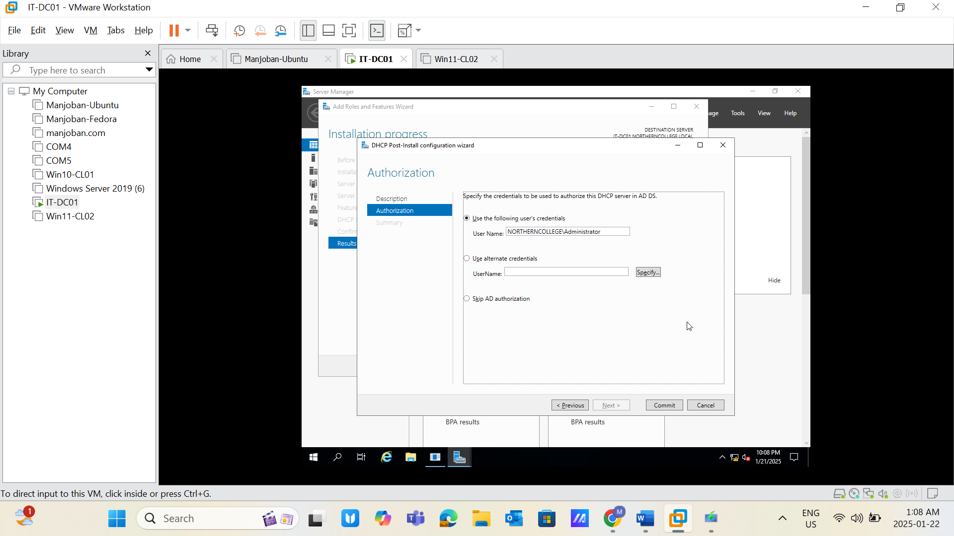
2. Configure a New Scope:
   * Open the DHCP Management Console.
   * Create a new scope named Lab LAN with the following settings:
     + Start IP Address (Take the range for the 50 IPs)
     + End IP Address (Take the range for the 50 IPs)

**Note: Make sure the IP range you are taking does not conflict with others**

* + - Length: 24
    - Subnet Mask: 255.255.255.0

1. Add Exclusions and Delay:
   * Exclude the range:
     + Start IP Address
     + End IP Address

**Note: Take 5 IPs on reserve out of the 50 IP pool.**

1. Set Lease Duration:
   * Configure the lease duration to:
     + Days: 0
     + Hours: 23
     + Minutes: 0
2. Configure Router (Default Gateway):
   * Enter the IP address of your router.
3. Verify Address Pool and Client Configuration:
   * Update the IPv4 settings on both client machines to use DHCP.
   * Log in as the administrator of NORTHERNCOLLEGE.LOCAL.
   * Confirm that both machines receive IP addresses from the DHCP server.

Required Screenshots:

* Screenshot 1: Results tab from the Add Roles and Features Wizard after successful installation. A computer screen with a black screen

  Description automatically generated
* Screenshot 2: New scope wizard showing the name Lab LAN. A computer screen with a black screen

  Description automatically generated
* Screenshot 3: IP address range settings. 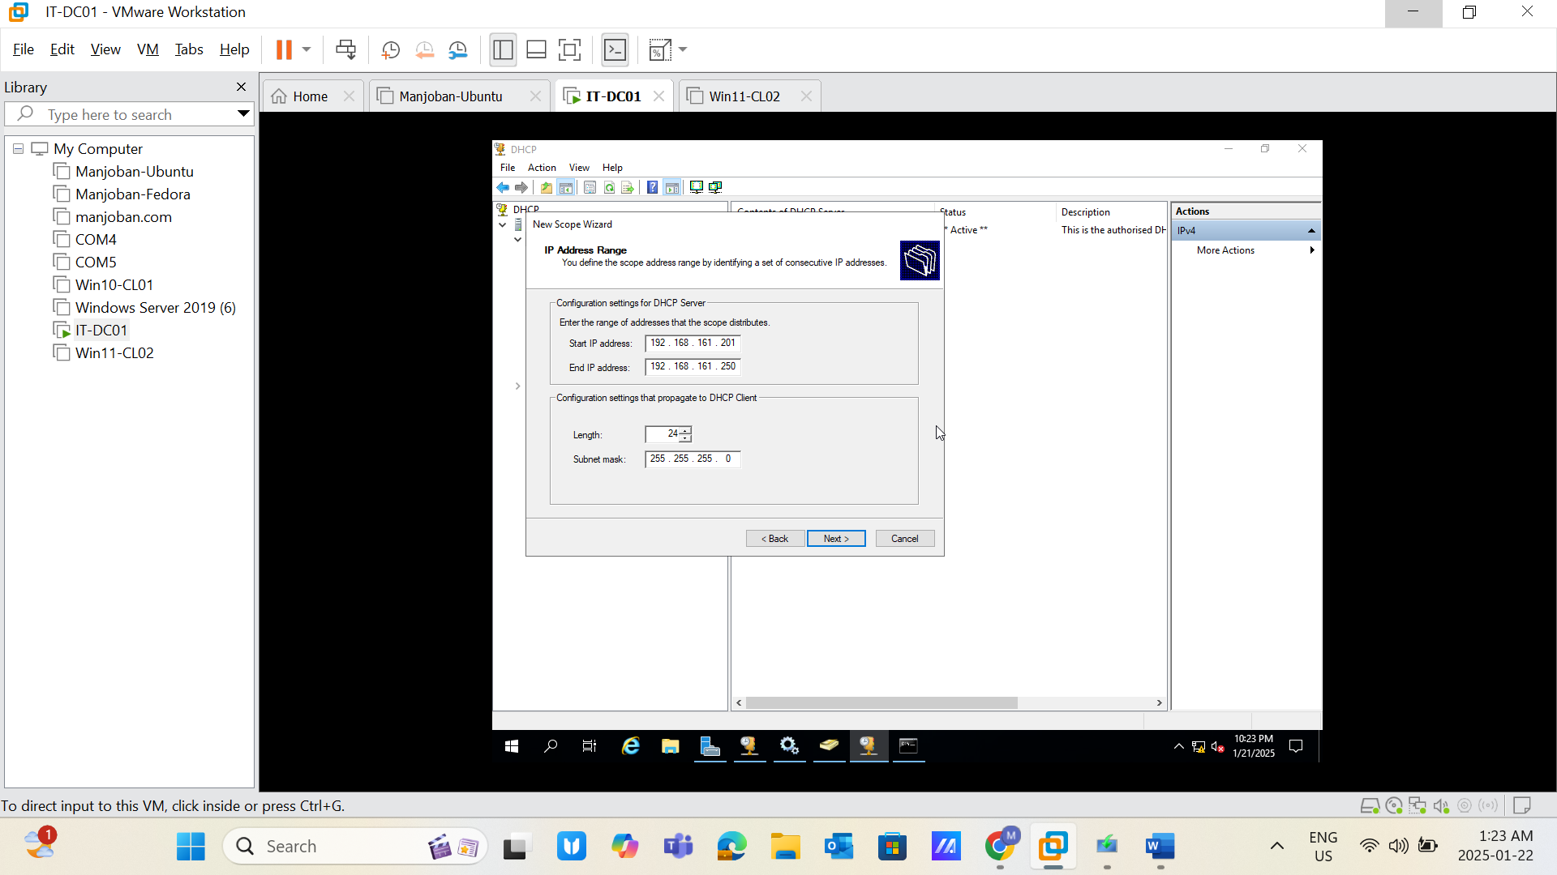
* Screenshot 4: Exclusion and delay configuration. 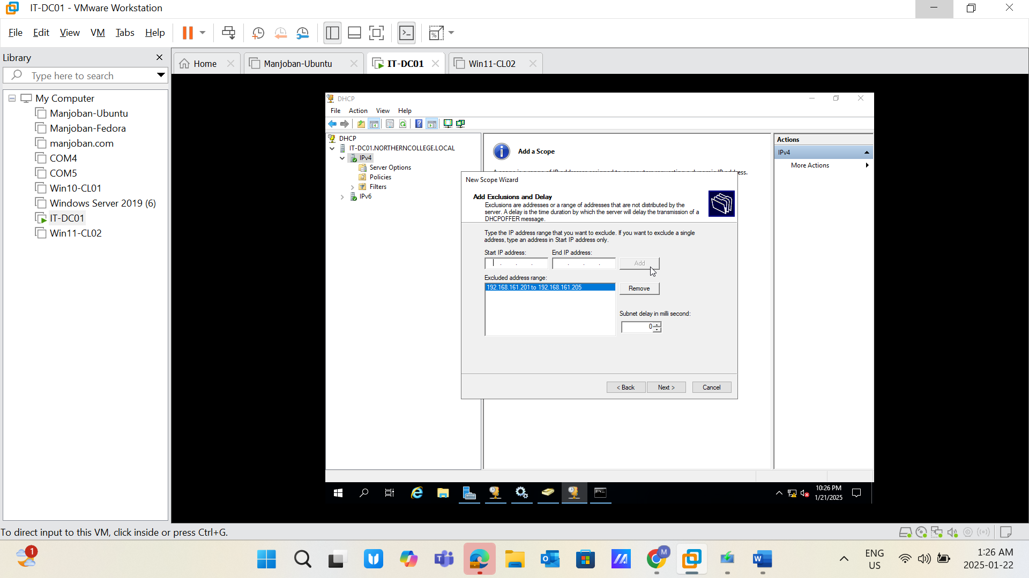
* Screenshot 5: Lease duration configuration. 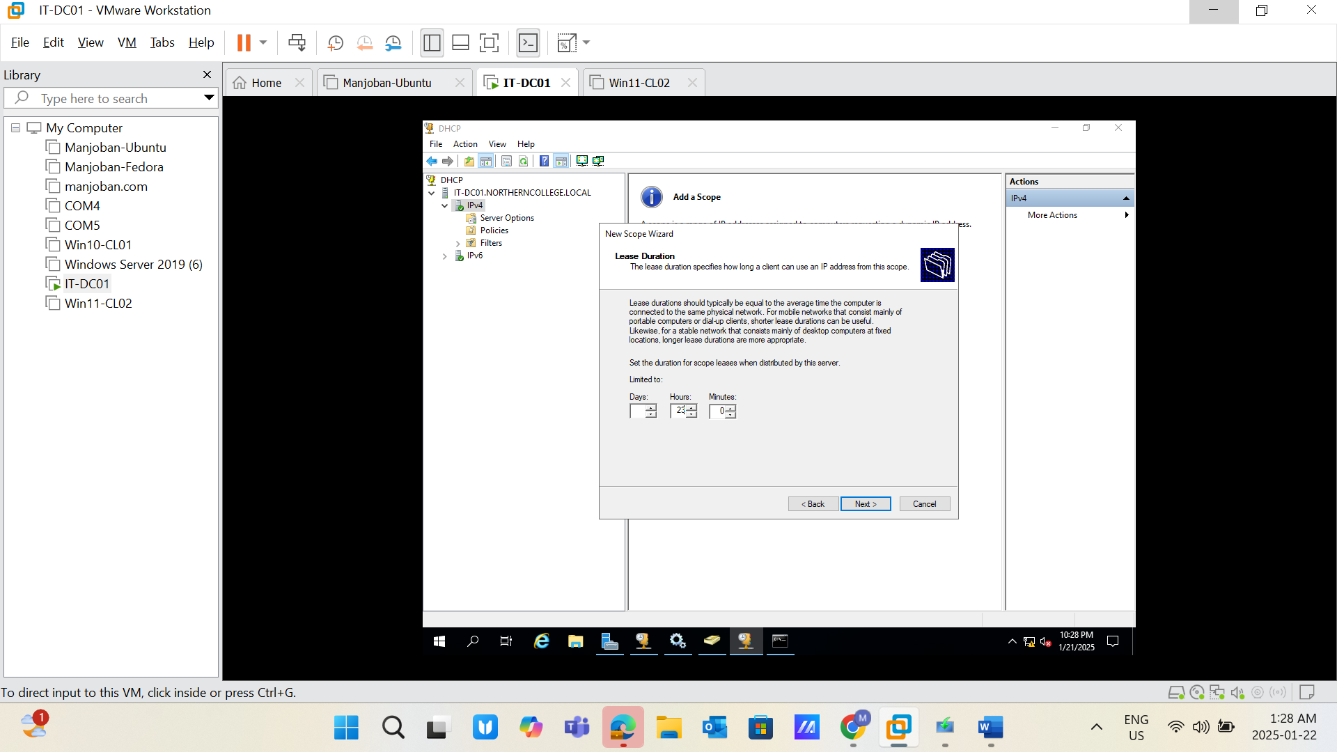
* Screenshot 6: Router (default gateway) settings. 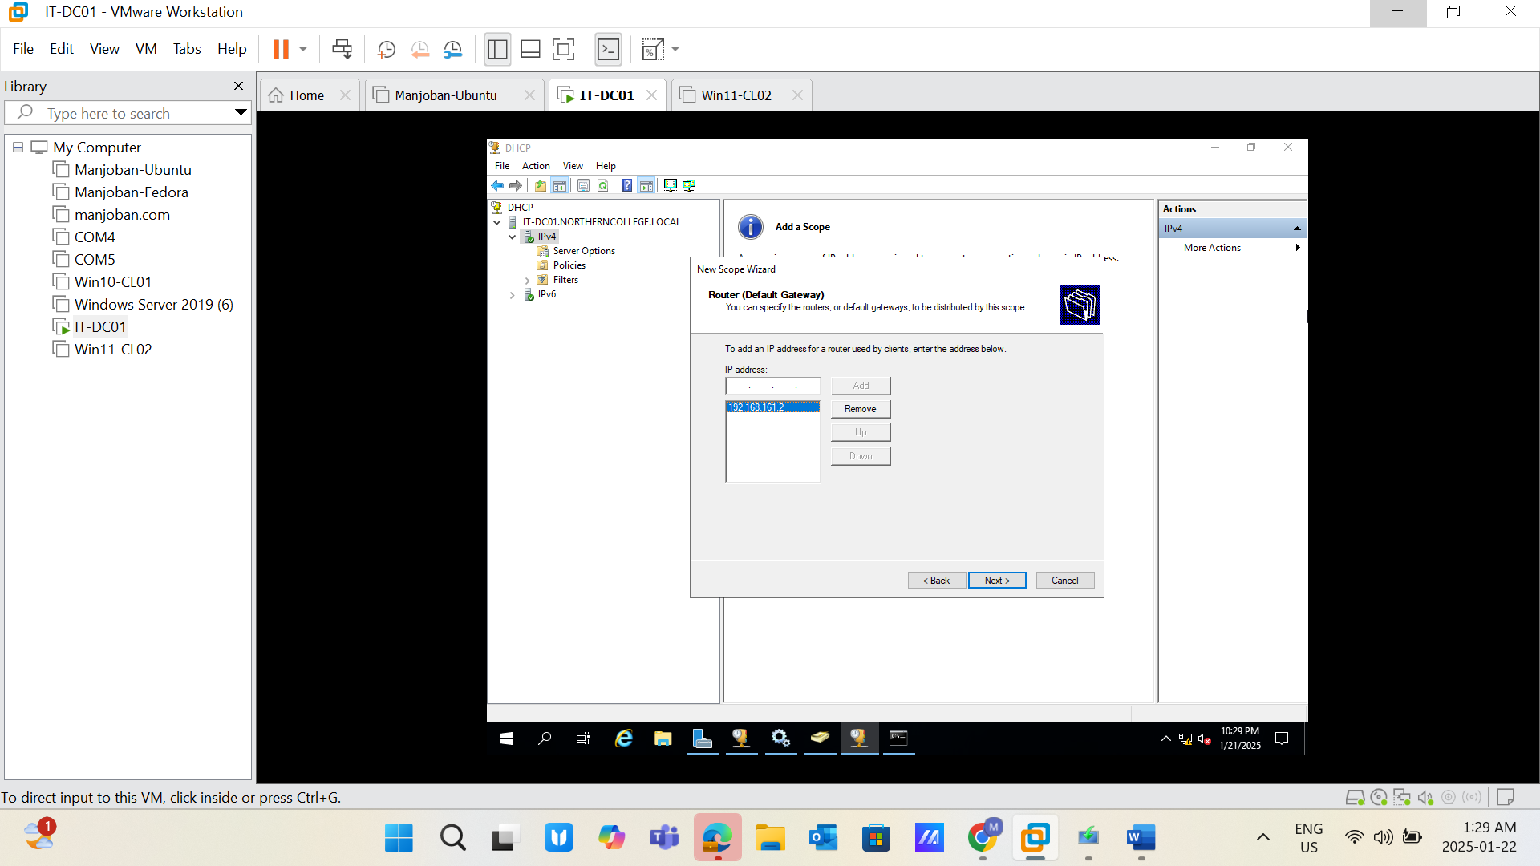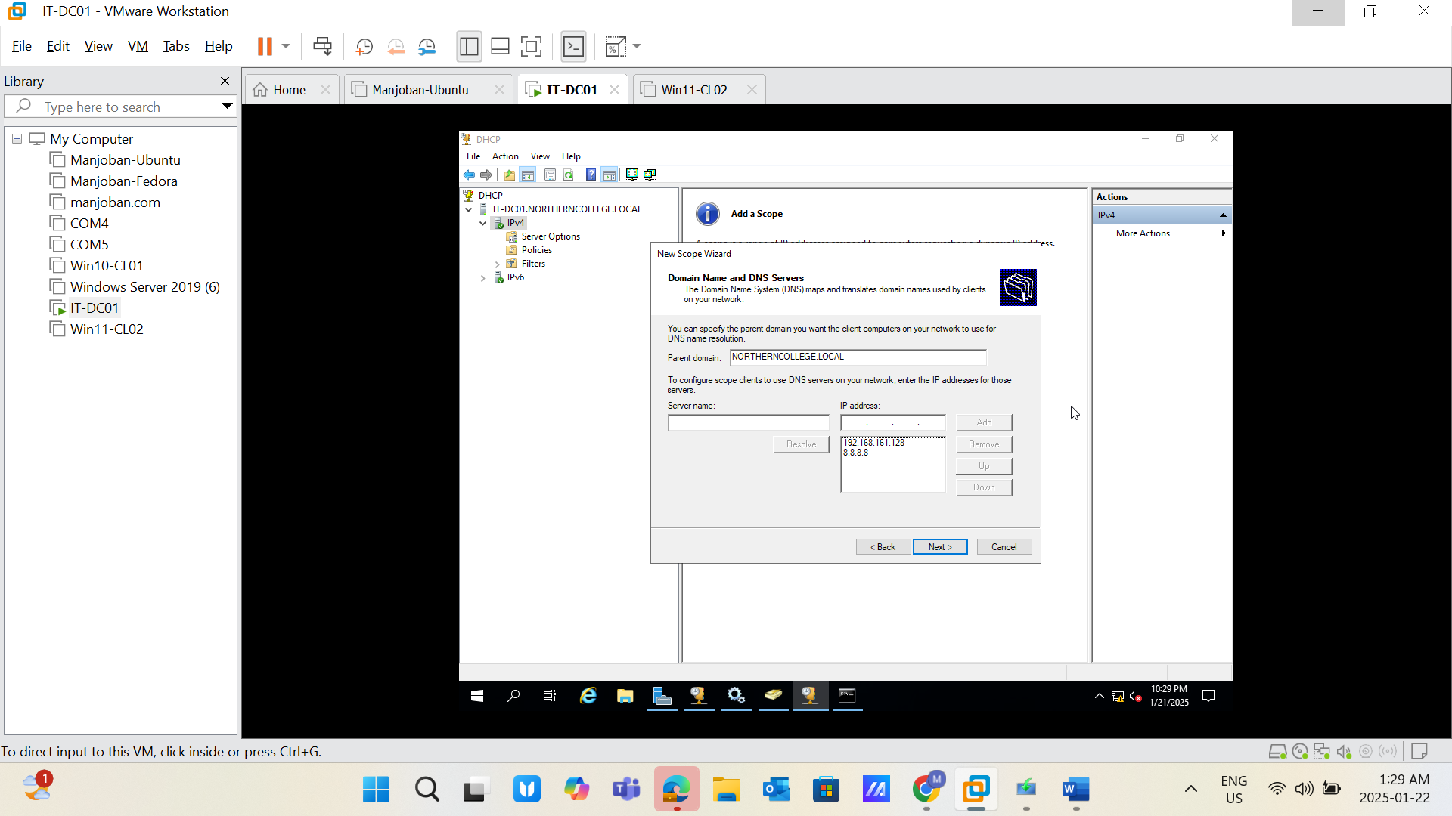
* Screenshot 7: Address pool in the IPv4 scope. A computer screen with a black screen

  Description automatically generated
* Screenshot 8: Network connection details page showing DHCP is enabled on both client machines. A screenshot of a computer

  Description automatically generated
* Screenshot 9: Address lease details for both Windows 10 and Windows 8 client machines. A computer screen with a white screen

  Description automatically generated

**Task 2: Install and Add Windows 10 VM to the Domain**

System Information:

* Host Name: Win10-CL01
* vCPU: 4
* RAM: 4 GB
* HDD: 60 GB

Instructions:

1. Install Windows 10:
   * Create a new VM in your hypervisor.
   * Allocate resources as per the system information.
   * Install Windows 10 operating system.
2. Add to Domain:
   * Configure the network adapter to match the domain settings.
   * Set the DNS server to point to your domain controller.
   * Join the domain NORTHERNCOLLEGE.LOCAL using administrator credentials.

Required Screenshots:

* Output of the command whoami.
* Output of the command ipconfig.
* IPv4 settings in the network adapter. A screenshot of a computer

  Description automatically generatedA screenshot of a computer

  Description automatically generated

**Task 3: Install and Add Windows 11 VM to the Domain**

System Information:

* Host Name: Win11-CL02
* vCPU: 4
* RAM: 4 GB
* HDD: 60 GB

Instructions:

1. Install Windows 11:
   * Create a new VM in your hypervisor.
   * Allocate resources as per the system information.
   * Install Windows 8 operating system.
2. Add to Domain:
   * Configure the network adapter to match the domain settings.
   * Set the DNS server to point to your domain controller.
   * Join the domain NORTHERNCOLLEGE.LOCAL using administrator credentials.

Required Screenshots:

* Output of the command whoami.
* Output of the command ipconfig.
* IPv4 settings in the network adapter. 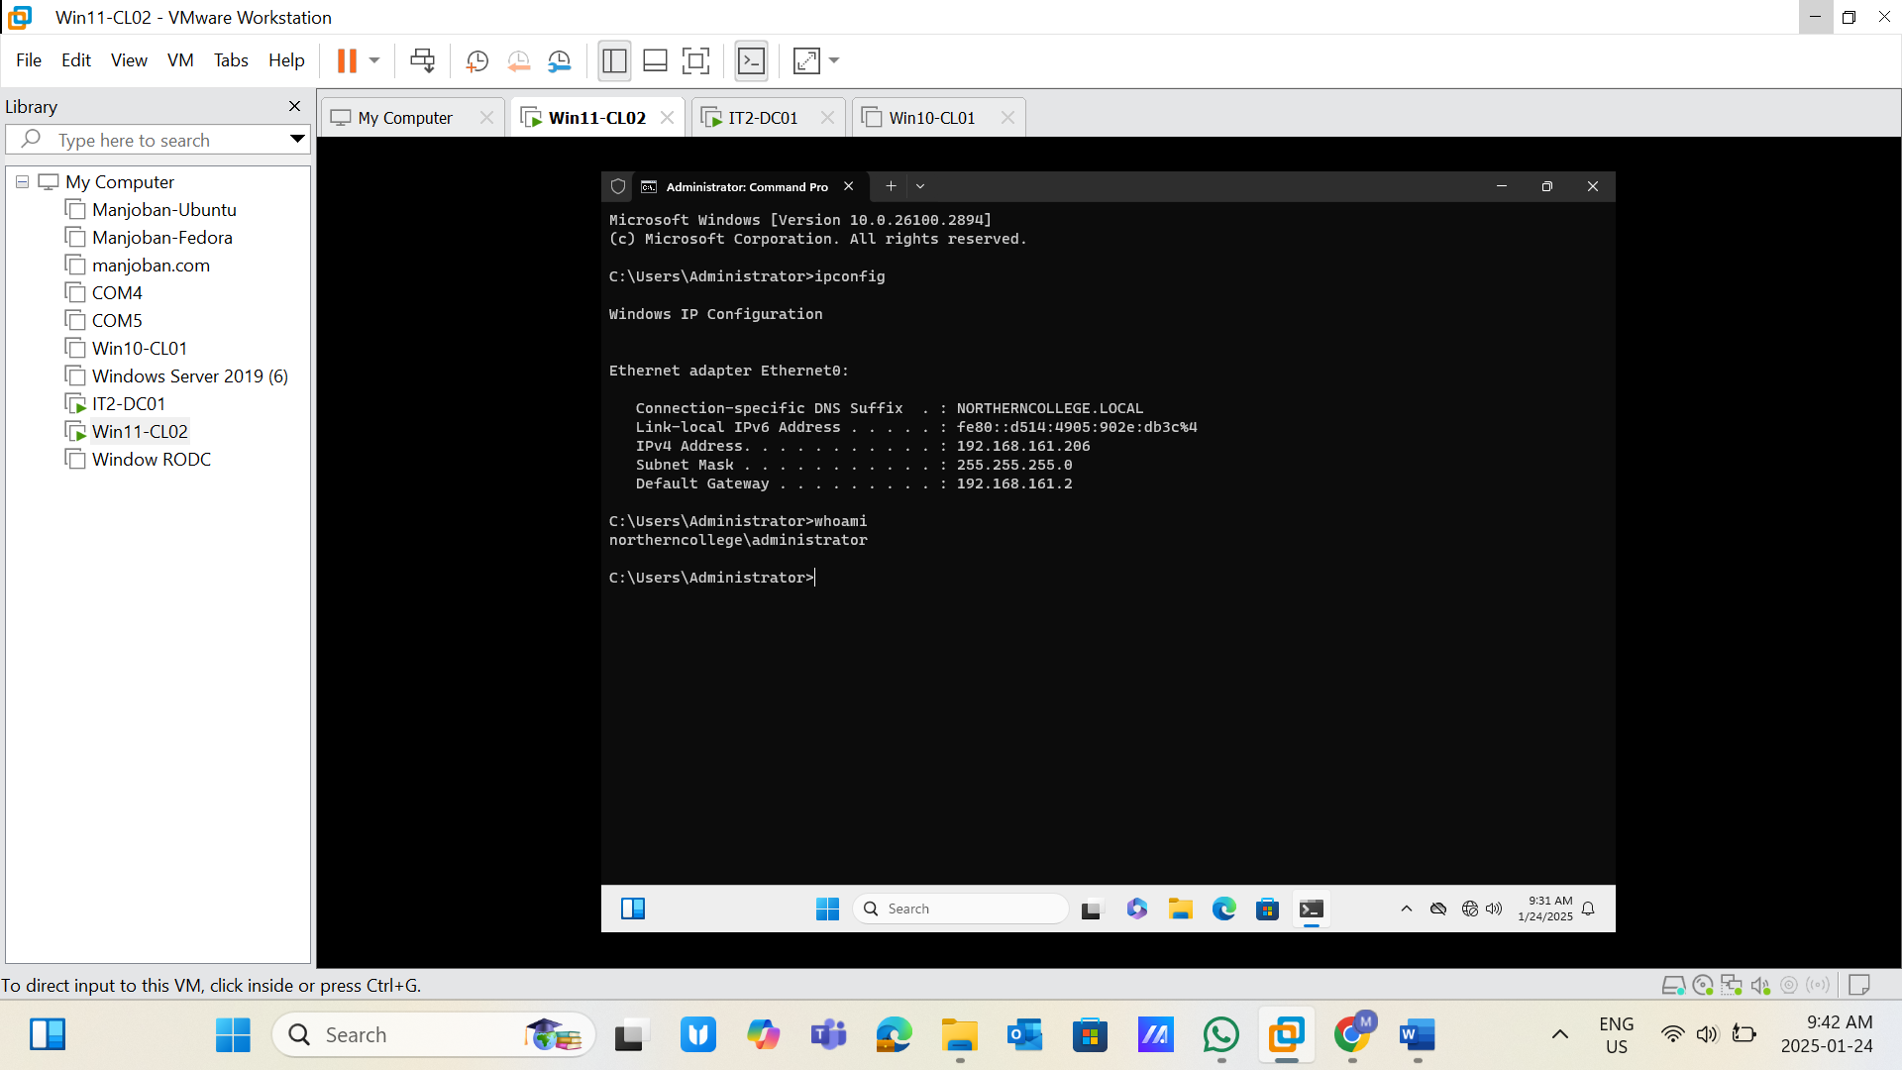A screenshot of a computer

  Description automatically generated