**Lab – 8: Setting Up a Linux Web Server in VMware Workstation**

**Objective**

In this lab, you will set up an Ubuntu 22.04 LTS web server inside VMware Workstation, install and configure Nginx, PHP, and MySQL, and deploy a simple PHP application.

**Task 1: Install Ubuntu Server 22.04 LTS *(5 points)***

**ISO Download Link:**[Ubuntu Server 22.04 LTS](https://ubuntu.com/download/server)

1. Download the Ubuntu Server ISO from the link above.
2. Open **VMware Workstation** and click **Create a New Virtual Machine**.
3. Select **Typical Installation**.
4. Choose the **downloaded Linux ISO** as the installation media.
5. Assign system resources:

o **CPU:** At least **2 cores** o **RAM:** At least **4GB** o **Disk Space: 20GB**

1. Choose **Bridged Networking** (recommended for external access) or **NAT**.
2. Complete the installation and boot into **Ubuntu**.

**Deliverable:** Screenshot of the successful Ubuntu installation.

**Task 2: Update System Packages *(3 points)***

Run the following command to update and upgrade all packages:

sudo apt update CC sudo apt upgrade -y

**Deliverable:** Screenshot showing successful package update.

**Task 3: Install and Configure Nginx *(5 points)***

**Step 1: Install Nginx**

sudo apt install nginx -y

**Step 2: Enable and Start Nginx**

sudo systemctl enable nginx

sudo systemctl start nginx

**Step 3: Verify Nginx Installation**

systemctl status nginx curl -[I http://localhost](http://localhost/)

**Deliverable:** Screenshot of the **Nginx status output**.

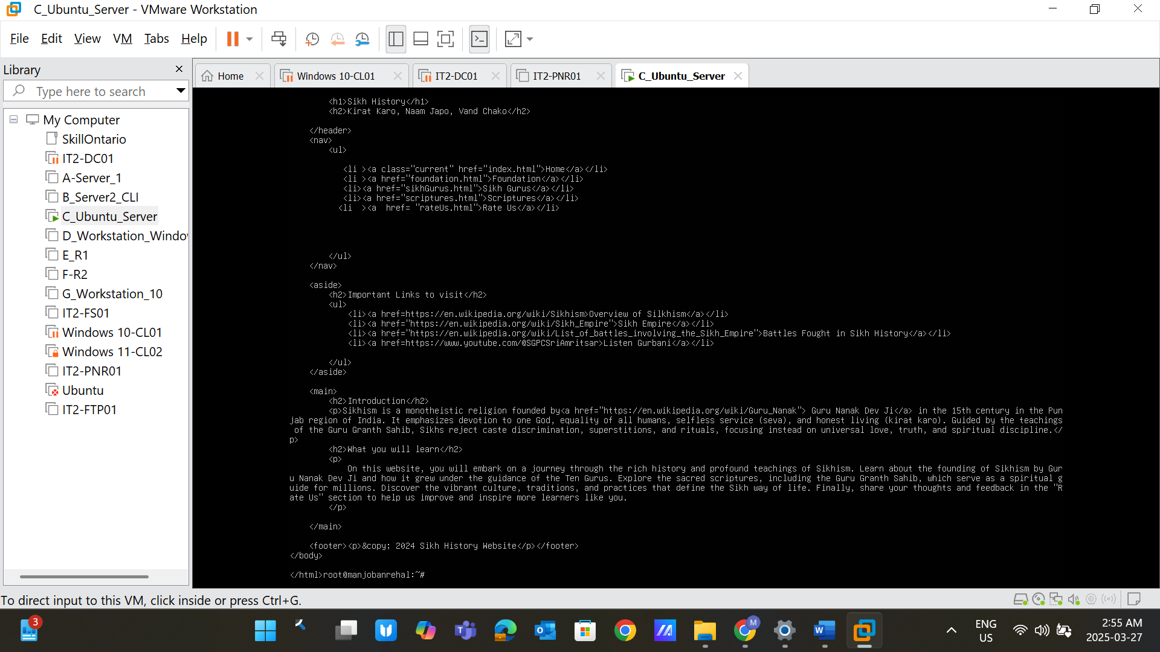

**Task 4: Configure Firewall for Nginx *(2 points)***

sudo ufw allow 'Nginx Full'

**Deliverable:** Screenshot of the firewall rules. 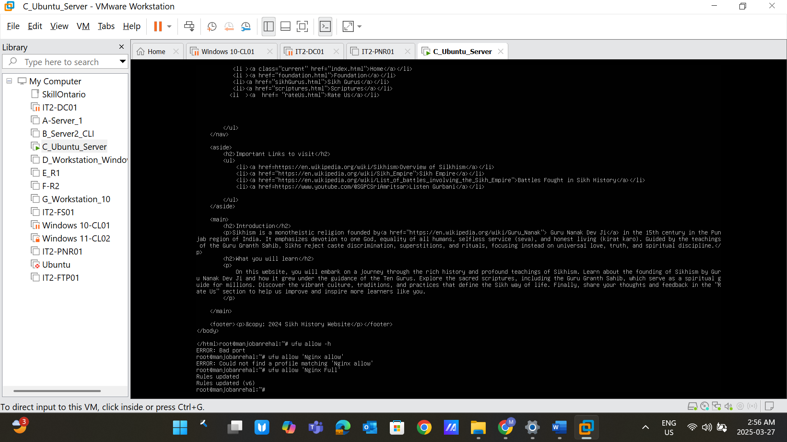

**Task 5: Install PHP and PHP-FPM *(5 points)***

sudo apt install php-fpm php-mysql -y

**Deliverable:** Screenshot showing successful PHP installation.

**Task 6: Configure Nginx to Use PHP-FPM *(5 points)* Step 1: Edit Nginx Configuration**

sudo nano /etc/nginx/sites-available/default

**Replace the file content with the following:**

server { listen 80;

server_name 192.168.85.131; # Replace with your IP address

root /var/www/html; index index.php index.html index.htm; location / { try_files $uri $uri/ =404;

}

location ~ \.php$ { include snippets/fastcgi-php.conf; fastcgi_pass unix:/run/php/php8.1-fpm.sock; # Adjust PHP version if needed fastcgi_param SCRIPT_FILENAME $document_root$fastcgi_script_name; include fastcgi_params;

}

location ~ /\.ht {

deny all;

}

}

**Step 2: Test Configuration**

sudo nginx -t

**Step 3: Restart Nginx**

sudo systemctl restart nginx

**Deliverable:** Screenshot of the **Nginx configuration test output**.

**Task 7: Verify PHP Processing *(3 points)***

echo "<?php phpinfo(); ?>" | sudo tee /var/www/html/info.php

Now, open your browser and visit:

<http://192.168.85.131/info.php>

**Deliverable:** Screenshot of the **PHP Info page**.

**Task 8: Install and Secure MySQL *(5 points)* Step 1: Install MySQL Server**

sudo apt install mysql-server -y

**Step 2: Secure MySQL Installation**

sudo mysql_secure_installation

* Set root password
* Remove anonymous users
* Disallow remote root login
* Remove test database
* Reload privileges

**Deliverable:** Screenshot of the **MySQL secure installation completion**.

**Task 9: Create a MySQL Database and User *(5 points)***

sudo mysql -u root -p

Inside MySQL, run:

CREATE DATABASE test_db;

CREATE USER 'test_user'@'localhost' IDENTIFIED BY 'password';

GRANT ALL PRIVILEGES ON test_db.* TO 'test_user'@'localhost';

FLUSH PRIVILEGES;

EXIT;

**Deliverable:** Screenshot of the **database creation process**.